Pan Hlaing River in the Yangon delta, Myanmar
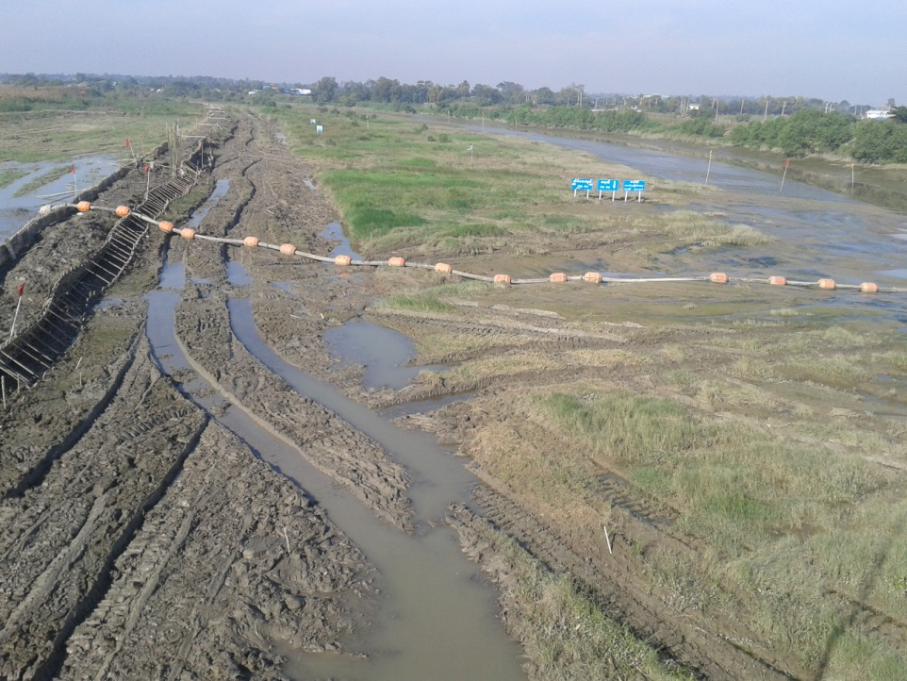
Considerations for developing a sluice gate near the Hlaing River confluence

February 2015


Contents

1 BRIEF DESCRIPTION OF THE PAN HLAING RIVER SYSTEM 1
2 PRESENT PAN HLAING RIVER STATUS (December 2014) 4
3 SOME HISTORICAL BACKGROUND INFORMATION 5
4 INTEGRATED WATER RESOURCES MANAGEMENT ASPECTS 5
5 SOME ADDITIONAL CONSIDERATIONS 6
6 POSSIBLE SOLUTION STRATEGY: A PHASED APPROACH WITH MULTIFUNCIONAL STRUCTURE 8
7 PRELIMINARY STAKEHOLDER LIST 8
8 AVAILABLE AND MISSING INFORMATION 8
REFERENCES 11

BACKGROUND
This report is based on two exploratory missions to Myanmar by members of the project team from UNESCO-IHE involved in defining the Terms of Reference for the design of a Sluice Gate in the Pan Hlaing River near the confluent with the Hlaing River in the Yangon delta. The first mission was performed by Prof. A.E. Mynett (1-6 Dec, 2014) with a focus on generic river/delta development considerations, the second mission by Dr. Suryadi (17-24 Dec, 2014) with a focus on agricultural and irrigation aspects. Further analyses on river sedimentation and morphodynamic considerations were carried out by Dr. A. Crosato (UNESCO-IHE) while Prof. C. de Fraiture (UNESCO-IHE) contributed to the analysis of agricultural aspects.
The report is part of the project MAK14MY02 carried out for the Rijksdienst voor Ondernemend Nederland (RVO) of the Netherlands Ministry of Economic Affairs.

1 BRIEF DESCRIPTION OF THE PAN HLAING RIVER SYSTEM

The Pan Hlaing is a 90km-long river originating as a distributary of the Ayeyarwady (or Irrawaddy) River in the delta area and joining the Hlaing River near the city of Yangon, Myanmar (Figure 1). For the first 30 km the river has a wide channel, with bankfull widths varying between 180 and 570 m, currently used for water transportation. The river then splits in two branches: the right branch is the continuation of the Pan Hlaing River, whereas the left branch is called Kokowa River (Figure 2). Both branches eventually join the Hlaing River, the Kokowa 30 km more upstream, the confluences being at a distance of some 85 and 55 km resp. from the Hlaing River mouth.

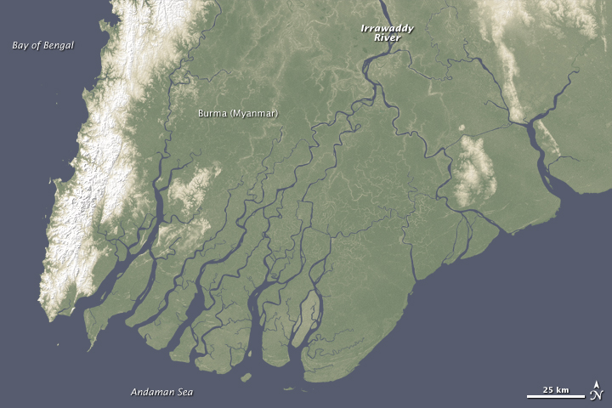
Figure 1. In red the study area (source: http://earthobservatory.nasa.gov/IOTD/view.php?id=40257)

Until recently, the Pan Hlaing River used to fulfill the functions of drainage system for the excess waters during the monsoon and of storage system for irrigation waters to be used in the dry season, but the part between the bifurcation with the Kokowa River and the Pan Hlaing Bridge (Figure 3) almost completely lost its functions due to extreme sedimentation along the major part (some 50 km out of the 54 km river course). Only the part near the confluence with the Hlaing River has remained open.
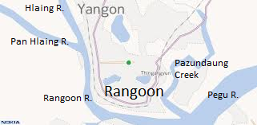
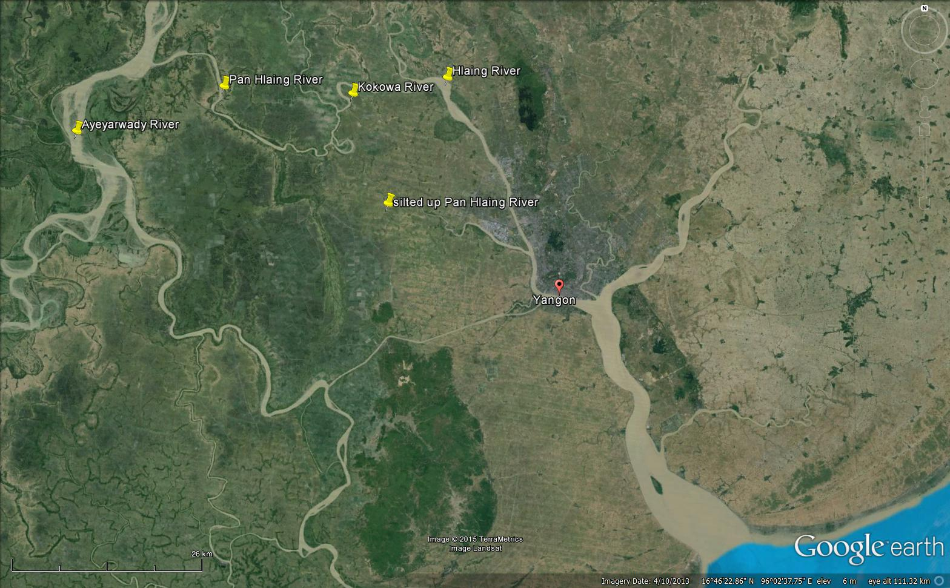
Kokowa
Pan Hlaing
Hlaing River
Ayeyarwady River

Figure 2. The Pan Hlaing River system (source: Google Earth). On the right a sketch of the river system around the city of Yangon.

The Kokowa is a 33km-long river with a bankfull width varying between 200 and 260 m in its first 15 km, widening to a width ranging between 270 and 600 m in its subsequent 18 km, after having received the waters of an important tributary. Originating from a bifurcation of the Pan Hlaing River, this river is strongly affected by the changes occurring in the other branch. This means that re-opening of the Pan Hlaing River, the increase of water extraction and all other types of interventions might lead to important morphological changes in the Kokowa River channel, for instance bed level raising or lowering, depending on the type of intervention and on the water and sediment distribution at the bifurcation.
The Hlaing River, also known as Yangon or Rangoon River, is one of the nine mouths of the Ayeyarwady River. It is a wide tidal channel draining the excess monsoon waters and serving as important navigation route, since it connects the city of Yangon to the inland areas and to the coast (Figure 4). It is much deeper than the Pan Hlaing River and shows no signs of sedimentation. In the summer months, salt intrusion reaches the Pan Hlaing River, where the sedimentation rates might be enhanced by the encountering of fresh and salt waters.

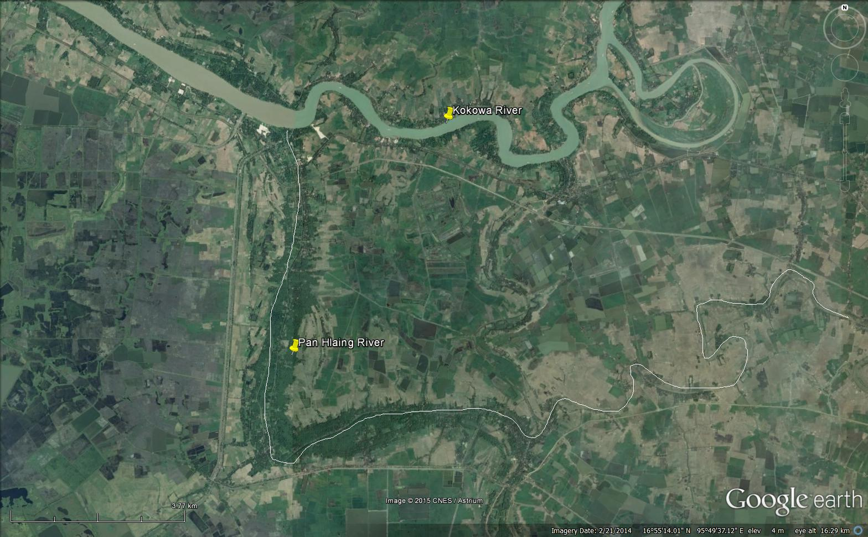
Figure 3. Old Pan Hlaing river path, now almost completely silted up, near the bifurcation with the Kokowa River (white line).

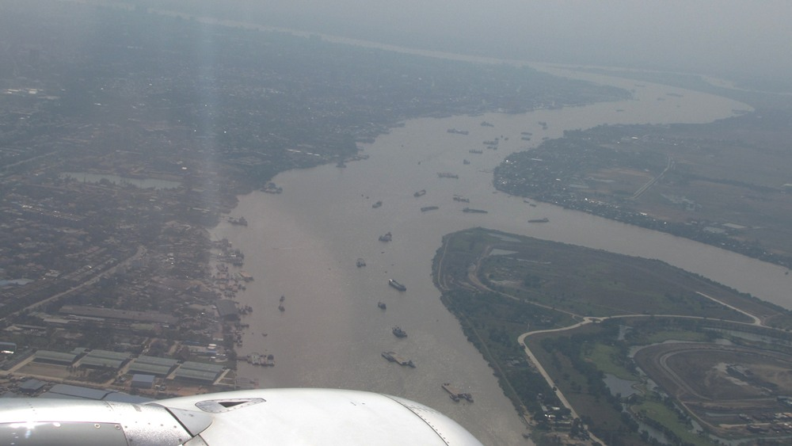

Yangon City

Hlaing River
Pan Hlaing River

Figure 4. Navigation in the Hlaing River (left) at the confluence with the Pan Hlaing River (right). The photo looks in downstream direction towards the sea.

2 PRESENT PAN HLAING RIVER STATUS (December 2014)

Since the major part of the Pan Hlaing River is now completely silted up (Figure 5), the Irrigation Department of the Ministry of Agriculture and Irrigation (MoAI) developed a scheme to rehabilitate the entire river (see e.g. MITV NEWS, Sunday February 1, 2015):
- In December 2014 both river ends were closed off by cofferdams constructed from local soil.
- At the Kokowa entrance, the barrier has already been constructed and excavation has started. Here, a drainage/intake sluice is projected similar to the nearby Mezzali suice, which is working well.
- At the Hlaing River side, a double bamboo curtain filled with sandbags is being constructed between the Pan Hlaing Bridge and the Golf Course. Some 300’ [ft] has already been completed, but more needs to be done (construction can take place at low tide only).
- At intermediate cross-sections, temporary earth fills (cofferdams) have been constructed as well, leading to a number of working compartments.
- The entire river is being excavated by multiple teams with multiple (6~8) shovels at several locations at the same time.
- The cross-sectional profiles to be excavated vary in width from 40’-60’-80’ [ft], with a common depth of ~20’ [ft].
- The choice for 40’-60’-80’ width sections was determined by MoAI based on the drainage area that the particular stretch of the river serves.
- The depth of ~20’ [ft] (6 m) is achieved in two stages of 3m to let the soil dry out for some time.
- The plan is that the entire excavation is finished before May 2015 (start of the rainy season).
- At some stretches negotiations with the local inhabitants (rural dwellers) were needed to define the detailed trajectory.

Figure 5. Pan Hlaing River channel almost completely silted up seen from the Pan Hlaing Bridge (looking upstream).

3 SOME HISTORICAL BACKGROUND INFORMATION

Apparently, it took less than 10 years (some say even only 3 to 5 years) for the Pan Hlaing River to almost completely silt up. Some (villagers) blame the construction of the Pan Hlaing Bridge to have accelerated siltation, others mention the construction of dams/roads across the river by the villagers themselves for transportation purposes. Fact is that one drainage/irrigation sluice in the mid-section constructed in 1997 was fully covered with sediments and had to be completely excavated and renovated. After sedimentation, the Pan Hlaing River could not provide the required drainage capacity in the rainy season or fresh water supply in the dry season, which caused considerable complaints from the inhabitants and led the government to finance the Pan Hlaing rehabilitation project from a special Presidential Fund MoAI because of successful recent completion of a similar project.

4 INTEGRATED WATER RESOURCES MANAGEMENT ASPECTS

Considering the old river functions (irrigation and drainage), MoAI is now considering the construction of a large sluice near the confluence of the Pan Hlaing River with the Hlaing River, the Pan Hlaing River Sluice. However, it appears wise to consider also other river functions that might become relevant in the future, with an integrated approach.
The agricultural land-use stretches from the Kokowa region to the Panhlaing Bridge. More downstream, the land-use is dominated by industrial development (Coca Cola, Unilever, Scania, Volvo, etc.) to the North of the Pan Hlaing River, while the Yangon City Development Committee (YCDC) is preparing Yangon City expansion to the South. YCDC is also currently exploring constructing a water intake and treatment facility at the Kokowa River (not far from Mezali intake), in order to supply (drinking) water for the new urban development. This plan includes transferring the treated water by pipeline along the main highway to a river crossing near the Golf Course. At the same time, the industrial area to the North is planning to increase its stormwater drainage capacity, perhaps even combined with waste water (this seems to be the present policy according to Myanmar Times, Friday 27 February 2015), using the Pan Hlaing River to discharge these effluents into the Hlaing River and then onwards to the open sea. Clearly, this will considerably affect the water quality in the Pan Hlaing River, which would deteriorate rapidly if the outlet to the Hlaing River is blocked by a Pan Hlaing River Sluice gate, in particular since measures for improving industrial stormwater and wastewater are not expected within the next 5 years or so (ref. YCDC). As a result, this would hamper using the Pan Hlaing River as fresh water supply for the new urban expansion, and probably also affect the water quality for agricultural uses upstream.
In order to avoid similar environmental problems as the Netherlands encountered after closure of the tidal arms during the Delta Works, an integrated water resources management (IWRM) approach seems much to be preferred. This could include the development of river navigation along the Pan Hlaing River which could become desirable after further industrial development in the area.

5 SOME ADDITIONAL CONSIDERATIONS

On the causes of accelerated sedimentation of the Pan Hlaing River
By looking at the physical conditions of the irrigated areas, it is clear that only minor land erosion occurred. It means that local soil erosion is not the main source of the sediments deposited in the Pan Hlaing River channel. Side bank erosion due to water transportation or speed boat does not occur, since there is no water transportation with high velocity and no significant waves are generated.
The most probable current sediment source appears the Hlaing River. In the past, the sediments from the Ayeyarwady River were most probably equally important, but now the open part of the Pan Hlaing River receives waters from the Hlaing River only. River cross sections and local experts indicate that the bed level of this river is much lower than the bed level of the Pan Hlaing River. This means that bed load from the Hlaing River does not enter the Pan Hlaing River. Therefore, siltation in the Pan Hlaing River is most probably caused by settling of suspended solids.
An important aspect to be considered is the instability of the bifurcation of the Pan Hlaing River (Marra et al., 2014). Some hydraulic changes occurred in the recent past, such as increased withdrawal of the Pan Hlaing River water for irrigation, may be the cause of the observed accelerated sedimentation and closing up of the Pan Hlaing branch. This means that increased sedimentation should not be necessarily attributed to increased sediment inputs, since the cause might be a decreased water flow in the Pan Hlaing River. Another cause of accelerated sedimentation in the Pan Hlaing River might be a recent change of location of the turbidity maximum in the estuary (Savenije, 2012). Salt water intrusion should therefore be investigated to establish whether this could have had a role in the silting up of the Pan Hlaing River.

On hydrodynamic-morphodynamic modelling of the Pan Hlaing system
The entire Pan Hlaing system can be modelled using a 1D model. Setting up a 2D model does not seem wise, given the current lack of data. In any case, modelling the hydrodynamic and morphodynamic processes in the Pan Hlaing River requires considering the entire Pan Hlaing and Kokowa rivers and a part of the Hlaing River (model domain in Figure 6).
The upstream boundary of the system should be set at a cross-section just downstream of the point in which the Pan Hlaing leaves the Ayeyarwady River and at a cross-section of the Hlaing River upstream of the confluence with the Kokowa River (Figure 6). The downstream boundary should be set at a cross-section of the Hlaing River, a few kilometres downstream of the confluence with the Pan Hlaing. The upstream boundary condition consists of the discharges entering the Pan Hlaing River and the Hlaing River at its upstream boundary, the downstream boundary condition being the water levels in the Hlaing River. The hydrodynamic model should then include all water losses, for instance the water withdrawals for irrigation, and all discharges entering the system, for instance from the tributary of the Kokowa River (Figure 6), and should consider seasonal variations as well as tidal oscillations. All this requires careful quantifications.
About the morphodynamic model, the quantification of the sediment inputs to be imposed at the boundaries poses a clear challenge. Averaged sediment inputs could be obtained from model calibration based on historical sedimentation speeds (volumes, porosity and growth rates of the deposits to be roughly derived from information from the locals). The hydrodynamic model on which the morphodynamic model is based should be calibrated and validated before setting up the morphodynamic model, on simultaneous water levels. This require new field investigations, since simultaneous water level data seem missing. For the setting up of the morphodynamic model, a specific new field campaign is needed to collect sediment samples from the areas that are silted up, from the river beds, and from the water column. Suspended solids should not be used to quantify the inputs of suspended sediment from the measured concentrations, since these are strongly seasonal and depend on upstream soil washout, but should be used to assess the granulometry of the sediment that is transported by the rivers in the water column to be compared with the granulometry of the deposited sediment. Wash-load should be distinguished from bed-material load. Sand that is present in the river bed can be assumed to be transported as bed-material load (not to confuse with bed-load), using the most appropriate sediment transport formula.

Ayeyarwady River
Kokowa River

Hlaing River

Pan Hlaing River

Figure 6. Sketch of the model domain (the part in red is the Pan Hlaing river section considered in this study).

On social aspects
With the siltation of the Pan Hlaing River, rural dwellings moved closer to river. At the recent start of the rehabilitation project, several dwellers already had to move their (bamboo) huts in order to allow adequate space for the riverbed to be excavated. However in other parts, notably near the strongly meandering mid-section, the excavation process would clearly benefit from "taking a short-cut" – but here the rural dwellers (land owners) object to making "space for the river". Negotiations between MoAI and the dwellers were on-going at the time of the site visits. Regarding the downstream part of the Pan Hlaing River (where entering the Hlaing River) the situation is even more complex.

On the collaboration between institutions
Apparently the various ministries and stakeholders (MoAI, MoI, MoT, YCDC, ...) are all involved to some extent in developing the area along the Pan Hlaing river, but not yet collaborating in a coherent way towards a joint development (Master Plan) for the Pan Hlaing River area. Strengthening collaboration between ministries, agencies, and other stakeholders involved in the area, appears to be the only way to achieve a sustainable integrated solution including an and to define the requirements to be imposed on the .

6 POSSIBLE SOLUTION STRATEGY: A PHASED APPROACH TOWARDS A MULTIFUNCIONAL STRUCTURE

Based on the problems and conditions, the following strategy seems worthwhile to be considered:
- The identification of an integrated water resources management (IWRM) solution for the Pan Hlaing River system (including the Kokowa and a part of the Hlaing rivers) together with all involved local parties, including institutions and stakeholders. The chosen solution might include the construction of one (or more) multifunctional structure on the Pan Hlaing River.
- It seems that a "phased approach" could be considered. This could start with the construction of a drainage (only) sluice gate in the Pan Hlaing River at a location near the Pan Hlaing Bridge within the shortest period feasible. This would solve the immediate need of the entire agricultural area. Meanwhile, further explore all IWM aspects, including the development plans for the industrial area and the new urban extension area, in particular related to water quantity and quality needs.
- The development of an integrated solution will require monitoring and evaluation activities to be carried out as soon as the dredging works are ready. These activities should cover technical analyses (water levels, sediment concentrations, different water needs, cropping pattern and calendar, salinity), social, economical and environmental impacts. More detailed soil mechanics and geo-technical investigations might be required in relation to the bearing capacity of the soil and the stability of the hydraulic multifunctional structure.

7 PRELIMINARY STAKEHOLDER LIST

The most important institutions and stakeholders in the Pan Hlaing River area are:
- The Ministry of Agriculture and Irrigation, direct contact the Department of Irrigation (MoAI);
- The Ministry of Transport (MoT);
- The Ministry of Industry (MoI).
- The Ministry of Environmental Conservation and Forestry (MoECF);
- The Ministry of Livestock, Fisheries and Rural Development (MoLFRD);
- The Yangon City Development Committee (YCDC).

8 AVAILABLE AND MISSING INFORMATION

Agriculture
Agriculture is the most important economical sector in the country's economy and different irrigation and drainage techniques are used depending on water availability, crops and drainage possibility. The Pan Hlaing area covers a total area of 132,669 acres of which 100,083 acres are sown (data 2013-2014). The cultivated crops are mainly monsoon rice (81,022 acres), summer rice (30,311 acres) and pulses (6,393 acres). The average cropping yield of paddy is low, about 3.2 ton/ha (IWRM, 2014). Summaries of agricultural developments included cropping patterns and calendars, inland water transportation and drinking water supply can be collected from the Socio Economic Survey Report (MoAI, 2014). The cropping pattern in the Pan Hlaing area is shown in Figure 5 (MoAI, 2014). It is planned based on the availability of the rainfall water and river runoff from upstream. In the future, small lift pumps will be used for agriculture water supply.

Figure 5. Cropping pattern.
Hydrometry
Water levels, discharges, cross sections and longitudinal sections are available for the preparation of the dredging activities in Pan Hlaing River (data refer to the situation before December 2014). These data can be obtained from MoAI. Water levels were measured at Ayeywa station in the period 2004-2012. Simultaneous water level data covering the Pan Hlaing area are missing.
Climate
There are three meteorological stations in the area (Twente, Htantabin, Nyaungdone) where data are available from 1967 to 2013. At Twente, the 10 year average rainfall is 108 rainy days and the annual rainfall 2,800 mm. At Htantabin, the 10 year average rainfall is 111 rainy days and the annual rainfall is 2,837 mm. At Nyaungdone, the 10 year average rainfall is 123 rainy days and the annual rainfall is 2,510 mm.
Sedimentation rates
No data on sedimentation rates are available.

Salt intrusion
In the summer period, salt intrusion reaches the Pan Hlaing River through the Hlaing River mouth. Near the Kokowa River the water remains fresh throughout the year.
Soils
General soil data are available from the Socio Economic data report (MoAI, 2014).
Geo-technics
No geo-technical data are currently available.
Urban, industry and drinking water supplies
There are no comprehensive data available concerning the current urban, industrial and drinking water supply in the Pan Hlaing area.
Socio economical situation
Socio-economical data include land use statistics, crops production, present cropping pattern, agricultural credit availability, farm mechanization and equipments, population, educational data, health facilities, and cost of production. Land use statistical data, educational data and health facilities data are available for the present year of 2013-2014 (MoAI, 2014).
Inland water transport
Only a small part of Pan Hlaing River can be currently used for water transportation. Water transportation could become more important in the future in relation to the rapid development of the Yangon region (mainly industry).
Relevant projects

Additional information can be obtained from the projects related to water resources already carried out in Myanmar. They are:
- Data Inventory to Support the Development of an Integrated Water Resources Management Strategy for Myanmar (TU Delft and Deltares, 2013).
- Myanmar Ayeyarwady integrated river basin management project. Environmental and social management framework (Directorate of Water Resources and Improvement of River Systems, 2014).
- Ribasim development for major river basins in Myanmar. Model set-up and calibration (Deltares, 2014).
- Vulnerability and Resilience Assessment, Ayeyarwady Delta, Myanmar. Scoping Phase (Delta Alliance Report, 2013).
- Identifying priority investments in water in Myanmar’s dry zone. Final Report for Component 3 (IWMI, 2014).

REFERENCES

TU Delft and Deltares. Data inventory to support the development of an Integrated Water Resources Management strategy for Myanmar. Delft, the Netherlands, 2013.
ESPIM. Proceeding of the Regional workshop on the future of large rice-based irrigation systems in Southeast Asia. Vietnam, 2005.

Marra, W. A., D. R. Parsons, M. G. Kleinhans, G. M. Keevil, and R. E. Thomas. Near-bed and surface flow division patterns in experimental river bifurcations, Water Resour. Res., 50, 2014.

Ministry of Agriculture and Irrigation. Pan Hlaing estuary sluice. Pre feasibility study report. Myanmar, 2014.
Ministry of Agriculture and Irrigation, Irrigation Department. Report on Socio-economic Data Collection in Related Area of Pan Hlaing River. Myanmar, 2014.
MITV NEWS. Pan Hlaing River Course: Prevention from Flooding & Irraigation. Sunday February 1, 2015. http://www.myanmarinternationaltv.com/news/pan-hlaing-river-course-prevention-flooding-irrigation
Myanmar Times. University plans to test Hlaing River. Friday 27 February 2015. http://www.mmtimes.com/index.php/national-news/5152-university-plans-to-test-hlaing-river.html
Novak. P, A.I.B. Moffat, C. Nalluri and R. Narayanan. Hydraulic Structures. Taylor and Francis, London, United Kingdom, 2007.
Royal Haskoning DHV, ABBEL, UNESCO-IHE, TYGRON, Arcadis. Myanmar integrated water resources management strategic study, Research and analysis, strategies and measures. The Netherlands, 2014.
Savenije H.H.G. Salinity and tides in alluvial estuaries. TU Delft Report, Delft, the Netherlands, 2012.

The Ayeyarwady River, also called Irrawaddy River, is the main river in Myanmar. It has a total length of about 1,350 mi (2,170 km). The river rises in northern Myanmar, flows southward through the center of the country, and discharges into the Bay of Bengal and Andaman Sea through nine river mouths. These mouths form the 13,500 mi² (35,000 km²) Irrawaddy Delta. One of these mouths is the Hlaing River flowing through the city of Yangon. The rivers are heavily silted with turbid waters and the delta is actively accreting seaward, forming a wedge shape (source: USGS, http://deltas.usgs.gov/irrawaddy.aspx).
(source: http://www.oilseedcrops.org/2013/02/25/aerial-views-of-yangon-myanmar-with-google-earth-map-references/ph-golf-club-1/).

