Communication Guidelines
These guidelines will help you as an implementing party of the Shiraka programme to ensure clear, effective and consistent communication. This includes different types of communication, channels as well as relevant materials. Communication materials include any materials such as Powerpoints, invitations, brochures.
Programme
Each communication material should include at least the:
- Brief description of the programme;
Noting that abbreviations such as G2G and STP are only used if they have been explained before; Government to Government (G2G) and Shiraka Training Programme (STP).

- Naming of the Netherlands Ministry of Foreign Affairs as the financier of the programme;
EN: Ministry of Foreign Affairs of the Netherlands
NL: Ministerie van Buitenlandse Zaken
- Referencing to RVO as the implementing agency of the programme;
EN: Netherlands Enterprise Agency (RVO)
NL: Rijksdienst voor Ondernemend Nederland (RVO)
Example (ENG): This project is funded by Shiraka, a programme commissioned by the Netherlands’ Ministry of Foreign Affairs and implemented by the Netherlands Enterprise Agency (RVO). With the Shiraka programme, the Netherlands partners with government organisations in the MENA region in order to cooperate on improvement of public service delivery, while building a network of peers and fostering bilateral relations between the Netherlands and the MENA region.
Types of communication
Typically we work with the following types of communication materials: news articles, impact stories and videos. In STPs, we would like to receive materials either during or (soon) after the training(s) has taken place. It is important to note that the story is catchy and provides a certain perspective, often a impact story best fits in with the STP’s. In G2G’s, we would like to receive materials after achieving a milestone or reaching other newsworthy results.
News articles (in EN, max. 350 words):
- Includes newsworthy information with relevance and inclusive information. There is a special angle;
- Includes an interesting title;
- Describes the aim, location and target group of the project;
- Describes at least 1 impressive achievement;
- Includes at least 1 quote;
- Finishes with the requirements in “Programme” section of this document;
- Is submitted to RVO with at least 3 free-of-rights photo’s in JPEG format (see ‘Visual material)’.
Impact stories (in EN, max. 350 words):
- Centralizes the success of the target group via the Shiraka project and dives into their experience, often in the form of an interview;
- Builds upon active and simple sentences and avoids jargon;
- Includes tips to peers and how Shiraka has helped them professionally or institutionally;
- Includes an interesting title;
- Describes the aim, location and target group of the project;
- Describes at least 1 impressive achievement;
- Includes at least 1 quote;
- Finishes with the requirements in “Programme” section of this document;
- Is submitted to RVO with at least 3 free-of-rights photo’s in JPEG format (see ‘Visual material)’.
Video (in EN and preferably with AR subtitles, max. 2 minutes):
            - If the video is commissioned through the project, a ToR/script should be discussed with the relevant RVO project advisor;
            - Describes the aim, location and target group of the project;
            - Describes at least 1 impressive achievement;
            - Finishes with the requirements in “Programme” section of this document in the form of a final slide;
            - Ensures that only the most important logos are displayed, see p.3.

Visual materials
Whether RVO can publish communication materials often relies on the quality of the visuals. Pictures and video’s taken on phone’s are often of too low quality. Therefore make sure to:
- Ensure quality (preferably 2.400 x 1.600 pixels);
- Preferably in JPG or PNG format;
- Horizontal photos are preferred;
- Photos are free of rights;
- The expressions/faces of people are well captured in the shot;
- Consent of those in the visuals are obtained and they are informed that RVO may use these photo’s for visibility of the Shiraka programme.
- Relevant to content: Images should support and enhance the content.

Communication by Third Parties
When engaging with the target group, make sure to emphasize the need to mention the Shiraka programme on their socials. This could, for example, be done in the Powerpoint introduction of a project activity. In doing so, take note of the following:
- If they post on LinkedIn, make sure to mention the Shiraka programme;
- It is preferred to use (at least) the #Shiraka hashtag
- If they met with Baukje Dijkstra (Shiraka Coordinator, MFA), they may tag her on LinkedIn;
- If they record video’s, these can be shared with you and RVO. Depending on the quality, we may or may not share externally if consent has been obtained.
It is good to note that the target group is free to post whatever they would like, but for the purpose of increasing the programme’s visibility, it is much appreciated if they at least mention the Shiraka programme. This will also help in localizing the posts on LinkedIn.

Communication Channels
RVO mainly uses LinkedIn, and as experience shows, the target group does as well. As an implementing party, you are likely to post on social media as well. When using LinkedIn, make sure to follow the requirements of the “Programme” section and to optionally tag the following:
- MFA and RVO colleagues:
  - the project advisor @RVO*
  - MFA: to be announced
- Netherlands Enterprise Agency (RVO) | Partner in Sustainable Development (reaches English target groups);
- RVO – Internationale Groei en Ontwikkeling (reaches Dutch targetgroups);
*Project Advisors:
Aafke Wortelboer
Annette Weijman
Anneke van den Berg
Esther Valstar
Karen van Zaal
Kardelen Akkus
Mohammed Badran

Promotion Materials
- Link to the video of the STP programme
- Link to the video of “Shiraka 10 years”
- The RVO Shiraka website for programme information (general)
- The Shiraka website (catered to participants of STP’s)
- Shiraka factsheet (see below)

Logos & Shiraka Factsheet
*Double-click on the images to view them.
MFA logo transparent | 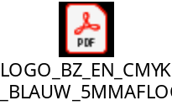
MFA logo white | 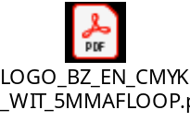
RVO logo transparent | 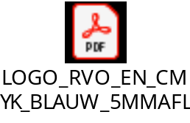
RVO logo white | 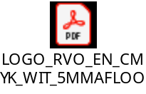
Government of the Netherlands logo transparent | 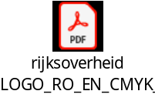
Government of the Netherlands logo white
Factsheet Shiraka Programme | 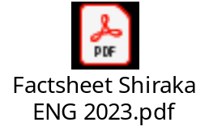

Guidelines on logo usage:
            - When you communicate about the Shiraka programme please use the MFA logo. In this case, RVO is mentioned as implementing agency (see p.1).
            - In case other ministries are also involved in the project/training, the Government of the Netherlands logo may be used;
            - The RVO logo is used when there is communication about the Shiraka programme through corporate RVO channels. In that case, MFA is mentioned as financier of the programme.
Contact
For more information about the programme, you may reach us via shiraka@rvo.nl.

