ANNEX 6 MINIMUM REQUIREMENTS “Dielectric Etcher”
This Annex 6 describe the specific requirements. A list has been attached with regard to the laid down mandatory requirements in which Tenderers must confirm that Tenderers unconditionally meet the specific mandatory requirements.

Note: The Technical Specification mentioned in this Annex 6 may be amended by the Contracting Authority, as referred to in paragraph 3.6 of the Request for Proposal. Tenderers will be informed of any amendments to the Technical Specification by means of the Memorandum of Information. After the final Memorandum of Information is published, the Request for Proposal including any amendments as they stand at that moment become the final version.

The tenderer must agree and comply with this final version by answer the question with “Yes” in this Annex 6 MINIMUM REQUIREMENTS of the Request for Proposal that it complies with the relevant requirements with comments of applicable, whereby the tenderer declares to fulfil this award requirement completely. Tenderer must add the fully completed Annex 6 MINIMUM REQUIREMENTS of the Request for Proposal to its Proposal and Upload this Annex 6 in TenderNed.

6.2 General:
Nr. |  | M / W | Yes/No | Comments
6.2.1 | 24 months warranty on hardware and software starting after successful site acceptance test. | M
6.2.2 | Free software updates and upgrades for a period of 5 years for the whole system. | M
6.2.3 | Expected response times: 1 workday technical response by mail / call, 5 workdays service onsite, part shipment within 1 week. | M
6.2.4 | Documentation should include test reports, operation and maintenance manuals written in English. Electrical drawings shall comply to IEC standards. All documents will be delivered in digital and printed form. | M
6.2.5 | Power supply is according to European mainland Standards.  Mains power supply is 230Vac PH-N and 400Vac Ph-Ph / 50hz. | M
6.2.6 | Delivery and installation within 12 months from the order date. | M
6.2.7 | Training for Process and Maintenance shall be supplied/available. | M
6.2.8 | Ease of access for simple process chamber cleaning, without requiring heavy disassembly or opening the machine from the inside. No major hardware modifications should be required, while ensuring process stability. | M

6.3 : System footprint and positioning in the cleanroom
Nr |  | M / W | Yes/No | Comments
6.3.1 | The system must be fitted with a loadlock | M
6.3.2 | The system must fit in the available cleanroom space as indicated in yellow in figure 6.3.1. | M
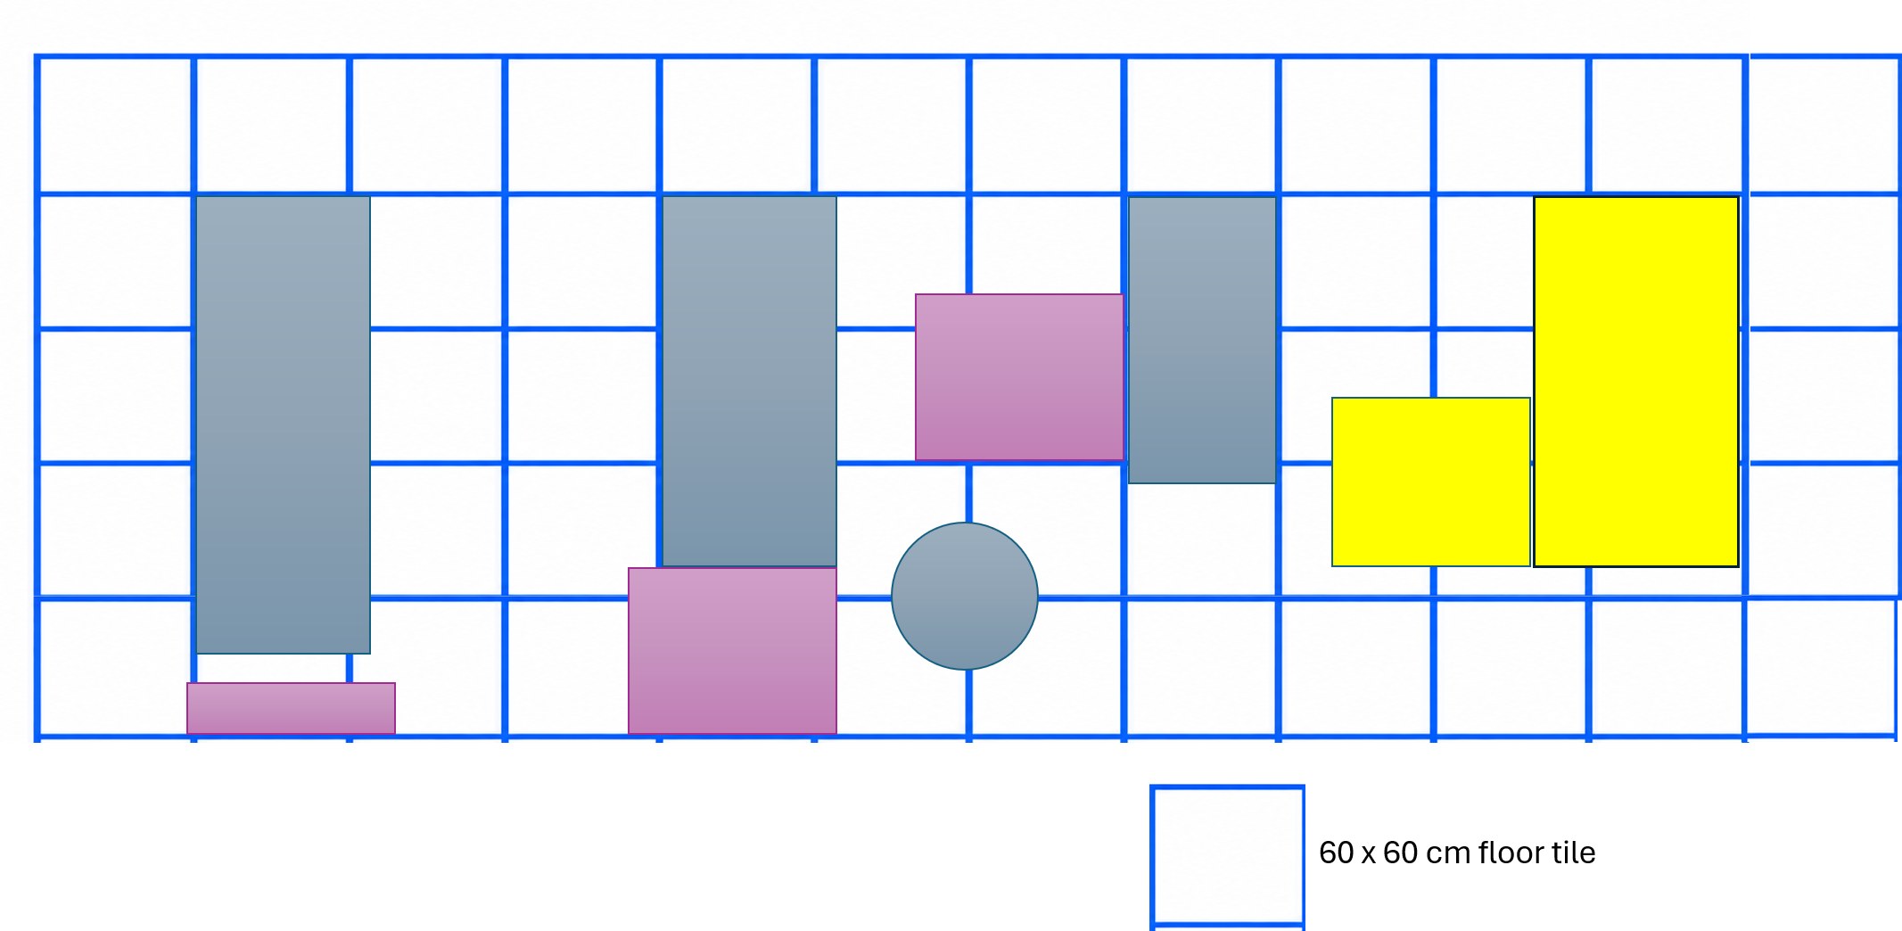

Figure 6.3.1 System positioning and footprint. The footprint of the system may not be larger than the area marked by two yellow boxes. The smaller yellow box is allocated for system computers.

6.4 Software and computer hardware:
Nr. |  | M / W | Yes/No | Comments
6.4.1 | Latest control software with free upgrades for at least 5 years. | M
6.4.2 | Continuous data logging of all interface-connected hardware. | M
6.4.3 | Data logging of all connected hardware per executed run/sequence or task. | M
6.4.4 | HMI/GUI software runs on version 11 or newer of MS-Windows or similar and it is compatible with updates. | M
6.4.5 | Remote monitoring of the system for limited users. | M
6.4.6 | Remote support from manufacturers via TeamViewer or similar. | M

6.5 Wafer Handling:
Nr |  | M / W | Yes/No | Comments
6.5.1 | Electrostatic chuck. | M
6.5.2 | He-backside cooling. | M
6.5.3 | Acceptable maximum and minimum thickness of substrate 700 µm and 500 µm respectively. | M
6.5.4 | It should be possible to handle double side polished InP wafers both conducting and semi-insulating. | M

6.6 Loadlock compartement:
Nr |  | M / W | Yes/No | Comments
6.6.1 | The loadlock must have the capacity for a full 4” wafer cassette of 25 wafers. | M
6.6.2 | Transfer pressure must be achievable < 5 minutes. | M

6.7 Gas system:
Nr |  | M / W | Yes/No | Comments
6.7.1 | Maximum of 8 gas lines including all gases required for tool operation | M

6.8 Etching of SiN & SiO2:
Nr |  | M / W | Yes/No | Comments
6.8.1 | Etching depth required 0-1000 nm | M
6.8.2 | Slow etch rate < 50 nm/min | M
6.8.3 | Fast etch rate > 50 nm/min | M
6.8.4 | Selectivity of SiN:PR ≈ 6:1, SiO2:PR ≈ 5:1 | W2-W3 | Not applicable | See Annex 7
6.8.5 | Profile angle > 88 ° | M
6.8.6 | Directionality of etching = Anisotropic | M
6.8.7 | Uniformity in etch rate for 4” wafers 3% with 5 mm edge exclusion – etch depth of 600 nm | W4 | Not applicable | See Annex 7
6.8.8 | The acceptable wafer-to-wafer variation in etch depth is ≤3%. | M
6.8.9 | No residual to be present post etching that cannot be removed by oxygen plasma | M
6.8.10 | EPS functionality must have (Laser interferometry endpoint system) | M
6.8.11 | Endpoint detection system (EDS). If different types of EDS are available, the one with an endpoint/depth accuracy of ±10% of the target thickness will be preferred. Please describe the EDS system that will be installed in the offered tool and the accuracy of this method, and this should be proved with data. | W5 | Not applicable | See Annex 7

