JDE is a coffee and tea producer located in Joure since 1753. Started as a small shop that sells coffee, nowadays strategic positioned and part of a multinational coffee and tea company. Last years, JDE Joure invested millions of euro in order to make world class coffee and tea, on a sustainable way, for the newest products in the market. Result is a highly technological production process integrated on the production site in Joure. A production process that is ready for the challenges of the future, but also gives further possibilities.
The current production process has residual heat (the factory is overheated), which will be cooled by ground water and pumped to the canal next to the production site. Furthermore, different residual heat streams goes to the air. Finding a good way to re-use the residual heat is one of the main challenges for JDE Joure. A good opportunity is to use the heat for a heatnet with the city of Joure, in order to replace the consumption of natural gas. JDE Joure has the following objectives with the participation in the heatnet project :
- Supplier of residual heat to the heatnet system
- The hand over of residual heat should have no impact on the production process of JDE joure
- Finding a technical solution whereby it is technical feasible and financially attractive to invest in heat coupling with the heatnet
- The indirect CO2 emissions will be transferred to JDE Joure.
- Hugh decline of need for cooling water by ground of towns water
- JDE will get colder water back from the heatnet after the heat transfer
- No negative effect on NOx emissions
- Limited extra electricity power required for Joure site grid
Production processes at JDE Joure
The image below shows a schematic overview of the production processes at the Joure site. The process from Roasting to Freeze/Spray drying is called coffee processing, and this process is associated with a lot of energy consumption and therefore energy intensive. On the image is the Energy centre not shown, however Joure has its own Energy centre in order to manage the energy supply and demand on the production site.
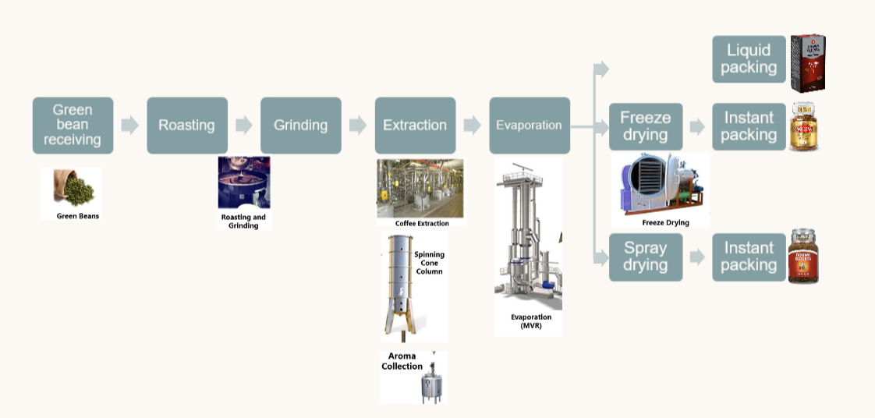

The main objectives of the energy centre related to the possible heatnet with Joure is the following :
- Responsible for Norton water distribution. Norton water is ground water which is used to cool the production process at the Joure site
- Responsible for 32 bar steam production by gas burning
- Responsible for 16 bar steam production by spent ground (rest product of coffee extraction), natural and bio gas
- Responsible for compressed air production, which results in heat that we are able to cool down with cooling water
- Responsible for distribution of heat from the internal heatnet Joure site
- Responsible for waste water treatment, whereby left over water will be transported to municipal sewage system.
Looking to the different production process, the following possible heat sources can be used for the heatnet, of in the future for internal consumption
- Roasting : Beans will be roasted, and therefore hot exhaust gasses will become available. At the moment, these heat goes into the air but might be a future heat source. Processes are running in 90% of the time, but not constantly.
- Coffee extraction NET : 10 year old process where coffee is extracted in order to make coffee extract and spent ground. This batch process goes to temperatures above 200 degrees Celsius. When a batch of Coffee is ready, a lot of steam is lost by pushing out the spent ground out of the perculators. This processing is running constantly over the year, however the heat comes free in batch process.
- Coffee extraction NGC : newest technology on the production site, where heat is maximum re-used internally. However, still heat left which is going to our own internal heat net. This heatnet will be used to heat up different production processes and building at the site
- Spray drier : Current spray drier is directly gas burned. The exhaust air flow has a lot of energy which could be recovered in the future (air flow 22000 kg per hour of 85 degree with 700 kg of water vapor in it per hour). Possible new Spray drier in 2029 which is 2,5 times the size of this one. Process should run 85% of the time and therefore really interesting to understand if we can re-use the heat for an heat net for example.
- Freeze drier : Electrical driven vacuum freeze drier, which generates a lot of heat in order to remove the water from the concentrate. Process is running 90 percent of the time with a constant outlet of energy
The last years, different studies were conducted in order to determine the right energy sources for the heat net. The following list of priorities are determined at the moment given the readiness to be able to exchange the heat :
- Norton Cool water : on average 150m3 per hour with a temperature around 20-23 degrees. These amount is approximately going on for 85 percent of the time. Norton water is de-ironized ground water and therefore really green and suitable as carrier for the heat to a possible energy factory for the heatnet
- Waste water cooling : on average 75m3 of waste water with a temperature of 30-35 degrees becomes available. These amount is approximately going on for 85 percent of the time
- Future possible new spray drier : The exhaust air flow has a lot of energy which could be recovered in the future (air flow 55000 kg per hour of 70 degree with 1600 kg of water vapor in it per hour). Pre-engineering starting for new spray drier at the end of 2026. Process running 85% of the time
- Residual heat from Freeze drier, which goes now into the air. Heat is available in 90 percent of the time. Technical calculations have to be made in order to see if this is a realistic heat source
- Spent ground boiler 11 : The exhaust air outlet of the boiler contain hot air from above 200 degrees Celsius, and around 1500kg of water vapour. Investing in a technology that can generates heat from this and supply to the heat net with it sounds interesting. No technical calculations and engineering are done at the moment about this possible heat sources. Process running 85% of the time.
- Heat recovery outlet air roasters, and 4 gas heated boilers. Different process available where hot exhaust air can be cooled down and heat up water for a possible heatnet. Process running 85% of the time. On average are we producing 12 tons of steam per hour with these installations.

