ANNEX 6 MINIMUM REQUIREMENTS “Hard X-ray Photoelectron Spectroscopy System for Energy Materials Characterization”
This Annex 6 describe the specific requirements. A list has been attached with regard to the laid down mandatory requirements in which Tenderers must confirm that Tenderers unconditionally meet the specific mandatory requirements.

Note: The Technical Specification mentioned in this Annex 6 may be amended by the Contracting Authority, as referred to in paragraph 3.6 of the Request for Proposal. Tenderers will be informed of any amendments to the Technical Specification by means of the Memorandum of Information. After the final Memorandum of Information is published, the Request for Proposal including any amendments as they stand at that moment become the final version.

The tenderer must agree and comply with this final version by answer the question with “Yes” in this Annex 6 MINIMUM REQUIREMENTS of the Request for Proposal that it complies with the relevant requirements with comments of applicable, whereby the tenderer declares to fulfil this award requirement completely. Tenderer must add the fully completed Annex 6 MINIMUM REQUIREMENTS of the Request for Proposal to its Proposal and Upload this Annex 6 in TenderNed.

6.2 General:

Nr. |  | M / W | Yes/No | Comments
6.2.1 | 24-Month warranty on hardware and software, starting after successful SAT. | M
6.2.2 | Free software updates and upgrades for a period of 5 years for the whole system. | M
6.2.3 | Service Contract for 5 years covering control/maintenance, including: vacuum system, X-ray sources and analyzer, analytical equipment /accessories/repairs in terms of yearly maintenance service starting after the warranty period. | M
6.2.4 | The maximum response time for addressing technical issues shall be within 24 hours during standard office hours. | M
6.2.5 | The complete system must have CE certification. This includes, but is not limited to, the Machine Directive and the EMC Directive. | M
6.2.6 | Documentation should include test reports and operation and maintenance manuals written in English. Electrical drawings shall comply with IEC standards. All documents will be delivered in digital and printed form. | M
6.2.7 | Technical drawings shall be ready within 2 months of order placement. | M
6.2.8 | Delivery time <12 months after acceptance of technical drawings. | M
6.2.9 | Training for Operation and Maintenance shall be supplied/available. | M

6.3 Software and computer hardware:
Nr |  | M / W | Yes/No | Comments
6.3.1 | Latest control software with free upgrades for 5 years. | M
6.3.2 | Software runs on MS Windows version 11 or newer and is compatible with updates. | M
6.3.3 | Continuous logging of all interface-connected hardware is implemented. | M
6.3.4 | The system shall include user-friendly, intuitive software with a graphical user interface (GUI) designed for ease of operation across a broad user base, including students, PhD candidates, postdoctoral researchers, and technical staff. The software should support guided workflows, clear data visualization, and simplified control of system parameters, minimizing the learning curve and enabling efficient, reliable operation for both novice and experienced users. | M
6.3.5 | Remote system monitoring shall be available for users via TeamViewer or a comparable platform, with the option of a secured intermediary ("stepping stone") setup to comply with local ICT restrictions. | M
6.3.6 | Remote support from the manufacturer shall be available via TeamViewer or a comparable platform, with the possibility of a secure intermediary ("stepping stone") configuration where required. | M

6.4 HAXPES system:
Nr. |  | M / W | Yes/No | Comments
6.4.1 | XPS/HAXPES Analysis Chamber based on an extendable and modular design to enable future upgrades and integration of additional components. | M
6.4.2 | X-ray Source: A monochromatic X-ray source providing selectable excitation energies spanning ~1–2 keV (surface-sensitive XPS), ~3 keV (intermediate probing depth), and ≥4.5 keV (bulk-sensitive HAXPES). Preference is given to an excitation range of ~3–6 keV, which offers an optimal balance between probing depth and photoelectron yield, recognizing that excessively high excitation energies reduce photoelectron count rates due to diminishing photoionization cross-sections. The system must support software control, enabling fully automated switching between excitation energies with a changeover time of less than 3 minutes. | W (25) | Not applicalble | See ANNEX 7
6.4.3 | Electron Energy Analyzer: The system shall be equipped with a hemispherical electron energy analyzer suitable for XPS and HAXPES measurements with kinetic energies up to at least 6 keV, fully integrated software control, including a pumping system. The analyzer shall support both high-resolution and angle-resolved measurement modes with an acceptance angle of at least ±30°. The system must support small-spot analysis (≤100 µm), provide stable high-voltage operation up to at least 6 kV, and allow flexible or upgradeable detector configurations. | M
6.4.4 | Multilayer analysis: The HAXPES system should enable multilayer analysis by integrating a high-resolution, spatially confined (small-spot) X-ray source and a wide-angular-acceptance energy analyzer, enabling efficient angle-resolved measurements. This combination should facilitate enhanced depth profiling and detailed characterization of complex, buried multilayer structures. A strong preference is given to the inclusion of a configurable CMOS-based detector system. The detector should offer high sensitivity, low noise, and fast readout, with adjustable acquisition modes and settings to optimize performance under different measurement conditions (e.g., high count rate vs. high dynamic range). The CMOS detector configuration should seamlessly integrate with the software and data acquisition workflows, enabling flexible, user-defined optimization of signal quality, angular resolution, and measurement speed. | W (15) | Not applicalble | See ANNEX 7
6.4.5 | The system shall be equipped with a motorized multi-axis sample manipulator to ensure precise positioning, high reproducibility, and stable alignment during measurements. The system shall support automatic multi-sample handling with a capacity of at least three sample positions, including the capability to accommodate flexible or foil-type samples.  The system must enable automated measurement workflows for at least 3 samples, including unattended sequential analysis. This shall include programmable measurement routines with automated sample exchange, as well as automated switching between different X-ray excitation energies/sources without user intervention. The solution should ensure reliable, repeatable operation during such automated sequences, minimizing idle time between measurements and enabling efficient use of instrument time. | M
6.4.6 | High-pressure/high-temperature Reaction Cell: The system shall include a high-pressure reaction cell for sample pretreatment under reactive gas environments. The cell must support operation at pressures of at least 20 bar and enable controlled gas dosing and evacuation via a software-integrated gas-handling system with mass-flow and pressure control. The design should allow safe operation with reactive gases such as hydrogen and oxygen and include appropriate overpressure protection. The cell must enable heating of the sample to elevated temperatures (≥600 °C, preferably higher, depending on the gas environment) while maintaining stable, well-defined experimental conditions. Integration with the UHV analysis system is required, including suitable pumping and rapid transfer between the reaction and analysis environments to preserve the sample state. | W (15) | Not applicalble | See ANNEX 7
6.4.7 | Load-lock and Transfer: The system shall include a load-lock and a sample transfer system, enabling contamination-free handling of samples under high- and ultra-high-vacuum conditions. The load-lock must allow rapid introduction of preferably multiple samples without breaking the vacuum in the main analysis chamber and achieve pressures suitable for UHV transfer. The system must provide the capability for high-vacuum transfer of samples between the HAXPES system and existing external infrastructure, specifically a Near-Ambient Pressure X-ray Photoelectron Spectroscopy (NAP-XPS) system and a glovebox. This shall be achieved via a compatible vacuum transfer interface or docking solution that enables sample exchange without exposure to ambient conditions. The solution should ensure reliable, reproducible, and contamination-free transfer, and support straightforward integration with the existing NAP-XPS facility. | W (10) | Not applicalble | See ANNEX 7
6.4.8 | The system shall support the integration of an existing ion source (type SPECS IQE 12/38), which will be transferred to and fully incorporated into the new instrument. The integrated ion source must enable controlled removal of surface layers, facilitate depth profiling, and allow for effective sample cleaning prior to analysis. The ion source is differentially pumped and can be scanned across the sample surface to ensure uniform sputtering performance. The system must provide the necessary hardware and software interfaces to fully control and automate the operation. In addition, the instrument shall include a compatible gas inlet system to support automated sputtering processes and enable reproducible, automated depth profiling workflows. | W (5) | Not applicalble | See ANNEX 7
6.4.9 | Pre-pumps shall be oil-free scroll pumps, ensuring clean, vibration-minimized, low-maintenance rough-vacuum operation suitable for high-vacuum systems (no membrane pumps). Roughing lines should be stainless-steel bellows. Pre-pumps shall be oil-free scroll pumps, ensuring clean, vibration-minimized, low-maintenance rough-vacuum operation suitable for high-vacuum systems (no membrane pumps). Roughing lines should be stainless-steel bellows. | M
6.4.10 | The system shall include a flood gun for effective neutralization of positive charges on insulating and semiconducting samples, suitable for XPS/HAXPES applications. The flood gun shall provide a stable, homogeneous electron flux over a large sample area, with an adjustable beam energy of 0–500 eV and an emission current of up to ~1 mA. The flood gun’s operation is fully integrated into the software. | M
6.4.11 | Chiller for water cooling of the whole system. | M

6.5 Footprint

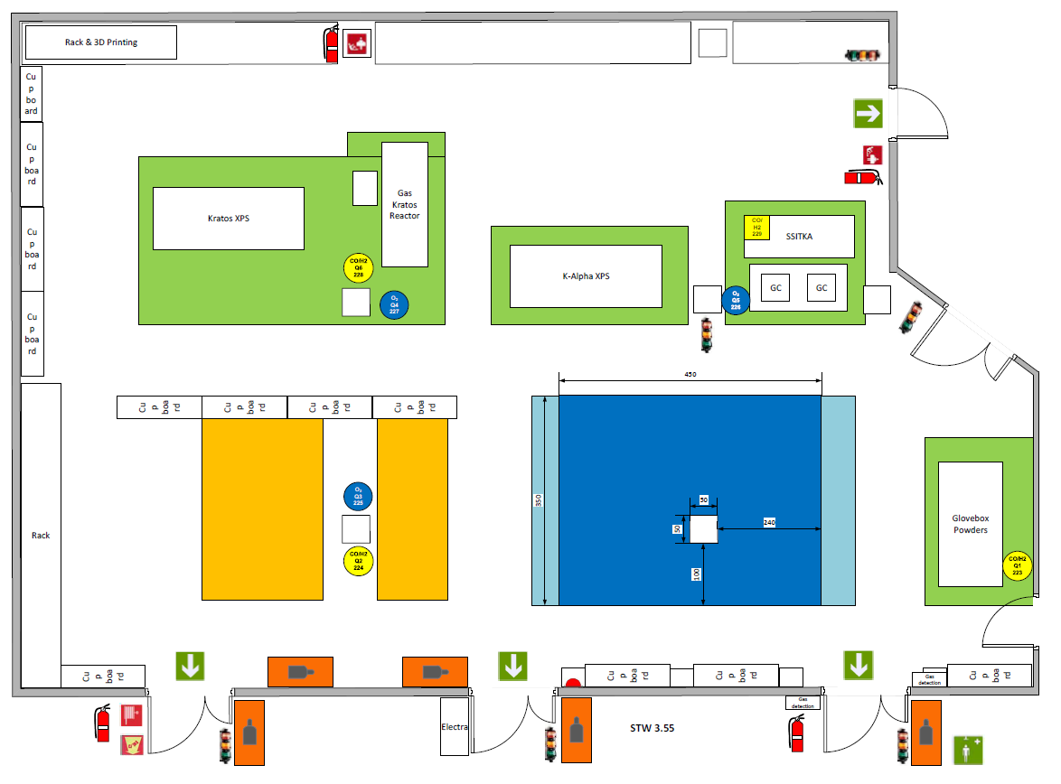

The Hard X-ray Photoelectron Spectroscopy System for Energy Materials Characterization will need to fit in the blue-indicated area.

