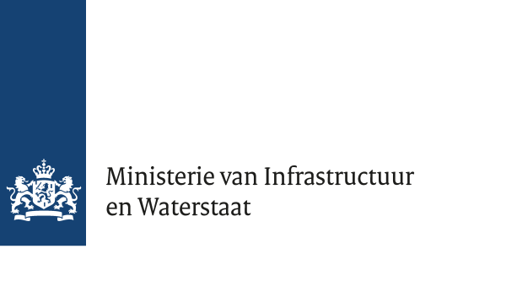

Annex 4 – Model Guarantee

Version 1.0
Date 25 February 2026
Status Final

Statement for the tender ‘Technical Support Organisation for Nuclear Security’

………………… (name of the guaranteeing company), with registered office at ………..……(business address), herein legally represented by ………….… (name of representative), in the capacity of ………………… (position of representative, which company is hereby referred to as the Guarantor,

hereby declares that if the contract is awarded to

………… (name of Tenderer), with registered office at ………… (business address),

and the Contracting Authority signs an agreement with this Tenderer to carry out the contract, the Guarantor guarantees to the Contracting Authority the payment of all debts owed by this Tenderer to the Contracting Authority arising from the contract(s) resulting from this tender.
The Guarantor’s ESPD has been submitted with this Tender.

Duly exexuted,

Name of the Guarantor's representative
Signature
Place and date

