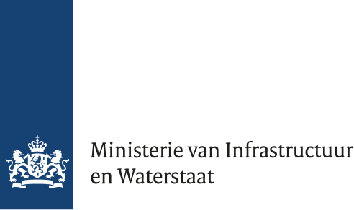

Annex 1 – List of Terms

Version 1.0
Datum 27 May 2026
Status Final

Terms
Bidder: an economic operator which submits a bid.
Candidate: an economic operator which has sought an invitation to take part in the procedure.
Consortium: Two or more companies can jointly form a consortium to participate in a tender as a collaborative partnership;
Contracting Authority: The State of the Netherlands, Ministry of Infrastructure and Water Management;
Defence and Security Procurement Act (ADV): Specific legislation within Dutch procurement law that applies instead of the Public Procurement Act for government contracts in the defence and security sectors (Aanbestedingswet op defensie- en veiligheidsgebied);
European Single Procurement Document (ESPD): A standard form with which companies declare that they meet the suitability requirements;
Request to Participate: A Request to Participate submitted by a Candidate based on the selection guide as published on TenderNed.
Technical Specifications: A collection of requirements for the service to be provided, defined by the client;
Tender Documents: All documents in a tender procedure that have been submitted by the Contracting Authority during the procedure;
Potential Supplier: an economic operator that may choose to seek an invitation to take part in the procedure
Tenderer: economic operator which has submitted a tender in the procedure.
Technical Support Organization (TSO): Organizations that provide independent technical services and advice to support national authorities in the fields of nuclear safety, radiation protection, and nuclear security;
Technical Support Services: Services provided by a Technical Support Organization;
TenderNed: The Dutch government's procurement system, used as an announcement platform where contracting authorities can digitally manage tenders;

