Market consultation & questionnaire for Common Information Service system
  - Request for Information

Status page

Document data
Title | Market consultation & questionnaire for Common Information Service system
Version date | 30-4-2026
Version status | Final

Table of Contents

1. Introduction 4
1.1 Company information 4
1.2 Background 4
1.3 Purpose of the RFI 5
1.4 Scope of the RFI 5
1.5 Contact person for ATC-NL 6
1.6 Questions for clarification 6
1.7 Additional terms and conditions 6
2. Objectives 7
3. Questionnaire on the Solution 8
3.1 Solution Overview 8
3.2 Functional and Operational fit 9
3.3 Technical Architecture and Integration 11
3.4 Maturity and Track Record 13
3.5 Delivery and Scalability 15
3.6 Commercial Aspects 16
4. Company details 18
4.1 Additional questions related to the organization 19
Appendix A: ATC-NL vision and high-level architecture 20
A.1 Objective and Positioning 20
A.2 Scope of this CIS 20
A.3 Phased approach 20

© 2026 Air Traffic Control the Netherlands
No part of this publication may be reproduced and/or published in any form, by print, photo print, microfilm or any other means, without prior permission from Air Traffic Control the Netherlands.

Introduction

Company information
Air Traffic Control the Netherlands (ATC-NL) is a Dutch independent administrative organization that is responsible for providing air traffic services to civil air traffic in the Dutch airspace in a safe, efficient, and environmentally sensible way. In the Dutch Aviation Act this and all other tasks of ATC-NL have been laid down. Besides the provision of air traffic services these tasks consist of the provision of communication, navigation, and surveillance services (including the modernization and management of these technical systems), giving aeronautical information, catering for air traffic control training and providing aviation charts and publications. In short, ATC-NL is responsible for the control of Dutch civil airspace as well as parts of the North Sea area and everything related thereto. ATC-NL became operational in 1923 and since 1993 as a so called "Independent Administrative Body (ZBO)". In providing air traffic control, Air Traffic Control the Netherlands (ATC-NL) relies on Communication, Navigation, Information, Surveillance and Air Traffic Control systems. These systems provide the "hands and eyes" for the air traffic controller and are therefore essential for the tasks of ATC-NL. On the website www.lvnl.nl you can read and download all relevant information about ATC-NL.

Background
The development of unmanned aviation in the Netherlands is increasingly driven by market demand. This includes use cases such as medical transport, infrastructure inspection, mapping and logistics, as well as dual-use developments involving both civil and military stakeholders.

To enable these use cases at scale, the availability of reliable, secure, and shared information between Unmanned Aircraft System (UAS) operators and aviation and non-aviation stakeholders operating within the same airspace is essential. This information exchange is not only critical for enabling and scaling drone operations, but also for maintaining a safe, resilient, and liveable society, for example by supporting situational awareness and counter-UAS activities.

The European U-space regulatory framework (EU) 2021/664 provides a structured approach to enable such operations within designated U-space airspace. Within this framework, the Common Information Service (CIS) fulfils a central role by providing the foundational information services that support U-space service provision and ensure consistent and reliable data exchange between all involved actors.

ATC-NL, as the designated Air Navigation Service Provider (ANSP) in the Netherlands, is identified as a preferred provider of CIS services within the U-space context. The provision of CIS is considered an additional regulatory activity, complementing ATC-NL’s existing Air Traffic Management (ATM) responsibilities.

At the same time, the Netherlands has a broader ambition to enable national Unmanned Traffic Management (UTM) services that extend beyond the scope of U-space airspace. This includes the provision of supporting information services outside U-space, enhanced data sharing, resilience and additional operational support functions to enable nationwide operations.

As a result, the envisioned capability builds on the CIS role within U-space, but may extend towards a broader role as an information broker within a wider national UTM ecosystem. This capability, providing supplementary data services, would facilitate the exchange of reliable, secure, and standardized information between multiple actors and systems, including static and dynamic airspace information, surveillance data, geospatial information, and operational constraints (see Appendix A for ATC-NL’s vision, scope and the envisioned high-level architecture).

At the same time, the market for CIS and supplementary data services is still evolving. Different technological approaches, architectural models, service concepts, and delivery models are being developed and applied across Europe and beyond. In order to determine the most suitable way forward, ATC-NL seeks to obtain structured market insight into available solutions, their capabilities, maturity, and potential fit for the Dutch context. The outcomes of this market consultation will be used as input for potential next steps, including further market engagement, demonstrations, and future procurement activities.

Purpose of the RFI
The purpose of this Request for Information (RFI) is to obtain structured insight into the current market for CIS solutions and related supplementary (UTM) services, in order to support ATC-NL in addressing the identified need for a trusted national information capability and shaping its strategy for the development and implementation of a CIS system and capability.

ATC-NL is specifically seeking market input on how such a capability can be realized in a scalable, compliant, and future-proof manner.

Through this RFI, ATC-NL aims to gain a comprehensive understanding of available solutions, suppliers, and approaches within the market, including the extent to which existing offerings align with the intended role of a CIS as an information broker within the evolving U-space, UTM, and ATM ecosystem.

In addition, this RFI is intended to facilitate a dialogue between ATC-NL and market parties, enabling a better understanding of technological developments, best practices, and innovative approaches relevant to the implementation and potential future procurement of CIS and supplementary service capabilities.

ATC-NL intends to use the insights obtained through this RFI as input for the preparation of a procurement process for a CIS system. Subject to the formal designation of the CIS role by the Dutch government, ATC-NL currently foresees initiating such a procurement process after the summer of 2026 with the aim to contract a supplier in 2027. This timeline is preliminary and non-binding but aims to provide transparency to market parties and to support alignment on feasible delivery approaches.

Scope of the RFI
This market consultation is issued for information-gathering purposes only. Its scope is limited to obtaining insights into available market solutions, supplier capabilities, and potential approaches related to the provision of CIS and broader supplementary information services.

This RFI does not constitute a call for tender, request for proposal (RFP), or any other form of procurement procedure. Participation in this market consultation does not create any rights or obligations for ATC-NL or responding parties, nor does it imply any commitment by ATC-NL to initiate a subsequent procurement process.

The information provided by respondents will be used by ATC-NL for internal purposes only, including the further development of its strategy, architectural considerations, and potential future requirements related to CIS and supplementary services.

ATC-NL will use the insights obtained through this market consultation to inform possible next steps, such as further market consultations, demonstrations, or formal procurement procedures. However, ATC-NL is not bound to any such follow-up actions.

Respondents are responsible for clearly indicating any confidential or commercially sensitive information in their submissions. ATC-NL will treat such information with appropriate care, in accordance with applicable regulations and internal policies.

Contact person for ATC-NL
Please address all communications and responses regarding this market consultation to:
Anil Jankipersad (a.p.jankipersad@lvnl.nl).

Questions for clarification
In case the contents of this market consultation necessitate you to ask questions for clarification, then please do so at your earliest convenience. You can send your questions for clarification directly to the contact person listed in paragraph 1.5. ATC-NL will make reasonable efforts to respond in a timely manner.

Additional terms and conditions
- This market consultation is not (part of) a tendering procedure governed by European regulation;
- This market consultation is expressly not intended to make a pre-selection of candidates in the context of possible follow-up projects;
- Market parties who do not participate in this market consultation are not excluded from potential follow-up projects. Nor are parties who participate in this market consultation in any way excluded or privileged in any follow-up projects;
- Parties (including parties who are not participating) cannot derive any obligations or rights from this market consultation;
- Participation in this market consultation provides no right to obtain a delivery order;
- ATC-NL does not reimburse any costs for participating in this market consultation;
- Participating parties agree that information provided by them can be further processed in ATC-NL documents;
- ATC-NL is in no way bound by the results of this market consultation or required to procure the subject of this market consultation;
- Claims on the use of information, confidentiality, or requests for reimbursement in connection herewith are not honoured;
- ATC-NL reserves the right to temporarily or permanently discontinue this market consultation;
- By participating in this market consultation, parties acknowledge accepting the terms as stated in this document unconditionally;
- Responses will not be evaluated in a comparative or competitive manner, nor used to pre-qualify suppliers;
- Price Information provided to ATC-NL in the context of this market consultation will not be made public.

Objectives
The primary objective of this RFI is to obtain a structured and comprehensive understanding of the current market for CIS and broader supplementary information solutions, in order to support ATC-NL in defining its future role, (functional and technical) capabilities, and implementation approach.

To achieve this, ATC-NL aims to:

- Identify existing solutions and suppliers active in the market for CIS and related supplementary information services;
- Assess the extent to which available solutions align with the envisioned functional, technical, and operational requirements;
- Understand the maturity of these solutions, including their readiness for operational deployment and scalability;
- Gain insight into suppliers’ experience in delivering CIS or comparable UTM systems within aviation or other safety-critical domains;
- Evaluate the organizational maturity, reliability, and long-term stability of potential suppliers;
- Obtain insight into indicative time-to-market and the approaches used for development, deployment, and scaling of CIS and supplementary data service solutions;
- Explore potential collaboration models, including partnerships, phased implementation, and co-development approaches, and identify market parties capable of acting as long-term partners for the further development and evolution of the system.

Questionnaire on the Solution
The questions in this section are structured into thematic categories:
- Solution overview
- Functional and Operational fit
- Technical Architecture and Integration
- Maturity and Track Record
- Delivery and Scalability
- Commercial Aspects
Note: questions related to the company are addressed in Chapter 4.
Respondents are requested to address all questions in a to-the-point manner, while providing sufficient detail for evaluation. Supporting attachments that are relevant to one or more responses may be submitted as part of the response package.

Solution Overview
- Please describe your CIS and/or UTM solution(s), including the key functionalities and services provided and the main use cases supported.
Answer

- Are you available to demonstrate your solution in a (online) demonstration?
Answer

Functional and Operational fit
- To what extent does your solution support the functionalities of a CIS as defined within the U-space framework (EU 2021/664)?
Please describe how your solution aligns with the applicable regulations and certification requirements for the provision of CIS.
Answer

- To what extent does your solution support operations both within and outside U-space airspace, including the provision of supplementary data service(s)?
Answer

- Which specific services and functionalities within your solution support your answers to questions 3 and 4?
Please provide concrete examples where possible.
Answer

- Which service(s) and functionalities are fully implemented, partially available, or planned for future development? Please provide estimated timelines where possible.
Answer 4
Fully implemented (operational):

Partially available (in testing phase):

Planned future development:

Technical Architecture and Integration
- Please describe the high-level architecture of your solution (e.g. centralised, distributed, hybrid), including the main architectural principles applied.
Answer

- To what extent is your solution modular versus monolithic?
Please describe how individual components can be independently replaced, integrated, or sourced from third parties, including any limitations.
Answer

- How does your solution ensure interoperability with external systems (e.g. ATM systems, USSPs, operators)?
Please describe the mechanisms, interfaces, and standards used.
Answer

- How is data quality, integrity, and security ensured?
Please also describe how responsibilities and liabilities related to data quality and data provision are defined and managed.
Answer

- How does your solution handle classified and sensitive data?
Please describe how data classification levels are supported, including storage, access control, and compliance with applicable security standards (EU 2023/203)
Answer

- What deployment models are supported (cloud, on-premise, hybrid)?
Please specify any constraints or dependencies related to deployment.
Answer

Maturity and Track Record

- What is the overall maturity level of your solution (e.g. concept, prototype, pilot, operational)?
Please describe the level of operational readiness, including the ability to support real-world operations at scale.
Answer

- Where has your solution been deployed or tested (locations, environments, scale)?
Please include the type of airspace or operational context where applicable.
Answer

- Can you provide examples of operational use in (unmanned) aviation?
Please briefly describe the scope, stakeholders involved, and your role.
Answer

- What key lessons learned or best practices can you share from previous implementations
Answer

- Have you supported or are you currently supporting any certification or regulatory approval processes (e.g. related to U-space, CIS, or comparable systems)?
If so, please describe your experience.
Answer

Delivery and Scalability
- What is the indicative timeline to deploy your solution (from contract to initial operational capability)?
Please provide a high-level breakdown of key phases and milestone
Answer

- What are the key dependencies and risks associated with implementation?
Please indicate how these risks can be mitigated.
Answer

- What level of involvement, roles, and resources would be required from ATC-NL during implementation and operation?
Answer

- How does your solution scale from local use cases to nationwide deployment?
Please describe any technical, operational, or organizational considerations.
Answer

- How does your solution support data portability and migration in the event of contract termination or supplier exit?
Please describe your exit strategy, including data ownership, data formats, migration support, and any dependencies or limitations.
Answer

Commercial Aspects
- Please provide an indicative order-of-magnitude estimate of the costs associated with your solution, including implementation and operational costs.
Where possible, please distinguish between one-time (CAPEX) and recurring (OPEX) costs
Answer

- What commercial and pricing models do you apply for your solution (e.g. licensing, subscription, usage-based, service-based)?
Please describe the structure of your pricing approach, including key pricing parameters (e.g. number of users, transactions, data volume, geographical scope).
Answer

- What contract duration(s) do you typically apply for your solution?
Please describe standard contract terms, including options for extension, renewal, and termination, as well as any minimum commitment periods.
Answer

- Are there any additional aspects, insights, or considerations that you believe are relevant for ATC-NL and have not been addressed in this RFI? If so, please provide further details.
Please note that questions related to the organization are further addressed in Chapter 4.
Answer

Company details
# | Item | Answer
a. | Company name
b. | Postal address
c. | Contact person
d. | Position of contact person
e. | Email address
f. | Number of offices (except head office)
g. | Number of employees
h. | Number of employees in relation to services as described
i. | Company turnover for the last three years
j. | Is your company part of a larger (parent) company? | o Yes, namely […]  o No
k. | Number of employees of parent company

Additional questions related to the organization

- What is your experience within the (unmanned) aviation domain, specifically related to U-space, UTM, or ATM?
If possible, please provide references.
Answer

- Which collaboration models do you propose (e.g. turnkey delivery, partnership, co-development)?
Answer

- How do you support long-term evolution and continuous improvement of the system?
Answer

Appendix A: ATC-NL vision and high-level architecture

A.1 Objective and Positioning
The Netherlands considers the CIS as a central information service enabling safe, efficient, and scalable (BVLOS) UAS operations. The Dutch approach explicitly extends beyond the minimum European CIS scope, as defined in EU Regulation 2021/664, by enabling information services both within and outside U-space airspace.

The main objective of the CIS is to:
- Provide reliable, timely, and secure information for UAS operations;
- Facilitate the continued development and scaling of the UAS ecosystem in the Netherlands.

A.2 Scope of this CIS
In the Netherlands, the CIS is positioned with a broader scope:
- Within U-space airspace: provision of mandatory, certified Common Information Services to U-space Service Providers (USSPs);
- Outside U-space airspace: provision of relevant UAS information services to a wider range of users, where applicable (supplementary data services).
This broader scope reflects the ambition to establish a nationwide information layer supporting all UAS operations. See next page for a schematic overview.

The CIS is expected to provide access to the information required for the safe, efficient, and scalable execution of UAS operations. These information needs are to be defined based on input from a wide range of stakeholders, taking into account both regulatory requirements and operational practices.

The required information spans multiple domains, including meteorological data, traffic information, and airspace data, as well as UAS-specific, environmental (e.g. obstacles), and CNS-related information. The exact scope and prioritization of these data services should be aligned with market needs and operational demand.

A.3 Phased approach
ATC-NL envisions a phased growth model for CIS service provision, consisting of an experimental phase, a scaling-up phase, and a fully operational phase. The system to be procured must therefore be inherently scalable, both in terms of geographical coverage and the number and complexity of operations supported.

The initial phase focuses on experimentation and validation of concepts. This is followed by a scaling phase in which services are gradually expanded in scope and usage. Ultimately, the CIS is expected to evolve into a mature, operational system supporting nationwide UAS activities.

Preparation | Experimental phase |  | Scaling-up |  | Operational phase
NOW | Max 3 years
 |  |  | Max 5 years
 |  |  |  |  | Undefined

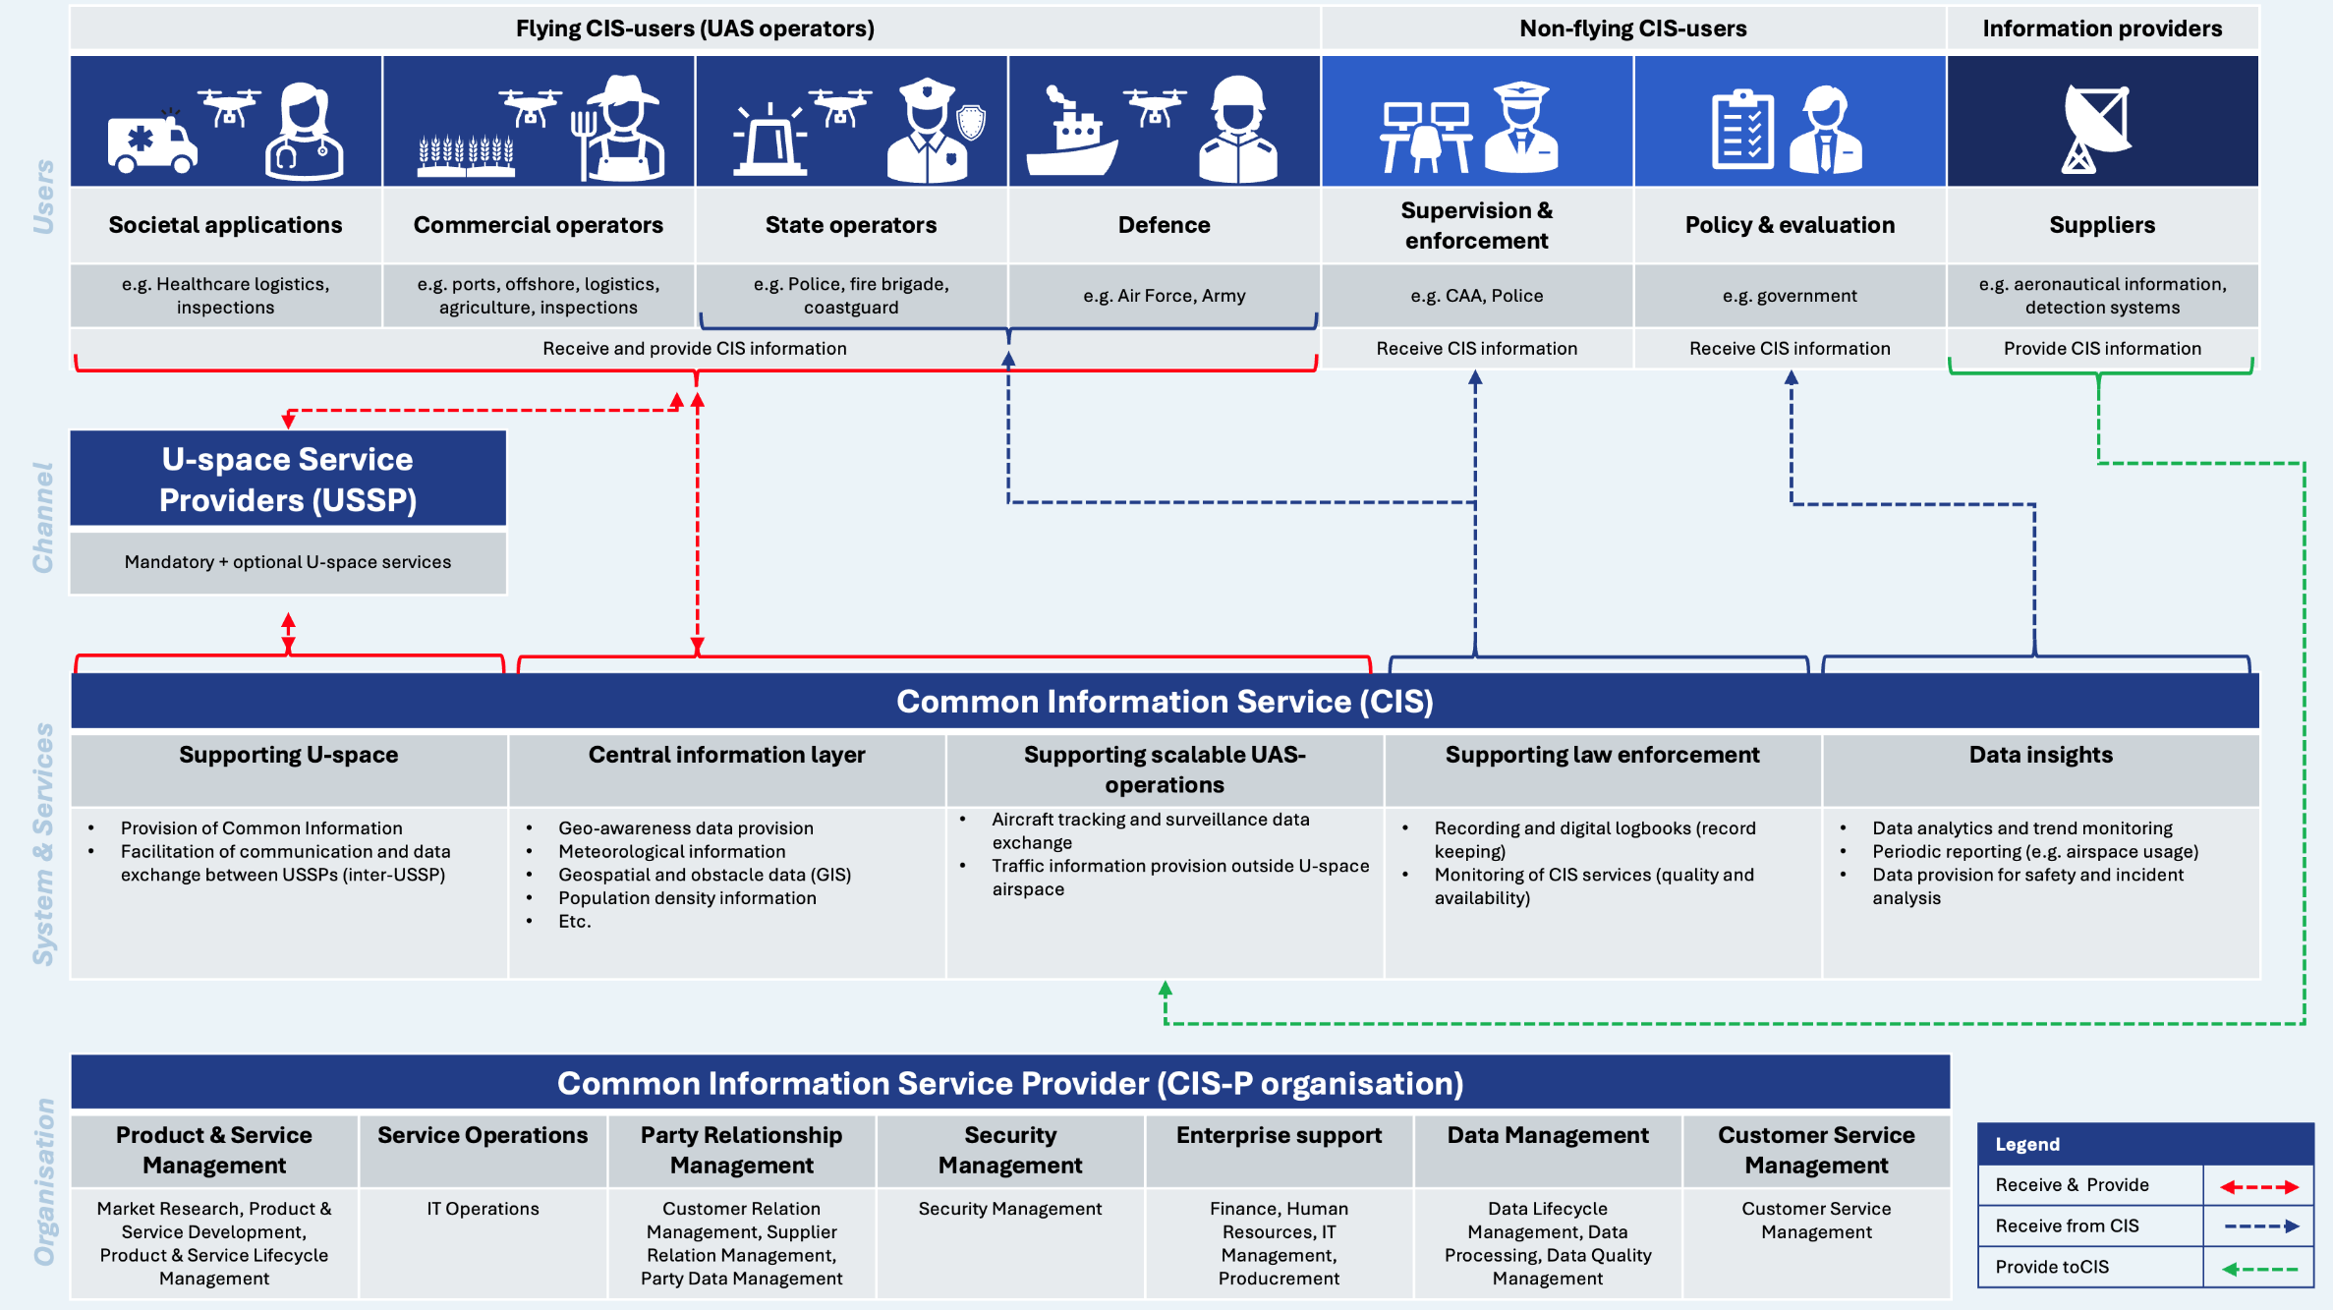

Luchtverkeersleiding Nederland

Stationsplein Zuid-West 1001
1117 CV Schiphol

Postbus 75200
1117 ZT Schiphol

T 020 406 2000

www.lvnl.nl

