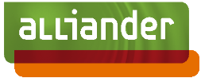

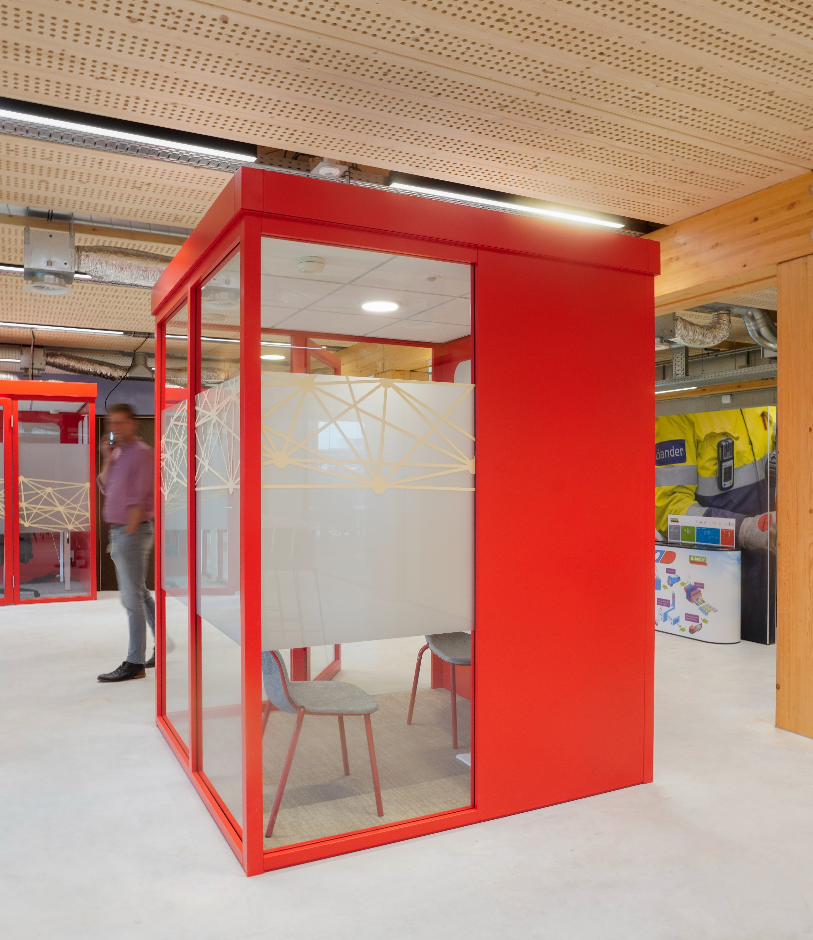
Appendix 2 - Declaration of no Russian involvement

Full-end-Loadcouplings

INNOVATION PROCEDURE
Reference number: TN 574720

Notwithstanding exceptions provided for by law, no part of this invitation to receiver may be duplicated and/or disclosed without the written consent of Enexis and Alliander.

STATEMENT RUSSIA SANCTIONS PACKAGE
FOR FULL-END-LOAD COUPLINGS

With this statement, [Company Name] declares in the tendering process for the development of full-end-load couplings under publication number TN 574720 that [Company Name] unconditionally and irrevocably agrees to the statement(s) below.

- [Company Name] is familiar with Regulation EU/833/2014 and its amendment by EU/2022/576. This Regulation imposes, inter alia, sanctions on Russia, Russian companies, (certain) residents of Russia and products and materials originating in Russia.
- [Company Name] is/are not among the persons or companies associated with Russia as referred to in Article 5(k)(1) of Regulation EU/2014/833, as amended by Article 1(23) of Council Regulation EU/2022/576 of 8 April 2022 concerning restrictive measures in view of Russia’s actions destabilising the situation in Ukraine (hereinafter: the Regulation) and which are listed below:
  - [Company Name] is not a Russian citizen, or a natural or legal person or entity established in Russia;
  - The proprietary rights of [Company Name] are not directly or indirectly owned for more than 50% by a Russian citizen, or a natural or legal person or entity established in Russia;
  - [Company Name] does not act on behalf or at the direction of an entity referred to in points (a) and/or (b).
- The person(s) or company(ies) involved in the contract as subcontractor(s) or supplier(s), or person(s) or company(ies) called upon in the context of the suitability requirements and representing more than 10% of the contract value, are not among the group of person(s) or company(ies) associated with Russia within the meaning of the Regulation.
- [Company Name] confirms and guarantees that during the duration of the contract, no subcontractors, suppliers or companies whose capacities are being relied on in connection with providing proof of suitability will be engaged, who exceed 10% of the contract value and who are among the group of persons or companies with connections to Russia within the meaning of the Regulation.

- [Company Name] agrees that should it emerge (at a later stage) that incorrect and/or incomplete information has been provided, the bidder may be excluded from the qualification system, from further participation in the tendering process and/or any contract already concluded may be dissolved on that basis without financial consequences for the DSOs.

In the case of a consortium of bidders, the following must be completed:

Name of consortium
Registered names of all participating bidders in the consortium
Main contractor of the consortium (registered name of the company)

On behalf of [Company Name]
Name: [name of authorised representative*
Position: […………..]
Signature:

------------------------------------
Date: ……………………

* This statement must be signed by a legally authorised representative of [Company Name]. In some companies, two or more representatives may have joint authority to represent the company. If so, all individuals who are jointly authorised to represent the company must sign this statement.

