Contact person | Johannes Hiemstra
Date | 27-02-2026
Reference | 201865003.001.136
Version | 1.1
Status | Final
We are looking for a provider of Energy Attribute Certificates

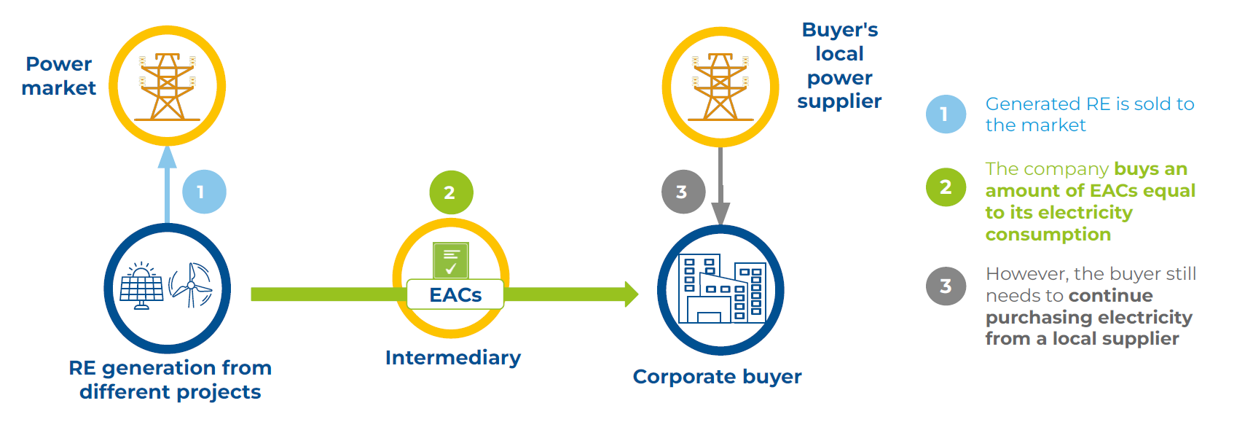
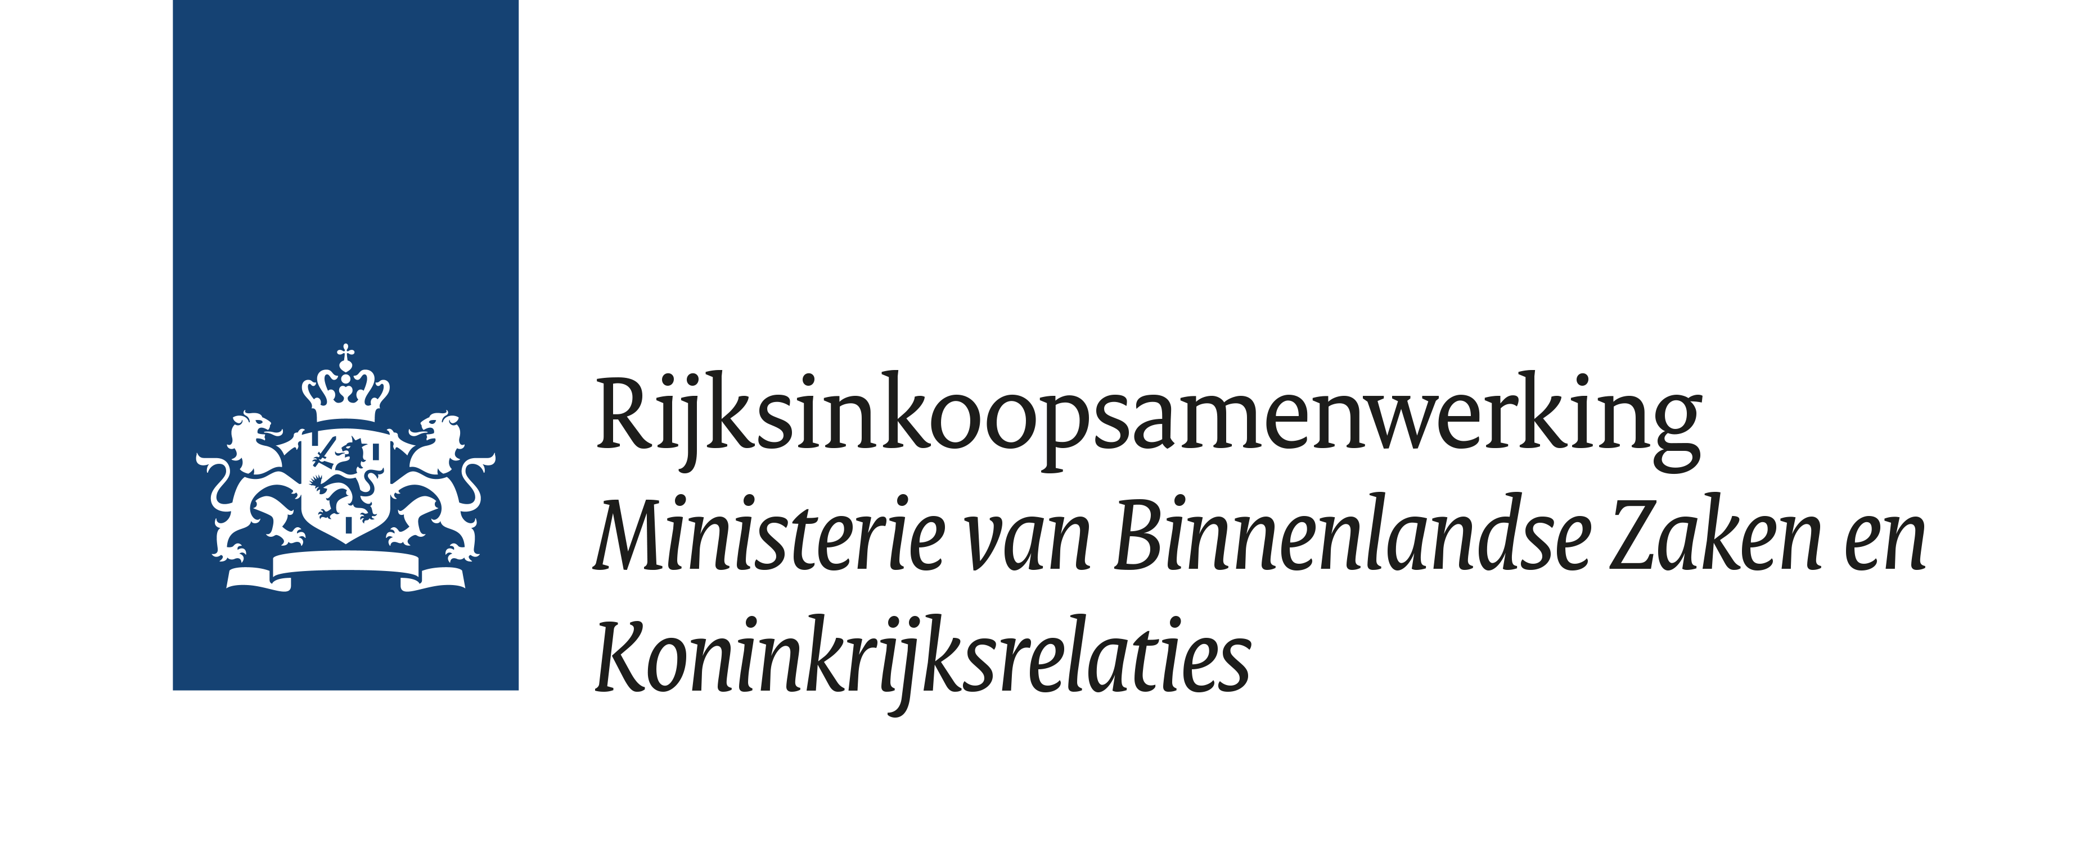

We are looking for two providers of Energy Attribute Certificates (EACs)
The Ministry of Foreign Affairs consumes electricity in around 115 markets , which totaled 28,6 gigawatt hours (GWh) in 2024. In 2024, as a pilot, 12,3 GWh (43% of the total consumption) was greened by purchasing EACs. We need two providers of EACs in the upcoming years for the purpose of greening locally consumed electricity by Dutch embassies, permanent representations and consulates-general outside of the Netherlands.

Who we are
We are the Ministry of Foreign Affairs (MFA). We are the contracting authority for this tendering procedure. RIS (Rijksinkoopsamenwerking or ‘Central Government Procurement Service’) will supervise this tender for us.

What we want
The required deliverable is the annual delivery of EACs (per order placed) that comply with our minimum requirements. We expect to purchase between 13 and 20 GWh per year, though you cannot derive any rights from this estimate.

Together with you we want to pursue the following goals:
1. Contribute to the climate policy of the Netherlands as laid out in the Global Climate Plan
2. Contribute to achieving significant CO₂ emission reductions of MFA (e.g., target of 40% reduction by 2030 compared to 2022)

We will conclude a purchase and supply framework agreement with (a maximum of) two contractors for four years. After two years we can cancel the contract with a notice of termination of at least six months. You will find the draft purchase and supply framework agreement in annex A. The ARIV-2018 applies to this contract.

During the framework agreement, each order is preceded by a request for quotation from the Purchaser for a specific volume of EACs. The order is then awarded to the Supplier offering the lowest price.

The maximum total value of the framework agreement is €400.000 (excl VAT). If the total value of the delivered EACs surpasses the maximum total value we cannot purchase anything anymore under this contract and a new tender procedure will be required.

Are you a provider of EACs?
Then we cordially invite you to submit a proposal for this tender. In the statement of work (Annex B) you will find the requirements that we set for the delivery of EACs. We also set eligibility requirements that you as a tenderer must meet.
What requirements must you meet as a tenderer?
We use a number of exclusion grounds for this purchase and supply framework agreement. We only do business with companies that have integrity. For example, you have not been criminally convicted. We use the European Single Procurement Document (ESPD), annex 2, for this. We also set requirements to determine whether the tenderer is eligible for the delivery. We call these eligibility requirements.

Does an exclusion ground apply to you or do you not meet an eligibility requirement? We will then in principle put your Proposal aside and exclude you from further participation in the tender.
Eligibility requirements
Financial and economic standing
Your company is financially stable. Your annual account of the most recent financial year was approved by your auditor.
Professional qualifications
You must be entered in the national professional or trade register in accordance with the requirements that apply in the country in which your
undertaking is registered.

Professional competence
You demonstrate with a reference order/contract that you comply with the following eligibility requirements:
- The tenderer has fulfilled an order from a governmental organization or multinational organization/enterprise with a contract value of at least €30.000 (excl VAT) per year, whereby the tenderer was responsible for the worldwide delivery of EACs, including at least the following:
  - Delivery and cancellation of EACs in at least three geographic regions outside Europe within the past five years. These regions are:
    - Asia, the Middle East, North America, South America, Africa and/or Oceania.
  - The referenced contracts have to include:
    - delivery of certified EAC products under at least two different certificate systems (e.g. Guarantees of Origin, I-REC(E), TIGR);
    - full administrative handling, including registration and cancellation in recognized registries.

The winning tenderers use Annex 1 to submit the reference order. A reference order that was completed more than five years ago (counting from the closing date for the submittal of Proposals) will not be evaluated. We can verify your claims with the client of the reference order.
Compliance
By participating in this tender and/or by submitting a Proposal, you accept and comply with all the requirements in this Request for Proposal and its annexes.

We evaluate your Proposal on price
We award the contract to the (maximum) two tenderers with respectively the lowest and the second lowest price. In your Proposal you comply with the requirements. After the award your Proposal becomes part of the contract.
Award criterion lowest price
In annex 3 you fill out the quotation form. Please fill out per volume band the markup for overhead, profit and risk per EAC.
Your Proposal is invalid when you don’t completely fill out the quotation form, fill out negative values in the quotation form, fill out a zero in the quotation form, or don’t meet the other requirements for the award criterion price.
Evaluation of price
The tenderers with respectively the lowest and the second lowest average weighted mark-up for overhead, profit and risk are the tenderers with the lowest price.

What happens after the evaluation?
After the evaluation you will receive our award decision. Did you submit a valid Proposal and the lowest or second lowest price? Then we will conclude the framework agreement with you. If your Proposal was not ranked the best or second best you will receive an explanatory letter, a standstill period of 20 calendar days will start.
Verification of the winning Proposal
If we award a framework agreement to you, we will first check your claims in the ESPD, the eligibility requirements and (if applicable) the holding company. We recommend you request the ESPD documents in advance, because there could be a long lead time. The documents must not be older than six months from the closing date for submitting the Proposal when verified. Submit within 10 working days the following documents:
- Extract from the trade register of the Chamber of Commerce (including power of attorney, if applicable).
- Certificate of Conduct for Procurement (not more than 2 years old)
- If applicable: Statement by the Dutch Tax and Customs Administration that confirms that you have paid the compulsory taxes and social security contributions.
- For the most recent past financial years an auditor's report approving the annual accounts of those years.
- Annex 1 Reference statement
- If applicable: Annex 4 Holding company statement

What happens if we receive only one valid and suitable Proposal?
In this case, we will conclude the framework agreement with that single tenderer. The yellow marked text in Annex A and B will then be amended to fit that situation. In the case of a single Supplier, the Purchaser will not use a competitive request for quotation but will instead request quotes solely from that Supplier.

After the Proposal is submitted you cannot amend the contract anymore
Please note that amending the contract terms is not possible after you have submitted your Proposal. Therefore please submit your enquiries and proposed amendments on the contract before you submit your Proposal.

What’s the approach for this tendering procedure?
We use a European open procedure for this tender. We publish the contract notice via TenderNed. More information on how to submit a Proposal is in annex D. The Public Procurement law from 2012 applies to this tender.

The following CPV codes apply:
- Financial consultancy, financial transaction processing and clearing-house services 66172000-6
- Business and management consultancy services 79410000-1

Timetable
Below you will find our timetable for this tender. You cannot derive any rights from this timetable.
Activity | Deadline
Publication of the contract notice | Wednesday 28th of January 2026
Deadline for registering for the online information session | Wednesday 11th of February
Online information session  (The exact time and duration of the online information session is not yet known. You will receive further information about this in due course via TenderNed) | Thursday 12th of February
Deadline for submitting enquiries and suggestions for improvements | Friday 20th of February
Publishing answers to enquiries and suggestions for improvements | Friday 27th of February 2026
Closing date to submit Proposal | Thursday 12th of March
Opening the digital safe | Thursday 12th of March
Assessment of Proposals | Friday 13th of March
Announcement of award decision | Friday 20th of March
Standstill period | Thursday 9th of April
Signing of the contract | Friday 10th of April
Expected commencement date of contract | Friday 10th of April
Publication of the contract award notice | Friday 17th of April
Do you want to submit enquiries?
Please submit these via TenderNed. We will share the answers to general enquiries with the other tenderers. You can also submit proprietary enquiries. These have to have a justified commercial interest to you. Otherwise we will not answer them. The answers to your proprietary enquiries will be shared only with you.

Contact person
Mr. Johannes Hiemstra, senior buyer, supervises this tender. You can reach him via TenderNed.

Are you interested in this contract?
You can submit a Proposal via TenderNed. More information on how to submit a Proposal can be found in annex D.
You have to attach the following documents to your Proposal:
- Reference statement (annex 1);
- ESPD - European Single Procurement Document (annex 2) ;
- Quotation form (annex 3);
- If applicable: Holding company statement (annex 4).
Annexes with information for the tenderer:
  - Draft purchase and supply framework agreement;
  - Statement of Work;
  - Additional information on how to submit a Proposal;
  - Countries for which EACS have to be delivered.

What other requirements must you meet?
- You submit your Proposal in a timely fashion and your Proposal is in English;
- You use the required formats and do not amend the format;
- Your Proposal is honored for at least 60 calendar days and does not contain any reservations or conditions;
- You provide a legally valid signature. This means that you have all annexes to your Proposal signed by the authorized signatory in your organization.

11 Do you have a complaint?
You can register a complaint using the complaints procedure via the digital counter of the RIS during and after the procedure.

12 Glossary
Request for Proposal This document and its annexes

Proposal An offer made by the tenderer based on the Request for Proposal in this tender

TenderNed Procurement platform for this tendering procedure

