Market Consultation Questionnaire for a

GNSS Monitoring Solution
  - PRJ3172 GNSS Monitoring

Status page

Document data
Title | PRJ3172 GNSS Monitoring
Reference number | prj3172-1375691083-51
Version date | 1-9-2025
Status | Definitief
Revision | 1.0

Table of content

1. Introduction 4
1.1 Purpose of the Market Consultation 4
1.2 Company information 4
1.3 Procedure for the Market Consultation 5
2. Required solution 6
2.1 Goal 6
2.2 Business specification (requirements) 6
2.3 The GNSS monitoring system 6
3. Your proposed solution 18
3.1 Benefits of your proposed solution 18
3.2 Implementation solution (GMS-SRD-10) 19
3.3 Integration in the operational ATM system (GMS-SRD-11) 19
3.4 Analysis and reporting (GMS-SRD-15) 20
3.5 Type of data to store (GMS-SRD-17) 20
3.6 Jammer and Spoofer types (GMS-SRD-19, 20) 20
3.7 Accuracy of localization function (GMS-SRD-25) 21
3.8 Use of airborne position data (e.g. ADS-B data) GMS-SRD-29 21
3.9 Inclusion of other system and position verification (GMS-SRD-30) 21
3.10 Safety and compliance 22
3.11 Cyber Security requirements 22
3.12 Reference installations 22
4. Lifetime support and maintenance 23
4.1 Maintenance strategy 23
4.2 Lifetime support services 23
4.3 Supporting services 23
4.4 Sustainability 23
5. Costs 24
5.1 Budgetary information 24
5.2 Cost drivers 24
6. Demand strategy 25
6.1 Contractual arrangements 25
7. Your company 26
7.1 General information on your company: 26
8. Other questions 27

© 2025 Luchtverkeersleiding Nederland
No part of this publication may be reproduced and/or published in any form, by print, photo print, microfilm or any other means, without prior permission from Air Traffic Control the Netherlands.

Introduction

Purpose of the Market Consultation
Air Traffic Control The Netherlands (ATC-NL) seeks your valued advice in order to prepare a sourcing strategy for a GNSS monitoring system that is suitable and matches the set requirements. For this purpose ATC-NL has published this market consultation on TenderNed and Tenders Electronic Daily (EU TED).

Due to the use of GNSS in civil aviation ATS procedures, local GNSS monitoring is required by ICAO regulations. In concrete terms, this means that a GNSS monitoring system must be setup by each member State. In addition to ATS procedures, GNSS is also used in aviation for other CNS functionalities. In particular, the timing function of GNSS (GPS) is a source of time information to synchronize systems between each other. Furthermore, the GNSS location data is used in ADS-B out surveillance messages.

In The Netherlands, DGLM has appointed LVNL (i.e. ATC-NL) as a delegated entity to perform the GNSS monitoring to fulfil the ICAO local monitoring requirements. Although spectrum monitoring is primarily a task for the national Telecom Agencies, the National Digital Infrastructure Inspectorate (RDI, formerly the Telecom Agency) indicated that LVNL is permitted to monitor GNSS signals in the context of the ICAO provisions.

Therefore ATC-NL is looking into the possibilities for sourcing a GNSS monitoring system. For that purpose ATC-NL has prepared a Market Survey Questionnaire that is accessible through the TenderNed tender platform.

Suppliers are invited to use this (template) questionnaire document as provided to submit their answers to the questions.

Company information
AIR TRAFFIC CONTROL THE NETHERLANDS (ATC-NL) is a Dutch independent administrative organization that is responsible for providing air traffic services to civil air traffic in the Dutch airspace in a safe, efficient, and environmentally sensible way. In the Dutch Aviation Act this and all other tasks of ATC-NL have been laid down. Besides the provision of air traffic services these tasks consist of the provision of communication, navigation and surveillance services (including the modernization and management of these technical systems), giving aeronautical information, catering for air traffic control training and providing aviation charts and publications. In short, ATC-NL is responsible for the control of Dutch civil airspace as well as parts of the North Sea area and everything related thereto. ATC-NL became operational in 1923 and since 1993 as a so called "Independent Administrative Body (ZBO)".

For the purpose of air traffic control, Air Traffic Control the Netherlands (ATC-NL) relies on Communication, Navigation, Information, Surveillance and Air Traffic Control systems. These systems provide the "hands and eyes" for the air traffic controller and are therefore essential for the tasks of ATC-NL.

On the website www.lvnl.nl you can read and download all relevant information about ATC-NL.

Procedure for the Market Consultation

Publication of the market consultation
ATC-NL has published this Market Consultation Questionnaire through the TenderNed tender platform to the TED website of the European Communion with reference number TN 543694.

Communication & questions
You are kindly requested to submit all communication regarding this market consultation and its contents through the message center on the TenderNed tender platform.

Should there be any questions or comments than please contact LVNL through the TenderNed tender platform. In case you have difficulties accessing the TederNed tender platform then please contact mr. Vincent van Roemburg (v.a.vanroemburg@lvnl.nl).

Planning of the market consultation
For this market consultation ATC-NL anticipates the following activities to place at the indicated dates:

- Publication of the Market Consultation 2 September 2025
- Submission of questions for clarification 29 September 2025
- Providing the clarifications by ATC-NL 6 October 2025
- Submission of the supplier responses 16 October 2025 – 13:00 CET

Additional terms and conditions
- The market consultation is not part of a tender procedure but a standalone survey;
- This market consultation is expressly not intended to make a pre-selection of candidates in the context of possible follow-up projects;
- Market parties who do not participate in this market consultation are not excluded from potential follow-up projects. Nor are parties who participate in this market consultation in any way excluded or privileged in any follow-up programs;
- Parties (including parties who are not participating) cannot derive any obligations or rights from this market consultation;
- Participation in this market consultation provides no right to obtain a delivery order;
- ATC-NL does not reimburse any costs for participating in this market consultation;
- Participating parties agree that information provided by them can be processed in ATC-NL documents;
- The language during this market consultation will be English;
- ATC-NL is in no way bound by the results of this market consultation or required to procure the subject of this market consultation;
- Claims on the use of information, confidentiality, or requests for reimbursement in connection herewith are not honoured;
- ATC-NL reserves the right to temporarily or permanently discontinue this market consultation;
- By participating in this market consultation, parties acknowledge accepting the terms as stated in this document unconditionally;
- ATC-NL will treat all received information as confidential. If it is decided to launch a European tender, the received information will then be used to uphold the principles of procurement law;
- Price Information provided to ATC-NL in the context of this market consultation will not be made public.

Required solution

Goal
The goal of this market research is to identify and evaluate current market offerings for implementation of a GNSS monitoring system at ATC-NL.

Business specification (requirements)
The GNSS monitoring system is used for:
- Detection of GNSS interferences;
- Classification of jammers and spoofers;
- Localization of the interferers
- Assessment of the impact on GNSS performance
The primary users are technical staff.

In the implementation of the GNSS monitoring system four steps are foreseen (see paragraph 2.3). The first 2 steps are foreseen to be part of a first project at Schiphol Airport. Step 3 and 4 describe the ideal end situation for which a development trajectory is foreseen. For this, an innovative partner from industry is needed to support ATC-NL along the way to the end goal.

Over the lifetime of the system, cost-effective maintenance and support is required.

The GNSS monitoring system
GNSS monitoring is part of the ICAO GNSS monitoring concept and consists of four functional components: performance assessment, operational status monitoring, interference monitoring and data recording.

ICAO: A State that approves GNSS-based operations should ensure that GNSS data relevant to those operations are recorded.

GNSS performance assessment: is a periodic off-line activity performed by a State, or delegated entity, aiming to demonstrate signal in space (SIS) conformance vs. Annex 10 relevant requirements, which can be done at system and/or application level.

GNSS operational status monitoring: is an activity performed by a State, or delegated entity, whose main objective is to provide timely information to technical staff and ATC services on the operational status of GNSS services in relation to a defined operation.

GNSS Interference Monitoring: is a monitoring activity performed by a State, or delegated entity, whose main objective is to provide timely warnings to technical staff and/or ATC services in case of detection of interferences on relevant GNSS frequency band for a specific location.

GNSS data recording: is an activity performed by a State, or delegated entity, whose objective is to have GNSS status historical data to support post-incident/accident investigations. It could cover also the legal recording part depending on national regulations.

The GNSS monitoring system will be used to detect local GNSS RFI events, in and around the aerodrome of Schiphol Airport, and determine the impact on ATS procedures with a GNSS component.

It is foreseen that the GNSS monitoring system conceptually consists of four basic components (see figure below):
- Remote sensor(s)
The remote sensor(s) measure and record RF Spectrum and GNSS related data. For this purpose, a number of sensors consisting of specific RF receiving equipment and GNSS receivers are to be installed on several locations (at least one) in the vicinity of Schiphol Airport.
- Processing Center at LVNL Office
At the LVNL Office, the monitoring data will be assessed, analyses performed and reports generated. Also from the LVNL Office, the GNSS monitoring system is being monitored and controlled.
- External sources
As the remote sensor(s) only record data locally, a correlation between the locally received data and actual performance perceived at the aircraft position is needed. Therefore, external, independent from GNSS, PNT data sources are foreseen to be included in the assessments.
- Database
Received data and assessments is to be stored in a database. The database could be hosted internally LVNL or externally.
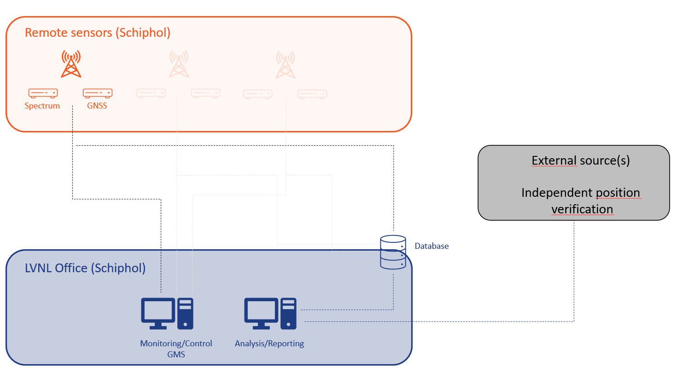

The main functions of the GNSS Monitoring System are related to the elements of “GNSS interference monitoring” and “GNSS data recording” of the ICAO GNSS Monitoring Concept.

Three generic methods can be distinguished:
- GNSS jamming/interference detection (and classification);
- GNSS jamming + spoofing detection;
- GNSS jamming + spoofing detection + localization.
In paragraph 2.3.2, the requirements of the above mentioned three methods are described in more detail.

The system will initially not be part of LVNL's operational ATM system, but it must have the potential to be integrated in the ATM system in the future. For that purpose, at a later stage, the element “GNSS operational status monitoring” considering the impact on the live ATC operations is expected to be added. Clearly, with operational status monitoring, the complexity plays a role in being able to translate a detected GNSS interference into the impact on GNSS performance in ATS procedures.

A phased approach is foreseen, consisting of 4 steps/phases:

Step 1:
Implementation of a ground network of RF sensors to detect and classify the RFI events. Locally the impact on the GNSS performance will be determined. For this purpose GNSS receivers are to be installed, next to the RF sensors. Analysis tools (e.g. Eurocontrol’s Pegasus) could be used in the assessments.
Step 2:
Localization of the jammer/spoofer.

Step 3:
Determination of the impact on the actual GNSS performance in flight. For this external sources are to be included in the analysis. Currently, typical market solutions are based on ADS-B out. One solution is being developed by Eurocontrol (the application GRID as part of the SHERLOCK platform)

Step 4:
As step 3 is mainly focused on larger areas, a more local implementation is foreseen. The solution is extended with local independent external sources for the independent position verification. International developments tend to base these kind of solutions on e.g. Mode S radars or WAM sensors.

A first upcoming tender potentially focuses on step 1 and 2. For steps 3 and 4 this market consultation seeks advice on the feasibility of these kind of solutions and how these steps could potentially be embedded in the demand strategy.

In step 1 and 2, only assessments on a technical level will be undertaken. It is not intended to realize an integration with the operational environment. The system we seek should have an open architecture to allow such integrations at a later stage.

Current situation
In the current situation no GNSS monitoring system is available at ATC-NL.

Desired situation
This paragraph describes the functional requirements for the GNSS monitoring system.

General requirements
The GNSS monitoring setup will be used to detect local GNSS RFI events, in and around the aerodrome of Schiphol Airport, and determine the impact of these GNSS RFI events on ATS procedures with a GNSS component. The GNSS monitoring system consists of three separate functionalities.

The subsystems each have a dedicated function:
- Detection and Classification of GNSS RFI events;
- Localization of GNSS RFI events (optional);
- Impact analyses on GNSS RFI events.
The above mentioned functionalities are an integral part of the overall GNSS monitoring setup with a logical interaction between the subsystems.

After detection and classification of a GNSS RFI event, it shall be possible to perform an impact analysis. It should also be possible to localize the RFI event.

The functional requirements of the GNSS monitoring system are described in the following paragraphs.

GMS-SRD-01
Systems to monitor
The system shall monitor the signals in all the frequency-bands of the GNSS core constellations: GPS and Galileo.
The augmentation signals of the EGNOS SoL (Safety of Life) shall also be monitored constantly.
Remarks
Other core constellations (Glonass, Beidou) could also be part of the systems to monitor.
Rationale

GMS-SRD-02
System composition
The detection of a GNSS RFI event shall be possible with an independent ground system of RF-sensor(s), taking into account the GNSS core constellations and GNSS overlays (SBAS).
Remarks
Rationale

GMS-SRD-03
Number of independent RF ground sensors
The number of independent ground RF sensors shall be sufficient to cover the CTR and TMA’s Schiphol.
Remarks
A site survey shall determine the required number of sensors. In this respect also the localization function shall be taken into account.
Rationale

GMS-SRD-04
Location of sensors
The receiving antenna(s)/sensors shall be placed on or around Schiphol
Remarks
Rationale

GMS-SRD-05
Coverage of sensors
The receiving antenna(s)/sensors shall be placed in such a way that they are representative of Schiphol signal/interference levels with a clear 360-degree view in the CTR and TMA’s of Schiphol Airport.
Remarks
Rationale

GMS-SRD-06
Relation to ATS procedures
The measured performance of the GNSS monitoring system shall be representative to the ICAO performance requirements for ATS procedure types
Remarks
For additional information see section 4.1.5.
Rationale

GMS-SRD-07
Expandability
It shall be possible to expand the system to other regions and/or strategic hotspots by connecting additional locations/sensors
Remarks
Rationale
The system shall not be limited to one region. It is intended that the system will be expanded to CTR’s and TMA’s of other civil airports in The Netherlands (Rotterdam, Eelde, Beek, Lelystad).

GMS-SRD-08
System management
It shall be possible to manage the system remotely in conformance with LVNL security requirements.
Remarks
See also paragraph 3.11 for the LVNL security requirements
Rationale

GMS-SRD-09
Availability of the system
The system shall operate autonomously 24/7
Remarks
Rationale

GMS-SRD-12
GNSS information in ATM operations
The system provides an indication of the operational usability of GNSS to the technical department.
Remarks
Only assessments on a technical level will be undertaken. It is not intended to realize an integration with the operational environment. It is not to be excluded that this will be done at a later stage.
Rationale

Data management

GMS-SRD-13
Data storage
The collected data shall be automatically stored in an accessible and secure manner on a central server.
Remarks
Rationale

GMS-SRD-14
User interface
The data shall be accessible via a well-secured web interface in conformance with LVNL Cyber Security requirements
Remarks
Rationale

GMS-SRD-16
Post-processing
It shall be possible to record/export GNSS data in the RINEX data format for post-processing.
Remarks
Rationale
Export options allow other analysis tools such as Pegasus (Eurocontrol) to be used.

Detection & Classification of RFI events
Detection of an RFI event occurs when a Radio Frequency Interference (RFI) is captured in the GNSS signal band by a monitoring network. Classification of a jammer/spoofer signal type relies on the properties and parameters derived from the spectrum of the RFI event. While signals frequently fall into categories such as chirp, continuous wave, stepped, sweep or wideband noise, there is a large and growing number of modulations encountered, both intentional and unintentional.

GMS-SRD-18
Types of disturbances Measuring RF-spectrum characteristics
The monitoring system shall be capable of detecting:
- Intentional disturbance: Jammers & Spoofers (incl. meaconing and time spoofers);
- Unintentional disturbances: jammers/interference (e.g. charging facilities).
Remarks
Not required are the measurements of unintentional disturbance, such as:
- In-band emissions (DME, TACAN, etc.);
- Out-of-Band emissions (harmonics, etc.);
- Spurious emissions (inter- & cross modulations, etc.);
- Natural disturbance (ionospheric effects, noise types, etc.).
In case of ionospheric effects the GNSS Monitoring System shall only determine the ionospheric propagation path delay by the standard broadcast of the GNSS ionospheric coefficients in the NAV messages, or by ionospheric correction received form the EGNOS correction data.

Rationale

GMS-SRD-20
Spoofer types
It shall at least be possible to identify the type of spoofer, being:
- Asynchronous attacks: GNSS signal outside the correlator of the GNSS receiver;
- Synchronous attacks: GNSS signal inside the correlator of the GNSS receiver;
- Synchronous attacks with multiple spoofers;
- Meaconing attack with repeater(s) (delaying and rebroadcast)
- Time spoofers: time delays in NAV messages
Remarks
Rationale

GMS-SRD-21
Signal quality monitoring methods
At least the following two types of signal quality monitoring methods shall be available:
- RF front-end
- Baseband processing GNSS receiver
Remarks
Rationale

GMS-SRD-22
General detection: consistency checks PNT data
For GNSS core systems at least the following monitored items shall be recorded for all satellites in view:
- Observed satellite carrier-to-noise density (C/No)
- Observed raw pseudo-range code and carrier phase measurements
- Broadcast satellite navigation messages
- Relevant recording receiver status information
- AGC (search-track modes)
- LAT-LON coordinates preferable in ETRS89/WGS84
- GNSS timestamps
- HDOP, VDOP, etc.
Remarks
In ICAO Annex 10 Vol. I, Attachment D chapter 10 & 11 and ICAO DOC 8071 Vol. II, chapter 1, Attachment 3, guidance is given regarding spectrum interferences.

Rationale

GMS-SRD-23
Complex detection & analyses: anomaly monitoring techniques (with embedded GNSS coarse data)
At least the following anomaly monitoring techniques shall be included:
- Coordinate monitoring with reference coordinates
- C/N_{o} monitoring
- Pseudo range Residuals monitoring
- Spectrum, Power and Gain monitoring
- Time Cross monitoring
Remarks
Rationale

Localization GNSS RFI events

GMS-SRD-24
Number of RF sensors localization function
The localization system consists of a network of ground-based RF sensors for localizing the GNSS RFI event the CTR and TMA’s of Schiphol Airport.
Remarks
A site survey shall determine the required number of sensors.
Rationale

Impact analyses of GNSS RFI events
After detection, classification and localization of a GNSS RFI event, an impact analysis needs to be performed. Therefore, an impact analysis tool should be available. With this tool, it is possible to determine the impact of a detected GNSS RFI event on the performance of published ATS procedures with a GNSS component.

The GNSS signal-in-space performance requirements are given in ICAO Annex 10, Volume I, chapter 3.7.

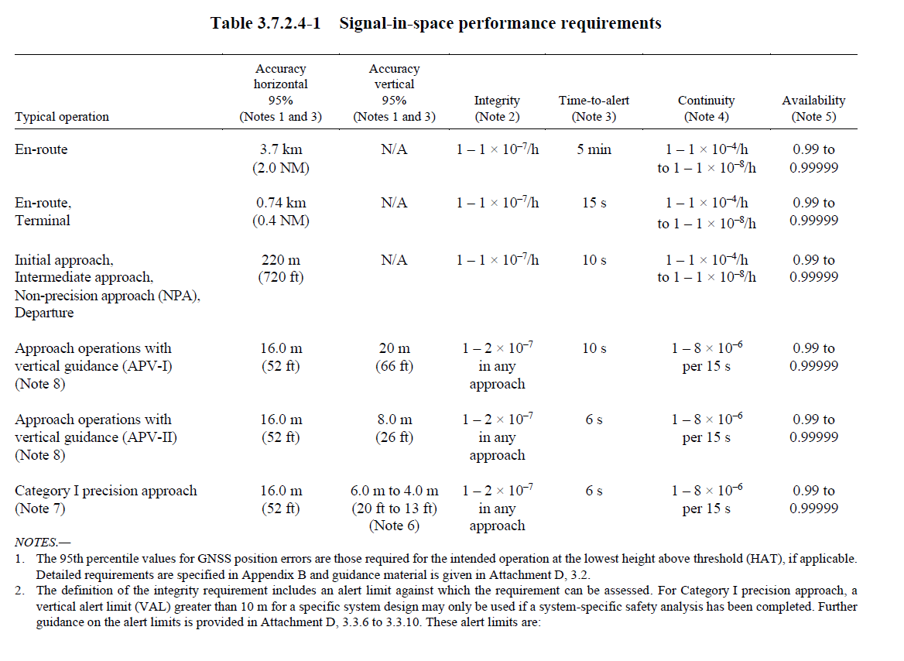
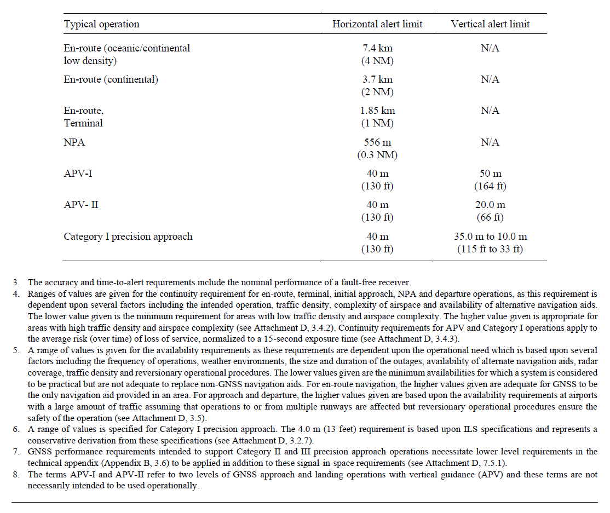

GMS-SRD-26
Input data impact analysis software tool
When a GNSS RFI event is detected, the software tool shall make use of the RF-spectrum and localization data.
Remarks
Rationale

GMS-SRD-27
Use of local GNSS receiver data
GNSS receiver data (positioning, timing) at location of RF sensor shall be analysed.
Remarks
Rationale

GMS-SRD-28
GNSS performance determination in light of PBN requirements
Impact analyses tool/algorithm(s) for detecting GNSS performance downgrading, based on PBN requirements for ATS procedure types shall be implemented.
Remarks
The signal-in-space requirements are described in ICAO Annex 10.
Rationale

Additional functional requirements

In the previous paragraphs, a number of concrete requirements have been formulated. In this paragraph, additional functional requirements are addressed for which more information is requested. More input from the market is needed to formulate more concrete requirements for a tender to follow. The related questions have been formulated in sections 3.2 to 3.9.

GMS-SRD-10
Implementation solution
The system, its subcomponents and antennas shall be easily, physically, accessible
Remarks
Rationale

GMS-SRD-11
Integration in the operational ATM system
The system will initially not be part of operational ATM system of LVNL, but it shall have the potential to be integrated into the operational ATM system in the future.
Remarks
With the integration into the operational ATM system is meant providing GNSS status information to the Air Traffic Controller.
Rationale

GMS-SRD-15
Analysis and reporting
The system provides reporting/presentation/analysis of GNSS data usable for aviation applications.
Remarks
Rationale

GMS-SRD-17
Type of data to store
The GNSS data or RFI event is stored for further analysis.
Remarks
Rationale

GMS-SRD-19
Jammer types
It shall be possible to classify the jammers. Classification types such as In-band, PRN-code jammers, AWGN (Additive White Gaussian Noise), AGC (Automatic Gain Control) attackers, , are to be used.
Remarks
Rationale

GMS-SRD-25
Accuracy of localization function
The accuracy of the localization should be sufficient to find the source of disturbance for which an adequate geometrical layout of the position of the RF sensors should be given.
Remarks
Rationale

GMS-SRD-29Use of airborne position data (e.g. ADS-B data)
It shall be possible to include in the impact analysis airborne position data.
Remarks
Rationale

GMS-SRD-30
Inclusion of other system and position verification
It shall be possible to perform a position verification with independent non-GNSS position sensor(s)
Remarks
The GNSS monitoring setup might be combined with other systems (e.g. ADS-B) providing independent GNSS performance information. e.g. MSSR Mode S data from LVNL radars (ICAO Annex 10 vol. IV, Eurocontrol ESASSP v1.3); (ICAO Annex 10 vol. I describes accuracy requirements
Rationale

Your proposed solution

Benefits of your proposed solution
3.1.1: What would be your proposed solution to the Required Solution (Chapter 2) and how would it benefit the goals and requirements?

Answer 3.1.1:

3.1.2: Please fill out the following table regarding the requirements mentioned in chapter 2.3.2 and indicate for each requirement whether for the proposed solution fulfilment is the default, requires development efforts, or is impossible to realize. Please provide for each outcome a short explanation under the remarks why this is the case. More detail can be provided in further questions.

Answer 3.1.2:
Requirement | Default / Development / Impossible/ Not applicable | Remarks
SRD-GMS-01
SRD-GMS-02
SRD-GMS-03
SRD-GMS-04
SRD-GMS-05
SRD-GMS-06
SRD-GMS-07
SRD-GMS-08
SRD-GMS-09
SRD-GMS-12
SRD-GMS-13
SRD-GMS-14
SRD-GMS-16
SRD-GMS-18
SRD-GMS-20
SRD-GMS-21
SRD-GMS-22
SRD-GMS-23
SRD-GMS-24
SRD-GMS-26
SRD-GMS-27
SRD-GMS-28

Implementation solution (GMS-SRD-10)

Based on the functional description of the desired GNSS monitoring system, different implementation scenario’s may be possible. Possible scenario’s could be:
  - Scenario 1:
    - Antennas at office building ATC-NL and/or aerodrome Schiphol
    - Connection either cable or wireless
    - Hardware on premises of ATC-NL office
    - Software and hardware under management ATC-NL
  - Scenario 2:
    - Same as scenario 1, but under management of supplier
  - Scenario 3:
    - Antennas outside aerodrome Schiphol
    - Wireless connection (e.g. 5G)
    - Hardware on premises of ATC-NL office
    - Software and hardware under management ATC-NL
  - Scenario 4:
    - GNSS monitoring as a Service (thus entire system under management of supplier, including all hardware, software, connections, etc), access is provided via e.g. a web-client
What is your preferred implementation strategy of your solution? Are other scenario’s viable/possible? Could you please elaborate on aspects of expected life time, costs, system integrity and continuity, performance, reliability and (legal) responsibility?

Answer 3.2:

Integration in the operational ATM system (GMS-SRD-11)
The system will initially not be part of operational ATM system of LVNL, but it shall have the potential to be integrated into the operational ATM system in the future. With the integration into the operational ATM system is meant providing GNSS status information to the Air Traffic Controller.

Is your solution capable of providing GNSS status information to the Air Traffic Controller? If so, please elaborate on this.

In order to allow an integration in the operational ATM system, monitoring and control of the solution is foreseen. Please provide information on how your proposed solution is able to be monitored and controlled.

Answer 3.3:

Analysis and reporting (GMS-SRD-15)
The system provides reporting/presentation/analysis of GNSS data usable for aviation applications.

What kind of reporting/presentation/analysis does your solution provide? Please take into account the intended purpose of the GNSS monitoring system with respect to detection, classification and localization.

Answer 3.4:

Type of data to store (GMS-SRD-17)
The GNSS data or RFI event is stored for further analysis. What kind of data is being stored in your solution?

Answer 3.5:

Jammer and Spoofer types (GMS-SRD-19, 20)
It shall be possible to classify the jammers and spoofers. Classification types such as In-band, PRN-code jammers, AWGN (Additive White Gaussian Noise), AGC (Automatic Gain Control) attackers, are to be used.
It shall at least be possible to identify the type of spoofer, being:
- Asynchronous attacks: GNSS signal outside the correlator of the GNSS receiver;
- Synchronous attacks: GNSS signal inside the correlator of the GNSS receiver;
- Synchronous attacks with multiple spoofers;
- Meaconing attack with repeater(s) (delaying and rebroadcast)
- Time spoofers: time delays in NAV messages

Please describe the method of detection and classification of the different jammer and spoofer types.
Answer 3.6:

Accuracy of localization function (GMS-SRD-25)
The accuracy of the localization should be sufficient to find the source of disturbance for which an adequate geometrical layout of the position of the RF sensors should be given.

Please describe your philosophy on localization and achievable accuracies.

Answer 3.7:

Use of airborne position data (e.g. ADS-B data) GMS-SRD-29
It shall be possible to include in the impact analysis airborne position data.

The first 2 steps of the foreseen phased approach as described in paragraph 2.3, focus on a local ground GNSS monitoring solution. This does not necessarily mean that an aircraft is affected by detected interference. Therefore, an impact analysis on aircraft level is needed. Please elaborate on your views and possibilities your solution can provide.

Answer 3.8:

Inclusion of other system and position verification (GMS-SRD-30)
It shall be possible to perform a position verification with independent non-GNSS position sensor(s). The GNSS monitoring setup might be combined with other systems (e.g. ADS-B) providing independent GNSS performance information. e.g. MSSR Mode S data from LVNL radars (ICAO Annex 10 vol. IV, Eurocontrol ESASSP v1.3); (ICAO Annex 10 vol. I describes accuracy requirements

Please elaborate on your views and possibilities your solution can provide.

Answer 3.9:

Safety and compliance
3.10: To which standards does your proposed product(s) comply? (e.g. EC directives: EMC, Interoperability, (Software) Safety Assurance, ESARR6, Declaration of suitability of use etc.)

Answer 3.10

Cyber Security requirements
For ATC-NL cyber security requirements apply.

- Availability of a valid ISO27001 certification for a product or service comparable to the one LVNL intends to procure;
- Implementation of an Information Security Management System (ISMS) in accordance with ISO27001, NIST, or an equivalent standard;
- Existence of an active cybersecurity policy and a structured security awareness program for employees, demonstrating a security-conscious organizational culture;
- Established security reputation of the products (including vulnerability assessments), or where applicable, the security reputation of the provided service (including uptime, cyber resilience, and recovery time);
- Capability to export and hand over monitoring system data to LVNL upon request.

Please elaborate on the cyber security measures applicable to your solution.

Answer 3.11:

Reference installations
3.12: Have you delivered similar solutions to meet similar requirements as described in Chapter 2 for air navigation service providers. If so, could you provide details of that solution and possibly the names of the organizations to whom you delivered such a solution?

Answer 3.12:

Lifetime support and maintenance

Maintenance strategy
4.1: What, in your opinion, would be an appropriate maintenance support strategy for the solution?

Answer 4.1:

Lifetime support services
4.2: Lifetime support would mean that the supplier has the functional responsibility to make sure that the delivered system can at all times be supported by supplier’s support organization. Please elaborate on how you would propose to render services and keep the offered product available for more extended periods of time?

Answer 4.2:

Supporting services
4.3: Which supporting service(s) do the product(s) you propose require? (i.e. what needs to be provided in addition to the units themselves?)

Answer 4.3:

Sustainability
LVNL values sustainable solutions that contribute to our corporate sustainability goals. You can read about these goals on the LVNL website https://en.lvnl.nl/organisation/sustainable-services and in Dutch https://www.lvnl.nl/kenniscentrum/duurzaamheid.

4.4: Please describe your organizations effort concerning the sustainability aspects for Climate, Circularity and Health & Social? Please also elaborate on any certifications concerning sustainability that your organization has obtained?

Answer 4.4:

Costs

Budgetary information
5.1.1: In advance of a tendering procedure ATC-NL takes great care in assuring that before commencing a procurement, adequate budgets are available. Therefore ATC-NL seeks your advice on what a GNSS monitoring solution would cost.
Please base your budgetary information on the required solution in as described in Chapter 2.
Please provide a rough order of magnitude (ROM) regarding the cost items of your proposed solution. The table leaves room for additional items that you find relevant.

# | Cost item | Rough order of magnitude (ROM) excluding VAT for a single cost item  [ € ]
1 | Step 1 | €
2 | Step 2 | €
3 | Step 3 | €
4 | Step 4 | €
5 | …. | €
6 | …. | €

5.1.2: What further budgetary information is relevant regarding using the units, for instance (maintenance) support and other services? Please list these services and the respective costs when applicable.

Answer 5.1.2:

Cost drivers
5.2 : Please indicate for the requirements in chapter 2.3.2 for each of them to what extent a requirement from LVNL constitutes a significant development cost driver for your organization:

Requirement | Level of significance as a cost driver?  [None/low/medium/high] | Remarks

Demand strategy

Contractual arrangements
6.1 : Using your experience in contractual relations and using the goals set out in the Required Solution (Chapter 2), what would your observations/recommendations be on the following:

- Form of contract;
- Duration of the contract;
- Exit strategy upon ending the contract & migration to a new contract with a new contract party (or parties);
- The contract governance needed on the contract(s) you propose;
- Performance-based contracting or contracting of services and/or products;
- How to deal with future additions like e.g. step 3 and step 4.

Please include relevant examples of contractual relations you are in (or have been in) that underline your answers.

Answer 6.1:

Your company

General information on your company:
# | Item | Answer
a. | Company name
b. | Postal address
c. | Contact person
d. | Position of contact person
e. | Email address
f. | Number of offices (except head office)
g. | Number of employees
h. | Number of employees in relation to services as described
i. | Company turnover for the last three years
j. | Is your company part of a larger (parent) company? | o Yes, namely […]  o No
k. | Number of employees of parent company

Other questions
8.1: Would you like to add anything relevant that we may have forgotten to ask? If so, please elaborate.

Answer 8.1:

Air Traffic Control the Netherlands

Stationsplein Zuid-West 1001
1117 CV Schiphol

PO Box 75200
1117 ZT Schiphol
The Netherlands

T +31 (0)20 406 2000

www.lvnl.nl

