Europeana Software Stack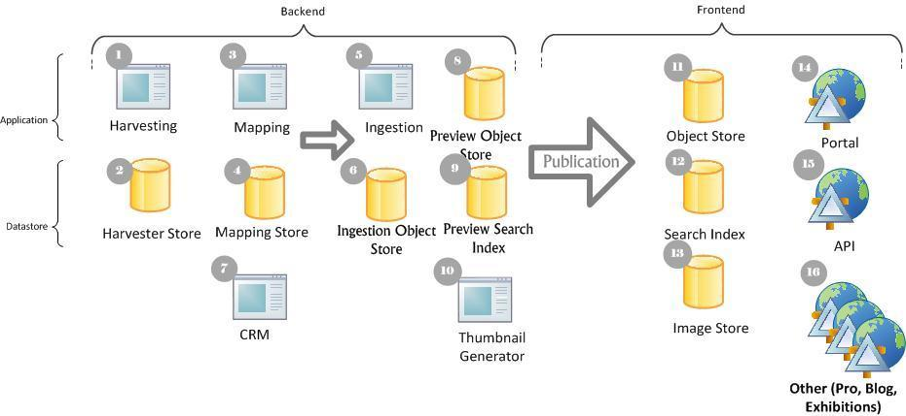

No. | Name | Description | Technology | Max Heap Size  (-XmX) | App Size  (binary) | Comments | POC
1 | Harvester  (REPOX) | Harvests datasets from datasources | Apache Tomcat | 1GB | 100MB | Requires access to the filesystem | Yes
2 | Harvester Storage | Storage for (1) | PostgreSQL | 8GB | N/A | Volume: 30GB | Yes
3 | Mapping  (MINT) | Metadata mapping tool | Apache Tomcat | 8GB | 45MB | Requires access to the filesystem | Yes
4 | Mapping Storage | Storage for (3) | PostgreSQL | 4GB | N/A | Volume: 100GB | Yes
5 | Ingestion Manager  (UIM) | Ingestion work flow manager | Apache Karaf | 32GB | 400MB | Requires access to the filesystem for configuration files and log files | Yes
6 | Ingestion Storage | Storage for (5) | MongoDB | 3GB | N/A | Volume: 100GB | Yes
7 | CRM | Out-of-scope
8 | Preview Object Store | Pre-production store. | MongoDB | 16GB | N/A | Volume: 1TB | No
9 | Preview Search Index | Pre-production search index | Apache Solr | 12GB | N/A | Volume: 1TB  Documents: 35M | No
10 | Thumbnail Generator | Out-of-scope
11 | Object Store | Production object store | MongoDB | TBD | N/A | Current setup: Cluster of 2,  8GB RAM e.o + 300GB volume e.o.  In the future space requirement will grow to 1TB. | Yes, 1 node
12 | Search Index | Production search index. | Apache Solr | TBD | N/A | Current setup: 5 instances in a LB  32GB RAM + 300GB e.o.  In the future move to master-slave configuration, space will grow to 1TB. | Yes, 1 node
13 | Thumbnail storage | Out-of-scope
14 | Portal | Europeana main web portal | Apache Tomcat | TBD | 100MB | Current setup:  4 instances in a LB, 8GB each  On average 50K web requests/day  Needs access to the filesystem for configuration files | Yes, 1 node
15 | API | Europeana API service | Apache Tomcat | TBD | 45M | Currently merged with (14), requirements are TBD | Yes
16 | Blog etc. | Out-of-scope

* Lines in yellow are out of the scope for the current RFP

Performance Statistics

No. | CPU# | Sysload* | RAM Utilization (GB)* | Disk GB | Disk Read (MB/Sec)* | Disk Write (MB/sec)* | Bandwidth In (MB/sec)* | Bandwidth Out (MB/sec)*
11 | 4 | 0.48 | 2.30 | 931.00 | 9.20 | 4.20 | 0.72 | 0.54
11 | 4 | 0.24 | 2.50 | 906.00 | 12.00 | 5.10 | 1.10 | 0.87
13 | 8 | 0.37 | 3.80 | 1361.00 | 3.70 | 4.40 | 0.30 | 0.70
13 | 8 | 0.27 | 3.50 | 1344.00 | 1.80 | 4.80 | 0.30 | 0.15
13 | 2 | 0.30 | 1.00 | 2108.00 | 5.70 | 4.90 | 0.57 | 0.75
12 | 4 | 2.30 | 14.60 | 770.00 | 14.10 | 5.70 | 0.08 | 0.16
12 | 4 | 2.70 | 23.60 | 692.00 | 24.80 | 5.20 | 0.18 | 0.39
12 | 4 | 3.37 | 21.60 | 932.34 | 18.80 | 4.00 | 0.09 | 0.34
12 | 4 | 2.41 | 21.67 | 690.37 | 24.70 | 5.20 | 0.13 | 0.36
12 | 4 | 2.91 | 18.85 | 690.33 | 19.00 | 3.60 | 0.11 | 0.33
14 | 4 | 0.77 | 2.78 | 15.30 | 1.60 | 0.80 | 0.57 | 0.57
14 | 4 | 1.14 | 3.25 | 12.46 | 0.40 | 0.80 | 0.98 | 0.48
14 | 4 | 1.50 | 3.45 | 12.36 | 0.20 | 0.70 | 0.71 | 0.80
14 | 4 | 1.19 | 4.05 | 12.14 | 0.20 | 0.90 | 0.69 | 0.83
1 | 2 | 2.23 | 2.64 | 229.64 | -1.00 | -1.00 | 0.12 | 0.94
5 | 2 | 0.74 | 15.16 | 322.57 | -1.00 | -1.00 | 0.41 | 0.39
3 | 2 | 0.77 | 4.39 | 214.71 | -1.00 | -1.00
7 | 1 | 0.06 | 0.61 | 3.40 | -1.00 | -1.00
6,8,9 | 4 | 0.65 | 10.33 | 594.54 | -1.00 | -1.00
6,8,9 | 1 | 0.33 | 9.28 | 0.96 | -1.00 | -1.00

* Averages are calculated using 15 minutes moving average window over last 5 weeks

