Market orientation concerning the next steps toward a coordinated vision for water resilience in the greater Semarang region, Indonesia

Reference number: 202504095

1. Organisation: The Netherlands Enterprise Agency
The Netherlands Enterprise Agency (in Dutch: Rijksdienst voor Ondernemend Nederland, hereinafter RVO) supports entrepreneurs, NGOs, policymakers, knowledge institutes, and organisations, in order to contribute to three societal transitions: (1) climate-energy transition, (2) sustainable agriculture and food system, and (3) future proof and digital economy. RVO aims to improve collaborations and strengthen positions through funding and networks and help realize national and international ambitions with financing, networks, expertise and compliance with laws and regulations.

RVO is a government agency that operates under the responsibility of the Ministry of Economic Affairs. Our activities are carried out on behalf of various Dutch ministries and the European Union.

For more information about RVO, please visit: Netherlands Enterprise Agency | RVO.nl.

2. Project initiator
The initiator of this project is the Partners for Water programme.

This Dutch government initiative is part of RVO and works to strengthen global water security through long-term collaboration with local stakeholders and the Dutch water sector. By supporting strategic planning and early-stage innovation, the programme aims to drive systemic change in sustainable water management and infrastructure. In this way, it helps to deliver meaningful, lasting improvements to the quality of life and the living environment.

The Partners for Water programme is commissioned by the Ministry of Infrastructure and Water Management, acting on behalf of the Interdepartmental Water Cluster.

For more information about the Partners for Water Programme, please visit: Homepage - Partners for Water.

3. Purpose of the market orientation
With this market orientation, RVO wants to collect information which will help with specifying a likely upcoming European tender regarding this project.

The objectives of this market orientation are:
- To identify potential parties interested in this assignment;
- To assess the feasibility of interested parties forming a team with a mix of international and local experts possessing the necessary expertise to deliver the required services;
- To gather input on the value of services that match the anticipated activities of this assignment;
- To gather insights to further refine the proposed tender content and process, with the goal of enhancing the quality of responses for the potential European upcoming tender.

4. Purpose of the project
The main goal of Phase II Semarang is to develop an integral, landscape-based, inclusive and finance-ready approach for water resilience in the greater Semarang area, detailed in two case studies. In line with national priorities of the Government of Indonesia to enhance coastal protection for North Java, an additional aim is to scale the approach along the North Coast of Java, specifically the Cirebon region. Further context and background on the dynamics in the greater Semarang region are provided in annex 1.

This project builds upon prior work such as Phase I: Setting the Scene, the Water as Leverage (WaL) approach (including WaL Semarang 1.0, WaL guidance and learnings in WaL Cartagena), and existing bilateral initiatives.

5. Scope of work
The scope of the Phase II assignment will focus on outputs that support the translation of the integrated water resilience vision into actionable, investable, and institutionally anchored investment project pathways. The contractor is expected to deliver a carefully balanced combination of strategic facilitation, technical support, policy and financial alignment, and stakeholder engagement. This will require close collaboration with local and national institutions, community representatives, and international actors.

Key components of the scope include:
- Co-creation of Project Intervention Package and stakeholder ownership: Organize and facilitate co-creation processes (e.g., Landscape, Finance and Governance Ateliers and local labs) to identify and design a portfolio of integrated water-related project interventions. Facilitate participatory processes with community representatives, local, regional and national partners, and international partners to co-design projects. Ensure inclusive representation and ownership throughout the process. Ensure the portfolio of interventions tangibly contribute to making catchment-wide impact.
- Institutional and Policy Alignment: Support institutional embedding of project ideas through alignment with the Blue Book, and other key policy frameworks. In an iterative manner, continuously relate outcomes of atelier sessions to policy criteria to ensure realistic, feasible outputs that align with Blue Book priorities and fit subsequent Green Book process steps. Using the mapped relevant governance structures and planning procedures in Phase I.
- Financial Strategy Development: Identify the criteria for project development from relevant finance channels, instruments, and partners that could support the future development and implementation of the selected project ideas. Explore how existing financial mechanisms could be leveraged during implementation by inviting financial assessors to be part of the steering committee / financial atelier sessions. Similar to policy alignment, iteratively mirror outcomes of atelier sessions with financiers to align with financial criteria to increase chance of uptake of outputs into further investment planning. Close alignment with others such as Invest International, WorldBank and Asian Development Bank is foreseen.
- Strategic Communication and Dissemination: Translate technical and institutional outcomes into bilingual, visually compelling formats that can be used in policy, public, and financial dialogues. Maintain and expand the digital knowledge repository started in Phase I.
- Support for Replication and Upscaling: Through close collaboration with local, regional and national authorities, the design-driven and co-creative approach applied should allow stakeholders to replicate the approach in other cities or regions across North Java facing similar challenges. This requires step-by-step guidance, close consultation and a well-documented to capture lessons from Semarang and assess their potential application in other cities in Northern Java.

The contractor will also provide ongoing documentation of the co-creation process, maintain the knowledge repository initiated in Phase I, and facilitate meaningful engagement moments such as stakeholder roundtables and international workshops.

Anticipated deliverables
The following key deliverables are anticipated outcomes of this project:
- Pre-feasibility documents for two selected hotspot areas in Greater Semarang Region, including an intervention package for follow-up investment. The intervention package contains detail on governance, technical and financial level, and addresses anticipated socio-economic and environmental impact of interventions. The outcomes should serve as input to decision-making to proceed into feasibility stage with Ministry of Public Works, Ministry of National Development Planning in close consultation with one or more development cooperation partners and investment programs (Such as National Urban Flood Resilience Project by WorldBank; Urban Flood Resilience Project by Invest International; Water Operator Partnership by VEI). The exact hotspots will be defined in close consultation with local and national authorities, and aligns with interest of development cooperation partners. Most probable the investment cases will focus on a coastal and an upstream region, requiring a nature-based approach to identify suitable intervention packages.
- Setting the Scene document for Cirebon region, with a preliminary study document as clear intermittent deliverable to Ministry of Public Works and Ministry of National Development Planning. The Setting the Scene process in Cirebon aims to detail further the root causes of pressing water system and coastal dynamics, socio-economic dynamics, the (local) stakeholder landscape, ongoing and planned infrastructure development. The StS aims to prepare for follow-up investment planning on coastal protection. While coastal dynamics closely relate to wider system functioning, the analyses should closely align with and take into account the intermittent outcomes and insights gained through the ongoing ADB Flood Management North Java Project, which focuses on the Cimanuk-Cisanggarung River Basin.
- Co-creation process in which process steps and intermittent outcomes are closely aligned with local and national government authorities, and development cooperation partners.
- Updated and expanded knowledge and data repository.
- Well-documented process guideline that allows for effective replication.

6. Required experience
- Team lead: Indonesia-based and/or international. First point of contact for the contracting authority and key counterpart organisations. Background in urban planning, integrated landscape design, water management or comparable profile, with experience in managing international projects. Ability to communicate in Bahasa is an added value.
- Co-lead: Indonesia-based expert, with a background in governance, project finance, water management or a combination. Ability to communicate in Bahasa is a requirement.
- Technical team: (group of) expert(s) with Indonesia-specific expertise on water infrastructure development, coastal protection, spatial planning, asset management, water system modelling, nature-based solutions, landscape design.
- Governance team: (group of) expert(s) with Indonesia-specific expertise on the Indonesian legal and jurisdictional system, particularly related to national, regional and local planning processes.
- Financial team: (group of) expert(s) on project structuring and financing in the Indonesian context, including a focus on private sector, (local) government, thorough understanding of the various process steps associated with Blue Book and Green Book, and international project financing. Ability to translate interventions packages into CAPEX and OPEX estimates is required.
- Logistical support team: (group of) expert(s) supporting the team in the logistical preparations required for the execution of this assignment, such as preparation and planning of interviews, meetings and atelier workshops.

We are currently still in the market orientation phase. Should a tender be published and you wish to submit a proposal, we advise you to take into account that, for environmental and budgetary reasons, it is strongly encouraged to propose an expert team and role division (local/international) that minimises the need for intercontinental travel.

7. Budget indication
The indicative budget for this assignment is set at €500,000 – €600,000, excluding Dutch VAT and including any applicable local (foreign) VAT, as well as all other costs and fees. No rights may be derived from this indication.

8. Duration of the assignment
Depending of the scope we anticipate the duration of the assignment to be one (1) year.

9. Application
Interested companies are invited to send an expression of interest to RVO by sending an e-mail to jessica.scheffers@rvo.nl of the Procurement Office and a copy to ylva.veldhuis@rvo.nl and simon.vanmeijeren@rvo.nl.

In your Expression of Interest, you are kindly requested to briefly address the following points:
- Information about the organisation: Please include your organisation’s website, along with a concise track record highlighting relevant experience and expertise in line with the requirements of this assignment. Additionally, kindly provide the name, position, and email address of the designated contact person.
- Reflection on the scope of work: Do you find the scope clearly defined and sufficiently comprehensive? Are there any activities you believe are missing or in need of further clarification?
- Proposed team composition and/or partners: You are requested to provide a concise overview of the proposed team and/or any partners you consider well-suited to fulfil the objectives and requirements of this assignment.
- Reflection on the requirements: Are you able to meet the stated requirements? Do you have any suggestions to revise, simplify, or expand specific elements of the requirements?
- Estimated value of services: What budget do you consider appropriate to effectively carry out the proposed activities?
- Daily rate: Please indicate the average daily rate (junior / medior / senior) for each expert position, distinguishing between international and local experts, and dividing by team. Fill in the table below (as much as possible) and add rows if needed.

 | Daily rate international expert (excluding Dutch VAT and including any applicable local (foreign) VAT, as well as all other costs and fees) | Daily rate local expert (excluding Dutch VAT and including any applicable local (foreign) VAT, as well as all other costs and fees)
Team lead
Co-lead
Technical team
Please state the expert’s position and corresponding seniority level (junior / medior / senior)
Governance team
Please state the expert’s position and corresponding seniority level (junior / medior / senior)
Financial team
Please state the expert’s position and corresponding seniority level (junior / medior / senior)
Logistical support team
Please state the expert’s position and corresponding seniority level (junior / medior / senior)

- Potential risks: What potential risks do you foresee executing this assignment (e.g. timeframe, budget, scope, or else)?
- Additional remarks or suggestions: Please share any other observations, recommendations, or questions you deem relevant to this assignment.
Note: please do not send a proposal. As a result of the market orientation, RVO can decide to start a follow-up process and publish an European tender.

10. Deadline
The deadline for responding to this market orientation is set at 4 July 2025.

Annex 1

Background

1.1 Regional context
Water management and climate change adaptation in the North Java region, particularly in Semarang, face several significant challenges. Semarang is highly vulnerable to coastal flooding, coastal erosion, and land subsidence. Rising sea levels, coupled with the sinking of land due to groundwater extraction, exacerbate the risk of inundation. This poses severe threats to infrastructure, housing, and livelihoods, particularly in low-lying areas.

The increasing frequency and intensity of extreme weather events, such as heavy rainfall and storms, lead to urban flooding. Semarang's drainage systems are often overwhelmed, resulting in prolonged waterlogging and disruption of daily activities. Climate change affects water availability and quality. Irregular rainfall patterns and prolonged dry spells challenge the region's ability to maintain a stable water supply. Additionally, saltwater intrusion from rising sea levels threatens freshwater resources, impacting both agriculture and domestic water usage. Mangrove forests and coastal ecosystems, which act as natural buffers against flooding and erosion, are under threat from both climate change and human activities. Their degradation reduces the natural resilience of the region to climate impacts.

Moreover, Semarang is a sinking city. Each year the soil drops 8 cm in the most affected areas. The main cause of this subsidence may be the pumping of groundwater from the deep aquifers. Regardless, the problem is acute and the land is expected to subside even further if the causes are not addressed, increasing the lands vulnerability to coastal and fluvial flooding. The flood problem is also deeply intertwined with the recent rapid urbanization that has been taking place especially in the upper hilly areas. The urbanization of the previously green space on the hills also leads to more flash floods and a decline in the water supply.

The socio-economic impacts are profound, particularly for vulnerable communities. Displacement, loss of income, and health risks associated with waterborne diseases are significant concerns. Effective water management and adaptation strategies must address these socio-economic dimensions to build community resilience. Investment in resilient infrastructure, such as improved drainage systems, seawalls, and sustainable urban planning, is critical to mitigate the impacts of climate change. Effective water management and climate adaptation require robust policy frameworks and coordinated governance. Challenges include limited resources, lack of data for informed decision-making, and the need for collaboration across various levels of government and stakeholders.

Addressing these challenges necessitates a multi-faceted approach, integrating scientific research, community engagement, and sustainable practices to enhance the resilience of Semarang and the broader North Java region to climate change.

Although the above challenges appear in the wider North Java region, the impacts are most pronounced in the greater Semarang region being a high risk, high hazard area. Given the considerable population density and predicted socio-economic growth potential, the region remains vulnerable. This is why, among others, the Government of Indonesia expressed interest to further look into the Semarang region, thereby building upon and integrate existing (bilateral) activities, knowledge and networks.

1.2 Previous work
Phase I: Setting the scene
- As part of the bilateral collaboration between Indonesia and the Netherlands, preparatory activities under the name of ‘Phase I: Setting the scene for a coordinated vision for the greater Semarang region towards 2045: sustainable, integrated and inclusive urban development’ took place from November 2024 – June 2025.

- As part of Phase I: An integrated analyses of technical and socio-economic challenges, governance and financial arrangements was prepared, combining outcomes of previous (bilateral) activities.
- An integrated overview of ongoing and recently finished activities in the greater Semarang region was generated.
- Following intensive stakeholder discussions, 6 hotspot areas were defined, in which an integrated approach could enhance coordination towards resilient urban development.

1A: Coastal Area – East
The Sayung coastal area faces severe tidal flooding (rob), land subsidence, and frequent inundation.
Annually, the area experiences up to 10 cm of land subsidence, accelerated by groundwater extraction by industries and settlements. Combined with rising sea levels, the heavy groundwater extraction, contributes to chronic flooding and rapid coastal erosion, threatening infrastructure, livelihoods, and local ecosystems, including mangroves.
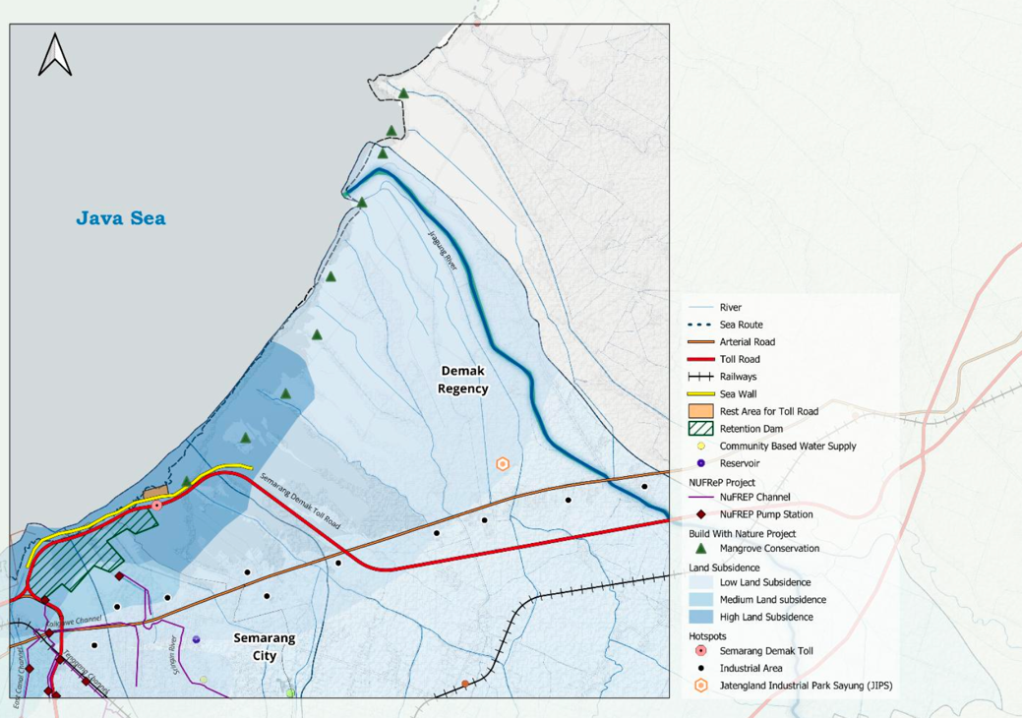

1B: Coastal Area – West
The western coastal area of Semarang, encompassing the Kendal region, is targeted by major national infrastructure projects including the Semarang–Kendal Harbour Toll and Sea Wall, and the Kendal Industrial Park. This area plays a strategic role in justifying the national Giant Sea Wall initiative. The development aims to enhance logistics and industrial accessibility while also addressing coastal vulnerabilities. In the National Medium-Term Development Plan (RPJMN), several infrastructure projects have been outlined for the area, including the proposed High-Speed Rail extension; however, detailed follow-up plans are yet to be finalized. The National Long-Term Development Plan (RPJPN) also highlights the importance of high-speed rail infrastructure, with the expectation that it will strengthen industrial connectivity to the Kendal region. These developments must be accompanied by significant measures to anticipate and mitigate potential environmental and social impacts resulting from large-scale construction activities.
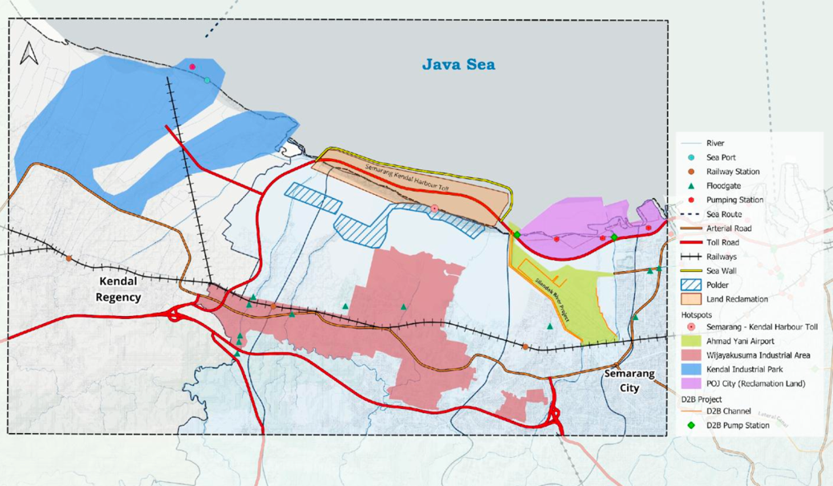

2: Downtown Area
The downtown area of Semarang is the city's core activity center and a critical focus for urban
development and flood resilience initiatives. This low-lying area is frequently impacted by urban flooding due to inadequate drainage systems, aging water infrastructure, and increasingly extreme weather events. As a strategically important location, numerous initiatives have been launched, mainly focusing on infrastructure improvements such as drainage upgrades. However, these efforts have yet to fully resolve the persistent issues of flooding and waterlogging. With high population density and dense commercial activity, the downtown area demands integrated and adaptive interventions to support both economic vitality and environmental resilience.
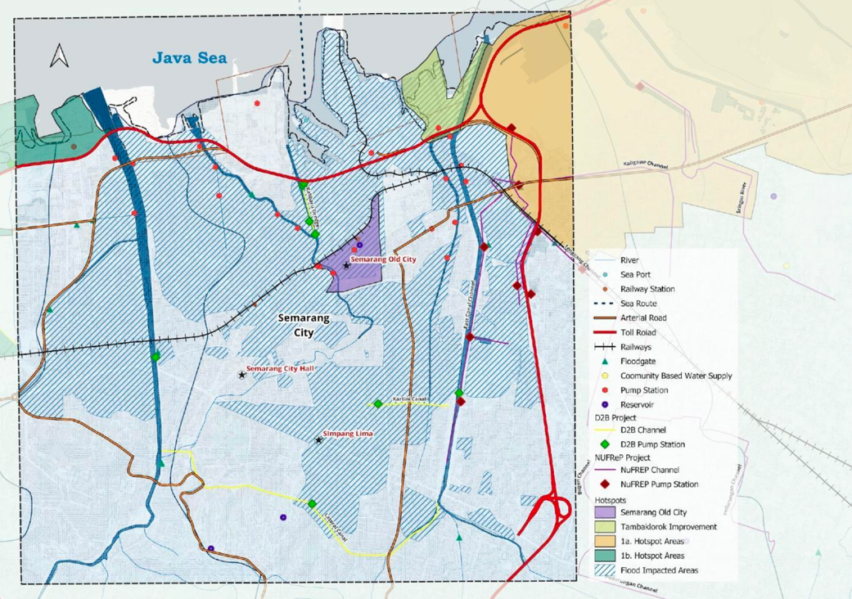

3A: Upstream Area in the Urban Fabric
The upstream area in the urban fabric of Semarang City plays a critical role in regional water conservation and houses key infrastructure. As a primary recharge and regulation zone, this area supports water security for the city by hosting important water sources such as upstream wells and spring water areas. It is essential for maintaining ecological balance, sustaining urban water supply systems, and managing flood risks. This area, which includes significant infrastructure like the Jatibarang Dam, West Semarang SPAM, and PDAM Water Treatment Plant (WTP), is crucial in safeguarding both the quantity and quality of water, addressing potential risks related to surface water sources. Additionally, the BSB area contributes to urban development by effectively managing its own waste and providing water supply through BSB dam, which is an important aspect for environmental sustainability in the area.
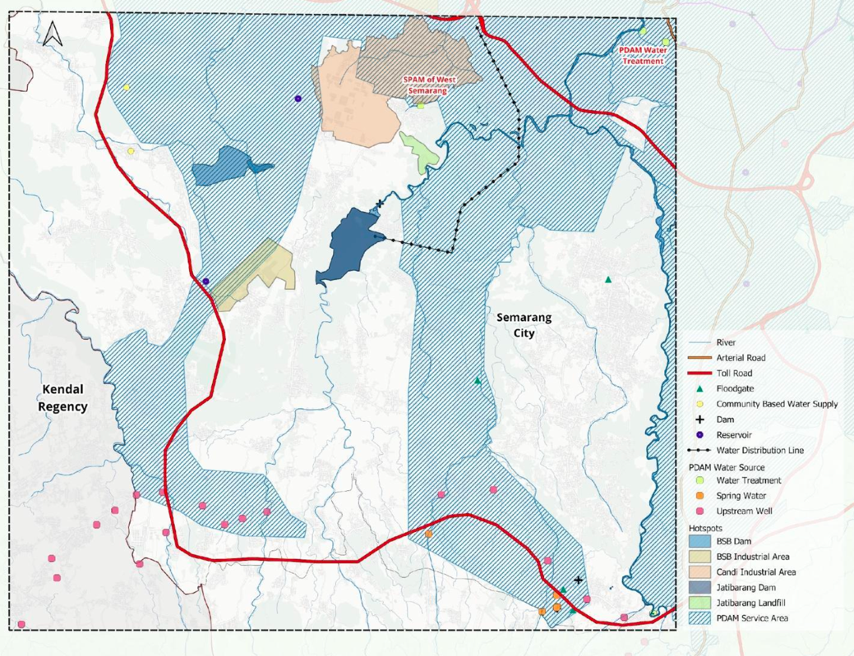

3B: Upstream Area with Rapid Growth
The upstream urban areas of Semarang, including Tinjomoyo, Banyumanik, and Gunungpati, form the hillycatchment zones that significantly influence downstream hydrological conditions. Rapid and unregulated urbanization in these areas has led to increasing conversion of green open spaces and natural drainage channels into impermeable surfaces such as roads, rooftops, and buildings. This transformation has drastically reduced the land’s natural infiltration capacity, accelerating surface runoff during rain events and intensifying flood risks in the lowland areas. Despite their critical function in the city’s hydrological balance, these upstream zones often receive less policy and planning attention, making them highly vulnerable to ecological degradation and informal settlement growth.
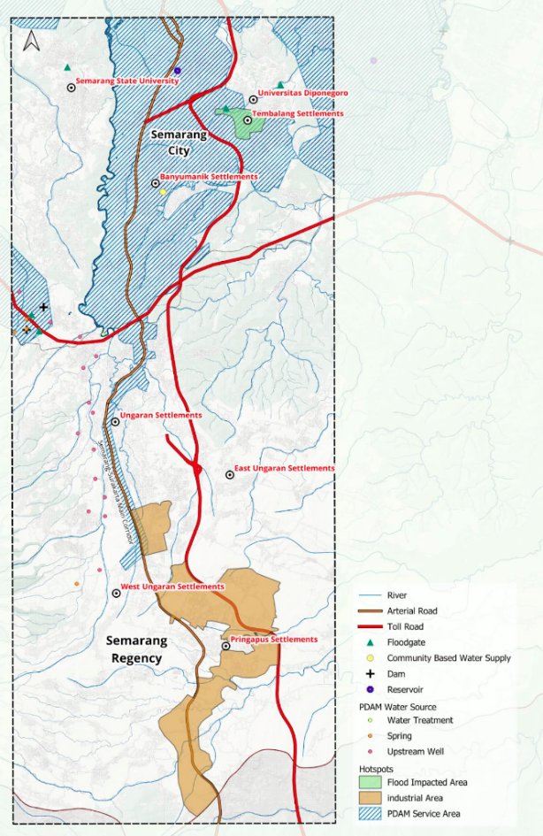

3C: Upstream Area with Green Open Space
This upstream region, spanning the Demak Regency and parts of Semarang Regency, is a vital catchment area providing clean water for downstream users in Semarang City and the Regency. Rich in natural vegetation and home to the Ungaran Mountain springs, the area contributes significantly to ecosystem services such as groundwater recharge, climate regulation, and biodiversity. However, increasing encroachment and infrastructure expansion threaten its ecological balance.
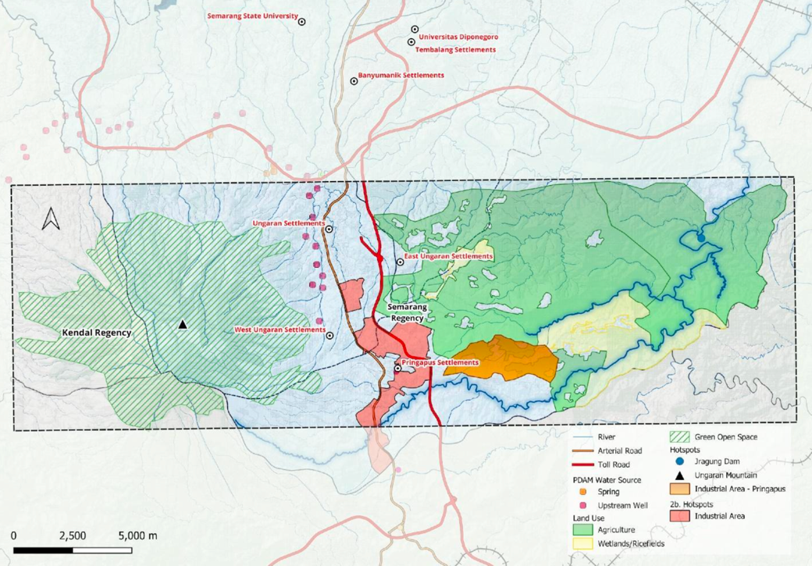

Water as Leverage (WaL) Semarang 1.0
From 2018-2020, the Water as Leverage for Resilient Cities Asia initiative, in which Semarang was a focus city, applied a holistic and inclusive design-led methodology. Though WaL Semarang generated strategic, integrated proposals, it lacked alignment with national development planning, investment frameworks and long-term financing. Its outcomes serve (and served) as crucial building blocks for Phase I and Phase II (described in this document).

