Market Consultation Questionnaire for a Visual Presentation System for simulation purposes
  - TenderNed TN 514510

Status page

Document data
Title
Reference number | PRJ3052 - TN 514510
Version date | 6-3-2025
Status | Definitief
Revision | 1.0

Management summary

Air Traffic Control The Netherlands (ATC-NL) seeks your valued advice in order to prepare a sourcing strategy for a visual presentation system that is suitable and matches the set requirements. For that purpose ATC-NL has launched a market consultation.

ATC-NL has installed a 360 degree tower simulator with a visual presentation part which is approaching its end of life. The tower simulator is a replica of an air traffic control tower with four working positions, as pictured below on the left. The current visual presentation system is depicted on the right and is a cylinder of 20 Plexiglas panels with a coating, on which 20 Barco F80 Q7 beamers project a continuous image. This image is generated by UFA simulation software, running on the Unigine gaming engine on one image generator per beamer with a GeForce RTX 3080 graphics card.

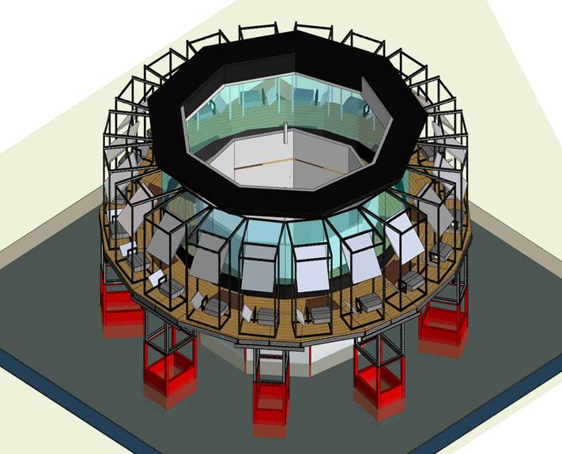
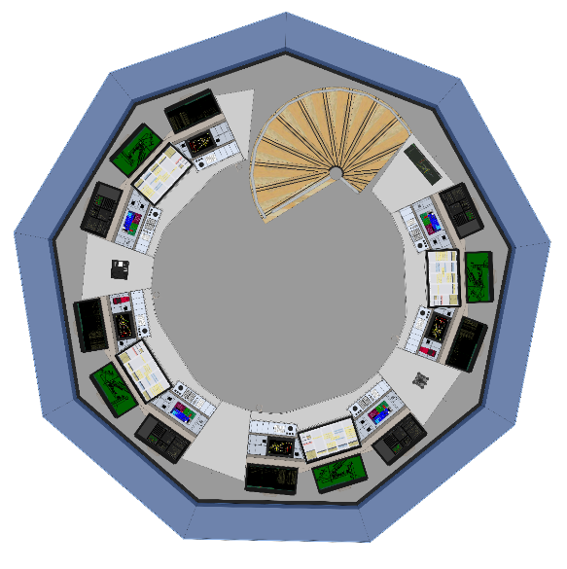
ATC-NL sees three possible scenarios:
- Keep the current visual presentation system, but update the beamers to beamers with better specifications;
- Change the visual presentation system to a solution using LCD screens;
- Change the visual presentation system to another solution ATC-NL has not considered but is advised by a third party knowledgeable on this subject.
Therefore, ATC-NL has specified functional and non-functional requirements in this document, which should provide enough input for a supplier to suggest the best solution.

Additionally ATC-NL has formulated some questions to get insight into the maintenance effort, costs and durability of possible solutions.

The simulator product itself is not part of this market consultation.

Table of content

1. Introduction 5
1.1 Purpose of the Market Consultation 5
1.2 Company information 5
1.3 Procedure for the Market Consultation 5
2. Required solution 7
2.1 Goal 7
2.2 Business specification (requirements) 7
2.3 The visual presentation system 7
3. Your proposed solution 15
3.1 Benefits of your proposed solution 15
3.2 Visual acuity 15
3.3 Image quality & correction capabilities 16
3.4 Maintainability 16
3.5 Performance and reliability 17
3.6 Monitoring and control 17
3.7 Screen connectivity 18
3.8 Safety and compliance 18
3.9 Risks 19
3.10 Reference installations 19
4. Lifetime support and maintenance 20
4.1 Maintenance strategy 20
4.2 Lifetime support services 20
4.3 Supporting services 20
4.4 Sustainability 21
5. Costs 22
5.1 Budgetary information 22
5.2 Cost effectiveness 22
5.3 Cost drivers 23
6. Demand strategy 24
6.1 Contractual arrangements 24
7. Your company 25
7.1 General information on your company: 25
8. Other questions 26
Appendix A: visual presentation factors 27

© 2025 Luchtverkeersleiding Nederland
No part of this publication may be reproduced and/or published in any form, by print, photo print, microfilm or any other means, without prior permission from Air Traffic Control the Netherlands.

Introduction

Purpose of the Market Consultation
Air Traffic Control The Netherlands (ATC-NL) seeks your valued advice in order to prepare a sourcing strategy for a visual presentation system that is suitable and matches the set requirements. For this purpose ATC-NL has published this market consultation on Tenders European Daily (TED).

ATC-NL has installed a tower simulator which broadly exists of a simulator part and a visual presentation part. In this tower simulator, UFA simulation software creates a realistic ‘outside view’ image that is presented to air traffic controllers during simulation exercises. The visual presentation system is approaching its end of life.

Therefore ATC-NL is looking into the possibilities for sourcing a visual presentation system for this tower simulator. This tower simulator is in a specific room which will be described further in this document.

For that purpose ATC-NL has prepared a Market Survey Questionnaire that is accessible through the TenderNed tenderplatform.

Suppliers are invited to use this (template) questionnaire document as provided to submit their answers to the questions.

Company information
AIR TRAFFIC CONTROL THE NETHERLANDS (ATC-NL) is a Dutch independent administrative organization that is responsible for providing air traffic services to civil air traffic in the Dutch airspace in a safe, efficient, and environmentally sensible way. In the Dutch Aviation Act this and all other tasks of ATC-NL have been laid down. Besides the provision of air traffic services these tasks consist of the provision of communication, navigation and surveillance services (including the modernization and management of these technical systems), giving aeronautical information, catering for air traffic control training and providing aviation charts and publications. In short, ATC-NL is responsible for the control of Dutch civil airspace as well as parts of the North Sea area and everything related thereto. ATC-NL became operational in 1923 and since 1993 as a so called "Independent Administrative Body (ZBO)".

For the purpose of air traffic control, Air Traffic Control the Netherlands (ATC-NL) relies on Communication, Navigation, Information, Surveillance and Air Traffic Control systems. These systems provide the "hands and eyes" for the air traffic controller and are therefore essential for the tasks of ATC-NL.

On the website www.lvnl.nl you can read and download all relevant information about ATC-NL.

Procedure for the Market Consultation

Publication of the market consultation
ATC-NL has published this Market Consultation Questionnaire through the TenderNed tender platform to the TED website of the European Communion with reference number TN 514510.

Communication & questions
You are kindly requested to submit all communication regarding this market consultation and its contents exclusively through the message center on the TenderNed tender platform.

Should there be any questions or comments, you may submit these questions or comments until the date and time stated in the planning through the Question and Answer module.

Additional terms and conditions
- The market consultation is not part of a tender procedure but a standalone survey;
- This market consultation is expressly not intended to make a pre-selection of candidates in the context of possible follow-up projects;
- Market parties who do not participate in this market consultation are not excluded from potential follow-up projects. Nor are parties who participate in this market consultation in any way excluded or privileged in any follow-up programs;
- Parties (including parties who are not participating) cannot derive any obligations or rights from this market consultation;
- Participation in this market consultation provides no right to obtain a delivery order;
- ATC-NL does not reimburse any costs for participating in this market consultation;
- Participating parties agree that information provided by them can be processed in ATC-NL documents;
- The language during this market consultation will be English;
- ATC-NL is in no way bound by the results of this market consultation or required to procure the subject of this market consultation;
- Claims on the use of information, confidentiality, or requests for reimbursement in connection herewith are not honoured;
- ATC-NL reserves the right to temporarily or permanently discontinue this market consultation;
- By participating in this market consultation, parties acknowledge accepting the terms as stated in this document unconditionally;
- ATC-NL will treat all received information as confidential. If it is decided to launch a European tender, the received information will then be used to uphold the principles of procurement law;
- Price Information provided to ATC-NL in the context of this market consultation will not be made public.

Required solution

Goal
The goal of this market research is to identify and evaluate current market offerings for replacing the visual presentation system for one of the tower simulators installed at ATC-NL. The aim is to find a solution that minimizes maintenance effort, and increases visual acuity.

Business specification (requirements)
The tower simulator is used for three main purposes:
- Reduce the time for on-the-job-training of new ground and tower controllers. For tower controllers the training will also include the visual circuit training with small aircraft;
- Train experienced controllers for the ever increasing traffic load on the airport, new procedures, emergency situations and special weather conditions;
- Train current controllers on new functionality of the operational tower systems.
The primary users of the tower simulator are:
- TO (Training Organisation):
  - TO/TF (Training Facilities)
  - TO/TA (Training Academy);
- R&D (Research and Development) and S&I (Systems and Integration) will use the system for research, integration, test and evaluation purposes;
- PRO (Procedures) will use the system for procedure development and test;
- Maintenance and control.
The tower simulator will be used for about 2.500-3.000 hours per year, based on:
- Year round training;
- 5,5 days per week;
- 2 trainings of approximately 5 hours per day.
ATC-NL wants to be able to perform in-house 2nd line support.

The visual presentation system
The tower simulator is a full 360 degree simulator and exists mainly of three components: the simulator (running on UFA software), working positions for the air traffic controllers/pseudo pilots and the visual presentation system. The current setup for the tower simulator in question can be simplified as follows:

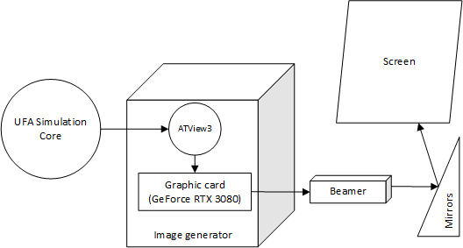
Figure 1: tower simulator image generation
In other tower simulators, ATC-NL makes use of LCD monitors.

The primary objective of this system is to provide the air traffic controller with a realistic ‘outside view’ in a simulated exercise environment. The scope of this consultation is only the projection system, the UFA simulation software and image generators themselves are not in scope.

Current situation (ist)
The current tower simulator is created around a mock-up of an air traffic control tower, in which four working positions are realised. This tower cabin rests on a technical room. The outside image is projected on a screen on the outside of the tower cabin by use of beamers and mirrors.
Figure 2: tower simulator physical setup
The current projection screen is a cylinder with a diameter of approximately 12 meters and a height of 4.6 meters, beginning about 1 meter from the ceiling. The ceiling of the projection room is neither strong nor stable enough to be used for projector mounting. The walls are not designed to support constructions, so all constructions shall be mounted on the floor.

The size of the room is 12 by 12 meters, with a height of about 7 meters. In the centre of the projection room is a tower cabinet, mounted on a technical room with a diameter of about 4 meters, and a height of about 3 meters. Access to the training cabinet is via a corridor under the projection screen, which LVNL prefers to maintain.
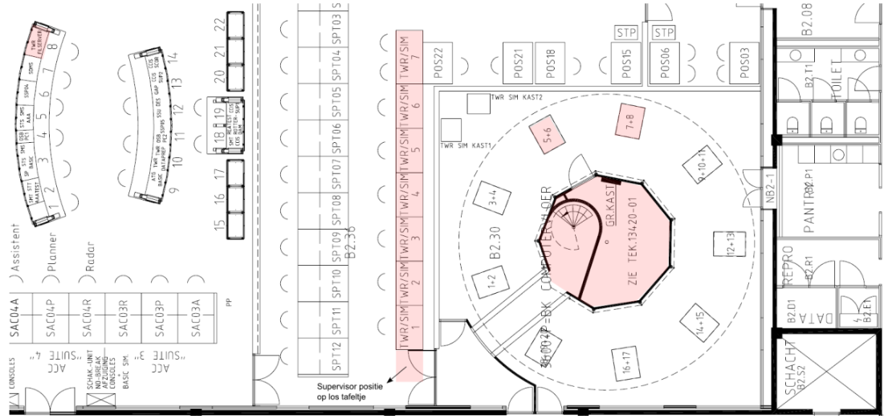
Figure 3: tower simulator room layout

Desired situation (soll)
This paragraph describes the requirements for the visual presentation system necessary for:
- trainees/controllers to perform air traffic control duties from a tower working position;
- trainees/controllers to receive on-the-job and recurrency training.
These requirements will be divided in functional and non-functional requirements:
- Functional user requirements, among which the following categories:
  - Observing the field: an ATC should be able to have an ‘as complete possible’ view of the airport, and be able to distinguish important landmarks;
  - Observing aircraft: an ATC should be able to identify the existence of aircraft from a specific range, within a specific range also be able to identify the type, within a specific range to identify the livery;
- Non-functional user requirements, among which:
  - Image quality: a trainee should not be distracted by edges in the screen, unsharp areas and other elements that are not present in real life;
  - Quality of life (QoL): a trainee should not be subject to excessive noise and heat;
  - System availability: the system needs to be used for a minimum amount of hours yearly.
Although the functional user requirements are also influenced by the simulation software and graphics card in use, these requirements give the necessary context for the visual presentation system and some of the requirements can be translated into technical specifications such as resolution and pixel pitch.

Functional requirements

VIS_func_obs_field 1
Field of view
The field of view has the following requirements:
- The visual presentation system shall display a 360 degrees outside view of the airport tower.
- The Vertical Field Of View of the trainee in the TWRsim cabinet shall be at least 45 degrees.
Remarks
In this picture, the vertical field of view is between 57 degrees (standing) and 65 degrees (sitting down). Note that these are modelled for ground positions on the outside of Schiphol Tower, the inner positions provide less vertical field of view.
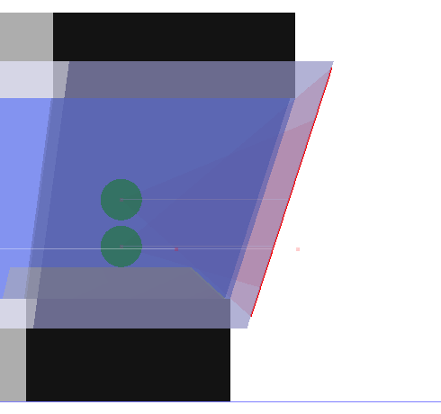
Rationale
In the current setup this VFOV is divided in 23 degrees below and 22 degrees above the horizon from the eye reference point. This point is at 1m30 from the from the design reference point at a height of 1m28 (a person sitting down at a controller working position).

VIS_func_obs_field2
Simulation realism
- The controller shall be able to observe the CTR as realistically as possible.
- The visual presentation system shall display a realistic image for all times of day, for all models, scenery and animation effects.
Remarks
The visual presentation system shall display a realistic image for all times of day, for all models, scenery and animation effects.
Rationale
Although the simulation software has the highest influence on the realism of the visual presentation, we believe that contrast and blackness levels influence the perceived realism.

VIS_func_obs_aircraft1
Aircraft observation
The following requirements allow a controller to properly observe aircraft in the simulation (for detailed explanation see the remarks):
- A controller shall be able to detect a C172 above point A in daylight circumstances.
- A controller shall be able to see the orientation (moving towards or away from the controller) of a C172 above point B/when turning into the circuit in daylight circumstances.
- A controller shall be able to recognize the aircraft type of a C172 (as opposed to an aircraft of another category) at the head of the runway in daylight circumstances.
- A controller shall be able to identify the livery on a C172 on the taxiway in daylight circumstances.
- A controller shall be able to detect a B737 at the edge of the CTR in daylight circumstances.
- A controller shall be able to see the orientation (moving towards or away from the controller) of a B737 at 6nm from the head of runway 18C in daylight circumstances.
- A controller shall be able to recognize the aircraft type of a B737 (as opposed to an aircraft of another category) at 2nm from the head of runway 18C in daylight circumstances.
- A controller shall be able to identify the livery on a B737 at the head of runway 18C in daylight circumstances.
- A controller shall be able to identify the livery on a B737 on the taxiway in night conditions.
Remarks
A controller needs to be able to detect, orient, recognize and identify aircraft and vehicles in relation to several reference locations at the aerodrome, its vicinity, and traffic circuit. To determine the requirements, For these requirements the definitions in Appendix A are used and table below this requirements has been determined for two types of aircraft (VFR and medium). Please note that the actual visibility of these aircraft are determined by both the image generation and not only the visual presentation system. Nevertheless, the (non-)functional technical requirements for the visual presentation system have to take these requirements into account.

For recognition, LVNL discerns four categories:
- Category 1; small single-engine propeller-driven aircraft (e.g. C172) and helicopters
- Category 2 (VFR); small twin-engine propeller-driven aircraft (e.g. Cessna Citation)
- Category 3 (medium); e.g. Boeing 737
- Category 4 (heavy and larger); e.g. Airbus 338
Rationale
The size and relative distance determine technical specifications of the solution like resolution and pixel pitch.

Aircraft type | Reference point | Distance from TWC in km | Distance from TWC in nm | Detec-tion | Orien-tation | Recog-nition | Identi-fication
C172  (2.25m) | Point A | 9,2 | 5 | X
C172  (2.25m) | Point B/ circuit | 5 | 3 | X | X
C172  (2.25m) | 1 nm final of RWY 04 | 4,3 | 2,6 | X | X | X
C172  (2.25m) | Head of RWY 04 | 2,8 | 1,5 | X | X | X | X
C172  (2.25m) | Taxiway | 2 | 1,1 | X | X | X | X
B737  (7m) | Edge of CTR | 15 | 8,1 | X
B737  (7m) | ILS 6 nm at RWY 18C | 14 | 7,5 | X | X
B737  (7m) | ILS 2 nm at RWY 18C | 6,5 | 3,5 | X | X | X
B737  (7m) | 1 nm final of RWY 18C | 4,6 | 2,9 | X | X | X | X
B737  (7m) | Head of RWY 18C | 3 | 1,6 | X | X | X | X
B737  (7m) | Taxiway A/B | 1,4 | 0,8 | X | X | X | X
Table 1: inbound flights reference point performance criteria (X: yes, /: partly)

Non-functional requirements
VIS_image_quality1
Uniformity and smoothness of the visual presentation
- The picture shall be uniform with no interruption, and no visible colour or intensity differences. Tenderer shall specify the maximum colour and intensity differences between all projection units.
- The movement of all models shall be smooth, with no jumping. Also the view from a model shall be smooth with no jumps.
- The visual presentation shall give a non-flickering impression to the human eye.
- The visual presentation shall avoid any unwanted, unnecessary discontinuities or non-uniformities in terms of presented scale, orientation and field of view of the area under observation by the controllerThe position of the trainee shall have little influence on the correctness of the presented picture.
Remarks
Rationale
Non smooth movements, non-uniformities and other distractions make the simulation less credible. Also, trainees are sometimes working standing up, sometimes sitting down.

VIS_image_quality2
Picture alignment
The alignment and linearity of the visual system shall be better then 1 mm.
Remarks
Rationale
A misalignment in alignment or linearity can be perceived in the simulated image as a big bump or hole in a runway.

VIS_image_quality3
Edges between projected images
Edges between projected images should be minimized.
Remarks
A bezel of 15mm like in other tower simulators is acceptable with certain setups
Rationale
Edges between images can lead to distractions or aircraft being ‘hidden’ behind bezels when monitors are used. It is possible to rotate the camera to make sure that most of the approach lines are not behind a bezel.

VIS_quality_of_life1
Viewing distance
The projected image shall be at least 2.5 meters away from the trainee sitting position
Remarks
Rationale
Most visual presentation systems have an optimal viewing distance.

VIS_quality_of_life2
Noise
The overall noise level for all systems which will be installed in the same room as the users, shall not exceed 48 dB(A).
Remarks
Rationale

VIS_quality_of_life3
Heat dissipation specification
The heat dissipation of all offered equipment shall be specified by the tenderer as part of the documentation package used for contract awarding
Remarks
Rationale
ATC-NL will need to know how much cooling is necessary.

VIS_availability1
System startup time
The visual presentation system startup time shall be at most five minutes.
Remarks
Rationale
The training startup time when the system is shut down completely is at most 15 minutes.

VIS_availability2
Repair time
The maximum repair time of the visual presentation system shall be at most 1 day – until the next training when there is an active course.
Remarks
Rationale

VIS_availability3
Repair time
The visual system unavailability shall be no more than 4 times per year, not including defective component replacement.
Remarks
Rationale

Your proposed solution

Benefits of your proposed solution
3.1.1: What would be your proposed solution to the Required Solution (Chapter 2) and how would it benefit the goals and requirements?

Answer 3.1.1:

3.1.2: Please fill out the following table regarding the requirements mentioned in chapter 2.3.2 and indicate for each requirement whether for the proposed solution fulfilment is the default, requires development efforts, or is impossible to realize. Please provide for each outcome a short explanation under the remarks why this is the case. More detail can be provided in further questions.

Answer 3.1.2:
Requirement | Default / Development / Impossible/ Not applicable | Remarks
VIS_func_obs_field 1
VIS_func_obs_field 2
VIS_func_obs_aircraft1
VIS_image_quality1
VIS_image_quality2
VIS_image_quality3
VIS_quality_of_life1
VIS_quality_of_life2
VIS_quality_of_life3
VIS_availability1
VIS_availability2
VIS_availability3

Visual acuity
3.2: How does your solution ensure high visual acuity? Please provide supporting specifications. For example:
- What is the color accuracy/quality (dE) of your solution?
- How does your solution ensure light accuracy?
- What is the pixel pitch of your display technology?
- What is the contrast ratio of your solution?
- How does your solution ensure sharpness in display output?

Where possible, please provide relevant measurement data.
Answer 3.2:

Image quality & correction capabilities
3.3: When applicable, please provide information on how the proposed solution ensures image quality, for example:
- How does your system prevent geometry errors, and does it provide a correction feature?
- How does your system prevent differences in light output, and does it provide a correction feature?
- How does your system prevent colour variations, and does it provide a correction feature?
- How does your system prevent imperfect blending, and does it provide a correction feature?

Answer 3.3:

Maintainability
3.4.1: ATC-NL wants to be able to perform in-house 2nd line support. How does your solution enable this? Please provide information on the following:
- How does your solution ensure component replaceability? Provide details on the process.
- What kind of training or documentation is provided?
- Can components be installed or replaced without requiring supplier assistance? Provide a short description of the process.

Answer 3.4.1:

3.4.2: How does your solution ensure in-house 2nd line configuration/calibration, for example:
- If using beamers, does your solution support color calibration and warping? Please describe.
- If using screens, does your solution support color calibration? Please describe.
- How can color, lighting, and other display properties be measured and calibrated in your system?

Answer 3.4.2:

Performance and reliability
3.5.1: ATC-NL has described some performance and reliability requirements, please provide more details on your proposed solution, for example by answering the following questions:
- What is the startup time of your system? Can it meet the maximum requirement of 2 minutes?
- Can your solution run continuously for 12 hours without issues? Provide reliability data.

Answer 3.5.1:

3.5.2: ATC-NL has defined a required expected lifetime for this type of hardware/solution at five years. What is the expected lifetime of the solution? Can it meet the 5-year requirement?

Answer 3.5.2:

Monitoring and control
3.6: Please provide information on how your proposed solution is able to be monitored and controlled. ATC-NL prefers SNMP v3 or higher over ethernet.

Answer 3.6:

Screen connectivity
3.7: If screens are used, ATC-NL prefers Displayport. Please provide for you solution a description of the following:
- Does your solution support DisplayPort as a preferred connection over HDMI?
- If 4K resolution is used, does your solution support at least DisplayPort 1.2?
- Does your solution provide lockable DisplayPort connections with a full connector?

Answer 3.7:

Safety and compliance
3.8.1: ATC-NL wants more information on the safety of your proposed solution:
- Does your system comply with EN 55032 Class B safety requirements? Provide certifications.
- Can the system be grounded according to best practices? Provide compliance details.
- Does your solution comply with hazard warning requirements? Provide relevant safety data.
- What are the noise and heat levels of the system? Provide operational data.

Answer 3.8.1:

3.8.2: To which other standards does your proposed product(s) comply? (e.g. EC directives, Interoperability, Safety Assurance, ESARR6, Declaration of suitability of use etc.)

Answer 3.8.2:

Risks
3.9: Which specific risks, and ways to minimize these risks, do you foresee for ATC-NL, deriving from the proposed way to source and use the solution as described in chapter 2?

Answer 3.9:

Reference installations
3.10: Have you delivered similar solutions to meet similar requirements as described in Chapter 2, not only for air navigation service providers, but also in other industries where a visual presentation system is used in similar use cases. If so, could you provide details of that solution and possibly the names of the organizations to whom you delivered such a solution?

Answer 3.10:

Lifetime support and maintenance

Maintenance strategy
4.1: What, in your opinion, would be an appropriate maintenance support strategy for the solution?

Answer 4.1:

Lifetime support services
4.2: Lifetime support would mean that the supplier has the functional responsibility to make sure that the delivered system can at all times be supported by supplier’s support organization. Please elaborate on how you would propose to render services and keep the offered product available for more extended periods of time?

Answer 4.2:

Supporting services
4.3: Which supporting service(s) do the product(s) you propose require? (i.e. what needs to be provided in addition to the units themselves?)

Answer 4.3:

Sustainability
LVNL values sustainable solutions that contribute to our corporate sustainability goals. You can read about these goals on the LVNL website https://en.lvnl.nl/organisation/sustainable-services and in Dutch https://www.lvnl.nl/kenniscentrum/duurzaamheid.

4.4: Please describe your organizations effort concerning the sustainability aspects for Climate, Circularity and Health & Social? Please also elaborate on any certifications concerning sustainability that your organization has obtained?

Answer 4.4:

Costs

Budgetary information
5.1.1: Please base your budgetary information on the required solution in as described in Chapter 2.
Please provide a rough order of magnitude (ROM) regarding the cost items of your proposed solution. The table leaves room for additional items that you find relevant.

# | Cost item (Assume N = 20) | Rough order of magnitude (ROM) excluding VAT for a single cost item  [ € ]
1 | e.g. projector | €
2 | e.g. matte screen | €
3 | e.g. cables | €
4 | e.g. installation cost | €
5 | e.g. testing and acceptance | €
6 | … | €

5.1.2: What further budgetary information is relevant regarding using the units, for instance (maintenance) support and other services? Please list these services and the respective costs when applicable.

Answer 5.1.2:

Cost drivers
5.2 : Please indicate for the requirements in chapter 2.3.2 for each of them to what extent a requirement attributes to the total cost for a unit (projector, screen or otherwise):

Requirement | Level of significance as a cost driver?  [None/low/medium/high] | Remarks
VIS_func_obs_field 1
VIS_func_obs_field 2
VIS_func_obs_aircraft1
VIS_image_quality1
VIS_image_quality2
VIS_image_quality3
VIS_quality_of_life1
VIS_quality_of_life2
VIS_quality_of_life3
VIS_availability1
VIS_availability2
VIS_availability3

Demand strategy

Contractual arrangements
6.1 : Using your experience in contractual relations and using the goals set out in the Required Solution (Chapter 2), what would your observations/recommendations be on the following:

- Form of contract;
- Duration of the contract;
- Exit strategy upon ending the contract & migration to a new contract with a new contract party (or parties);
- The contract governance needed on the contract(s) you propose;
- Performance-based contracting or contracting of services and products.

Please include relevant examples of contractual relations you are in (or have been in) that underline your answers.

Answer 6.1:

Your company

General information on your company:
# | Item | Answer
a. | Company name
b. | Postal address
c. | Contact person
d. | Position of contact person
e. | Email address
f. | Number of offices (except head office)
g. | Number of employees
h. | Number of employees in relation to services as described
i. | Company turnover for the last three years
j. | Is your company part of a larger (parent) company? | o Yes, namely […]  o No
k. | Number of employees of parent company

Other questions
8.1: Would you like to add anything relevant that we may have forgotten to ask? If so, please elaborate.

Answer 8.1:

Appendix A: visual presentation factors
The purpose of the visual presentation is to create a realistic view out of a virtual control tower on a busy airport. Together with all other equipment it will be used to create an as realistic as possible training environment for both trainees as well as experienced controllers.

The visual presentation should provide an ‘outside view’ which will enable the controllers to maintain continuous watch on all flight operations at and in the vicinity of the aerodrome as well as on vehicles and personnel on the manoeuvring area.

The quality of the visual presentation can be defined as the combination of the image quality factors and image similarity to human eye vision. However, there is no general consensus about the objectives to be met by tower simulator systems. Therefore this document will first describe how these are interpreted by LVNL. From there, more concrete requirements will be described.

Image quality factors

Image quality factors (e.g. sharpness, contrast) are driving the granularity and fidelity in which the reality rendered by the simulator is presented in the visual presentation.

These parameters may be defined as performance objectives indicating the controller’s capability to perform specific actions (e.g. detection, recognition) of targets (e.g. aircraft, vehicles, personnel) on certain parts of the aerodrome (e.g. distance or specific points).

These specific capabilities include:
- identification of several reference locations at the aerodrome, its vicinity, and traffic circuit;
- definition of the expected action(s) from the controller on each of those points (e.g. detection/tracking of a vehicle, recognition of an aircraft);
- establishment of the performance requirements for the visual presentation (image quality) taking into account each of the expected action(s).
Because in real-life situations the (e.g. visibility) conditions vary, this analysis takes ‘clear skies’ as a starting point for the visual representation. The simulator software itself will be responsible for creating other conditions and the necessary visual adjustments.

Johnson criteria

One basis to derive image quality parameters are the Johnson Criteria. Based on the size and distance of the object and the required level, the Johnson Criteria lead to the required image resolution. The following picture illustrates a part of this analysis:
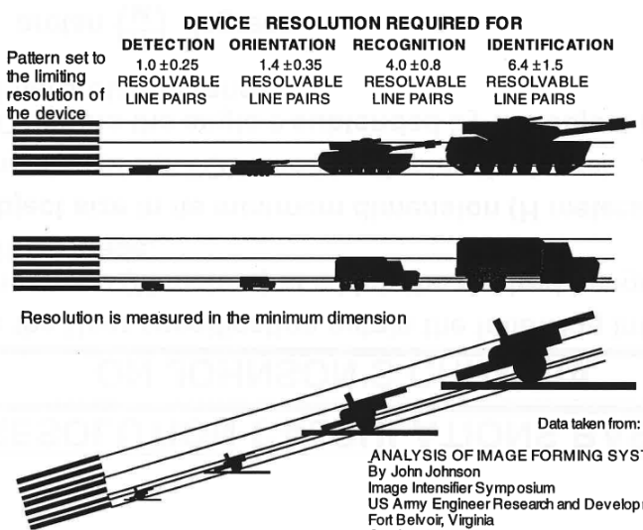
Figure 4: example of Johnson criteria analysis
The performance evaluation criteria for the LVNL tower simulator is expressed in five levels:

Level | Short name | LVNL interpretation
No detection | - | A controller cannot distinguish an aircraft from its background
Detection | Detection | A controller can distinguish an aircraft from its background
Shape orientation | Orientation | A controller can determine if an aircraft is moving towards or away from the tower
Shape recognition | Recognition | A controller can determine the difference between different aircraft classes (e.g. medium/heavy)
Detail recognition | Identification | A controller can determine the type and livery of an aircraft
Table 1: performance evaluation levels tower simulator

Image similarity to human eye vision

The similarity of the presented image to the human eye vision is another factor. Irregularities or other disruptive effects which may lead to human performance issues (e.g. fatigue) may influence the situational awareness of the controller. In this sense, the visual presentation system should include (as applicable, depending on the selected technical solution) the means to:
- provide in the visual presentation a non-flickering impression to the human eye;
- provide a visual presentation with smooth and regular impression of moving objects to the human eye;
- avoid any unwanted, unnecessary discontinuities or non-uniformities in terms of presented scale, orientation and field of view of the area under observation by the controller.

Air Traffic Control the Netherlands

Stationsplein Zuid-West 1001
1117 CV Schiphol

PO Box 75200
1117 ZT Schiphol
The Netherlands

T +31 (0)20 406 2000

www.lvnl.nl

