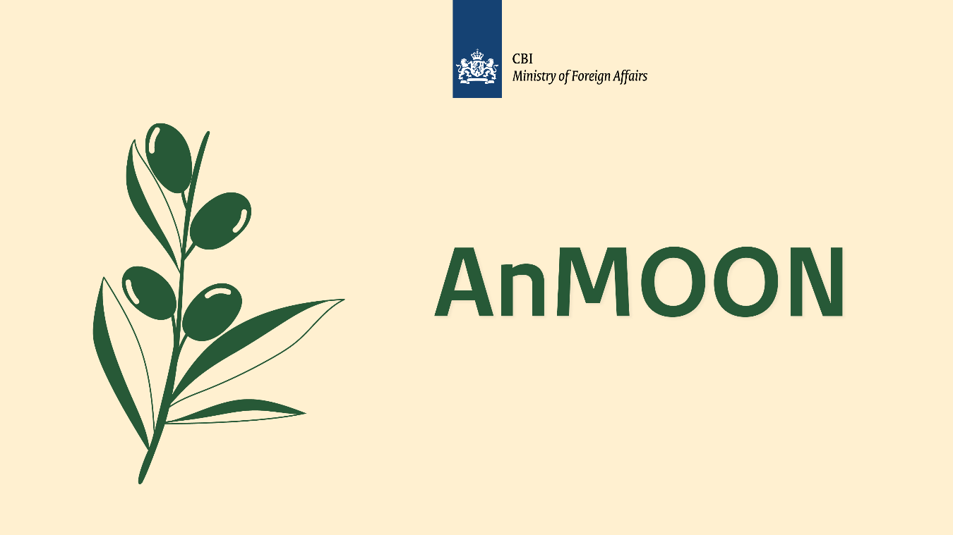

Market orientation regarding the project
“Morocco Olive oil and youth (AnMOON)”
Reference number: 202412027
Date: 23 January 2025

Market orientation regarding the project “Morocco Olive oil and youth (AnMOON)”
Reference number: 202412027

Organisation: The Netherlands Enterprise Agency
The Netherlands Enterprise Agency (in Dutch: Rijksdienst voor Ondernemend Nederland, hereinafter RVO) supports entrepreneurs, NGOs, policymakers, knowledge institutes, and organisations, in order to contribute to three societal transitions: (1) climate-energy transition, (2) sustainable agriculture and food system, and (3) future proof and digital economy. RVO aims to improve collaborations and strengthen positions through funding and networks and help realize national and international ambitions with financing, networks, expertise and compliance with laws and regulations.

RVO is a government agency that operates under the responsibility of the Ministry of Economic Affairs. Our activities are carried out on behalf of various Dutch ministries and the European Union.

More information on RVO can be found on the website Netherlands Enterprise Agency (www.rvo.nl).

Project initiator
The initiator of this project is the Centre for the Promotion of Imports from Developing Countries (CBI). CBI is part of RVO. More information about CBI can be found on www.cbi.eu.

Project “Morocco Olive oil and youth (AnMOON)”
Morocco’s olive oil sector offers great potential for economic growth and job creation. Olive oil is an important food product in Morocco. The global market is increasingly demanding high-quality extra virgin olive oil. The aim of the AnMOON project is to transform Morocco's olive oil sector into a more resilient and sustainable one, that offers employment and entrepreneurship opportunities for young women and men.

AnMOON

With this project we want to contribute to making the Moroccan Olive Oil sector ready for the Next generation (MOON). The name “AnMOON” is derived from the Amazigh language, symbolizing “Togetherness”. It reflects the collective commitment of CBI and various stakeholders to achieve common objectives, including promoting sustainable practices, fostering youth employment inclusion, and driving positive change within the olive oil value chain in the Fez-Meknes region.

To facilitate and support the "future proofing" of the olive oil sector in the Meknes-Fes region of Morocco, RVO intends to procure expertise.

For the intended procurement of expertise, a distinction has been made between three types of experts needed:

- Lot 1. (youth) entrepreneurship expert
- Lot 2. Olive oil sector expert with knowledge on exports and sustainable production in Morocco
- Lot 3. Education and employment expert agri sector Morocco
More information about the project and the required expertise per lot can be found in Annex 1. Assignment overview. For your convenience, the assignment overview is also available in French in Annex 2. In case of any discrepancies between the English version in Annex 1 and the French version in Annex 2, the English version in Annex 1 shall prevail.

Project duration and budget indication
RVO intends to conclude a framework agreement for a maximum term of four (4) years with each expert. The intended start date of the framework agreement is July 1, 2025.
The budget indication per lot is stated below:

- Lot 1. (youth) entrepreneurship expert
The maximum budget for lot 1 for a period of four (4) years is € 250,000 excluding Dutch VAT and (if applicable) including local foreign VAT, and all other costs and/or fees.
- Lot 2. Olive oil sector expert with knowledge on exports and sustainable production in Morocco
The maximum budget for lot 2 for a period of four (4) years is € 250,000 excluding Dutch VAT and (if applicable) including local foreign VAT, and all other costs and/or fees.
- Lot 3. Education and employment expert agri sector Morocco
The maximum budget for lot 3 for a period of four (4) years is € 200,000 excluding Dutch VAT and (if applicable) including local foreign VAT, and all other costs and/or fees.
Purpose of the market orientation
With this market orientation, RVO wants to collect information which will help with specifying a likely upcoming European tender regarding the project “Morocco Olive oil and youth (AnMOON)”.

The objectives of this market orientation are:
- To gauge the overall interest for the proposed tender;
- To explore the field of interested parties and their expertise and experience with the project region of interest and the topic;
- Harvesting insights to further finetune the proposed tender content and process, to increase the quality of responses for the possible upcoming European tender.
Questions
Substantive questions regarding the market orientation, the assignment overviews, and the draft data processing agreement can be submitted in English via email to jessica.scheffers@rvo.nl. The deadline for submitting questions is January 31, 2025. All questions, along with their corresponding answers, will be anonymized and collected in a memorandum of information. The memorandum of information will be published on TenderNed by the end of the day on February 5, 2025.

Application
Interested experts/companies are invited to submit an expression of interest by completing the questionnaire below in English and sending the completed form to RVO via email at jessica.scheffers@rvo.nl of the Procurement Office. The deadline for responding to this market orientation is February 11, 2025 (12:00 CET). Please note: This market orientation is not a request for proposal, it is not allowed to send a proposal.

As a result of the market orientation, RVO may decide to initiate a tender. In the case of a tender, it will be announced on www.tenderned.nl, and no distinction will be made between parties that participated in the market orientation and those that did not.

Name expert / company
Address
Website
Name contact person + e-mail address
In which lot are you interested? | Lot 1. (youth) entrepreneurship expert: Yes / No  Lot 2. Olive oil sector expert with knowledge on exports and sustainable production in Morocco: Yes / No  Lot 3. Education and employment expert agri sector Morocco: Yes / No
Do you expect to carry out the work for the lot you are interested in as one or as a team of experts?" | Lot 1. (youth) entrepreneurship expert: One expert / Team of Experts  Lot 2. Olive oil sector expert with knowledge on exports and sustainable production in Morocco: One expert / Team of Experts  Lot 3. Education and employment expert agri sector Morocco: One expert / Team of Experts
You are requested to give a brief explanation of your interest in this assignment, your relevant experience with similar work, and any experience you have in the Meknes-Fes region of Morocco.
Could you indicate whether you a) are based in the Meknes-Fes region, b) are based in Morocco, or c) are based elsewhere? If you are not based in the Meknes-Fes region, are you willing to travel to this region?
Do you have experience with European tender submissions, and are you familiar with using the platform www.tenderned.nl for submitting proposals?
Do you feel you would benefit from a coach to help you navigate TenderNed?
If a tender is initiated, the data processing agreement (DPA) in Annex 3 will become part of the contracts to be concluded for lots 1, 2, and 3. Could you indicate whether you can comply with the provisions set out in the draft DPA? If not, please specify which provisions you are unable to comply with.

