CALL FOR A REQUEST TO PARTICIPATE
IN A EUROPEAN TENDER FOR AN INNOVATION PARTNERSHIP
ISSUED BY THE NATIONAL ROAD TRAFFIC DATA PORTAL (NDW)
ON BEHALF OF THE MINISTRY OF INFRASTRUCTURE AND WATERMANAGEMENT
FOR THE DEVELOPMENT AND DELIVERY OF SERVICES IN THE NETHERLANDS
AIMED AT THE BENEFICIAL USAGE OF EXISTING VEHICLE DATA
FOR COMPREHENSIVE AND CONSISTENT ROAD NETWORK MONITORING

THIS TC VERSION DATED OCTOBER 10, 2024 HAS BEEN MADE AVAILABLE TO CANDIDATES TO QUICKLY SCAN THE AMENDMENTS ON THE RTP OF OCTOBER 2, 2024 AND IS FOR CONVENIENCE ONLY

Date: September 27, 2024 (modified on October 3, 2024 to correct minor errors and amended on October 10, 2024)
TenderNed-id: TN-488577

CONTENT

1. Prologue 3
2. To be realizes use cases in this innovation partnership 4
3. Anticipated scope of the diverse assignments 5
4. A substantial number of candidates is expected to submit a Request to Participate (phase 1) 6
5. The pre-selection process in more detail (phase 2) 7
5.1 The pre-selection process of class 1 (vehicle manufacturers or tier 1 suppliers) in phase 2 7
5.2 The pre-selection process of class 2 (aggregators) in phase 2 8
5.3 The pre-selection process of class 3 (service providers) in phase 2 8
6. The planning of the pre-selection process (phase 2) 12
7. The final selection process in more detail (phase 3) 12
8. Requirements on the Request(s) to Participate 14
9. Applicable rules of conduct 14

Prologue
Modern cars produce, collect, and share increasing amounts of data. The growing amount of vehicles offers significant possibilities in the areas of traffic management, traffic information and incident management, with positive effects on traffic flow, safety, and emissions from car traffic.

Road Monitor 2 (hereinafter: “ROMO-2”) involves utilizing sensors that are standard in modern day vehicles, which may provide new insights for road operators that participate in NDW. NDW is the purchasing body on behalf of the Dutch Ministry of Infrastructure and Water Management for this tender. NDW is a partnership directed towards the collection, distribution and application of data for solutions in mobility and public space. More information on NDW is available at: https://english.ndw.nu/about-us/governance.

ROMO-2 is initiated to encourage the majority of road operators in the Netherlands to use vehicle data to advance and enhance their daily operational processes by applying the granularity (quality of being composed of many individual pieces or elements) and volume that connected vehicles can deliver as of today and even more in the near future.

The purpose of this innovation partnership is to enable the transformation of vehicle-generated data into use cases that directly support our road operators. This includes (1) data holders, (2) aggregators who are prepared to license their data for such applications, as well as (3) service providers who can develop and deliver the use cases listed below.

These three (3) classes of candidates are needed to realize the innovation partnership needed in ROMO-2. They are however, dissimilar when it comes to their role and added value in this innovation partnership.

As a consequence thereof, the selection process of candidates (and applicable suitability requirements) between classes 1 and 2 and class 3 is slightly differentiated. The (high-level) figure on the procurement process below shows the disparity in phase 1 in this tender process.

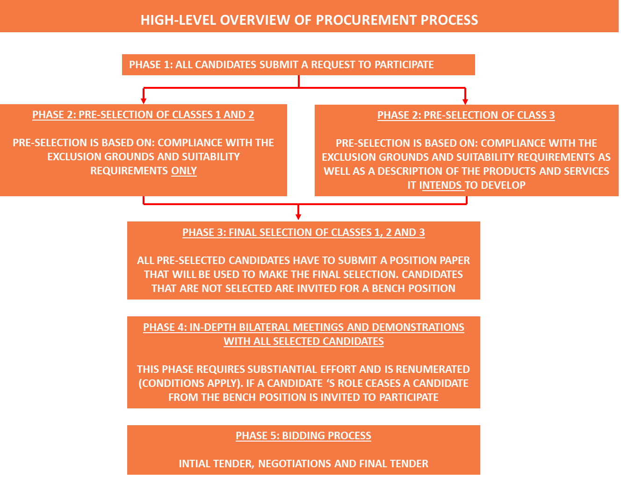

To be realized use cases in this innovation partnership

The twelve (12) use cases in this tender (ROMO-2 has a broader scope) are listed below. The current description of these use cases is at a high-level. The accurate scoping of these use cases as well as the requirements on development and fulfillment will be done during in-depth conversations with selected candidates. The outcome of this tender could well be that a candidate is awarded a contract for developing and delivering several use cases. For instance, candidate A is selected to develop and deliver use cases 1.4 and 2.1 and 3.2, candidate B is selected to also develop and deliver use cases 1.4 and 2.1 but also 3.1. while candidate C is selected to develop use cases 1.4 and (also) 3.1.

This tender is to realize an innovation partnership; hence candidates are invited from the start until phase 5 to suggest alternatives and variants to realize the ambitions of ROMO-2.

Candidates should realize that NDW (representing over 300+ road operators) is also in the possession of numerous other data sources that, combined with the new data from classes 1, 2 and 3 could be very useful to develop and deliver new products and services.

The use cases currently envisioned in this tender are:
- Uses cases for asset management
The use cases for asset management encompasses development of new products and services and subsequent delivery thereof on (1) the acquisition, (2) processing and (3) delivery of the data on:

1.1 disintegration of an asphalt road surface;
1.2 longitudinal unevenness (IRI100);
1.3 height difference longitudinal direction II;
1.4 road markings for asset management;
1.5 fuel consumption/energy consumption related to the road surface/conditions.
2. Use cases on actual weather conditions
The use cases on actual weather conditions encompasses development of new products and services and subsequent delivery thereof on (1) the acquisition, (2) processing and (3) delivery of the data on:

2.1 road friction information;
2.2 road temperatures;
2.3 air temperatures and other weather conditions (rain, snow);
  - decline in visibility of existing road markings.

- Use cases for safety
The use cases for safety encompasses development of new products and services and subsequent delivery thereof on (1) the acquisition, (2) processing and (3) delivery of the data on:

3.1 safety hotspots;
3.2 road markings for safety purposes;
3.3 accidents and stationary vehicles.

Please note that traffic sign detection is not included as one of the use cases in this tendering procedure, as it will be subject to a separate (ROMO-2) tender to be issued by NDW.

Anticipated scope of the diverse assignments

The assignments (alike the different classes of candidates) might be diverse as well. For instance:

- a class 1 candidate (data holder) might decide to only offer data. But is also entitled to submit a tender for a use case or act as an aggregator;
- a class 2 candidate (aggregator) might decide to only aggregate data. But is also entitled to submit a tender for a use case.

It is for this reason that this tender for an innovation partnership is necessary: to have in-depth discussions with selected candidates and to be able to jointly design the actual scope of the various assignments. In line with the ambitions of ROMO-2, with respect to the business cases of other selected candidates, and to ensure that to be developed products and services have a substantial impact on the roads in the Netherlands.

A substantial number of candidates is expected to submit a Request to Participate (phase 1)

Based on our insight we expect that numerous candidates (classes 1, 2 and 3) are prepared to participate in this tender for an innovation partnership. Presenting the challenge how do we:

- select the right candidates within each class (1, 2 and 3), as well as;
- the combination of selected candidates;

to create a strong and blooming innovation partnership that endures after the initial funding by the Ministry of Infrastructure and Watermanagement ceases.

The candidates that can meet the suitability requirements are also diverse. For instance:

- large international active candidates versus much smaller candidates that only operate on a national level;
- candidates that can (1) deliver data, (2) act as well as an aggregator and (3) are also able and willing to develop and deliver one or more use cases versus candidates limited to one (1) or two (2) classes;
- candidates that have their own research and development infrastructure (technical, staff, otherwise) and corporations that need to subcontract the development infrastructure or need to organize a combination with other corporations to develop and deliver one, more or all use cases.

In order to solve this puzzle, the selection process of candidates for this tender has been structured in the following three (3) phases:

Phase one (1): Request to Participate
Phase one (1) is equal towards all interested candidates. The same exclusion grounds (listed below) apply to all candidates that submit a Request to Participate.

Phase two (2): Pre-selection of candidates
Phase two (2) differentiates between classes 1 and 2 versus class 3. The suitability requirements are different as well as the effort(s) to demonstrate that the suitability requirements are met.

The outcome of phase 2 (pre-selection of candidates) is presented below. Every candidate in class 3 that does fulfill the suitability requirements but is not pre-selected is invited to take a bench position.

Phase three (3): Final selection of candidates
Phase three (3) is equal to all interested candidates. They all have to provide a so-called position paper.

The number of candidates that can pass the final selection phase is listed below:

Interested candidates need to realize that although the a total of 64 candidates might appear as a large number of competitors, it might very well be that one or more competitors are selected for classes 1, 2 and 3, or classes 2 and 3 or classes 1 and 3.

It is anticipated that during the tender process the number of candidates will be further reduced. For instance: their proposals do not fit or a candidate withdraws from participating in this tender. In which case a candidate that was selected during the final selection but positioned on the bench is invited to participate in phase 4 (depends on when such a candidate withdraws or is unsolicited by NDW). Or, when the bench during phase 3 is empty, one or more candidates (class 3) that were positioned on the bench during the pre-selection (phase 2) might be invited to submit a position paper and move on to phase 4 if their submitted proposition paper engenders this (based on the final selection criteria).

The pre-selection process in more detail (phase 2)

This paragraph describes the pre-selection process in more detail for each of the three (3) classes of potential candidates.

5.1 The pre-selection process of class 1 (vehicle manufacturers or tier 1 suppliers) in phase 2

Candidates that can qualify to participate in this tender as a class 1 candidate need to:

    - demonstrate that none of the exclusion grounds apply (see paragraph 9, rule 23 and the ESPD document in TenderNed);
    - provide evidence that they are a vehicle manufacturer or the direct supplier (tier 1 only) to a vehicle manufacturer;
    - guarantee that they are entitled to use and distribute the vehicle data aggregated by at least 10.000 connected vehicles registered in the Netherlands;
    - guarantee that they hold sufficient title to the vehicle data to make it available (conditions to be determined during this tender process) to NDW and the contracted entities in the innovation partnership ROMO-2;
    - submit a document describing the vehicle data items they have title to and consider relevant for the use case(s) indicated in Annex 1

Evidence of 1, 2, 3, 4 and 5 shall be submitted as part of the Request to Participate. If needed, candidate is allowed to enclose the draft NDA made available on TenderNed as part of the Request to Participate. Please note that TenderNed has generated the Dutch language in the ESPD-document. We have published an MS Word version to facilitate candidates that need a (machine) translation of this ESPD (in Dutch UEA) for convenience only (the Dutch version has to be filled in and signed).

There is no pre-selection of candidates for class 1. All eligible candidates that comply with the requirements listed in paragraph 9 are invited to phase 3 of this tender. .

5.2 The pre-selection process of class 2 (aggregators) in phase 2

Candidates that can qualify to participate in this tender as a class 2 candidate need to:

- demonstrate that none of the exclusion grounds apply (see paragraph 9, rule 23 and the ESPD document in TenderNed);
- provide evidence that they have access to vehicle data of at least 10.000 connected vehicles registered in the Netherlands;
- guarantee that they are entitled to use and distribute said vehicle data of these 10.000 connected vehicles;
- guarantee that they hold sufficient title to the vehicle data to make it available (conditions to be determined during this tender process) to NDW and the contracted entities in the innovation partnership ROMO-2;
- submit a document describing the vehicle data items they have title to and consider relevant for the use case(s) indicated in Annex 1.

Evidence of 1, 2, 3, 4 and 5 shall be submitted as part of the Request to Participate. If needed, candidate is allowed to enclose the draft NDA made available on TenderNed as part of the Request to Participate.

There is no pre-selection of candidates for class 1. All eligible candidates that comply with the requirements listed in paragraph 9 are invited to phase 3 of this tender.

5.3 The pre-selection process of class 3 (service providers) in phase 2

Candidates that can qualify to participate in this tender as a class 3 candidate need to:

- demonstrate that none of the exclusion grounds apply (see paragraph 9, rule 23 and the ESPD document in TenderNed);
- meet the suitability requirements listed below;
- provide a reference compliant to the requirements listed below (A);
- provide the documents listed below (B and C).

Evidence of 1, 2, 3 and 4 shall be submitted as part of the Request to Participate.

The applicable suitability requirements are:
- Candidate shall demonstrate in its Request to Participate that is has:
- the ability to deliver the pledged use case(s) based on unique probe vehicle data already available to candidate only at the time of submitting a Request to Participate, AND ;
- recent (2022-2024) experience in:
  - combining various sources of vehicle data, AND;
  - enhancing the quality of these vehicle datasets, AND;
- an - as of today - existing infrastructure (by itself or procured with a subcontractor) to process vehicle data and distribute the processed vehicle data to third parties, AND;
- recent (2022-2024) experience in working with road operators in Europe.

The pre-selection of candidates for class 3 is done based on:

- past performance;
- assurances that the candidate shall allocate existing research and development infrastructure with respect to the proposed products and services;
- assurances that the candidate shall allocate an innovative, motivated and collaboration-driven spirit team.

- Past performance
Candidate shall demonstrate in its Request to Participate that it has successfully developed an innovative product or service over the past three (3) years in delivering products or services based on vehicle data to a satisfied client. Satisfied means that the outcome of the table below is at least a seven (7).
Candidate shall submit a document signed by said client that includes the organization name, the name of the referent, the statement that the referent is entitled to provide a reference on behalf of the organization concerned, as well as a telephone number and an e-mail address to of the referent for verification purposes.

In assigning the valuation, the following assessment shall be made by the referent:
Score Quality of service
10: excellent quality: the contracted service and products exceeded the initial offer to the referent;
8: good quality: the contracted service and products fully complied with the initial offer to the referent;

6: lees than expected quality: the contracted service and products were sometimes inadequate or untimely towards the initial offer to the referent;
0: there has been an imputable failure to fulfill the contractual obligations towards the referent.
To be allocated scores are 10, 8, 6 or 0. Deviations like 6- or 7,5 are not allowed. The reference shall have a minimum weighted average final score of 7. All four (4) assessment criteria must have scored at least a 6 each and the average score should be at least 7.
NDW and The Ministry of Infrastructure and Water Management are entitled to contact the referent and check whether the referent was actually satisfied with the services provided.
- Assurance that the candidate shall allocate existing research and development infrastructure with respect to the proposed products and services

Candidate has to provide in a document of maximum five (5) pages (letter type Calibri 11 and spacing 1,15) a description evidencing its pledge to allocate its (or subcontracted) existing research and development infrastructure thereby providing sufficient certainty to NDW that the required products and services can be delivered.

In order to do so, candidate shall also indicate the type of products and services it intends to develop and deliver by using the promised research and development infrastructure. This way, NDW can make a robust assessment if the to be used research and development infrastructure provides sufficient assurance for the delivery of the indicated products and services.

The document submitted shall be evaluated by NDW compliant to the evaluation criteria listed in the table below.

- Assurance the candidate shall allocate an innovative, motivated and collaboration-driven spirit team

Candidate has to provide in a document of maximum two (2) pages (letter type Calibri 11 and spacing 1,15) a description of the team members and their roles/responsibilities it pledges while developing the indicated products and services (these team members are required to also participate in phases 4 and 5 of this tender procedure). Their resumes shall be added (the restriction of 5 pages does not apply to these resumes) to the Request to Participate. This way, NDW can make a robust assessment if the allocated pledged team provides sufficient assurance for the delivery of the indicated products and services.

The document submitted shall be evaluated by NDW compliant to the evaluation criteria listed in the table below.

NDW shall evaluate each Request to Participate based on the tables listed above. Initially, each member of the procurement team assesses the various scores. Subsequently, the (differences in) individual scores are discussed, after which all members of the evaluation team are given the opportunity to adjust their scores (or not). Then, the average score is calculated for (B and C) and added up to one (1) final score.
In the event candidates are equally ranked based on these scores, the highest score submitted by the referent determines the winner(s) between them. For the avoidance of doubt we have included a possible outcome below (easy to understand example):
If the outcome by including the referent scores still results in an equal scores, than a dice shall be used.

The planning of the pre-selection process (phase 2)

The planning of the pre-selection process is listed in the figure below:

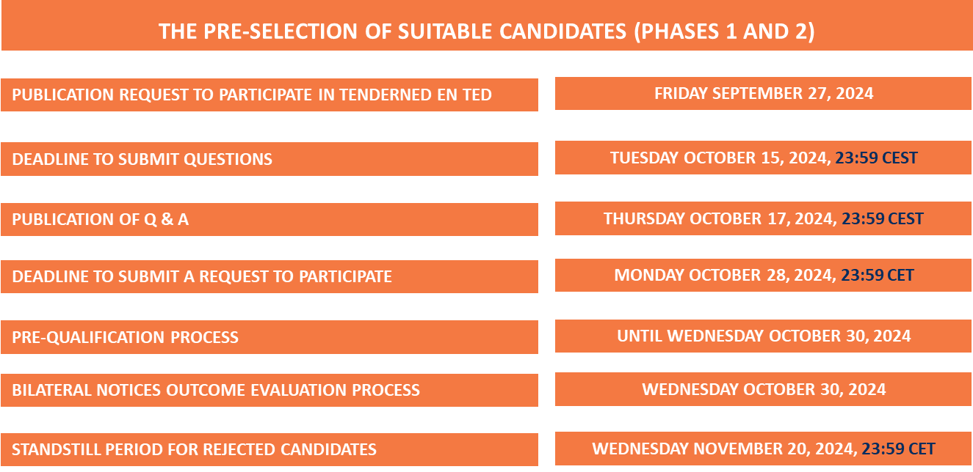

The final selection process in more detail (phase 3)

To achieve a well working innovation partnership, it is important that – before selecting the most appropriate candidates to participate in phase 4 – NDW knows the outcome of the preselection in phase 2. Simply because it needs an overview of preselected candidates to resolve a rather enigmatic pre-selection result. For instance:

- how do we assure there is no dominance by, or future dependency of, a candidate;
- how do we ascertain that all use cases will be covered (some of these use cases might be more attractive from a commercial point of view than others for pre-selected candidates);
- how to guarantee that SME’s are also able to participate;
- and so forth.

NDW shall resolve this enigma by requiring all preselected candidates to submit a position paper after the pre-selection process has ended and the time has elapsed for candidates that did not pass the pre-selection process were able to challenge said outcome in court.

Candidates shall submit one (1) position paper for each use case for which they were pre-selected.

The requirements on the position paper as well as the applicable evaluation methodology thereto are currently being drafted. They will be made available on Monday November 4, 2024 (prior to the deadline of Monday, November 25, 2024 to submit the position paper(s)..

Figure 1: Where C stands for candidate
The applicable (tentative) time schedule for the final selection process (phase 3) is listed below.

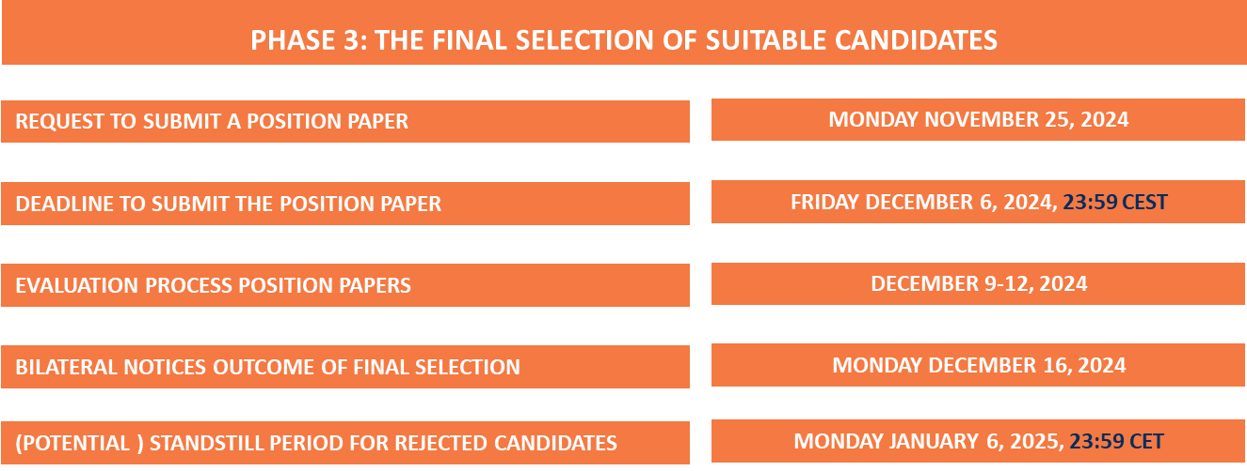

Requirements on the Request(s) to Participate

Each candidate that has an interest in participating in this tender shall do so by submitting a Request to Participate and the required documentation thereto in TenderNed. This Request to Participate shall be compliant to all applicable rules of conduct described in paragraph 9.

Applicable rules of conduct
This paragraph contains the rules of conduct that candidates shall comply with:

- Documents required when submitting a Request to Participate:

Class 1 (a vehicle manufacturer or a tier 1 supplier):
  - The Request to Participate itself. This is a standard letter, made available on TenderNed for Class 1,igned by a representative of candidate that is legally mandated thereto;
  - Annex 1 – made available on TenderNed - is a template in Excel that needs to be used by candidate when submitting a Request to Participate and clearly indicates the use cases candidate wants to develop and deliver;
  - Annex 2 is the ESPD (in Dutch: UEA) made available on TenderNed that has to be signed by an authorized representative of candidate;
  - Evidence that it is a vehicle manufacturer or direct supplier (tier 1 only) to a vehicle manufacturer;
  - Evidence that candidate is entitled to use and distribute the vehicle data aggregated by at least 10.000 connected vehicles registered in the Netherlands;
  - A guarantee from candidate that it has sufficient title to the vehicle data to make it available (conditions to be determined during this tender process) to NDW and the contracted entities in the innovation partnership ROMO-2;
  - A document describing the vehicle data items they have title to and consider relevant for the use case(s) candidate indicated in Annex 1;
  - If necessary, the NDA made available on TenderNed.

Class 2 (an aggregator):
  - The Request to Participate itself. This is a standard letter, made available on TenderNed for Class 2, signed by a representative of candidate that is legally mandated thereto;
  - Annex 1 – made available on TenderNed - is a template in Excel that needs to be used by candidate when submitting a Request to Participate and clearly indicates the use case(s) candidate wants to develop and deliver;
  - Annex 2 is the ESPD (in Dutch: UEA) made available on TenderNed that has to be signed by an authorized representative of candidate;
  - Evidence that it has access to vehicle data of least 10.000 connected vehicles registered in the Netherlands;
  - Evidence that candidate is entitled to use and distribute the vehicle data aggregated by at least 10.000 connected vehicles registered in the Netherlands;
  - A guarantee from candidate that it has sufficient title to the vehicle data to make it available (conditions to be determined during this tender process) to NDW and the contracted entities in the innovation partnership ROMO-2;
  - A document describing the vehicle data items they have title to and consider relevant for the use case(s) candidate indicated in annex 1;
  - If necessary, the NDA made available on TenderNed.

Class 3 ( a service provider):
  - The Request to Participate itself. This is a standard letter letter, made available on TenderNed for Class 3, signed by a representative of candidate that is legally mandated thereto;
  - Annex 1 – made available on TenderNed - is a template in Excel that needs to be used by candidate when submitting a Request to Participate and clearly indicates the use case(s) candidate wants to develop and deliver;
  - Annex 2 is the ESPD (in Dutch: UEA) made available on TenderNed that has to be signed by an authorized representative of candidate;
  - Annex 3: an Excel made available on TenderNed to be used by the referent of candidate;
  - Evidence of:
- the ability to deliver the pledged use case(s) based on unique probe vehicle data already available to candidate only at the time of submitting a Request to Participate, AND ;
- recent (2022-2024) experience in:
- combining various sources of vehicle data, AND;
- enhancing the quality of these vehicle datasets, AND;
- an – as of today - existing infrastructure (by itself or procured with a subcontractor) to process vehicle data and distribute the processed vehicle data to third parties, AND;
- recent (2022-2024) experience in working with road operators in Europe;
  - A maximum five (5) pager indicating the type of products it intends to develop and deliver by using the promised research and development infrastructure;
  - A maximum two (2) pager describing the team members and their roles/responsibilities it pledges while developing the indicated products and services;
  - The resumes of these team members;
  - Optional: the NDA.

- Only two (2) options for submitting a Request to Participate:

Option 1: as a main contractor/sub-contractor construction, whereby the main contractor shall act as the contract party and is severally liable for performing all obligations, including the sub-contracted obligations.
Option 2: as a combination, whereby each participant in the combination declares to be severally liable for full and proper performance of all obligations towards the Ministry of Infrastructure and Water Management. The Request to Participate must state who oversees the combination and who is authorized to act as responsible representative towards the Ministry of Infrastructure and Water Management. If a Request to Participate is submitted as a combination, each individual legal entity within such a combination shall sign the Request to Participate (legally binding). The Ministry of Infrastructure and Water Management is entitled to terminate the participation of a combination at any time during the acquisition process or thereafter if the configuration of the combination changes.

- Apply only once: a candidate can apply only once. It shall indicate in Annex 1 for which use cases candidate applies. For each use case: candidate can apply either as main contractor or as participant in a combination for a specific use case. It can not also act as a sub-contractor for another candidate that submits an application for the same use case.

- Main contractor: a candidate that applies as main contractor for a specific use case may not also participate in a combination and/or act as sub-contractor to a combination for the same use case.

- Only one (1) legal entity: only one (1) legal entity within a combination is allowed to submit the Request to Participate for a use case.

- Valid signature: the Request to Participate (and the final tender) has to be signed by the person(s) who is lawfully qualified to represent the candidate’s organization.

- Term of validity: with a view to the option of summary proceedings being instituted against the announcement of a decision not allowing an entity from participating in this acquisition process (or against the pre- or final selection), candidate must stand by its Request to Participate for a minimum of six (6) months calendar days following the closing date thereof.

- Communication and language(s): the Request to Participate and all further correspondence and communication regarding this acquisition process in phases 1, 2 and 3 shall be formulated in the English language only. During phase 4 and thereafter (bilateral meetings and exchanging documents) might take place in the Dutch and/or English language.

- Meetings will be recorded: all meetings will be electronically recorded and these recordings will be provided to the relevant candidate.

- Termination of the acquisition process: NDW reserves the right to terminate the acquisition process in its entirety or in part, temporarily or permanently, and refrain from making an award. In such a situation, candidates are not entitled to any indemnification or compensation (other than the 5.000 Euro (including VAT) which only applies as of phase 4 if the conditions thereto are met for any expenses incurred in the context of this acquisition process (rule 20 below).

- No claim for compensation of expense: the drawing up and submitting of a Request to Participate, including any further information to be provided, does not entail any expense for NDW. Any costs and/or damages that (may) arise by not allowing candidate to participate in phase 1, 2 and 3 of the acquisition process are at the expense and risk of such candidate.

- Additional information: NDW may request candidate to provide an explanation and/or additional information provided in their Request to Participate. Candidate must comply with such a request within three (3) work days. If the information requested is not provided within said period, NDW may decide to refrain from taking the Request to Participate into consideration. NDW may reject Requests to Participate submitted if, in its opinion, they are incomplete, incorrect or not submitted in time.

- Completeness and correctness of the Request to Participate: it is emphasized that candidate itself is responsible for ensuring that its Request to Participate is complete and correct. If, at a later moment in time, candidate appears to have provided incorrect information, it may be excluded from further participation in this acquisition process.

- Confidentiality: candidate will observe strict confidentiality with regard to all information from NDW that is or will be known to him or that has been gathered during this acquisition process procedure. It will only disclose confidential information to its staff insofar as the submission of the Request to Participate so requires (pre-selection and final selection).

NDW shall observe strict confidentiality during this acquisition process. Please be aware that NDW seeks innovative candidates focused on adopting new products and services. As a consequence thereof, NDW expects selected candidates to provide information (new ideas, roadmap and so forth) that may very well be “confidential information”. It is up to candidates themselves to specifically indicate information provided during the bilateral meetings as “confidential information”. Using general remarks (for instance all the information in this PowerPoint presentation is confidential) is not allowed.
Selected candidates need to realize that classifying too much “insight” as “confidential” will frustrate the acquisition process. If this occurs, NDW shall inform said candidate that its participation in the acquisition process is terminated. If and when NDW uses its right to terminate the participation of a candidate, as a consequence of classifying too much “insight” as “confidential”, it shall be able to do so without any right by candidate for financial compensation.

- Contradictions, inadequacies and/or objections: this document has been carefully compiled. Should candidate nevertheless encounter contradictions or inadequacies, it must report so to NDW without any delay and in writing, stating the proposed corrections and any substantiation.

NDW cannot be blamed or held liable for any inadequacies, contradictions and/or flaws in acquisition documents that are discovered at hindsight and were not reported by candidate during the acquisition process. Candidates are expected to adopt a proactive attitude.

This means that a candidate cannot make any lawful appeal to inadequacies or contradictions that it has not reported within the time schedule of this acquisition process, whereas such would in reasonableness have been possible. In this situation, candidate shall have forfeited its rights with regard to challenging these inadequacies or contradictions.

In the event that a candidate has timely reported inadequacies, contradictions and/or flaws to NDW, but NDW makes it clear that, in its opinion, the acquisition document(s) do(es) not contain any inadequacies, contradictions and/or flaws, and NDW refrains from making adjustments or changes in this respect, candidate must take further action (for example, summary proceedings) in order to avoid forfeiting its rights (again) to lodge a legal complaint regarding these inadequacies, contradictions and/or flaws (if any).

- Reservations are not allowed: conditional Request to Participate and/or Request to Participate with reservations are void. The same applies to the tenders (initial and final) submitted in Phase 5.

- Copyright: the copyright of information provided by NDW rests with NDW. Save exceptions as stipulated in the Copyright Act, no part of the procurement document(s) and/or information provided by NDW may be reproduced (other than for the purpose of submitting a Request to Participate or a tender) by means of print, photocopying, microfilm or otherwise, without written permission from NDW. Nor may the procurement documentation and/or information provided by NDW and/or parts and/or components thereof be used for commercial purposes of whatever nature, without written permission from NDW.

- Changes in candidate’s situation: the final contract resulting from this acquisition process will be the result of all information and documentation provided by candidate to NDW. Candidate shall guarantee that for the term of the contract including any extensions thereof its organisation possesses the capacities, skills and resources required to meet the requirements and preferences offered in their final tender. NDW and the Ministry of Infrastructure and Water Management must be informed immediately of any – foreseen or anticipated - substantial change in candidate’s situation affecting its ability to meet the contractual obligations. The Ministry of Infrastructure and Water Management reserves the right to terminate the contract if such information is not forwarded promptly.
- No remuneration for phases 1, 2 and 3: contrary to phases 4 and 5 where (final) selected candidates will receive a remuneration for participation (conditions do apply) there will be no financial compensation for participation in phases 1, 2 and 3.
- Renumeration phases 4 and 5: the investment of candidates in phases 4 and 5 (time to prepare, the bilateral meetings with adequate representatives, and the follow-up thereafter, is substantial. Each selected candidate will (afterwards) receive a lumpsum compensation of 5.000 Euro (including VAT) for participating in phases 4 and 5 unless it becomes evident during the bilateral meetings (phase 4) that:
- there was an evident lack of the requested expertise and experience during the bilateral meeting(s);
- the representatives were ill prepared;
- there was no adequate follow-up after one or more meetings;
- too much information (in the opinion of NDW) was classified as confidential and therefore useless;
- candidate is excluded or withdraws during the tender process;
- phase 5: no initial tender is submitted or the final tender is invalid (for instance: it does not meet the minimum requirements in the TOR).

- The anticipated scope of the development assignments: the intention is to contract multiple contractors for each of the use case to be developed and – if the development is successful – to be awarded one or more delivery assignment(s).
More information will be made available once phase 3 has ended. The scope of the to be developed use cases will be introduced in a so-called Terms of Reference document (TOR) which will be made available prior to commencing phase 4 (bilateral meetings, in-depth conversations and demonstrations).
- As a consequence of the in-depth dialogues during phase 4 of the tender process, candidates need to prepare themselves of the fact that:
- the requirements of each of the individual development assignment(s) as well as their consecutive delivery assignments might be modified;
- the preferences of each of the individual development assignments might be modified;
- the composition of use cases might be modified;
- the substance of the development assignments might be modified;
- the terms and conditions of each development assignments might be modified;
- the terms and conditions of each consecutive delivery assignments might be modified;
- the participation of one or more candidates might be discontinued;
- the available budgets (including the products and services) might be modified before phase 5 commences;
- the criteria to determine the most economically advantageous tenders might be modified in phase 4;
- the evaluation methodology for each use case might be modified in phase 4, or
- any other modification NDW decides to implement in this tender procedure.

- Applicable exclusion grounds: candidate shall complete and sign the ESPD document made available on TenderNed. And confirm that all applicable exclusion grounds marked in said ESPD are either marked NO, or, if not able to do so provide the details therefore in lieu with articles 2.86a, 2.87a and 2.88 of the Dutch Procurement Law (Aanbestedingswet 2012).

- Please note: NDW does not seek Requests to Participate from candidates that are interested to:
- install (new) hardware devices in the road network in the Netherlands;
- install new (aftermarket) products in vehicles to collect vehicle data.
Requests to Participate based on these proposals will be rejected.

End of document Request to Participate

