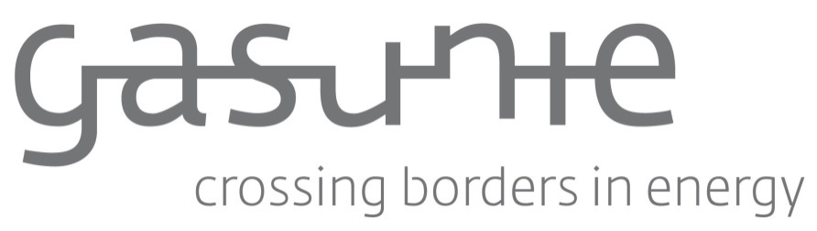

FALL BACK CONTRACT

Technical services management and maintenance
for the benefit of N.V. Nederlandse Gasunie

Reference number: WS4473315964/CWXXXXXXX

Version 1.0

N.V. Nederlandse Gasunie
Groningen, August 2024
© Full or partial adoption or reproduction of the contents of this document, in whatever manner, without prior written permission from the copyright owner, is prohibited, except for restrictions set by law. This prohibition also covers full or partial adaptation.

FALL BACK CONTRACT TECHNICAL SERVICES MANAGEMENT AND MAINTENANCE

1. <name Supplier>, established in <location>, registered under number <number trade register>, hereafter referred to as: ‘Supplier’, as one party,

and

2. N.V. Nederlandse Gasunie, established in Groningen, registered under number 02029700, hereafter referred to as: ‘Client’, as the other party,

The Supplier and Gasunie are hereafter also referred to as: separately as ‘Party’ or together as ‘Parties’.

Taking into consideration that:

- In the context of technical services management and maintenance, the client has invited market parties to submit a tender for this purpose;
- The supplier has submitted a tender;
- The supplier has offered the economically most advantageous tender for this call for tenders;
- The client wishes to place the service under a framework contract (Referred to below as "the Framework contract ") with the party submitting the most economically advantageous tender, which is [name] (referred to below as: the Contracted Party);
- The supplier has submitted the second/third most economically advantageous tender and has ended as second/third in the tender procedure;
- The client wishes to conclude this contract with the Supplier, with the purpose of being able to take over the service in the event of the Contracted Party no longer being able to meet his obligations under the Framework contract (referred to below as: the Fall back contract), as indicated in the tender documents.
- This Fall back contract for <naam opdracht> is being entered into between the Parties on this basis.

declare that they have entered into contract as follows:

- Duration and termination of the Fall back contract
  - The Fall back contract is entered into for a period of 24 months, commencing on <datum> and ending by operation of law on expiry of this period without any notice being required. The Fall back contract can be extended unilaterally by the Client for a single period of <aantal jaren> (5) years. If the Client wishes to avail himself of this opportunity to extend the Fall back contract, he will inform the Supplier of this in writing three (3) months at the latest prior to the expiry of the term. The Fall back contract will be converted into a framework contract only if the Framework contract with the Contracted Party is prematurely terminated.

  - The Fall back contract can be prematurely terminated with mutual contract and with due observance of a notice period of 1 (one) month by sending written notification to that effect to the other party.

  - The Fall back contract can be terminated with immediate effect if:
- the Supplier is declared bankrupt or has applied for a payment moratorium;
- the Supplier has failed to meet his obligations concerning the payment of social insurance premiums and income tax or to meet them in full;
- the business of the Supplier is liquidated or taken over, if he discontinues his current business, if an attachment is imposed on a substantial share of the Supplier's assets or if the Supplier cannot reasonably be regarded as still being able to meet his obligations under this Fall back contract for any other reason.

  - This contract will be governed by Dutch law. Disputes arising from this contract, to the extent that they come under the jurisdiction of a court, will be referred in the first instance to the court with competent jurisdiction in the District chosen by the Client.

- Price changes
  - If the Fall back contract is invoked during the term of the regular Framework contract, which runs from <datum> to <datum>, the Supplier will be entitled to introduce a price change, as specified in the tendering guidelines.

  - Price changes can only occur, after proposal by the Supplier and their approval by the Client based on the price change proposal specified in the tendering guidelines.

- Conditions
  - The Supplier's General Terms and Conditions of Delivery and Payment or other general or special conditions are not applicable and are explicitly rejected.

- Investments
  - Following the termination of this Fall back contract there will not under any circumstances be any settlement between the Supplier and the Client in respect of the investments made by the Parties for the purpose of this Fall back contract.

- Conversion of the Fall back contract
  - By signing this contract the Supplier binds himself to the text of of the <naam aanbesteding> including the concept of the framework contract, under the suspensive condition that the Framework contract with the Contracted Party is terminated.
  - On termination of the Framework contract with the Contracted Party the Supplier will cooperate on the Client's first request with the actual formation and execution of the concept framework contract provided for in article 6.1a for the remaining term as specified in the tendering guidelines.

- Applicable provisions
  - The following documents form an integral part of the Fall back contract. The annexes are sufficiently known to the Parties and have therefore not - with the exception of the Supplier's tender - been attached to this Fall back contract.
- Concept framework contract;
- Notes of information dated ... (offer stage);
- The tender documents... ;
- Best and final offer dated … with reference number …;
- Summary of unit prices and operational costs offered by the Supplier.
- Summary of delivery times offered by the Supplier
- General Conditions for Supply Contracts 2011

  - In the event of conflicts arising between the documents provided for in section 1, the document with the highest listing will take precedence.

Thus agreed upon on <date>,

Gasunie: Contractor:

<name> <name>
<position> <position>

Annexes:

Annex 1: Supplier's tender

