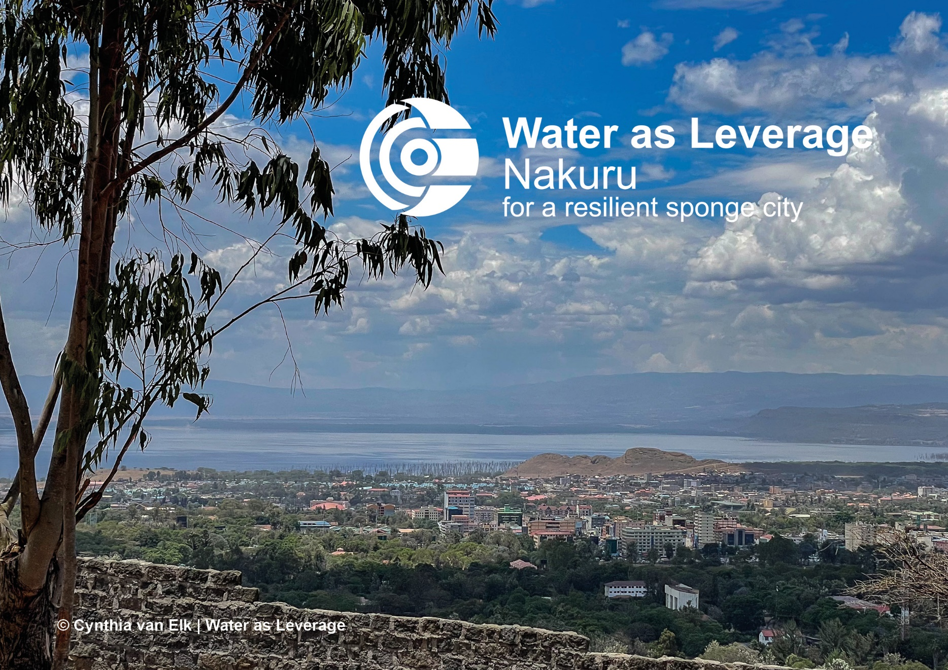

WaL Framework for
Cost-Benefit Analysis and
Financial Pre-Feasibility Assessment
June 2024

Why use this framework?
This framework comprises two sections: first, the Cost-Benefit Analysis and second, the Financial Pre-Feasibility Assessment.

The Cost-Benefit Analysis (CBA) framework presented in this paper has three purposes:
- To assist the project teams for the Water as Leverage (WaL) program in performing a CBA, by guiding them through the steps with information and examples.
- To provide the project teams a document where they can gather and record the findings of their CBA study in one place.
- To support the project teams in thinking about the beneficial aspects of their projects, but also non-beneficial aspects and risks, and about ways to optimize the projects by explicating effects to society.

The Financial Pre-Feasibility Assessment framework presented in this paper has two purposes:
- To assist the WaL project teams to develop a first business case and insights into the financial feasibility of their projects.
- To provide the project teams a document where they can gather and record the respective findings of their financial assessment.

Contents
Economic analysis versus financial analysis 3
Economic: Cost-Benefit Analysis 5
1. Problem analysis 7
2. Base case 9
3. Determining Effects 11
4. Valuing effects 14
5. Results 18
6. Robustness and flexibility 21
7. Stakeholders 22
Financial Pre-Feasibility Assessment 24
1. Funding and feasibility 25
2. Financing 27
APPENDIX I – Long list of effects 28
APPENDIX II – Monetizable effects 30
APPENDIX III –Sources + References 32

Economic analysis versus financial analysis

This framework contains information on both the economic analysis and financial analysis you will need to do for your project(s). Before diving into all the steps of doing both types of analysis, you need to understand the difference between them:

- Financial analysis tends to focus on the financial feasibility of a project. It is sometimes referred to as the ‘business case’. A financial analysis determines if there are enough funds available to finance the project. Values are calculated using market prices and the result of the analysis is presented in terms of the financial Net Present Value (NPV) or financial Internal Rate of Return (IRR).
- Economic analysis focuses on the costs and benefits of an investment for society: a CBA. An economic analysis determines whether the costs of a project can be economically justified by its benefits to the economy. It concerns all effects on all members of society. Values are calculated using the economic valuation of effects (willingness to pay). A CBA results in an economic NPV or economic IRR.

There is overlap between the effects calculated in a financial and economic analysis, as illustrated in the picture below. Some effects are only included in the CBA, because they have a (positive or negative) effect on society but not a direct financial effect. Examples are: health gains or CO2-reduction.

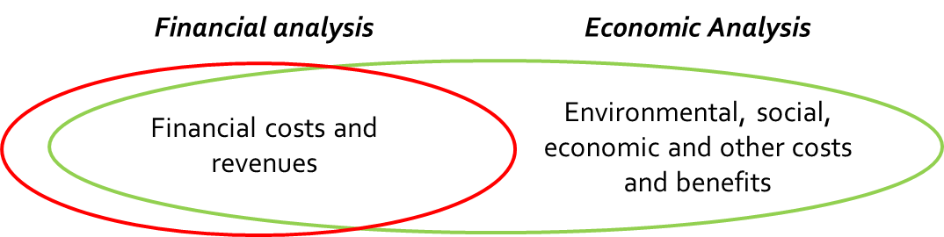

Other effects, however, will only occur in the financial analysis and not in a CBA. In a CBA, only ‘real’ costs to society are included. Any costs that are a ‘transfer’ within the society but are not actually representing any real value, should be left out. The most important example is taxes (or the positive version: subsidies). Here, one player of society (e.g. the consumer) pays a tax to another player in society (e.g. the government). These costs might be a financial expense for the consumer and a financial revenue for the government, but the net effect to society is zero. Therefore, financial costs need to be corrected for those transfers, before using them as economic costs in a CBA (see text box below). When doing the CBA, please always check if you are taking into account an actual economic effect.

Correcting financial costs
The financial costs of a projects are the cash expenditures required to realize a project (the bills that have to be paid for). In contrast, in a CBA, the economic costs of the project have to be considered. These are the real cost of the resources used for the project to the economy. While this might sound quite complex (and theoretical) it means something rather simple and can be accounted for in the following way: Check if the financial cost estimate you have, is including any transfers. Transfers within society are typically taxes and subsidies. Why would we not want to include a tax (or subsidy)? These costs are a financial expense for the consumer and, at the same time, a financial revenue for the government, but the net effect to society is zero. They have no value in a CBA. Therefore, correct your financial costs estimates for those transfers before using them as economic costs in the CBA by (i) subtracting any taxes and by (ii) adding-back any subsidies.

In a comprehensive CBA you would normally also correct the financial costs for unskilled /low-skilled labor. The World Bank guidelines (2013), amongst others, describe how this is done. This framework is excluding this correction for reasons of simplicity. If you have the knowledge and capacity to perform this correction, please feel free to do so.

In the following chapters, you are guided through the steps of economic analysis and financial analysis for your WaL project(s). With each step, some theoretical background information is given. You are also provided with separate space in each chapter to record the results of your analysis, so that in the end you have all information in one place.

The Excel-model that is part of this framework helps you in monetizing economic effects (step 4 of the economic analysis) and calculating the preliminary business case (step 1 of the financial analysis).

If your conceptual design consists of more than one project, you should make the results of both the financial and the economic analysis as specific as possible for each single project. You can either fill this template with results once and make clear in each step what result corresponds to which project, or you can fill it for each project separately. If there are any synergy effects that you expect to result from combining projects, think about how you want to show the expected added value of an integral implementation of the projects (e.g. in an separate template or added to each single project).

Economic: Cost-Benefit Analysis

A Cost-Benefit Analysis (CBA) is a method used to reveal and, if possible, monetize the costs and benefits of a project to society. In a CBA you look at all types of effects (environmental, social, economic etc.), both positive and negative. CBAs are often done before a project is started or an investment decision is made, based on prognoses. It can, however, also be used to evaluate projects.

A CBA has the following potential uses:
- Project decision-making: by determining the costs and benefits of a potential project to society and by balancing them, a CBA provides important information on whether an investment gives net benefits to society and should be pursued.
- Project optimization: clarifying the causal relations between interventions and effects is a way to gain insight in the impact of interventions and the extent to which they contribute to the main objectives of the project. This helps in changing the project design and optimizing impact.
- Project funding: identifying benefits to society and the amount in which each stakeholder will profit, can assist in discussing potential (co-)funding of the project. For public stakeholders a CBA provides a legitimization of public funding.
- Project support: stakeholder analysis can also be a way to determine where resistance or support for the project lies, by mapping relevant stakeholders, their interests, and how much they gain or lose with the project.

In a CBA you are basically comparing two situations: the situation without the project (called ‘base case’) and the situation with the project (called ‘project alternative’). The effects that you take into account are only the differences between the two situations – both positive and negative. This is important to bear in mind.

The CBA is done in a series of steps. It is important to stick to the order and to not skip any step if for example the information is lacking. There are various common international guidebooks for CBA, but in general they follow the same logic. For this framework we distinguish the following steps:
- Problem analysis: What is the key problem that the project will solve? What are the objectives of your project?
- Base case: What will happen without your project?
- Determining effects: What are the positive and negative effects of your project, as compared to the base case?
- Valuing effects: How big are the effects of your project? Which effects can be quantified / monetized and what information is needed?
- Results: What is the outcome of your analysis? Do the benefits outweigh the costs? Which effects are not monetized but important to include in the result?
- Robustness and flexibility: How certain are the costs and benefits? How future-proof is your project?
- Stakeholders: How do stakeholders benefit from or lose with the project?

Problem analysis

Background information
Key questions:
- What is the key problem that the project will solve?
- What are the objectives of your project?

The goal of this step is to explicate the main problem you are solving and to determine the main objectives of your project. By making this explicit at the start, it becomes clearer at a later stage to what extent your project design will succeed in reaching its objectives. Part of the problem analysis is a description of any water-related issues in the project area and the current environmental, social and economic challenges.

Record of the results
Go through this first step by answering the questions below. Summarize briefly from your project proposal and refer to the pages of the proposal for further reading. When describing environmental, social and economic challenges, really only focus on the challenges that your proposal is – directly and indirectly – addressing (not all challenges that exist in the project area). And sort the challenges in terms of importance to your project.
Questions
What are the main water-related issues in the project area? E.g. flooding, erosion, landslides, subsidence, water quality.
Also mention if water threats could turn out to be catastrophic events, not only leading to damage but to the loss of lives and livelihoods.

What are the main environmental/climate challenges in the project area? E.g. air quality, water supply, solid waste

What are the main urban social challenges in the project area? E.g. lack of housing, crime, social cohesion, inclusiveness

What are the main urban economic challenges in the project area? E.g. business interruptions, employment, tourism

After having summarized the main problems and challenges that your project is addressing, convert them to the key objectives of your project.

Questions
What are the key objectives that you aim for in your project?

- Base case

Background information
Key question:
- What will happen without your project?

The goal of this step is to make clear what you are using as baseline to compare the project with. The base case describes the development that would happen if the project is not implemented. In order to assess the impact of the project, or the added value, it is important to understand what “difference it makes” compared to the natural development of the situation.

In the graph below, the black line illustrates in a simplified way, the development in the base case and the blue line the development of the project alternative. The difference between the two is the effect, or impact, the project has (most often: a negative difference at the start of the project because of extra costs, and a positive difference in the later phase of the project because of extra benefits).

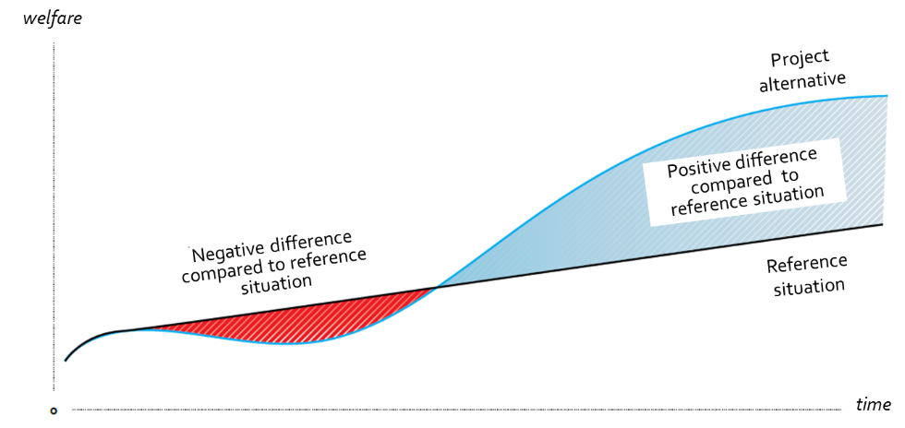

The base case reflects the most plausible scenario without the project being implemented. For simplicity you can assume that no other projects carrying the same objectives are implemented or comparable investments are made in the project area. However, you do need to think about how environmental, social and economic conditions would change in the short and long term if the project were not implemented.

Record of the results
Describe what the base case looks like, which you use to determine if costs and benefits from the project are additional. Consider potential future development in environmental, social and economic conditions. After that, also think about possible interfaces with other projects/plans, either ongoing or soon to be started.
Questions
What would realistically happen in the project area, in the short term and long term, if your project would not be realized? E.g. chance of flooding damages will increase due to changing climate conditions.

Are they any interfaces with other projects/plans in the area and, if so, how strong is the interdependency between the projects?

- Determining Effects

Background information
Key question:
- What are the positive and negative effects of your project, as compared to the base case?

In this step you make an overview of all the costs, revenues and effects for society (positive and negative) that are related to the project, compared to the base case. Scoring of these effects is done in the next step. For the purpose of gathering and structuring effects, it is highly recommended that you draw a “cause-effect tree” for the project. A cause-effect tree gives a full overview of all the interventions, intermediate effects, effects and parameters to calculate the effects. It is a very nice method to sharpen the thought process, get an idea which interventions are most important for reaching your goal, and separate between cause and effect. Cause-effect trees are generally structured in the following way.

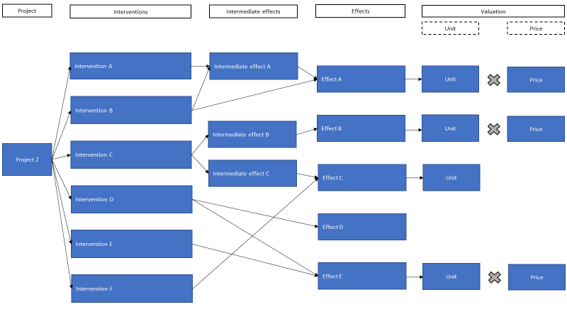

There are two common ‘pitfalls’ to keep in mind when determining effects: they are sometimes double counted or they are not corrected for substitution. See the examples in the following textboxes.

Double counting
A point of attention is to prevent double counting the same effect. Sometimes it may seem as if there are two different effects occurring, but they actually overlap. One example that illustrates the risk of double counting is the somewhat simplified example of “insulating an apartment”. The insulation comes at a price (the cost). And, brainstorming on some benefits, it leads to a more comfortable internal climate which reduces the need for heating and cooling, to lower energy costs, and – in case you are renting out – to a higher rent. These might seem valid arguments at first, but looking at them more closely reveals that they are indicators of the same effect: a better insulation leads to less ‘circulation’ to the outside. That is the direct effect. One way to ‘value’ or ‘monetize’ this direct effect, is to look at the energy bill. The lower energy costs are thus not an extra effect, but a valuation of the same effect. And also the higher rent is a valuation of the same effect: the rent reflects the potential savings in energy cost – again, the same direct effect.

This was a simple, straightforward example. Depending on the project, the cause-effect-valuation relationship might be a bit more complex. Sometimes, multiple effects are measured in the same value. Real estate values are a perfect example: they represent the willingness to pay of residents in part for what is inside of the house but in part also what is outside of the house, including the mobility situation, safety, cleanliness, recreational facilities, green and blue areas, social areas etc. (in general: livability). If a project is ‘a new blue-green park’, many positive effects could play a role: more space for recreational activities, a greener environment, places to meet and have social gatherings. All of these might be somewhat reflected in the real estate value. So, first, we need to be careful not to double count ‘the greener environment’ and ‘real estate value increase’ (the same effect) and also, we need to consider, that real estate value increase is the valuation for many different effects – and that counting an increase for each might be overstating the overall effect.

Substitution effect
Another typical thing to watch out for when determining effects is substitution. One example is: will hosting the Olympics generate more tourists or is it just a substitution of tourists in time? For example, some visitors of the Olympics might have planned to visit the hosting country anyways and are now picking their moment to visit accordingly. They are thus not extra tourists for the country. We speak of substitution in time here.

Another point of attention is substitution in location, for instance: is a new port generating extra employment or is it cannibalizing the activity of another port in the neighboring city, which is losing jobs? In this example, only the net effect is the benefit of the project, from the whole country’s point of view.

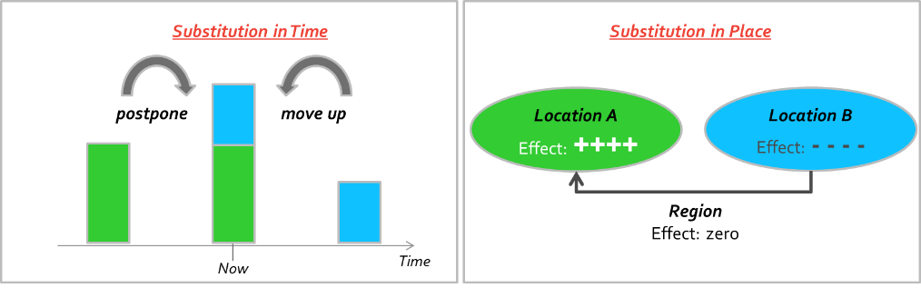

Record of the results
Appendix I gives a long list of effects that could occur as a result of your project, including the descriptions. This list was reviewed by you and the other WaL project teams and should be (nearly) complete. However, feel free to add additional effects in your analysis if you miss any. Appendix I provides a long list of potential effects; focus only on those that apply to you project and that are most important.
Go through this step by filling the table below. Determine what costs, revenues and environmental, social and economic effects apply to your project. Do not forget that drawing a cause-effect tree is a very useful tool to separate cause and effect, and to prevent double counting. Drawing a cause-effect tree is in itself not enough; you should also provide support to substantiate the existence of a causal relation between interventions and effects (e.g. based on earlier research).
Questions
What are the types of costs your project faces? E.g. investment costs, maintenance costs, resettlement costs

What sources of revenue and which cost savings does the project realize? E.g. user fees, sale or rent of land

Which environmental effects does the project generate? E.g. biodiversity, ground water quality, air quality
Also: how is the causal relationship between your project and the occurrence of these effects supported? E.g. based on scientific literature, comparable reference projects

Which social effects does the project generate? E.g. identity and social cohesion, spatial quality, health
Also: how is the causal relationship between your project and the occurrence of these effects supported? E.g. based on scientific literature, comparable reference projects

Which economic effects does the project generate? E.g. income from existing source, employment, mobility
Also: how is the causal relationship between your project and the occurrence of these effects supported? E.g. based on scientific literature, comparable reference projects

- Valuing effects

Background information
Key questions:
- How big are the effects (costs and benefits) of your project?
- Which effects can be quantified / monetized and what information is needed?

Not all the effects that you have listed and visualized in Step 3, are effects that can be given a money value. We distinguish three ways on how to include effects in a CBA: monetized, quantitative and qualitative.

Monetizing effects: This means that you express the benefit in monetary terms, in the case of this CBA: ‘euros’. How can this be done?
- Costs: The preparation, construction and operational costs of your projects should be estimated (at least a ball-park number). Some adjustments need to be made to correct those estimates to be used in the CBA, as explained before. See the text box below for some points of attention when calculating costs.
- Revenues: if you are ‘lucky’, the benefit has a proper price on the market. In other words: the ‘willingness to pay’ for the effect is well-known. An easy example: the benefit you experience from a roller coaster ride (joy and thrill) is monetized by the price of the ticket you are willing to purchase. We categorize those effects as ‘revenues’, as they are most often also a revenue for the business case. Any other effects in this category include cost savings (for example, reduced production cost of water).
- Valuation of other effects: most of the effects will not have a known market rate. Yet, some of them can be monetized. Typical ways to do that are:
- Prevented damage: especially the benefits from better flood protection can be assessed by looking at prevented damage. Watch out again for double counting. You can either include the benefits from prevented damage in the calculation or the increase in real estate value due to better flood protection – not both, because they represent the same effect.
- Willingness to pay: some benefits can best be monetized by determining the willingness to pay for the effects. For example: The extra price that people are willing to pay for their house (as a buyer or for rent) is a good indication of the extra value that is created through an intervention. In other words: the real estate value.
- Standardized values: some effects also have a standardized valuation method. For example, there are international best practices on the pricing of CO2-reduction, or for the value of a life.

Costs – points of attention
Here are some instructions and things to keep in mind for the cost-part of a CBA:
- Costs that have already been made, are not included in a CBA. They are so-called ‘sunk costs’ and should not influence the decision-making for the future.
- Make sure to only include costs that are additional / arise due to your proposed project. For example: if you elevate a coastal road through a dike in order to improve flood protection, the maintenance costs of that elevated road are not additional (assuming the maintenance costs were the same before).
- From a CBA point of view, it is important to consider all costs to society – so not only the public sector cost, but also the costs that households and the private sector have to make in order for the project to be fully implemented.
- If your project is generating negative effects, we propose to consider these negative effects as ‘negative benefits’, and not in the cost-section of the CBA.
- Check for inflation: by convention, in a CBA, neither the costs nor the benefits are inflated. Please use un-inflated cost estimates in the CBA.

Overall, the advice is to prioritize: start with monetizing and providing proof for the most important effects. Focus your energy on those effects that you want to achieve with the project – the other side-effects are ‘nice to have’ but should not take too much room of your main story and of your time. A general note: do not forget to monetize negative effects as well (as ‘negative benefits’ in the model). Sometimes, compensation is paid for a negative effect that can be used as a proxy.

In Appendix II, guidance is provided for the effects that could possibly be monetized. Furthermore, an Excel-model is developed to assist you in calculating the effects of your project; at least the costs and some of the most important benefits should be monetized in that model. There are a few things to note before you get started with the model:
- The model contains a user manual in a separate work sheet; you are advised to read through the manual before using the other work sheets.
- The discount rate applied as a default is: 6% (see the text box below on why a discount rate is used in a CBA). This corresponds with the social discount rate the ADB is suggesting for water-related projects. The dashboard of the Excel-model gives you the possibility to do a sensitivity analysis on the CBA-outcome by changing the discount rate to 3% and 9%.
- You will be asked to fill in a couple of time inputs to put project in the right time frame, which is relevant for discounting. The model assumes that all effects during the operational period will last 30 years.

Discount rate
A euro received today is worth more than a euro received in a year from now, because of the return that can be made by investing the money and due to the risk of an uncertain future – better a certain euro today than an uncertain euro tomorrow. Because the costs and benefits in a CBA occur in different years, it is necessary to convert the values for both to ‘today’s value’. Effects in a CBA are therefore ‘discounted’ to today’s value and expressed in the NPV. The model is built to account for this discounting.

Inflation / indexation
By convention, in a CBA costs and benefits are expressed in constant prices, so without correcting for general inflation.
In the rare case that inflation is applied to costs and benefits, also the discount rate has to be increased by that same inflation rate – leading to a deflation of the costs and benefits back to their original value. Therefore, in this framework, un-inflated values are used.

Quantifying effects: some effects cannot be valued due to a lack of information or a way to calculate the value in monetary terms. For these, it is important to still try to quantify them. For instance, it might be difficult to assess the monetized value of having more people educated about hygiene. But quantifying that effect might be possible, by assessing the number of people (e.g. XX children and XX adults), and by providing information on type of costs that could occur if hygiene is not improved (e.g. sickness).

Qualitatively describing effects: if both monetization and quantification is hard to provide, due to a lack of information, they need at least be described in a qualitative sense. Please be aware that a monetized effect is not necessarily ‘larger’ or ‘more important’ than an effect that is described qualitatively, even though it may sometimes be perceived to be the case. Therefore, the logic reasoning (in words) of how a project is causing a positive effect is equally important.

Record of the results
You can do the actual valuing of effects (monetized or qualitative) in the Excel-model that is provided together with this framework. Before starting with calculating effects in the model, it is necessary to determine for each effect: any assumptions and the sources of information you will use. This strongly improves the traceability and transparency of your calculations. Use the table below to indicate your assumptions and logic with regard to monetizing your effects. If needed, appendix III provides extra space for summarizing sources.
Effect | Assumption | Relevant source

- Results

Background information
Key questions:
- What is the result of your analysis?
- Do the benefits outweigh the costs?
- Which effects are not monetized but important to include in the result?

At this stage, the outcome of the calculations in the Excel-model and the qualitatively described effects come together. Both taken together make up the result of the CBA; either positive or negative.

Social inequity and income differences
This CBA framework is striving to be simple and straightforward. Therefore, as a ‘default setting’, this CBA treats all members of society as equal and does not account for income differences between individuals. While this makes monetization straightforward, it neglects that these income differences can potentially have a large impact. For example, losing a house in a slum is a small material loss from a high level perspective – but represents the loss of the home and all belongings for a poor family, and a relatively high cost for them to replace it.

There are advanced methods to adjust for this income effect. However, for this CBA framework, we advise all teams to:
- first, disregard income differences in the monetization,
- then, elaborate on income differences qualitatively, if applicable (in this Step 5 as well as Step 7)
- and then, only if capacity is available, to adjust for income differences in a separate scenario.

Record of the results
Use the spaces below to copy relevant numbers and graphs from the Excel-model to this document, to make a ranking of the most important qualitative effects, and to answer the questions in the table for commenting on the main results of your CBA.
Results (NPV total amounts, in euro):
Category | Amount
Total Costs | € [amount]
Total Revenues | € [amount]
Total Benefits | € [amount]
Result | € [amount]

Benefits (real values p/year, in euro):

[insert graphs from dashboard here]

Results (real values p/year, in euro):

[insert graphs from dashboard here]

Sensitivities (NPV total amounts, in euro):
Sensitivity analysis | CBA result
Investment costs:  + [x]%  - [x]% | € [amount]  € [amount]
Revenues and savings:  + [x]%  - [x]% | € [amount]  € [amount]
Economic discount rate:  + [x]%  - [x]% | € [amount]  € [amount]
Environmental effect:  + [x]%  - [x]% | € [amount]  € [amount]
Social effect:  + [x]%  - [x]% | € [amount]  € [amount]
Economic effect:  + [x]%  - [x]% | € [amount]  € [amount]
Please add a short discussion of the results of the sensitivity analysis.

Qualitative effects (ranked, top 5 effects):
Qualitative effect | Importance to project
1. [effect] | [description]
2. [effect] | [description]
3. [effect] | [description]
4. [effect] | [description]
5. [effect] | [description]

Questions
What can you conclude about the main outcome of the CBA?

What are the largest cost items?

What are the most important benefits (monetized and qualitative)?

Accounting for income differences (see textbox above)
Please elaborate how income differences affect the outcome by explaining how benefits (and negative effects) might affect some income groups to a relatively larger extend then others.

[ If applicable, please add the results of a separate income-adjusted scenario here, using the same templates as as above ]

- Robustness and flexibility

Background information
Key questions:
- How certain are the costs and benefits?
- How future-proof is your project?

Doing a CBA before the project is implemented (ex-ante) means you need to take several risk and uncertainties into account. These can influence the outcome of the CBA if they materialize. You are recommended to make a list of the risks that potentially have most impact on the outcome and think about how either the occurrence or the impact of that risk can be mitigated. Regarding the latter, mitigating the impact, it is also useful to record in what way the project could be adapted if risks materialize.

It is common in a CBA to do several sensitivity analyses (‘What if … is X% higher or lower?’). These sensitivities generally concern the inputs that carry the most insecurity and have the largest potential impact.

Record of the results
Determine the biggest risks and uncertainties and fill the table below. In the Excel-model that accompanies this framework, a couple ‘standard’ sensitivities are included; use these to determine how the outcome of the CBA would change if risks and uncertainties materialize.
Questions
What are the key risks and uncertainties that may affect your project and how would they affect the scoring of effects (step 4)? NB comment on the sensitivity analysis results that you presented in the previous step.

How well can the project be adapted in case any of the risks materialize? E.g. through upscaling, downscaling, delaying, speeding up.

- Stakeholders

Background information
Key question:
- How do stakeholders benefit from or lose with the project?
- Who are potential supporters? Where could opposition come from?
- Is there a case for re-allocation of benefits or costs, through compensation, contributions or other transfers?

In this final step the results of the CBA are allocated to all relevant stakeholders. That means determining who the relevant stakeholders are, what their interests in the project are, and how much they benefit from or lose with the project. This will give you an understanding of the level of support to be received or the resistance that needs to be taken away to successfully implement the project.

Vulnerable groups
A CBA is a rather theoretical, economic instrument. However, other arguments and considerations (political, social, ethical, etc.) might be very important for decision-making, too, and should be considered in a project’s assessment.
One important aspect in water-related projects are the effect on vulnerable groups of society. This effect is usually not well-captured in a CBA. This is true for the monetization in this CBA as well. Yet, vulnerable groups have special attention in the WaL Program and we therefore ask the teams to also elaborate qualitatively on the (positive and negative) impact of their project on vulnerable groups.

Record of the results
In this last step, determine the key stakeholders, their interests and what part of the costs and benefits you can allocate to each stakeholder (monetized, quantified or qualitative).
Questions
Who are the key stakeholders in your project’s area and what are their interests (positive or negative) in your project? E.g. municipality, local residents, businesses.

Who are the key stakeholders outside your project’s area and what are their interests (positive or negative) in your project? E.g. AIIB, FMO.

How are the costs and benefits of the projects allocated to each of the abovementioned stakeholders?
What can you conclude about potential support/ opposition to the project and are transfers necessary?

Are there any vulnerable groups that are especially benefitting from your project that would have been especially harmed by a catastrophic event?

Financial Pre-Feasibility Assessment

The financial analysis is divided into two parts:

      - determining the funding available to this project and the feasibility based on a pre-financing cash flow, and
      - determining the financing requirement of the project.

Both steps will be explained in this chapter.

Funding versus financing
The words funding and financing are often used interchangeably, but in this framework, we mean two distinct things. The difference between the two is important to understand when doing the financial analysis.

Financing is the sum of money provided to a project with the expectation to be repaid with a return (interest or dividend). Financing is needed to bridge the gap between when investments are made and when the return of that investment is generated. It comes in two basic forms: debt and equity (as well as many variants).

Funding is the actual income generated to cover costs. It is the sum of money provided to a project without repayment requirement. Examples are: a user fee, a government contribution or donor money.

- Funding and feasibility

Background information
Key questions:
- What are the costs of your project(s) and when do they fall?
- What are the revenues (or other financial contributions) generated that can pay for these costs?

As explained in the beginning of Section 1, the scope of a financial analysis is much narrower than the scope of an economic analysis: While the economic assessment considers all project effects on the economy, the financial assessment is only concerned with the financial effects (costs and revenues). The objective of financial analysis is to verify the financial feasibility of a project: are there sufficient revenues and contributions available to cover the costs over time? In other words: is the business case positive? Please keep in mind that a project could have a positive CBA result, but still there are not enough revenues and other contributions that can pay for the costs.

In this first step of the financial analysis, you will make a preliminary assessment of the financial feasibility of your project, focusing on the so-called ‘pre-financing cash flow’. This includes two things:
- Determining the project’s operational cash flow
- Calculating the project-IRR and the NPV, based on the project’s operational cash flow.

This analysis will help you to determine the funding gap (or surplus) of your project.

For calculation of the project IRR, you will need to incorporate a discount rate in the model. This is a different discount rate than the one used for the economic analysis. The discount rate for the financial analysis is based on the weighted average cost of capital in the country. In this framework, we assume the following discount rates: Bangladesh: 16%, India: 14%, Indonesia: 12%. Please choose the one applicable to your project. Unlike in the CBA, you will also need to incorporate indexation rates for both costs and revenues to account for inflation.

The project can be considered financially feasible if the calculated NPV with the above discount rate is positive and the project IRR is larger than the discount rate of the country. That implies that the revenues are sufficient to cover the operating and maintenance costs and also to repay potential loans and equity used for the initial investment, including the return required by lenders and equity investors (interests and dividends).

As in the CBA, a very important output is the allocation of results to stakeholders. In the preliminary financial analysis, we ask you to make an overview of the financial cash flows by stakeholder or stakeholder group. Such an overview can be helpful in the consultation with stakeholders, in order to achieve a balanced equilibrium between costs and benefits for all parties involved.

Record of the results
Determine the funding gap of your project by answering the questions in the tables below and by copying the main results of the dashboard to this template.

Questions
What are the investment costs (before and during constructions) and O&M-costs of your project? NB these should already be determined in the CBA-analysis, check Step 5 of the framework. This time, use the financial estimate of these costs.

What are the revenue streams generated by your project and what are the underlying assumptions made?

Which indexation rate do you use for costs, which for revenues, and what are the sources used that support your choice for the rates? NB for simplicity, choose only one indexation rate for costs and one for revenues.

Main results (model-output):
Category | Amount
NPV of pre-financing cash flows | € [amount]
Project IRR | [x]%

Sensitivities:
Sensitivity analysis | NPV of pre-financing cash flows
Investment costs:  + [x]%  - [x]% | € [amount]  € [amount]
Revenues and savings:  + [x]%  - [x]% | € [amount]  € [amount]

Conclusion funding gap:
Questions
What can you conclude about the funding surplus/gap? To your knowledge at this stage, is the project financially feasible? If not, what would be needed to make it feasible?

- Financing

Background information
Key question:
- How can the timing gap between costs and revenues for the project be overcome?

As described in the beginning of this Section, we distinguish between funding and financing. The former has been assessed in Step 1. In Step 2, we will now look at the financing of the project. Financing is needed to overcome the time-gap between the moment when the costs of the project have to be paid for (the majority, in the beginning) and when the revenues of the project come in (usually, during the operational period). This can be done through a loan (that has to be paid back), or through investors that put their money in the project (and expect to make a profit as their return).

In this step 2, you will make a first assessment of potential ways to overcome the timing gap – who could provide a loan and what with which conditions? Who is willing to invest own money in the project? Assuming that you are still in a preliminary phase of the project, an analysis in qualitative terms suffices at this stage.

Record of the results
Answer the following questions (qualitatively) to get an understanding of how the time gap between costs and revenues for your project can be overcome.

Questions
What is the financing requirement for the project?

Who are potential financiers and investors for this project, and what are their (general) financing conditions?

APPENDIX I – Long List of Effects

Category | Effect | Description
Economic Costs | Pre-construction costs | Costs incurred before the start of construction, such as design, feasibility study(ies), overhead, and other.
Economic Costs | Construction costs | Costs incurred during the construction period, such as purchase of property/land, construction costs, resettlement costs, cost of ‘soft measures’ (eg. capacity building, education and awareness raising).
Economic Costs | O&M costs | Costs incurred during the operations and maintenance period, such as personnel salaries, energy consumption, ‘soft measures’ and maintenance costs.
Economic Revenues | One-time revenues | Revenues from sale of reclaimed areas of land, assets, etc.
Economic Revenues | Operational revenues | Revenues from rent of land or assets, usage fees, sales, cost savings, taxes, etc.
Economic Revenues | Other revenues? | [The model has space to enter three additional revenue streams.]
Environmental Effects | Ecosystem and biodiversity | A change in the conditions of the local ecosystem and/or biodiversity.
Environmental Effects | Energy efficiency | Savings on energy usage as a result of project implementation.
Environmental Effects | Greenhouse gas emissions / sequestering | A change in the amount of greenhouse gas emissions (increase/decrease) and/or Co2-reduction through sequestering.
Environmental Effects | Air quality | A change of air quality caused by project activities, e.g. an increase in the level of NOx.
Environmental Effects | Urban heat island effect | A change in the temperature in urbanized areas due to project activities.
Environmental Effects | Public disturbance / nuisance | A change in the level of disturbance local residents might experience due to project activities, such as the smell of waste, closed roads due to constructions, or noise.
Environmental Effects | Industrial water supply | A change in the amount of water available to the industry.
Environmental Effects | Drinking water supply | A change in the amount of drinking water available to the local communities for drinking and household activities.
Environmental Effects | Agricultural water supply | A change in the amount of water available for agriculture sector.
Environmental Effects | Surface water quality | A change in the quality of surface water.
Environmental Effects | Groundwater quality | A change in the quality of groundwater.
Environmental Effects | Solid waste reduction | A net reduction of the amount of solid waste produced due to project implementation.
Environmental Effects | Other environmental effects? | [The model has space to enter three additional environmental effects.]
Social effects | Reduction of expected casualties / injuries | Reduction of expected casualties and/or injuries.
Social effects | Project induced resettlement | Any negative welfare effects experienced due to resettlement (e.g. joy of life), which are not already covered by the resettlement costs paid.
Social effects | Identity and social cohesion | A change in the level of cohesion amongst project-affected peoples/communities and/or the feeling of being part of a group.
Social effects | Recreation | A change in the possibilities for people partake in recreational activities in the project area.
Social effects | Cultural heritage | A (perceived or real) change in the cultural heritage.
Social effects | Accessibility | A change in the accessibility of certain areas or public facilities due to project.
Social effects | Spatial quality / ‘beautification’ | An improvement of the aesthetics of a certain area, which can generate a positive feeling among the local community, or disruption of the existing space against the local communities’ liking.
Social effects | Food security | A change in the state of having reliable access to a sufficient quantity of affordable and nutritious food.
Social effects | Health (hygiene) | Health effects generated by a change in hygiene conditions, e.g. improvement of the quality of public toilets.
Social effects | Health (fitness) | Health effects generated by a change in the level of fitness, e.g. an expected increase in sports participation due to new walking trails.
Social effects | Other social effects? | [The model has space to enter three additional social effects.]
Economic effects | Reduction of asset damages | Reduction in repair cost for damaged assets (properties, infrastructure, utilities, etc.)
Economic effects | Reduction in loss of land | Value of retained land due to project interventions.
Economic effects | Cost of temporary housing | Cost of temporary housing of locals, which is incurred due to a natural disaster (ie. flooding).
Economic effects | Cost of emergency services | Costs of emergency services, which is incurred during a natural disaster (ie. flooding).
Economic effects | Income from existing sources | An increase or decrease in the total income level from existing sources. Eg. due to decrease in business interruptions or an expected increase in tourism activities.
Economic effects | Income from new sources | New opportunities for the community to generate income, e.g. fishery.
Economic effects | Employment (temporary) | A temporary change in the level of employment, e.g. as a result of the construction work.
Economic effects | Employment (permanent) | A permanent change in the level of employment (e.g. through new permanent jobs), which is not already covered by an increase in income.
Economic effects | Mobility and transportation | A change in the net amount of time necessary to move from one place to the other.
Economic effects | Other economic effects? | [The model has space to enter three additional economic effects.]

APPENDIX II – Monetizable Effects

Financial Effects
Category | Effect | Information needed | Information sources
Economic Costs | Pre-construction costs | Total costs in EUR per category:  Design  Feasibility study(ies)  Overhead  Other costs in pre-construction period | Project cost estimate (or realized cost/ cost estimate of a similar project)
Economic Costs | Construction costs | Total costs in EUR per category:  Cost of Property  Cost of Resettlement  Cost of construction  Cost of soft measures | Project cost estimate (or realized cost/ cost estimate of a similar project)
Economic Costs | O&M costs | Costs in EUR / year per category:  Salary,  Energy,  Operational soft measures,  Maintenance cost | Project cost estimate (or realized cost/ cost estimate of a similar project)
Economic Revenues | One-time revenues | Total revenues in EUR from  One time sales (land, assets)  Or other one time revenues | Project estimate (or estimate from similar project)
Economic Revenues | Operational revenues | Revenues in EUR / year from  Rent of new land/ assets  Increase in existing rent  Usage fees  Sales  Cost savings  Other revenues | Project estimate (or estimate from similar project)

Other Effects
Category | Effect | Information needed | Information sources
Environmental effects | Energy efficiency | Units: energy savings in selected unit per year  Amount: unit price of energy | Project team’s estimate / specialized agency services for calculating energy usage  Current average local energy prices
Environmental effects | Greenhouse gas emissions / sequestering | Units: Million Metric Tons of Carbon Dioxide Equivalent  Amount: price of CO2 | Project team’s estimate / specialized agency services for measuring CO2  Studies done on the pricing of CO2-effects
Social effects | Reduction of injuries / casualties | Units: # of people injured, # of casualties  Amount: healthcare costs of injuries per person | Project estimate or historic data / damage reports  Current average local healthcare costs, studies done on Qquality Adjusted Life Years (please research for each country)
Social effects | Health (hygiene) | Units: # of people with waterborne diseases  Amount: healthcare costs of waterborne disease per person | Project estimate  Current average local healthcare costs per person
Economic effects | Reduction of asset damages | Units: project teams will determine the unit (eg. # of assets, m², etc.)  Amount: value of reduction in asset damages per selected unit | Project estimate or historic data / damage reports  Historical data on asset damages and expected reduction of that value
Economic effects | Reduction in loss of land | Units: m²  Amount: price per m² | Project estimate or historic data / damage reports and expected reduction of that value  Current average local price of land per m²
Economic effects | Cost of temporary housing | Units: # of families in need of temporary housing due to natural disaster (ie. flooding) in a year  Amount: annual cost of housing per family | Project estimate or historic data / damage reports  Current average local price of housing
Economic effects | Cost of emergency services | Amount: reduction in costs of emergency services needed  (in EURk / year) | Project estimate or historic data / damage reports and expected reduction of that value
Economic effects | Income from existing source | Amount: annual income increase due to project interventions  (in EURk / year) | Project estimate
Economic effects | Income from new source | Amount: annual income increase due to project interventions (in EURk / year) | Project estimate
Economic effects | Employment (temporary) | Units: # of staff (full-time equivalent (FTE))  Amount: average salary per staff (FTE) | Project estimate  Current average local salary per staff (FTE) (possibly: corrected for differences between sectors)
Economic effects | Employment (permanent) | Units: # of staff (FTE)  Amount: average salary per staff (FTE) | Project estimate  Current average local salary per staff (FTE) (possibly: corrected for differences between sectors)
Economic effects | Mobility and transportation | Units: # of hours saved on transportation  Amount: value of one hour travel time | Project estimate / specialized agency for modelling traffic  Studies done on the pricing of travel time improvement

APPENDIX III –Sources + References

[please use this space to add additional references, sources that support your analysis and are not already included in Step 4 of the CBA ]

This framework is written by Rebel, in request of RVO.nl. Rebel is a financial and economic consultancy firm located in Rotterdam, the Netherlands. The CBA-framework and the accompanying Excel-tool are administered by RVO.nl. For any questions relating to the WaL program and this framework, please use the following email address: wal@rvo.nl.
E.g. ADB (2017) Guidelines for the Economic Analysis of Projects, World Bank (2013) Economic Analysis Guidance Note, European Commission (2014) Guide to Cost-Benefit Analysis of Investment Projects.
Don’t forget to correct for purchasing power differences if you use values from a different country.
ADB (2017) Guidelines for the Economic Analysis of Projects, World Bank (1998) Handbook of Economic Analysis of Investment Operations. In paragraph 194 of this Guideline, the ADB explains that a lower discount rate of 6% (as opposed to their standard discount rate of 9%) can be applied for projects that primarily generate environmental benefits (including flood protection, disaster risk management and pollution control). Given the flood + water quality focus of the WaL program, the lower rate can be justified for this framework.

