Project Einstein Telescope
The underground Einstein Telescope will be Europe's most advanced observatory for gravitational waves. It will allow researchers to hear black holes collide and gain knowledge about the early universe. The Netherlands, Belgium and Germany are jointly studying whether to host this world-class observatory.
See https://www.einsteintelescope.nl/ for more info.

ET-EMR Project office (PO ET-EMR)
A joint candidacy of the Netherlands, Belgium and Germany requires good preparation. Therefore, many partners are working together and investigating the suitability of the subsurface, the network of interested companies and knowledge partners and the expected yield of the Einstein Telescope.
At the ET Ministerial Conference 26 September 2023 in Brussels, delegates from Belgium, the Netherlands and the German state of North Rhine-Westphalia agreed to prepare a bid book and form a joint consortium to establish the Einstein Telescope in the Meuse-Rhine Euroregion. The ET-EMR Taskforce has been assigned several tasks, including preparations for the bidbook.
The PO ET-EMR is responsible for providing all feasibility studies (civil engineering, geology, environmental planning and costs) to realise the Einstein Telescope in the Meuse-Rhine Euroregion.
The ET-EMR Project Office started in January 2023. Below is the organisational chart of the project office (ET-EMR Project Office). The Environment manager is member of the management team.
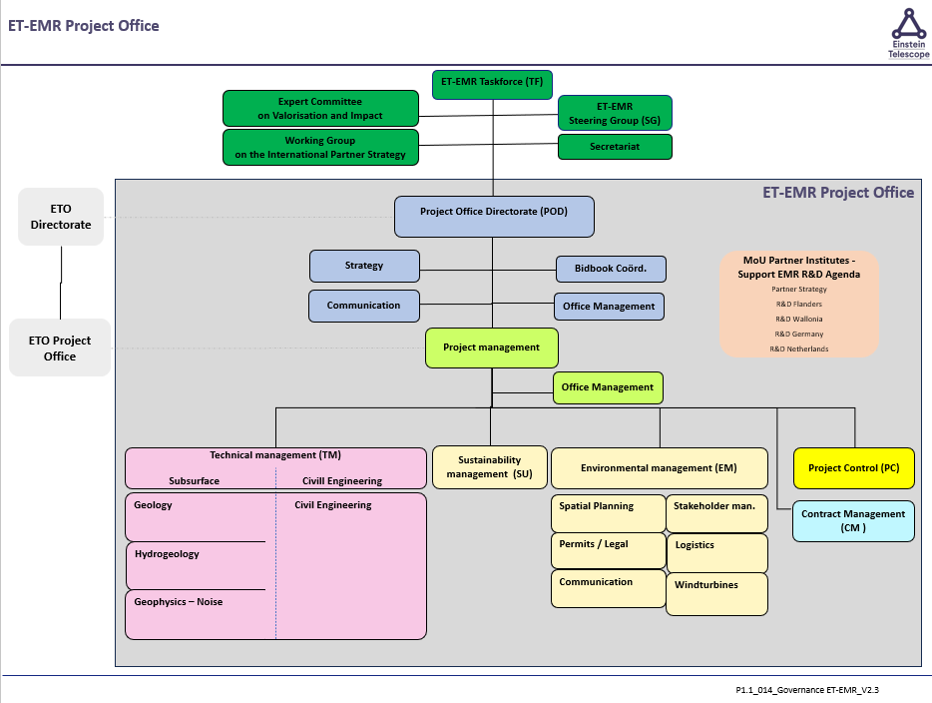

Environment manager:
The Environment Manager is responsible for the field of Environment Management and, together with his team, ensures delivery of relevant products from the product planning. The acceptance of the project by (external and internal) stakeholders is crucial for the success of the project, as is the spatial and social embedding of the project. This makes the Environment Manager the intermediary between the project organisation and stakeholders. This environment is formed by the parties that have an interest in the project.
The Environment Manager anticipates this environment. He establishes and maintains contacts with persons and organisations important to the job. He communicates with technical management about the requirements of and agreements with stakeholders. The environmental management discipline therefore cooperates intensively with the technical management discipline (management of the topsoil-subsoil interface is crucial in the Einstein Telescope feasibility study). The environment manager also works closely with the Sustainability manager, who secures the sustainability aspect in the project. The environmental manager is responsible for the following processes:
- Planning - Permits.
- Conditioning.
- Land matters.
- Stakeholder management.
- Communication.
- Logistics/released materials.
The environment manager organises and leads the environment team and is responsible for the realisation of the OM products. Below is the product schedule in outline: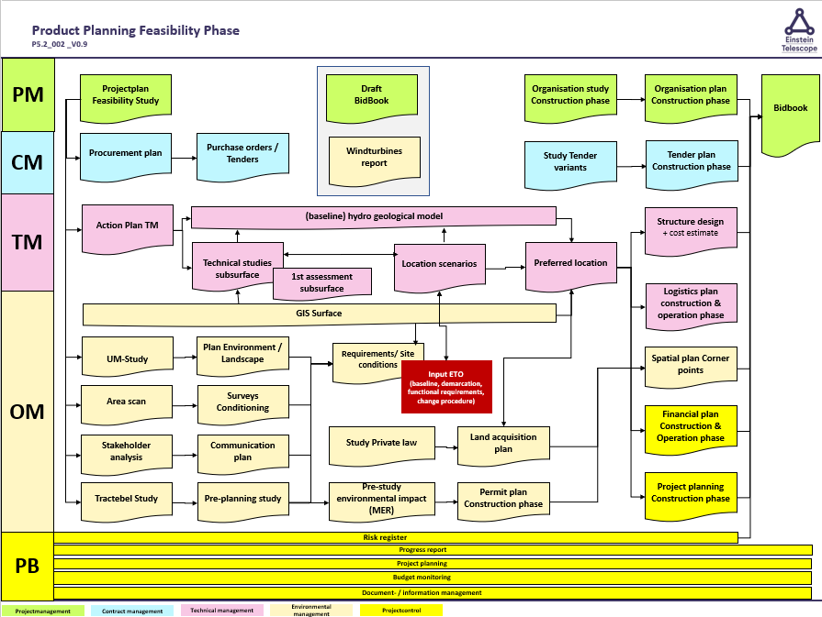

Job requirements:
- Higher education in the technical direction of the project, such as Civil Engineering, Mechanical Engineering, Construction Engineering or related, or (Technical) Business Administration;
- Experience as an environment manager in an IPM team within (large) infrastructure projects.
- Knowledge of systems engineering process (the stakeholder analysis process; retrieving, recording and honouring customer requirements; verifying and validating customer requirements; transferring honoured customer requirements to the technical manager).
- Knowledge of planning processes.
Competencies:
- Political antenna / administrative sensitivity;
- Customer orientation: takes into account the needs and interests of the customer/user and investigates the client's wishes;
- Networking: develops, maintains and exploits relationships and contacts, within and outside the organisation, to acquire information and cooperation. The aim is to embed the project well in the environment;
- Environmental awareness: takes into account relevant external developments and circumstances.
- Verbal and written communication in Dutch and English
- Command of French is considered as an advantage.
- Empathy.
Practical:
- Work location: Maastricht, Duboisdomein 30 (at least 2 days per week on location);
- Duration: from 01-09-2024 to 31-12-2026, 32 hours per week.

