Market consultation

Reading List Management-tool

for

Wageningen University & Research

Reference number: 2024-TN 464935

Version number: 2.0
Date: 07 May 2024

Table of contents
1 General 3
2 Introduction 4
3 Contracting Authority 4
4 What we want to know 5
5 How you can respond 5
6 Continuation 5
7 The procedure – terms and conditions 5
8 Contact 6
9 Time schedule 6
10 Questions 6

General

Definitions
In this document, defined terms are capitalised and defined as follows:

Contracting Authority: | Wageningen University & Research.
Market Consultation: | A market consultation (section 2.25 Aw 2012) is a request for information (RfI) organised by a contracting authority with interested parties about a proposed procurement. Interested parties are often entrepreneurs but can also be interest groups.
TenderNed: | The online electronic procurement environment used by the Contracting Authority; www.TenderNed.nl

Introduction
This publication concerns a Market Consultation for a Reading List Management-tool (further RLM-tool). Our Library is (as far as this consultation concerns), primarily in search of ways to support teachers (and our organization) in being copyright compliant. Further value can be gained by making it easier to set up and share reading lists.
The purpose of this Market Consultation is to gather information from the market that can help us make choices on whether such a tool can be supportive of our goals and can fit our application landscape and processes.
Wageningen University & Research (WUR) offers all potentially interested parties the opportunity to participate in this process. The Market Consultation is public and published for this purpose on the online platforms, TenderNed and Ted.

Contracting Authority
The Contracting Authority is Wageningen University & Research, which is a partnership of Wageningen University and Wageningen Research Foundation.

The cooperation is shaped in five Sciences Groups, within which a department of Wageningen University is functionally integrated with one or more specialised research institutes of the Wageningen Research Foundation.

The organisation chart is as follows:
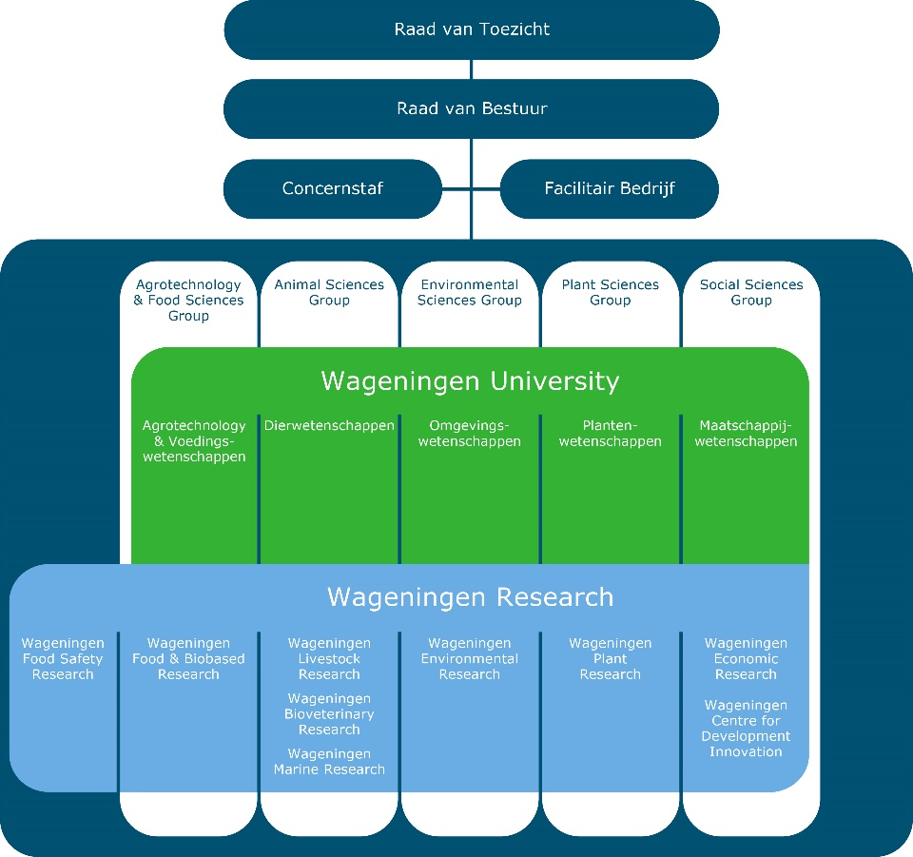

Wageningen University & Research has approximately 6,800 employees (in FTE) and approximately 13,000 students and has offices throughout the Netherlands. More information: Annual report Wageningen University & Research - WUR.

What we want to know
Materials like (electronic) books and articles are critical for our teachers and students to respectively deliver and participate in education. Our university library tries to keep thresholds to use and share materials as low as possible, while being compliant to copyright-law and agreements with publishers when sharing. Copyright-protected materials are common, and therefore we support our teachers to be compliant while sharing these materials. Also, we try to organize our work efficiently. We are interested in what a reading list management-tool can offer us to support us with these challenges.

Our main objective with the introduction of an RLM-tool is to make it possible to set-up a workflow in which teachers indicate which materials they wish to use; the Library can check these materials for availability and compliance issues and students can access the reading lists.

Secondary goals concern:
- Improved availability of reading lists, for instance for students exploring courses and suppliers of materials.
- Centralizing reading lists in one source (instead of multiple, in different applications).
- Optimize the ease with which materials can be added to reading lists by teachers.
- Providing easy access to the materials themselves for students.
- Gaining more insights in the demand for materials and optimize the collection for the library.

Further, the solution …:
- … must integrate seamless with our online learning environment Brightspace from D2L.
- … must integrate seamless with our library discovery tool, Worldcat Discovery from OCLC.
- … must integrate seamless with our library management system, WMS from OCLC.
- … should integrate seamless with our curriculum management tool AscMe from Vorsen.
- … must facilitate that different audiences have different rights (read, edit, delete entries) to reading lists.

To gain insight in the possibilities of an RLM-tool fitting our needs we kindly request participants of this RfI to answer the questions of this RfI.

How you can respond
Please use the Messages (Berichten) module in TenderNed or send an email to the primary contact to ask questions if anything warrants a clarification. You may also require additional information to ensure that you are better able to elaborate your answers to our questions. Feel free to indicate what is missing.

You can respond to the Market Consultation by answering the questions as listed in paragraph 10 Questions of this document and uploading your response document in the sections Other Documents (Overige documenten) in the Tender in TenderNed or via e-mail.

If registering on TenderNed does not work for you, we want to offer potential suppliers the opportunity to participate in this RfI and be able to respond to our questions. Please send an e-mail to the primary contact and we will forward this document to you by e-mail.

Continuation
WUR will use the information received to define its final demand to the market. If the outcome of this RfI gives rise to more comprehensive research, we may get in touch with you to exchange more information.

The procedure – terms and conditions
In addition to the terms and conditions set out elsewhere in this document and its annexes, the following terms and conditions apply to this Market Consultation:
- Market parties are requested to submit their answers to the questions posted by the end of May 21, 2024.
- The Market Consultation is not part of a tender but a consultation round.
- The Market Consultation expressly does not serve to pre-select candidates in the context of any follow-up processes.
- Market parties not participating in the Market Consultation are therefore not excluded from participating in possible follow-up processes. Nor are market parties participating in the Market Consultation in any way excluded from or privileged in possible follow-up processes.
- Market parties (including parties not participating) cannot derive any (mutual) obligations or rights vis-à-vis the Contracting Authority from this Market Consultation.
- Participation in this Market Consultation does not confer any right to obtain a contract.
- Any costs incurred for participation in this Market Consultation will not be reimbursed by the Contracting Authority.
- Participating market parties agree that information provided by them may be used in the tender documents yet to be written by the Contracting Authority for a future tender concerning an RLM-tool. The results from this Market Consultation may be used irreducibly in the tender documents.
- All written and spoken communication in this Market consultation is in English or Dutch.
- The Contracting Authority is in no way bound to the outcome of this Market Consultation or obligated to tender an RLM-tool.
- Input from participating parties will be treated and kept confidential as much as possible.
- The responses can be submitted via the Documents menu in TenderNed or by e-mail.
- There are no formats or layout requirements for answering the questions posed in this document. Market parties may choose to either answer the questions in this document or submit a separate document in custom layout.
- If you wish to ask any further questions about this document, you may do so until Wednesday May 15, 2024, 09:00 am. The answers to all questions will be answered in an (anonymised) information note and published on TenderNed and distributed by e-mail (for those without access) no later than Tuesday May 21, 2024.

Contact
All communication between market parties and Contracting Authority goes through the primary contact person, see below.

Name of Contracting Authority: | Wageningen University & Research
Primary contact person | Sander Dillema
Job title | Purchaser
E-mail | sander.dillema@wur.nl

Please use the Messages module in TenderNed or e-mail the primary contact.

Time schedule
Omschrijving | Datum
Publication of market consultation documents on www.TenderNed.nl | Friday April 26, 2024
Closing date for asking questions | Wednesday May 15, 2024, 9:00 am
Date by which questions will be answered | Tuesday May 21, 2024
Closing date for sending in response to the market consultation | Tuesday May 28, 2024, 17:00 pm

Questions
Please fill in your responses below.

Question | Answer
General information
Question 1
Company information
Company name
Address
Postal code and city
Phone number
Website
Contact details
Name
Title
Phone number
Email address
Form and type of business
What is the organizational structure of your company (independent, holding, etc.)
What are your organisation’s core activities?
In which regions/countries does your company operate?
Specific questions
Question 1: A) Can your organisation provide a solution as described in this document? If so, can you motivate why? If not, specifically what cannot be provided?
B) Can your product integrate with the products mentioned above (see ‘What we want to know’)? If not, do you have any plans to provide this integration in the future?

Question 2: Would your organisation be willing to discuss the possibility to participate in a pilot (so that WUR can gain more insights in the possibilities of introducing an RLM-tool in the organisation)?

Question 3: Can your organisation reference a customer with a similar application landscape to ours as described? If so, please note that we would like to contact this customer to get more insights.

Question 4: We are worried that it will prove difficult to get teachers to enter their reading lists timely and provide suggestions for alternative materials (if needed) with enough time for them to change materials. Can your solution be of help in tackling this challenge? If so, can you motivate your answer?

Question 5: Can you give us an indication of the cost involved with the A) license fees and hosting costs or other SaaS-fees, B) implementation, C) exploitation and D) maintenance E) training of key-users of an RLM-tool? Please note that your answer will be treated confidentially.

Question 6: Based on your professional experience, can you give us an indication of the total time investment required from the selection of an RLM-tool until full exploitation?

Question 7: Based on your professional experience, can you describe the effort (time and/or staff) required of the client during implementation, exploitation, and management of an RLM-tool?

Question 8: Is there anything else that we should be considering before deciding to introduce the RLM-tool as described?

