Metocean Campaigns for Various Wind Farm Sites in the Dutch North Sea

Annex 6

STARTING POINTS AND ASSUMPTIONS

Colophon
Project name | Metocean Campaigns for Various Wind Farm Sites in the Dutch North Sea
Project number | 202306104
Version | Final
File name | VS67_MC_Annex 6 Starting Points and Assumptions
Appendix(ces) | 4
Author | MWI
Reviewed | FvE
Approved | MB

Contents

1 Introduction 4
2 General introduction to the offshore wind energy in the Netherlands 5
2.1 Existing offshore wind farms 5
2.2 The roadmap 2030+ towards 21 GW offshore wind power 5
3 General introduction Investigation Area & Search Areas 8
3.1 Layout & coordinates 8
3.2 Cables and pipelines within the Investigation Area & Search Areas 10
3.3 Units 12
3.4 Vertical and horizontal datum 12
4 Quality requirements 13
4.1 Spatial data 13
4.2 Taxonomy 13
4.3 GIS Metadata requirements 13
4.4 Document control requirements 13
4.5 Standards, formats, templates 14
4.6 Other data 15
4.7 Storage of data (electronic / hardcopy) 15
5 Communication 16
5.1 Confidentiality 16
5.2 Accessibility public information 16
5.3 Authorities 16
5.4 Media 16
5.5 Email 17
Appendix A: GIS Metadata requirements 18
Appendix B: MetOcean Metadata requirements 19
Appendix C: GIS Maps & Packages 20
Appendix D: Sample metadata .xml 21

Introduction
This document provides the starting points and assumptions for the Supply of Metocean Data for Various Sites within the Dutch Offshore Wind Farm Zones Investigation Area. The starting points and assumptions are to be used by Contractors when executing investigations, studies or likewise, for the development of the Various Sites within the Dutch Offshore Wind Farm Zones Investigation Area and commissioned by one of the following organisations:
- The Ministry of Economic Affairs and Climate Policy
- The Ministry of Infrastructure and Water Management
- Netherlands Enterprise Agency (RVO), henceforth Contracting Authority
- Rijkswaterstaat
- TenneT TSO B.V.

This document is part of the QA/QC process for these studies.

Please note:
- This is a living document; before use check for the latest updates (to be confirmed by your Contracting Authority)

If you have any queries, please contact your Contracting Authority.

General introduction to the offshore wind energy in the Netherlands

2.1 Existing offshore wind farms
The Netherlands’ existing offshore wind farms have a combined capacity of approximately 4,700 MW, of which 2,400 MW is fully operational, and another 2,300 MW will be operational at the end of 2023 (see Table 1).
Table 1: Wind Farm in the Dutch North Sea
Windfarm | Sites | Distance of the coast | Year of commissioning | Turbines | Owner
Offshore Wind Farm Egmond aan Zee (OWEZ) |  | 10-18 km | 2008 | 36 Vestas 3 MW | Noordzeewind (joint venture NUON and Shell)
Prinses Amalia Wind Farm |  | 23 km (12 NM) | 2009 | 60 Vestas 2 MW | Eneco
Luchterduinen |  | 23 km (12 NM) | 2015 | 43 Vestas 3 MW | joint venture Eneco and Mitsubishi Corporation
Gemini |  | 85 km | 2017 | 150 Siemens 4 MW | Northland Power, Siemens, Van Oord and HVC
Borssele | I - II | 22 km | 2020 | 94 Siemens 8 MW | Ørsted
Borssele | III - IV | 22 km | 2020 | 77 Vestas 9,5 MW | Blauwwind
Borssele | V | 22 km | 2021 | 2 Vestas 9,5 MW | Two Towers
Hollandse Kust Zuid | I - IV | 18 km | Under Construction | 140 Siemens 11 MW | Vattenfall
Hollandse Kust (noord) | V | 18,5 km | Under construction | 69  11 MW | Crosswind
Hollandse Kust (west) | VI | 53 km | In preparation |  | Ecowende
Hollandse Kust (west) | VII | 53 km | In preparation |  | Oranje Wind Power II

2.2 The roadmap 2030+ towards 21 GW offshore wind power
The Dutch government has created the offshore wind roadmaps 2030+ to set out a schedule of tenders for wind farm permits (see Figure 1 and Table 2). In the beginning of 2022, the Dutch Government announced three new Wind Farm Zones called Lagelander, Nederwiek (Nederwiek zuid site I and Nederwiek noord sites II and III) and Doordewind. The development of the southern part (HKWWFS VIII) of the Hollandse Kust (west) Wind Farm Zone and the IJmuiden Ver Wind Farm Site Gamma in the IJmuiden Ver Wind Farm Zone were also confirmed. The total capacity of offshore wind energy will then be 21 GW and around 90 TWh of power production. This equals around 75% of the current Dutch electricity consumption.

The wind farms will be built in designated Wind Farm Zones. Wind farms outside these Wind Farm Zones are prohibited. Within the designated Wind Farm Zones, the government defines the specific sites where wind farms can be constructed using a so-called Wind Farm Site Decision (‘Kavelbesluit’). This Wind Farm Site Decision contains all conditions for building and operating a wind farm on that specific site.

Developers can apply in tenders for the permits to build and operate a wind farm according to a Wind Farm Site Decision. Winners of these permit tenders will be granted a permit and a grid connection to the mainland.

The Dutch Government provides comprehensive site data and Dutch transmission system operator TenneT is responsible for grid connection. RVO is responsible for the site data, which can be used for the preparation of bids for these tenders.

Table 2: Wind Farm Zones in the Dutch North Sea
Wind Farm Zone | Wind Farm Site | Tender | Capacity | Owner
Borssele | I and II | 2015 | 752 MW | Ørsted Borssele 1 B.V.
Borssele | III and IV | 2016 | 731 MW | Blauwwind II C.V. (Shell, Van Oord, Eneco, Diamond Generating Europe)
Borssele | V | 2016 | 19 MW | Two Towers
Hollandse Kust (zuid) | I and II | 2017 | 740 MW | Chinook (Vattenfall)
Hollandse Kust (zuid) | III and IV | 2018 | 760 MW | Vattenfall
Hollandse Kust (noord) | V | Q4 2019 | 759 MW | Crosswind
Hollandse Kust (west) | VI | 2022 | ≥700 MW | Ecowende
Hollandse Kust (west) | VII | 2022 | ≥700 MW | Oranje Wind Power II
Ten noorden van de Waddeneilanden | I | postponed | ≥700 MW | t.b.d.
IJmuiden Ver | Alpha | Q1 2024 | ≥ 2 GW | t.b.d.
IJmuiden Ver | Beta | Q1 2024 | ≥ 2 GW | t.b.d.
IJmuiden Ver | Gamma | Q2 2025 | ≥ 2 GW | t.b.d.
Nederwiek | I | Q2 2025 | ≥ 2 GW | t.b.d.
Nederwiek | II | 2026 | ≥ 2 GW | t.b.d.
Nederwiek | III | 2026 | ≥ 2 GW | t.b.d.
Hollandse Kust (west) | VIII | 2026/2027 | ≥700 MW | t.b.d.
Ten noorden van de Waddeneilanden | I | 2026/2027 | ≥700 MW | t.b.d.
Doordewind | I | 2027 | ≥ 2 GW | t.b.d.
Doordewind | II | 2027 | ≥ 2 GW | t.b.d.

An overview for the roadmap 2030+ is provided in Figure 1.

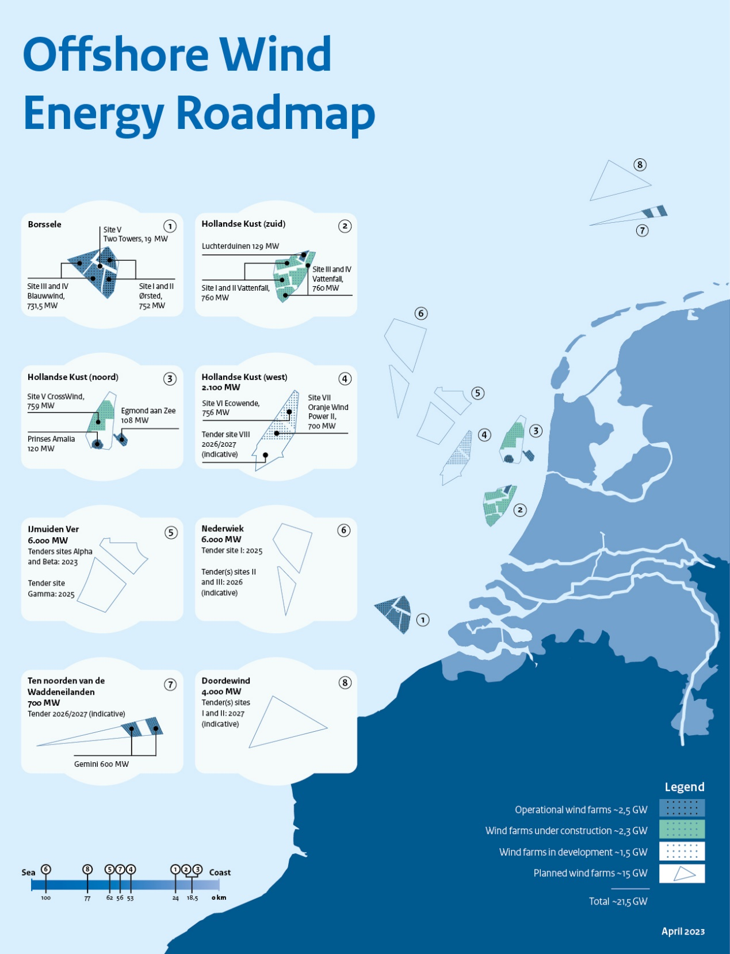
Figure 1: Dutch Offshore Wind Farm Zones overview for roadmap 2030+

General introduction Investigation Area & Search Areas

Layout & coordinates
The Investigation Area (henceforth IA) is located in the Dutch shelf of the North Sea. The Search Areas 6 & 7, 3 and 8 are located within the northern part of the IA (see Figure 2), which are located approximately 40 to more than 150 kilometres off the coast of the Netherlands. General characteristics of the IA are shown in Table 3. Table 4 shows the coordinates of the IA and Table 5 to Table 7 show the coordinates of the individual Search Areas.
A separate map and a GIS dataset of the IA and Search Areas can be found in a zipped file attached in Appendix C: GIS Maps & Packages.
Table 3: Characteristics of the Investigation Area
Characteristics
Water depth | Approximately 10-50 m LAT
Distance from shore | Approximately 40-150 km
Total Investigation Area surface area | Approximately 25,164 km²

Table 4: Coordinates of the Investigation Area
Coordinates Investigation Area
Coordinates according EPSG 25831 – WKID: 25831 Authority ESPG
Point No. | Easting | Northing | Point No. | Easting | Northing
IA_01 | 563161 | 5862811 | IA_16 | 521159 | 5958103
IA_02 | 526946 | 5819240 | IA_17 | 530358 | 5970027
IA_03 | 508514 | 5819926 | IA_18 | 545353 | 6036870
IA_04 | 512326 | 5830227 | IA_19 | 628382 | 6077645
IA_05 | 513740 | 5848219 | IA_20 | 629067 | 6054408
IA_06 | 511689 | 5859339 | IA_21 | 695683 | 6008502
IA_07 | 508479 | 5878009 | IA_22 | 702364 | 5991238
IA_08 | 506805 | 5887691 | IA_23 | 703638 | 5987945
IA_09 | 504989 | 5898196 | IA_24 | 708292 | 5979609
IA_10 | 504552 | 5900695 | IA_25 | 714831 | 5967897
IA_11 | 504578 | 5900696 | IA_26 | 656118 | 5949233
IA_12 | 503778 | 5905881 | IA_27 | 629197 | 5943214
IA_13 | 501017 | 5924596 | IA_28 | 604723 | 5916094
IA_14 | 500174 | 5930335 | IA_29 | 582895 | 5885138
IA_15 | 509576 | 5943453 | IA_30 | 563161 | 5862811

Table 5: Coordinates of Search Area 6 & 7
Search Area 6 & 7
Coordinates according EPSG 25831 – WKID: 25831 Authority ESPG
Surface area: 4,539 km²
Point No. | Easting | Northing | Point No. | Easting | Northing
SA67_01 | 587733 | 5992788 | SA67_12 | 608304 | 6077115
SA67_02 | 538463 | 5987173 | SA67_13 | 628170 | 6085037
SA67_03 | 547764 | 6024837 | SA67_14 | 628497 | 6073575
SA67_04 | 552005 | 6036010 | SA67_15 | 628567 | 6071121
SA67_05 | 554221 | 6041848 | SA67_16 | 628859 | 6060861
SA67_06 | 564157 | 6041978 | SA67_17 | 629047 | 6054265
SA67_07 | 567397 | 6042021 | SA67_18 | 630609 | 6053189
SA67_08 | 580903 | 6042198 | SA67_19 | 629605 | 6051380
SA67_09 | 580726 | 6050115 | SA67_20 | 587899 | 5993020
SA67_10 | 580760 | 6050132 | SA67_21 | 587766 | 5992800
SA67_11 | 580597 | 6059228 | SA67_22 | 587733 | 5992788

Table 6: Coordinates of Search Area 3
Search Area 3
Coordinates according EPSG 25831 – WKID: 25831 Authority ESPG
Surface area: 276 km²
Point No. | Easting | Northing
SA3_01 | 540020 | 5954594
SA3_02 | 530910 | 5966451
SA3_03 | 532261 | 5968131
SA3_04 | 549568 | 5971954
SA3_05 | 565675 | 5974304
SA3_06 | 540020 | 5954594

Table 7: Coordinates of Search Area 8
Search Area 8
Coordinates according EPSG 25831 – WKID: 25831 Authority ESPG
Surface area: 176 km²
Point No. | Easting | Northing
SA8_01 | 596950 | 5916325
SA8_02 | 596007 | 5914579
SA8_03 | 593463 | 5915369
SA8_04 | 580837 | 5919294
SA8_05 | 602809 | 5935198
SA8_06 | 597311 | 5917490
SA8_07 | 596950 | 5916325

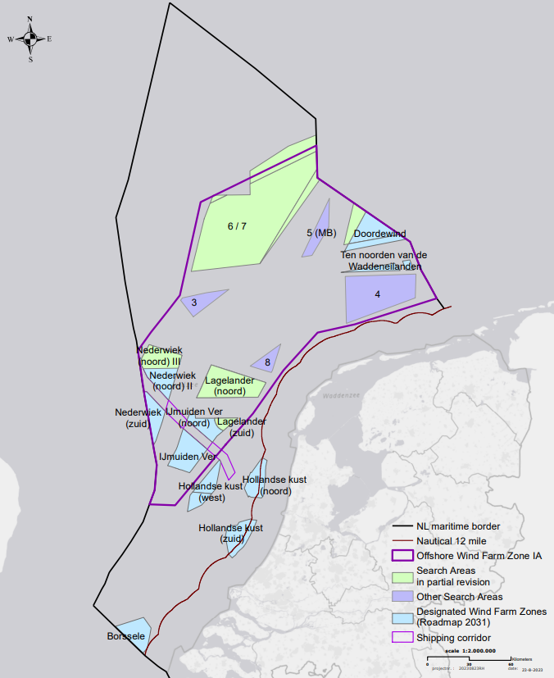
Figure 2: Map of the Offshore Wind Farm Zone Investigation Area, Search Areas in partial revision and other search areas

Cables and pipelines within the Investigation Area & Search Areas
Pipelines and their status, the platforms (above and below water) and cables and their status located within the Investigation Area are illustrated in Figure 3 and Table 8 to Table 11. Digital data on cables, pipelines and platforms can be found in Appendix C: GIS Maps & Packages.
Several inactive cables cross the Search Area 6 and 7 and an active pipeline enters this area to the south connecting to a platform that is not in use. Search Areas 3 has one pipeline in use crossing its area and Search Area 8 has several pipelines in use that cross the area, see Figure 3.
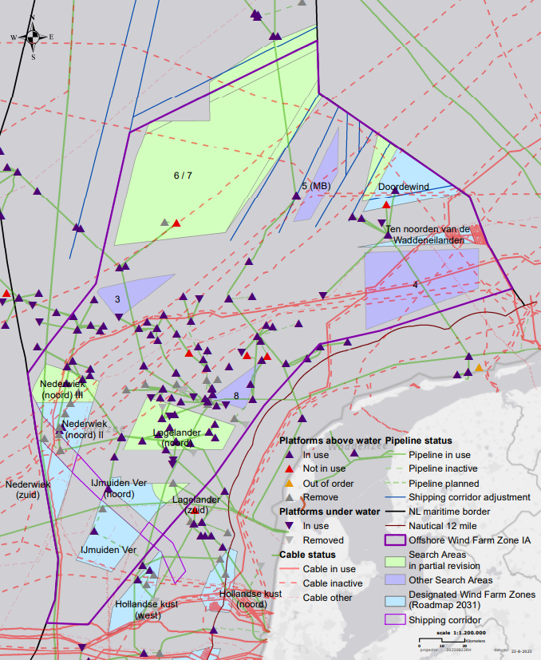
Figure 3: Map of Cables, Pipelines, Platforms within the Investigation Area

Table 8: Characteristics of cables in Search Area 6 & 7
Name | Operator | Trace | Diameter [in] | Type | Status
KB0047 | Eu Networks B.V. | Eemshaven (NL) to England | N/A | Fiber Optic | In-active
KB0070 | British Telecom | Scarborough (GB) to Norggeich (DE) | N/A | Fiber Optic | In-active
KB0024 | Unknown (UKN) | Weybourne (GB) to Esbjerg (DK) | N/A | UKN | In-active
Table 9: Characteristics of pipelines in Search Area 6 & 7
Name | Operator | Trace | Diameter [in] | Type | Status
PL0090_PR | Neptune Energy Netherlands B.V. | F3-FB-1P to L2-FA-1 | 24 | Pipe | Active
PL0168_PR | Wintershall Noordzee B.V. | F16-A to NGT (K2) | 24 | Pipe | Active
Table 10: Characteristics of pipeline in Search Area 3
Name | Operator | Trace | Diameter [in] | Type | Status
PL0142_PR | Noordgastransport B.V. | D15-FA-1 to L10-AC | 36 | Pipe | Active
Table 11: Characteristics of pipelines in Search Area 8
Name | Operator | Trace | Diameter [in] | Type | Status
PL0152_PR | Wintershall Noordzee B.V. | L8-P4 to L11-NGT sidetap | 16 | Pipe | Active
PL0069_PR | Noordgastransport B.V. | L8-G to L11b-A | 14 | Pipe | Active
PL0003_PR | Noordgastransport B.V. | L10-AR to Uithuizen (NL) | 36 | Pipe | Active
PL0083_PR | Noordgastransport B.V. | L11a-A to NGT-Leiding | 10 | Pipe | In-active

Units
SI units (ISO/IEC 8000) are applicable for any activities carried out at the Investigation Area and Search Areas.

Vertical and horizontal datum
The chart datum is Lowest Astronomical Tide (LAT).

All positioning data shall be collected in the European Terrestrial Reference System 1989 (ETRS89)
and projected using ETRS89 Transverse Mercator Coordinate Reference System (UTM Zone 31N).
The reference for this system is EPSG Projection code 25831 - ETRS89 / UTM zone 31N.

Quality requirements
This chapter describes quality requirements including data model and GIS data deliveries. During the process and delivery of the data further information or explanations can be requested at RVO.
As RVO will make this data publicly available, the metadata needs to be in line with the GDPR (AVG) requirements.

Spatial data
All created data in the study must be delivered by the supplier in GIS format. The supplier must comply with the data requirements set out by RVO and provide an inventory list of the deliverables supplied if the data is delivered in the form of a hard drive or webservice. The inventory should include project name, the name of Contractor’s organisation and the person within the organisation responsible for the data delivery; the survey date, the product medium (i.e. hard drive, web service, etc.); and overview of the folder structure and a description of data’s contents.

- All the data is required to be delivered in the geodetic system European Terrestrial Reference System 1989 (ETRS89) ETRS89 UTM ZONE 31 N - EPSG code: 25831 http://www.epsg-registry.org/.
- The data should be delivered in one of the following formats: Value / Parameter Encoded Raster, TIFF or ESRI Shapefile (.shp), ESRI File Geodatabase, or Geopackage (*.gpkg). Should another format be used, this can only be delivered after consulting with RVO.
- Both raw data and processed data along with any relevant GIS workspaces (*. ppkx / *.mpk) are required and should also include the associated reports and charts.
- All GIS data shall be provided with Metadata describing specific details and origin regarding the spatial data.

Taxonomy
All Contractors must use the taxonomy as presented in the taxonomy list, which is available online at:
https://offshorewind.rvo.nl/files/view/dff880d4-9494-4e6d-b398-8fd1f097957e/162642502520210714_taxonomy%20list%20offshore%20wind%20energy_dutch-english.xlsx

GIS Metadata requirements
The requirements for GIS metadata which all Contractors shall comply with is shown in Appendix A of this document.

Document control requirements
The naming of the documents shall be standardized in order to facilitate the document control during the whole project. The following naming code is required for all documents produced within the project:

VS67_Date_Organization_Name document_Author_Version_Status

- VS67: Metocean Campaigns for Various Wind Farm Sites in the Dutch North Sea
- Date: yyyymmdd, e.g. 20240101
- Organization: Name of the organization e.g.
  - ”RVO” for all internal and general documents produced by the Netherlands Enterprise Agency (RVO).
  - Consultant or Contractor name (shortened).
- Name document: Make sure the name clearly explains the content, include here the original name if from external party.
- Author: Abbreviation of the author if an internal document. Author shall be removed for final documents.
- Version: Revision number or date, respectively V01 till V0x_D or 20200101_F.
- Status: (D) for draft documents, (F) for signed final and approved documents.

Standards, formats, templates
All reports will be written in English and include both an English and Dutch management summary.
Contractors provide for each completed study a publishable summary for the Project and Site description. Maximum 2 A4 including some high-resolution pictures or graphs.
All reports must use the terminology as specified in the online taxonomy list (https://offshorewind.rvo.nl/files/view/dff880d4-9494-4e6d-b398-8fd1f097957e/162642502520210714_taxonomy%20list%20offshore%20wind%20energy_dutch-english.xlsx)
All reports must use the terminology as specified in Appendix A of the starting points and assumptions. For your convenience this dictionary is also available as XLSX file.
Reports and deliverables will be delivered by Contractors in pdf and original, regular, formats (docx; xlsx; ppt; etc).
Final reports will have a cover according to the corporate identity of the Netherlands Enterprise Agency, with the following text:
• Front:
Offshore wind energy Netherlands
Metocean Data for Various Sites within the Dutch Offshore Wind Farm Zones Investigation Area
Name document
• Back:
A colophon with the following content:
The creative commons license 4.0 apply to this material. (including a Creative Commons logo and hyperlink to the relevant Creative Commons website page: https://creativecommons.org/licenses/by/4.0/)
• The (investigation) (report) was carried out by <<name Contractor>>, commissioned by RVO, an agency of the Ministry of Economic Affairs. Whilst a great deal of care has been taken in compiling the contents of this document and the mentioned investigations, Netherlands Enterprise Agency (RVO) cannot be held liable for any damages resulting from any inaccuracies and/or outdated information.
• Contact
Netherlands Enterprise Agency (RVO)
Graad van Roggenweg 200 | 3531 AH | Utrecht | The Netherlands
P.O. box 8242 | 3503 RE | Utrecht | The Netherlands
www.rvo.nl/ http://english.rvo.nl
• Netherlands Enterprise Agency (RVO) | Date of publication

Other data
In the case of collected data: primary data must be delivered in regular formats.

Requirements for the Metocean metadata can be found in Appendix B.

Storage of data (electronic / hardcopy)
The Netherlands Enterprise Agency will store all reports and other relevant documents for at least five years electronically.

Communication

Confidentiality
All information provided to Contractors/suppliers by the Ministry of Economic Affairs and Climate Policy and/or the Netherlands Enterprise Agency and/or the Ministry of Infrastructure and Water Management and/or Rijkswaterstaat and/or TenneT must be regarded confidential.

All deliverables produced by Contractors/suppliers remain confidential until a deliverable has been made public by the Ministry of Economic Affairs and Climate Policy and/or the Netherlands Enterprise Agency and/or the Ministry of Infrastructure and Water Management and/or Rijkswaterstaat and/or TenneT.

Accessibility public information
- Site investigations: https://offshorewind.rvo.nl/
- SDE: http://english.rvo.nl/subsidies-programmes/stimulation-sustainable-energy-production-sde
- Wind farm Site Decisions and EIA: https://www.rvo.nl/subsidies-regelingen/bureau-energieprojecten/lopende-projecten
- General Wind at Sea information: https://www.rvo.nl/onderwerpen/windenergie-op-zee
- General Wind at Sea information: https://windopzee.nl/

Authorities

Wind Farm Site Decision (‘Kavelbesluit’):
Ministry of Economic Affairs and Climate Policy
Laura Jansen
E l.e.jansen@minezk.nl
T +31 (0)6-29645189

Rijkswaterstaat:
Raoul Syrier
E raoul.syrier@rws.nl
T +31 (0)6 11072554

Site data:
Netherlands Enterprise Agency
Matté Brijder
E matte.brijder@rvo.nl
T + 31 (0)6 27878952

Grid connection (‘Transmissiesysteem op zee’):
TenneT TSO BV
Johan Dekkers
E johan.dekkers@tennet.euT +31 (0)6 29360328

Netherlands Coast Guard
T +31 0900 0111

Media
All media contacts will be coordinated by the Ministry of Economic Affairs and Climate Policy. If a supplier is approached by press representatives than he/she should refer to the spokesman of the Ministry only.
Ministry of Economic Affairs and Climate Policy
Caspar Itz
c.itz@minez.nl
+ 31 610551061

5.5 Email
All emails related to the site investigations must be send in CC to the project mailbox: VS67@rvo.nl

The subject of an email related to the Various Sites within the Dutch Offshore Wind Farm Zones needs to start with the date and the abbreviation of the Various Sites within the Dutch Offshore Wind Farm Zones so VS67. Then also it needs to be followed by an abbreviation of the type of site survey. E.g. : 20220806 VS67 MC for the Supply of Metocean Data for the Various Sites within the Dutch Offshore Wind Farm Zones Investigation Area.

5.6 Emergency Response
In case of an emergency suppliers are obliged to inform the Netherlands Enterprise Agency immediately.

Appendix A: GIS Metadata requirements

Appendix B: MetOcean Metadata requirements

Appendix C: GIS Maps & Packages

Appendix D: Sample metadata .xml

