Market Consultation
CW, narrow-bandwidth titanium-sapphire (TiSa) laser system with frequency-downconversion unit

Date version: 29 January 2024

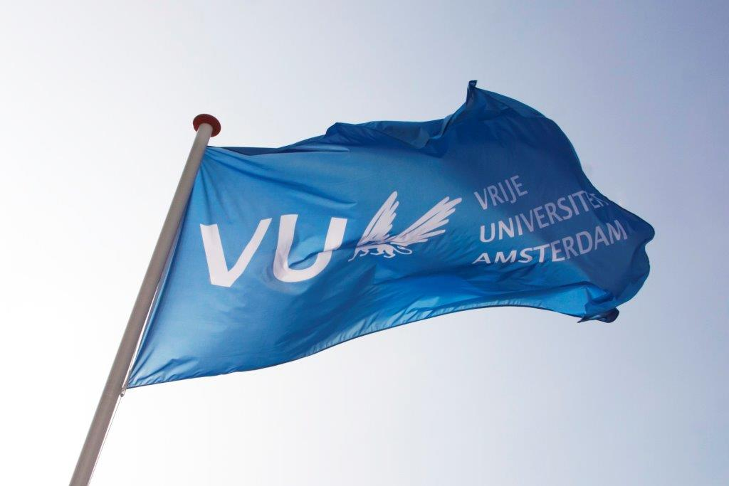
Contents

1. Background information regarding the application………………………………………………………………………..…3
2. Required specifications of the TiSa Laser System………..........................……..…………………………..…………3
3. Procedure and timetable of the Market Consultation …………………………………………………..…………………4
4. Other terms and conditions ………………………………………………………………………………………....…………………5

Background information regarding the application

The Vrije Universiteit Amsterdam (VU) is a large innovative university which actively contributes to developments in education and research. For more information about the VU, see https://www.vu.nl/en
The Department of Physics and Astronomy has the intention to acquire a cw, narrow-bandwidth TiSa laser system for precision measurements in small molecules.
The purpose of this market consultation is to find potential suppliers of such an instrument. Candidates are invited to respond on the basis of the information provided in this document regarding functional specifications, delivery, service provision and other conditions.
If, after requesting the information, you decide not to respond further, we kindly request you to notify us.
To be clear: this is NOT a quote request.

2. Required specifications of the Ti:Sa Laser system

2.1 General description
Fully automated and compact “out of plane” tunable Ti:Sa ring laser with additional cavity length stabilization via an external reference cavity and difference-frequency mixing unit with periodically poled crystals.
The Ti:Sa laser should be field-serviceable, i.e., the customer should be able to align the ring cavity.

2.2 The Ti:Sa laser system should include the following features:
Hardware
- High-power 532nm CW DPSS pump laser (20W, Power Stability: ±1%, Noise: < ±0.04% rms, Spatial Mode: TEM00, M2 <1.1, Beam Pointing Stability: <2 urad/°C).
- Chiller, Solid State Rack-mounted.
- Ultra-Narrow Linewidth Tunable Ti:Sapphire Ring Laser (fully automated and compact Out of Plane tunable Ti:Sa ring laser with additional cavity length stabilization via an external reference cavity, option to readily upgrade for higher resolution, 50 GHz of mode-hop-free tuning, Scan Stitching, Dynamic Scan Range, Adjustable Low Frequency Locking, Linewidth: <50 kHz (measured over 100 msec), Spatial Mode: TEM00, Beam Diameter: 0.8-1.0 mm (typical), Divergence: <1.2 mrad (half angle), Noise: <0.1% rms (above pump noise, added in quadrature, broadband option 668-1068nm, wavemeter coupling).
- Difference Frequency Mixer for Tunable CW Lasers (requency mixing of the output from a tunable CW laser and a fixed 1550 nm CW fiber laser in periodically polled crystals, unable from 1650-2800 nm with built in temperature stabilization and motorized crystal selection).
Note: fiber laser is provided by customer
- Baseplate to mount pump laser and ringlaser.

2.3 Other features
- Warranty of at least 1 year for the instrument.
- Free software upgrades during warranty
- Phone and remote support are always available.

2.4 Delivery
Preferred delivery of the TiSa Laser System is Fall 2024.

2.5 Price
The purchase price (our budget) is max. 215k€ and includes all costs, such as shipping & handling, installation and implementation, training and documentation, and any additional costs for travel, accommodation, training and testing.

3. Procedure and timeline of the market consultation

During the market consultation, all communication with regard to this subject is conducted via the purchasing management department of the VU University. Contact details, see below:
Name: | Purchasing Management Department  Dhr. Tarik Ouchan
Faculty / Department  : | Finance Department
Address: | Van der Boechorststraat 1  1083 BT Amsterdam
E-Mail: | aanbestedingen.fpc@vu.nl
Citing | Market Consultation: (TiSa) laser system

Timetable Market Consultation:
Description | Deadline
Publication on www.tenderned.nl | 29-01-2024
Deadline for questions | 09-02-2024, 11.00 a.m.
Publication Memorandum of Information | 13-02-2024
Last moment to submit response | 19-02-2024, 11:00 a.m.
Sending summary to participants and closing the market consultation process | 23-02-2024

You are requested to respond to this market consultation no later than 11:00 am on 19-02-2024. Responses received after this period will no longer be considered.
The VU would like to give you the opportunity to ask any questions you may have about this market consultation.
You can do this by e-mail until 09-02-2024, 11:00 a.m. at the latest. You should send your application and questions by e-mail to aanbestedingen.fpc@vu.nl for the attention of the Purchasing Management department.
When submitting your response, please include TiSa Laser System in the subject line.
Answers to the questions will be published on Tenderned by means of an information memorandum by 13-02-2024 at the latest.
The VU will keep the option open to invite parties, in response to the submitted responses, to provide additional explanations to your answers orally and/or by means of a presentation. The VU will contact these parties and schedule a meeting in consultation.
The results of the market consultation can be used as input for any tender to be followed. After the market consultation has ended, written feedback of the market consultation is provided to all respondents in the form of a summary of the answers, taking into account any commercial interests of the parties. This feedback does not affect the obligation of the market consultation. Prices and/or rates are excluded from publication.
Candidates who have participated in this market consultation and who have answered the questions will receive the summary by e-mail, no later than 23-02-2024.
This summary will also be published as an appendix to any tender to be followed.

4. Other terms and conditions
In addition to the terms and conditions stated elsewhere in this document, this market consultation is subject to the following terms and conditions:
• Parties cannot derive any (mutual) obligations or rights towards the VU from this market consultation;
• Participation in this market consultation does not guarantee a role as supplier;
• Any costs for participating in this market consultation will not be reimbursed by the VU;
• The official language during this market consultation is in principle English;
• the VU is in no way bound by the results of the market consultation or obliged to realize and/or tender for the subject to which the market consultation relates;
• Claims about the use of information, confidentiality or requests for compensation in connection therewith will not be honored;
• The VU reserves the right to suspend this market consultation temporarily or permanently.

