Market Consultation
Single Cell Microscope

Date version: 19 December 2023

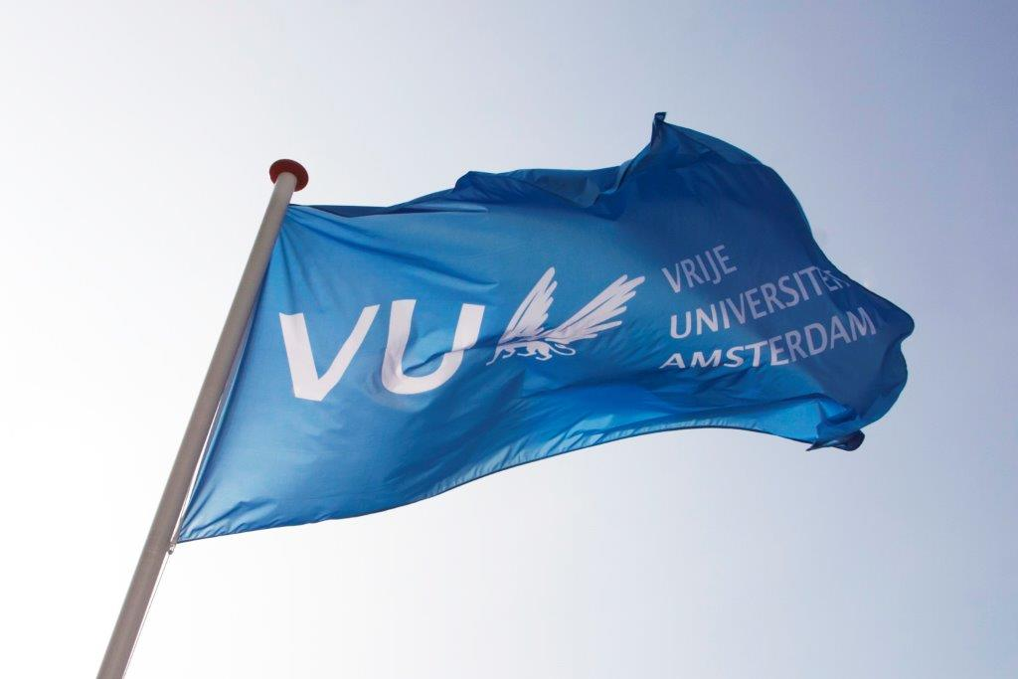
Contents

1. Background information regarding the application………………………………………………………………………..…3
2. Required specifications of the Single Cell Microscope ..........................……..…………………………..…………3
3. Procedure and timetable of the Market Consultation …………………………………………………..…………………4
4. Other terms and conditions ………………………………………………………………………………………....…………………5

Background information regarding the application

The Vrije Universiteit Amsterdam (VU) is a large innovative university which actively contributes to developments in education and research. For more information about the VU, see https://www.vu.nl/en
The Amsterdam Institute for Life and Environment (A-LIFE), has the intention to acquire a super-sensitive and flexible fluorescent microscope to measure various functions in individual living cells, such as gene expression, protein localization and diffusion, and concentration of certain metabolites.
The purpose of this market consultation is to find potential suppliers of such an instrument. Candidates are invited to respond on the basis of the information provided in this document regarding functional specifications, delivery, service provision and other conditions.
If, after requesting the information, you decide not to respond further, we kindly request you to notify us.
To be clear: this is NOT a quote request.

2. Required specifications of the Single Cell Microscope

2.1 General description
the Single Cell Microscope should be fa fully motorized inverted research microscope, with a motor xy-stage with >20 mm/s travel speed and 0.1 um encoder resolution
The system minimum requirements are listed below.

2.2 The Single Cell Microscope should include the following features:
Hardware
- The system should be a complete set of hardware and software according to the specifications below, and rack mounted.
- Hardware autofocus system which optimally performs in combination with detection of (far-) red fluorescence (>765nm)
- Hardware autofocus system with long effective focus range (> 600 µm at 10X and > 4 µm at 100X) and compatible with plastic bottom multiwell carriers
- Motorized 6-position fluorescent filter cube turret with ability to hold dichroic mirrors sized ≥ 44 x 32 mm to minimize vignetting
- Motorized 14-position fluorescent emission filter turret which can mount 32 mm emission filters to minimize vignetting
- Automatic recognition and calibration of multi-well plates
- LED lightsource with minimal: 400, 435, 470, 500, 550, 580, 635, 740nm
- LED lightsource which can house 25 mm excitation filters for each channel to negate necessity of slow and vibration-inducing excitation filterwheel
- Objective lenses: 10X with ≥ 0.3NA, 40X with ≥ NA1.30, 100X ≥ NA1.45
- sCMOS monochrome, ≥ 22 mm FOV (pixel size 6.5 μm x 6.5 μm), QE 95%, ≥ 498 FPS at full frame
- Optical image splitter with bypass functionality for performing simultaneous detection of two channels (CFP + YFP, CFP + RFP and GFP + mCherry)
- Parallel operation of emission filterwheel movement and LED lightsource utilizing electronic camera output signal
- Microscope enclosure for thermal control of sample stage and objective lens environment
2.3 Other features
- Warranty of at least 1 year for the instrument.
- Free software upgrades during warranty
- Phone and remote support are always available.

2.4 Delivery
Preferred delivery of the Single Cell Microscope is early or Spring 2024.

2.5 Price
The purchase price (our budget) is max. 200k€ and includes all costs, such as shipping & handling, installation and implementation, guarantees, training and documentation, and any additional costs for travel, accommodation, training and testing.

3. Procedure and timeline of the market consultation

During the market consultation, all communication with regard to this subject is conducted via the purchasing management department of the VU University. Contact details, see below:
Name: | Purchasing Management Department  Dhr. Tarik Ouchan
Faculty / Department  : | Finance Department
Address: | Van der Boechorststraat 1  1083 BT Amsterdam
E-Mail: | aanbestedingen.fpc@vu.nl
Citing | Market Consultation: Single Cell Microscope

Timetable Market Consultation:
Description | Deadline
Publication on www.tenderned.nl | 20-12-2023
Deadline for questions | 03-01-2024, 11.00 a.m.
Publication Memorandum of Information | 08-01-2024
Last moment to submit response | 12-01-2024, 11:00 a.m.
Sending summary to participants and closing the market consultation process | 19-01-2024

You are requested to respond to this market consultation no later than 11:00 am on 12-01-2024. Responses received after this period will no longer be considered.
The VU would like to give you the opportunity to ask any questions you may have about this market consultation.
You can do this by e-mail until 03-01 2024, 11:00 a.m. at the latest. You should send your application and questions by e-mail to aanbestedingen.fpc@vu.nl for the attention of the Purchasing Management department.
When submitting your response, please include Single Cell Microscope in the subject line.
Answers to the questions will be published on Tenderned by means of an information memorandum by 08-01-2024 at the latest.
The VU will keep the option open to invite parties, in response to the submitted responses, to provide additional explanations to your answers orally and/or by means of a presentation. The VU will contact these parties and schedule a meeting in consultation.
The results of the market consultation can be used as input for any tender to be followed. After the market consultation has ended, written feedback of the market consultation is provided to all respondents in the form of a summary of the answers, taking into account any commercial interests of the parties. This feedback does not affect the obligation of the market consultation. Prices and/or rates are excluded from publication.
Candidates who have participated in this market consultation and who have answered the questions will receive the summary by e-mail, no later than 19-01-2024.
This summary will also be published as an appendix to any tender to be followed.

4. Other terms and conditions
In addition to the terms and conditions stated elsewhere in this document, this market consultation is subject to the following terms and conditions:
• Parties cannot derive any (mutual) obligations or rights towards the VU from this market consultation;
• Participation in this market consultation does not guarantee a role as supplier;
• Any costs for participating in this market consultation will not be reimbursed by the VU;
• The official language during this market consultation is in principle English;
• the VU is in no way bound by the results of the market consultation or obliged to realize and/or tender for the subject to which the market consultation relates;
• Claims about the use of information, confidentiality or requests for compensation in connection therewith will not be honored;
• The VU reserves the right to suspend this market consultation temporarily or permanently.

