Market Consultation
Tunable IR laser

Datum version: 21 November 2023

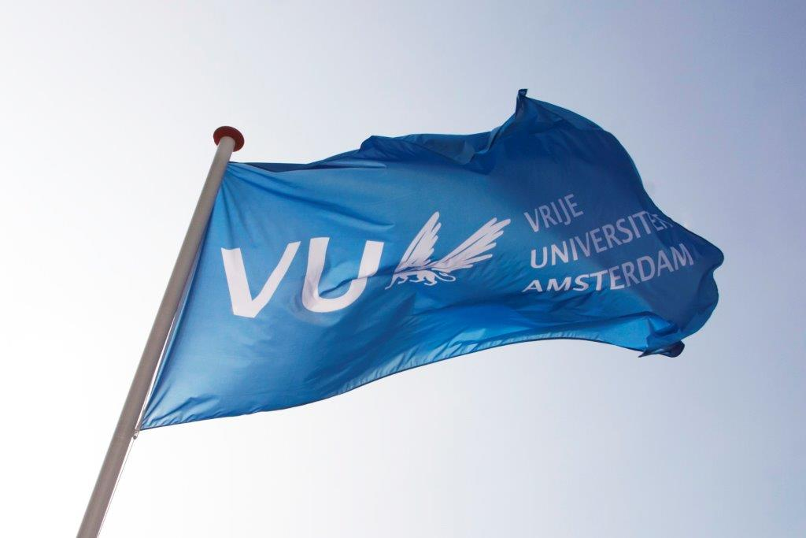
Contents

1. Background information regarding the application……………………………………………………………………..…3
2. Required specifications of the IR laser.……..........................……………………………………………………………3
3. Procedure and timetable of the Market Consultation ……………………………………………………………………5
4. Other terms and conditions ………………………………………………………………………………………..…………………6

Background information regarding the application

The Vrije Universiteit Amsterdam (VU) is a large innovative university which actively contributes to developments in education and research. For more information about the VU, see https://www.vu.nl/en
The Division of BioAnalytical Chemistry (BAC), of the Chemistry and Pharmaceutical Sciences department, has the intention to acquire a high power, high repetition rate and highly tunable infrared laser for infrared spectroscopy in use with mass spectrometry.
The purpose of this market consultation is to find potential suppliers of such an instrument, which fulfill our specific demands (listed below) and price point, in order to give direction on which procurement procedure the Vrije Universiteit Amsterdam should follow for this purchase.
Therefore, we ask potential suppliers to respond based on the information provided in this document regarding technical product specifications, functional specifications of the listed main applications, delivery, service provision and other conditions.
If, after requesting the information, you decide not to respond further, we kindly request you to notify us.
To be clear: this is NOT a quote request.

2. Required specifications of the IR laser

2.1 General description
The infrared laser should be a turn-key system, that is tunable in a large wavelength range in the infrared (2.5 – 20 µm). It should have a high repetition rate (< 50 MHz range), a linewidth of less than 15 cm⁻¹ over the entire wavelength range and high average power (> 500 mW for 2.5-3.5 µm, >35 mW for 3.5-10 µm, >5 mW at 15 µm and >0.5 mW at 20 µm).

2.2 The IR laser should include the following features:
Hardware (general)
- The system should be a complete set of hardware and software according to the specifications below.
- The system should be a single operating system, without the need to change between separate modules.
- The wavelength range should be gapless tunable between 2.5 and 20 µm.
- The spectral bandwidth should be less than 15 cm⁻¹ and constant over the entire tuning range.
- Pulse duration should be in the picosecond range and constant over the entire tuning range.
- Output power stability (<0.5 % rms in 24 hours) is required.
- Between 2.5 and 3.5 µm the output power should be minimal 500 mW, while between 3.5 and 10 µm this should be minimum 35 mW.
- Wavelength should be very highly reproducible (< 1 cm⁻¹ over multiple hours), when repeatedly cycled through a sequence of identical wavelength settings.
- Wavelength should be highly stable over long periods of time (<0.005 % rms and <0.3 cm⁻¹/h) without active feedback.
- Spectral beam profile should be constant over the entire tuning range.
- The speed of the wavelength tuning should be controllable and able to vary between very slow (1 cm⁻¹/min) to very fast (100 cm⁻¹/s).
- The whole system has to be smaller than 1.00 m x 0.50 m x 0.16 m (l x b x h).
Software
- The laser system should have accompanying software, and should be controllable by an external computer.
- The software should be user-friendly and grant access to all system features, in particular the possibility of putting in a start and end wavelength and tuning speed.
- The software should support simultaneous system control through a user program (e.g., python or LabVIEW).
- The software must supply a “set and repeat” modality that enables precisely and rapidly returning the laser system to a previous system state (desired switching time < 5s) without intermediate optimization.
Other features
- Warranty of at least 1 year for the instrument.
- Free software upgrades during warranty.
- Phone and remote support are always available.
- The IR laser is deliverable within 7 months of purchase.

2.3 Budget
The purchase price includes all costs, such as shipping & handling, installation and implementation, guarantees, training and documentation, and any additional costs for travel, accommodation, training and testing.

3. Procedure and timeline of the market consultation

During the market consultation, all communication with regard to this subject is conducted via the purchasing management department of the Vrije Universiteit Amsterdam. Contact details, see below:
Name: | Purchasing Management Department  Dhr. Tarik Ouchan
Faculty / Department  : | Finance Department
Address: | Van der Boechorststraat 1  1083 BT Amsterdam
E-Mail: | aanbestedingen.fpc@vu.nl
Citing | Market Consultation: Highly tunable IR laser

Timetable Market Consultation:
Description | Deadline
Publication on www.tenderned.nl | 21 November 2023
Deadline for questions | 30 November 2023, 11:00 a.m.
Publication Memorandum of Information | 4 December 2023
Last moment to submit your interest | 11 December 2023, 11:00 a.m.
Sending summary to participants and closing the market consultation process | 19 December 2023

You are requested to respond to this market consultation no later than 11:00 am on 11 December 2023. Responses received after this period will no longer be considered.
The VU would like to give you the opportunity to ask any questions you may have about this market consultation. You can do this by e-mail until 30 November 2023: 11.00 a.m. at the latest. You should send your application and questions by e-mail to aanbestedingen.fpc@vu.nl for the attention of the Purchasing Management department. When submitting your response, please include "Tunable IR laser” in the subject line.
Answers to the questions will be published on Tenderned by means of an information memorandum by 4 December 2023 at the latest.
The VU will keep the option open to invite parties, in response to the submitted responses, to provide additional explanations to your answers orally and/or by means of a presentation. The VU will contact these parties and schedule a meeting in consultation.
The results of the market consultation can be used as input for any tender to be followed. After the market consultation has ended, written feedback of the market consultation is provided to all respondents in the form of a summary of the answers, taking into account any commercial interests of the parties. This feedback does not affect the obligation of the market consultation. Prices and/or rates are excluded from publication.
Candidates who have participated in this market consultation and who have answered the questions will receive the summary by e-mail, no later than 19 December 2023.
This summary will also be published as an appendix to any tender to be followed.

4. Other terms and conditions
In addition to the terms and conditions stated elsewhere in this document, this market consultation is subject to the following terms and conditions:
• Parties cannot derive any (mutual) obligations or rights towards the VU from this market consultation;
• Participation in this market consultation does not guarantee a role as supplier;
• Any costs for participating in this market consultation will not be reimbursed by the VU;
• The official language during this market consultation is in principle English;
• the VU is in no way bound by the results of the market consultation or obliged to realize and/or tender for the subject to which the market consultation relates;
• Claims about the use of information, confidentiality or requests for compensation in connection therewith will not be honored;
• The VU reserves the right to suspend this market consultation temporarily or permanently.

