Market consultation on intended call for tenders for a FIT test method for the purpose of population screening for colorectal cancer



Date: 9 October 2023
Version: 1.0
CONTENTS

1. Introduction 3
1.1 Bevolkingsonderzoek Nederland 3
1.2 Population screening for colorectal cancer 3
1.3 The reason for this market consultation 4
1.4 Indication of the contract for the FIT test method 4
1.5 Indicative scope 5
2. Market consultation premises 5
2.1 The premises 5
2.2 Timetable 6
2.3 Communication during the market consultation 6
2.4 Rounding off the market consultation and report 6
3. Questionnaire 6
Annex 1 Questionnaire 7
Annex 2 Draft SoR 8

Introduction

Bevolkingsonderzoek Nederland
The Dutch health screening organisation Bevolkingsonderzoek Nederland (hereinafter: ‘BVO NL’) is responsible for conducting breast cancer, cervical cancer and colorectal cancer screenings. These population screenings are part of the National Population Screenings Programme undertaken by the Dutch Ministry of Health, Welfare and Sport. BVO NL is an organisation that employs approximately 900 staff members. The high-quality population screenings that BVO NL conducts contribute substantially to the early detection of cancer for the purposes of achieving health benefits and reducing mortality.

Population screening for colorectal cancer

At the instruction of the Dutch National Institute for Public Health (RIVM), BVO NL is responsible for conducting population screenings for colorectal cancer (‘PSCRC’). Colorectal cancer is a common form of cancer: in 2021, almost 13,000 people were diagnosed with the disease. Because colorectal cancer has a clear preliminary stage and develops slowly, it can be diagnosed and treated early. The national population screening for colorectal cancer was introduced in 2014 and is available to men and women aged 55 to 75. The screening uses a stool test called Faecal Immunochemical Test (‘FIT’) for haemoglobin to look for blood in stool. If the test results show a higher haemoglobin level than the cut-off level, the participant is referred for an intake for a colonoscopy. The purpose of this bowel examination is to detect and remove adenomas (a pre-stage of colorectal cancer) and colorectal cancer. In 2021, more than 1.6 million people participated in the screening. Cancer was found in more than 2,700 participants.
The illustration below provides a schematic overview of the population screening for colorectal cancer.

Primary process
Schematic representation of the population screening for colorectal cancer, including subsequent care
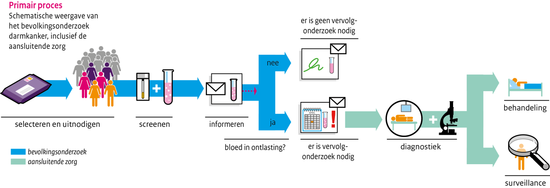
subsequent care
population screening
treatment
diagnostics
no follow-up examination necessary
follow-up examination is needed
no
yes
blood in stool?
informing
selection and invitation
screening

In January 2023, BVO NL instructed the Core Team to prepare and carry out the calls for FIT chain tenders for the PSCRC. Specifically, this concerned the following tenders:

- FIT test method (stool test, consumables, instruments and service);
- Analysis services (screening laboratories for implementing the test method);
- Preparing and handling postage packages for the PSCRC;

In addition to the above, the call for tenders for the Packaging for the population screening for cervical cancer (‘PSCC’) is also part of the project. That call involves the procurement of the following supply and service:

- Preparing and handling postage packages for the PSCC.

At present, the analytical services are performed by four laboratories. This number might still change in the new call.

More information is available (in Dutch) on the RIVM’s website at: Beleidskader Bevolkingsonderzoeken naar Kanker | RIVM (Policy Framework for Population Screenings for Cancer) and Uitvoeringskader bevolkingsonderzoek darmkanker | RIVM (Implementation Framework for Population Screenings for Colorectal cancer).

The reason for this market consultation

BVO NL organises the process of the population screening at national level. The process consists mostly of outsourced services and supplies. The underlying agreements were concluded based on European tender procedures. To guarantee the continuity of the population screening, new agreements must be concluded and implemented sufficiently ahead of time.

This market consultation concerns the call for tenders for the FIT test method.
BVO NL values the opinions of market parties and wishes to consult with them before calling for tenders. Therefore, in preparation for the call, BVO NL will conduct a written market consultation. In the consultation, market parties are asked to provide information that can be used to help flesh out the details of the call. The information and understanding that is gathered can help to improve the tender procedure.

Indication of the contract for the FIT test method

The FIT test method that BVO NL wishes to procure for its population screening for colorectal cancer consists of a number of elements. It involves supplying and implementing analytical instruments, the associated reagents and self-collection tubes for performing FIT analyses, including IT interfaces and other services.
In this phase, the services and products requested are broadly defined as follows:
Supplying the FIT test method, which consists of:

- supplying, testing, putting into operation, maintaining and optimising analytical instruments and peripherals (at multiple locations) and the associated reagents, calibrators and controls (including installation & implementation) for the purpose of automated and validated FIT analysis;
- supplying, testing, putting into operation, maintaining/optimising one or more interfaces between the hardware and software required by the contractor and BVO NL’s software, which includes ScreenIT (in consultation between BVO NL and the laboratories that will be contracted);
- supplying self-collection tubes, including buffer and instructions for use;
- supplying the consumables for the FIT test method;
- providing user support (instruction and other support);
- providing implementation, regular services and exit services.

For a better understanding of the contract, the draft Schedule of Requirements (‘SoR’) is attached as Annex 2. Important: this is a draft and is not yet final. The scope of the contract will be finalised during the tendering phase.

Note: The supervision of quality assessment and the control materials used for that purpose was procured in the past and has since been entrusted to Foundation for Quality Assessment in Medical Laboratory Diagnostics (SKML), which also plays a role in the present call in helping to draft and monitor the performance criteria.

Indicative scope

The indicative scope of the agreement that will be concluded can best be described based on the number of self-collection tubes needed for inviting the target group to participate in the population screening for colorectal cancer and the number of self-collection tubes that will be returned to the laboratories for analysis using analytical instruments that the contractor will supply.

The expected scope of the population screening for colorectal cancer is based on the situation at present (persons aged between 55 and 75 receive an invitation to participate once every two years) is:
Year | # Invitations* | # Analyses* | Average # of analyses per day * | Minimum # of analyses per day * | Maximum # of analyses per day *
2026 | 2,125,083 | 1,551,311 | 6,205 | 562 | 12,683
2027 | 2,140,004 | 1,562,203 | 6,249 | 566 | 12,772
2028 | 2,145,682 | 1,566,348 | 6,265 | 567 | 12,806
2029 | 2,144,151 | 1,565,230 | 6,261 | 567 | 12,796
2030 | 2,135,114 | 1,558,633 | 6,235 | 564 | 12,743
2031 | 2,125,128 | 1,551,343 | 6,205 | 562 | 12,683
2032 | 2,113,676 | 1,542,983 | 6,172 | 559 | 12,615
2033 | 2,099,397 | 1,532,560 | 6,130 | 555 | 12,529
2034 | 2,089,720 | 1,525,496 | 6,102 | 552 | 12,472

* These are projected numbers. The actual numbers might differ.

BVO NL prefers to conclude a long-term agreement. As a consequence, long-term developments regarding population screening for colorectal cancer must be anticipated as best as possible now. These are developments that might take place in the coming years and that might affect the services and products under the call, e.g., changes to the interval between invitations, changes to the target group’s age group, changes to the invitation period after a colonoscopy, personalising the invitation packages and fluctuations in the participation rate.

Market consultation premises

The premises

This market consultation is based on the following premises. By participating in the market consultation, the participating market party affirms without any reservations that it agrees to the provisions described here.
- Based on the response that you submit, BVO NL will have the option of contacting you for further clarification or to ask questions.
- No rights can be derived from the market consultation. Participating in the market consultation will not affect the tender procedure that might follow.
- You cannot claim compensation for any costs you incur in connection with the market consultation.
- BVO NL reserves the right to use the understanding and information that this consultation yields to prepare the tender documents. However, BVO NL may also decide not to.
- Any confidential business information that you provide will be treated confidentially. BVO NL expects you to identify any business information that is confidential.
- In this market consultation, BVO NL at all times assumes a level playing field for all market parties.
- The information provided by BVO NL during the market consultation will be published at the start of the tender procedure. The information provided by BVO NL during the market consultation might deviate from the information provided during later phases of a tender procedure.
- Information provided by participating parties will not be returned after the market consultation.

Timetable

The envisaged timetable for the tender procedure is shown in the table below. This schedule is still indicative. No rights can be derived from it. BVO NL is at liberty to decide at a later point in time to temporarily or permanently discontinue the market consultation and/or possible tender.

Milestone | Date
Publication of the market consultation document | 9 October 2023
Opportunity to ask questions about the market consultation procedure | before 1.00pm on 13 October 2023
Closing date for submitting responses to the market consultation | before 1.00pm on 26 October 2023
Optional: in-depth talks and/or presentations. Invitations will follow after responses have been submitted in the market consultation. | Week 44 (30 October – 3 November) 2023

Communication during the market consultation

Communication will take place using TenderNed’s messaging module. You can consult the messaging module if you have any questions about the procedure and other matters and/or comments on the market consultation. Market parties are asked to first submit their written answers to the questions listed in Annex 1. You can also include comments in Annex 2 (SoR), which you may also submit through TenderNed.

Rounding off the market consultation and report

To round off the market consultation, BVO NL will prepare a report in anonymous form, summarising the main findings from the market consultation. That report will be added as an annex to the tender documents when the call for tenders goes out.

Questionnaire

You are kindly requested to answer the questions listed in Annex 1. You can fill in your answers in the Word document. You can then submit the completed document plus attachments through TenderNed in accordance with the timetable set out at 2.2 above.

Annex 1 Questionnaire

Annex 2 Draft SoR

