Market consultation effects of Vibropiling on marine mammals and specifically the harbour porpoise

Asking for creative and/or cooperative ideas!

Wozep
In 2016, the Ministry of Economic Affairs commissioned RWS to deploy an integrated research program to reduce the knowledge gaps with regard to the effects of offshore wind farms on the North Sea ecosystem. This program has been initiated, based on previous experience with research and monitoring for wind farms, coming to the conclusion that the knowledge gaps are mainly of a generic nature rather than specific for a certain wind farm. In addition, a central research program can be managed more efficiently. This resulted in the Offshore Wind Energy Ecological Program (Wozep). Wozep phase 1 has a duration from 2016-2023 and has been extended into phase 2 with a duration from 2024-2030. Wozep research results are used in the Ecology and Cumulation Framework (KEC). With the KEC, the cumulative effects of the existing and proposed wind farms on the species with a protected status is tested.

The Wozep program focuses on the following themes:
- Bird collisions and habitat loss;
- Bats;
- Marine mammals and underwater noise;
- Benthos, fish and electromagnetic fields;
- Ecosystem changes
- Data and information management.

Background information about Wozep and completed research reports are published on the Noordzeeloket. https://www.noordzeeloket.nl/en/functions-and-use/offshore-wind-energy/ecology/offshore-wind-ecological-programme-wozep/

The Wozep project has the following goals:
- Reduce the uncertainty surrounding the assumptions and knowledge gaps of the KEC, MERn and PBn;
- Reduce the uncertainty surrounding the assumptions and knowledge gaps around long-term effects in the scaling up of offshore wind energy (for future road maps for the deployment of offshore wind energy).
- Gain insight into the effectiveness of mitigating measures.

The assignment
As part of the Wind at Sea Ecological Program (Wozep), Rijkswaterstaat intends to commission research into the effects of vibropiling (the driving in of piles) on marine mammals and in particular on the harbor porpoise, similar to the research into the effects of pile driving on marine mammals (Kastelein et al., 2015; Kastelein et al., 2017). By conducting a market consultation, Rijkswaterstaat wants to determine which parties can contribute to this study or be able to conduct the entire study.

Vibratory hammers function differently from ordinary pile drivers; instead of hard blows at intervals, the piles are struck more gently where intervals are much shorter or even absent. The piles can be said to be vibrated into the ground. A vibratory hammer strikes with less energy so the sound produced by striking a pile is also less loud. Next to that, the frequency of the sound is different. As a result, the effects on the hearing, behavior and health of porpoises and other marine mammals may also be different from traditional pile drivers. Until now, the main focus has been on the disturbance caused by this noise, because more severe effects (see Fig 1.) occurred in a much smaller area and the most severe could be prevented with mitigation measures. However, for noise of a different nature, like vibropiling, disturbance may not be the most important aspect determining population effects.

Furthermore, the effects must be quantified so it can be determined how much effect the construction of future wind farms will have on the harbor porpoise population. Different types of effects (Fig 1.) must also be able to be converted into a suitable input for population models, either in the form of disturbance days or in the form of population parameters such as probability of survival and reproduction. Effects on other marine mammals such as the two seal species (common and gray seal) found in the North Sea and other marine mammal species should not be forgotten.

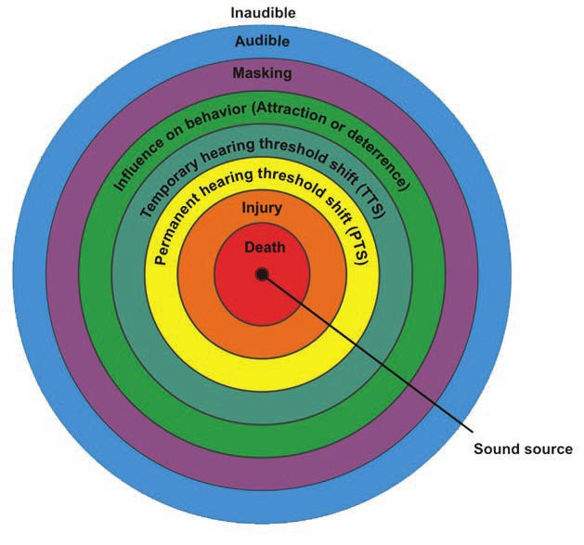

Fig 1: Different type of effects of noise on a marine mammal in order of severity and distance from the source of the noise. This is a simplified schematic representation of the degree and order of severity of different effects. For a complete list, see Table 2 of Southall et al., 2021.

It is important to know in what ways effects lead to changes in behavior or physiological differences that in turn converge to changes in so-called vital rates (Fig 2). Research is needed under controlled conditions on noise as well as on porpoises, to understand the extent of the area in which different effects are felt, the duration of these effects and how they can be converted into population effects.

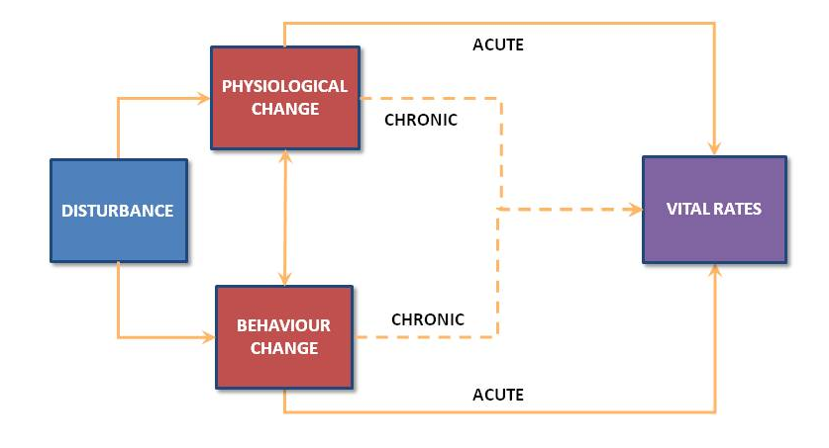
Fig 2. Effects of disturbance on marine mammals.

Questions
Research should be directed towards answering the questions listed below. Where particular research needs to be conducted in a particular order because of interdependencies, this should also be indicated. The sound signal required for this research will be provided if needed.

- What effects on porpoise hearing (TTS, PTS and masking, see Southall et al., 2021) and fitness in the evolutionary sense (death, disturbance and also TTS, PTS and masking, see Southall et al., 2021) are most likely and what is the range in which they occur?
- What is the duration of these effects and at what level are effects on so-called vital rates (Fig 2) likely?
- How can the magnitude of these effects on the individual be measured?
- How can the effects on the individual be calculated that they form the input for the model used by the Dutch government to calculate the effects of Wind at Sea on the population of the harbor porpoise?

Form of consultation
Parties wishing to express interest in this research must have the following facilities, experience and qualifications:

- Parties are asked to indicate their ability to conduct this research to answer the government's questions.
- Parties must have suitable facilities to conduct such a study under controlled conditions; for example, a research facility in which acoustic and behavioral studies can take place that is quiet enough so that influences of outside noise on the results can be excluded, and whose acoustic properties are known.
- Parties must be able to provide the necessary specifics on these facilities.
- In the case of research with live animals, parties must have one or more porpoises with normal representative hearing as evidenced by an audiogram (Kastelein et al., 2017) and behavior. These porpoises must be trained to participate in hearing and behavioral studies.
- Parties must have the technical means for generating low frequencies of sound corresponding to vibration noise.
- Furthermore, knowledge and experience in acoustic and behavioral research on porpoises is preferred, for example by reports and publications on similar research conducted by researchers still associated with the company.
- Parties can enter into a collaboration to be able to supplement parts of these requirements that they do not have with facilities or expertise from other parties.
- The research must be completed by the end of 2024.

However, we are open to receive creative/out-of-the-box ideas that could also answer our research questions even if the party does not comply with the above mentioned demands. We do ask to clearly state why the demands are not applicable to the set proposal.

Literature:

Southall, B. L., Nowacek, D. P., Bowles, A. E., Senigaglia, V., Bejder, L., & Tyack, P. L. (2021). Marine mammal noise exposurecriteria: Assessing the severity of marine mammal behavioral responses to human noise. Aquatic Mammals, 47(5), 421–464.ry

Kastelein, R. A., Helder-Hoek, L., & Van de Voorde, S.(2017). Hearing thresholds of a male and a female harbor porpoise (Phocoena phocoena). The Journal of the Acoustical Society of America, 142(2), 1006-1010.

Kastelein, R. A., Gransier, R., Marijt, M. A. T., & Hoek,L. (2015). Hearing frequencies of a harbor porpoise(Phocoena phocoena) temporarily affected by playedback offshore pile driving sounds. The Journal of the Acoustical Society of America, 137(2), 556-564.

