Market Consultation

of Mass Spectrometers and lasers for The Netherland state-of-the-art Isotope GEochemistry Laboratory (NIGEL).

Date version: July 11 2023

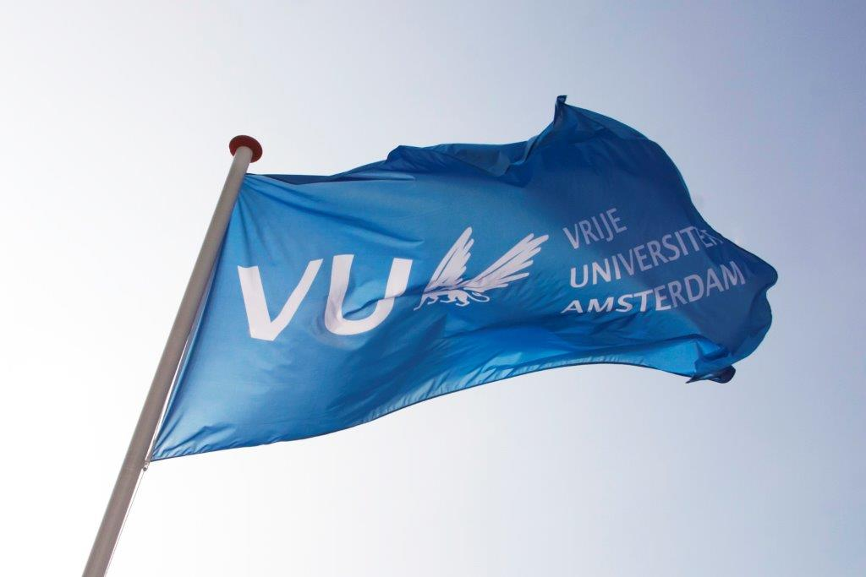
Contents

1. Background information regarding the application………………………………………………………………………..…3
2. Required specifications of the Frequency Comb Laser..........................……..…………………………..…………3
3. Procedure and timetable of the Market Consultation …………………………………………………..…………………5
4. Other terms and conditions ………………………………………………………………………………………....…………………6

1. Background information regarding the application
The Vrije Universiteit Amsterdam (VU) is a large innovative university which actively contributes to developments in education and research. For more information about the VU, see Vrije Universiteit Amsterdam (vu.nl)
The Netherlands state of the art Isotope GEochemistry Laboratory (NIGEL) will be established at the Vrije Universiteit Amsterdam in 2024. It will enable cutting edge multi-disciplinary research by the Earth & planetary science, archaeology, forensic and cultural heritage research communities. In conjunction with the fabrication of a new clean laboratory, future research will utilise the latest technological improvements to analyse precise and accurate trace-element and isotopic compositions in all these disciplines.
NIGEL will be housed in a new building that contains both a purpose built mass spectrometry laboratory and a new generation metal free clean laboratory that will allow optimal exploitation of the new technology and a marked increase in capacity. The latter is needed given the major increase in demand for isotopic analysis from outside the traditional Earth & planetary science disciplines.
The assignment consists of the purchase of a total of five mass spectrometer systems and their peripheries plus two laser ablation system. The reason for the purchase is the establishment of a national facility funded by the Dutch Research Council (NWO).
The purpose of this market consultation is to find potential suppliers of the full instrument package. Candidates are invited to respond on the basis of the information provided in this document regarding functional specifications, delivery, service provision and other conditions.
If, after requesting the information, you decide not to respond further, we kindly request you to notify us.
To be clear: this is NOT a quote request.

2. Required specifications of the instruments

2.1 General description
Two technologies in particular will be used. First, sensitive mass spectrometer (MS) detection systems with amplifiers using 10¹³ Ω resistors, pioneered at Vrije Universiteit, Amsterdam (VU), will allow analysis of small samples (<10 ng) opening innovative research directions where sample size is limited. Second, improvements in collision/reaction cell technology on MC-ICP-MS instruments fitted with pre-cell mass filtering technology, will allow separation of isobaric interferences. This technology will open up new research avenues, particularly in laser ablation analysis.

2.2 The new facility should include the following instrumentation:
- two multi-detector thermal ionization mass spectrometers fitted with 10¹³ Ω resistor amplifiers;
- two new multi-detector inducted coupled plasma mass spectrometers one fitted with a reaction cell and pre-cell mass filter both including 10¹³ Ω resistor amplifiers;
- An inductively coupled plasma triple quadrupole mass spectrometer;
- Inductively coupled plasma optical emission spectrometer.
- A nano and femto second laser ablation system that will allow optimal sampling of a diverse range of materials.
The aim is to purchase all the instrumentation from a single manufacturer to optimise software synergy.

2.3 Requirements
- A single package to deliver five mass spectrometers, one Inductively coupled plasma optical emission instrument and two laser ablation systems.
- Two thermal ionization multi-collector mass spectrometers (TIMS) with precise moveable Faraday collectors with resolution of 0.005 mm.
- Two multi-collector Inductively coupled plasma mass spectrometers (MC-ICPMS) with precise moveable Faraday collectors with resolution of 0.005 mm.
- One MC-ICPMS with MS/MS functionality that combines a pre-cell mass filter with collision cell technology for interference removal across a wide range of masses.
- All four multi-collector mass spectrometers (2 x TIMS & 2 x MC-ICPMS) with functionality for switchable amplifiers that in combination include 10¹⁰, 10¹¹, 10¹³ Ω resistors.
- Inductively coupled plasma mass spectrometers (MC-ICPMS) and Inductively Coupled Plasma Optical emission spectrometer (ICP-OES).
- All four plasma source instruments should operate on a common software system that can be interfaced with laser ablation systems.
- Nano and femtosecond laser ablation systems each fitted with a two volume ablation cell with internal stages and interchangeable tube cell and slow washout inner chamber.

2.4 Other features
- A full warranty of at least 1 year for all the instrumentation with a further 5 year warranty on parts for the mass spectrometers.
- Free software upgrades during warranty.
- Phone and remote support are always available.
- Preferred delivery of the instruments is June / July 2024.

2.5 Price
The purchase price includes all costs, such as shipping & handling, installation and implementation, guarantees, training and documentation, and any additional costs for travel, accommodation, training and testing.

3. Procedure and timeline of the market consultation
During the market consultation, all communication with regard to this subject is conducted via the purchasing management department of the VU University. Contact details, see below:
Name: | Purchasing Management Department  Dhr. Tarik Ouchan
Faculty / Department  : | Finance Department
Address: | Van der Boechorststraat 1  1083 BT Amsterdam
E-Mail: | aanbestedingen.fpc@vu.nl
Citing | Market Consultation: Mass Spectrometers and lasers for The Netherland state-of-the-art Isotope GEochemistry Laboratory (NIGEL)

Timetable Market Consultation:
Description | Deadline
Publication on www.tenderned.nl | 12-07-2023
Publication Memorandum of Information on TED | 14-07-2023
Deadline for asking questions | 28-07-2023, 11:00 a.m.
Answering the questions (information memorandum) | 04-08-2023
Last moment to respond to this market consultation | 11-08-2023, 11:00 a.m.
Sending summary to participants and closing the market consultation process | 18-08-2023

The VU would like to give you the opportunity to ask any questions you may have about this market consultation.
You can do this by e-mail until 28-07-2023, 11:00 a.m. at the latest. You should send your application and questions by e-mail to aanbestedingen.fpc@vu.nl for the attention of the Purchasing Management department.
You are requested to respond to this market consultation no later than 11:00 am on 18-08 2023. Responses received after this period will no longer be considered.
When submitting your response, please include ‘Mass Spectrometers and lasers for The Netherland state-of-the-art Isotope GEochemistry Laboratory (NIGEL)’ in the subject line.
Answers to the questions will be published on Tenderned (and send by e-mail) by means of an information memorandum by 04-08-2023 at the latest.
The VU will keep the option open to invite parties, in response to the submitted responses, to provide additional explanations to your answers orally and/or by means of a presentation. The VU will contact these parties and schedule a meeting in consultation.
The results of the market consultation can be used as input for any tender to be followed. After the market consultation has ended, written feedback of the market consultation is provided to all respondents in the form of a summary of the answers, taking into account any commercial interests of the parties. This feedback does not affect the obligation of the market consultation. Prices and/or rates are excluded from publication.
Candidates who have participated in this market consultation and who have answered the questions will receive the summary by e-mail, no later than 18-08-2023.
This summary will also be published as an appendix to any tender to be followed.
4. Other terms and conditions
In addition to the terms and conditions stated elsewhere in this document, this market consultation is subject to the following terms and conditions:
- Parties cannot derive any (mutual) obligations or rights towards the VU from this market consultation;
- Participation in this market consultation does not guarantee a role as supplier;
- Any costs for participating in this market consultation will not be reimbursed by the VU;
- The official language during this market consultation is in principle English;
- the VU is in no way bound by the results of the market consultation or obliged to realize and/or tender for the subject to which the market consultation relates;
- Claims about the use of information, confidentiality or requests for compensation in connection therewith will not be honored;
- The VU reserves the right to suspend this market consultation temporarily or permanently.

