Market Consultation
High-intensity amplified femtosecond Ytterbium laser

Datum versie: 22 March 2023

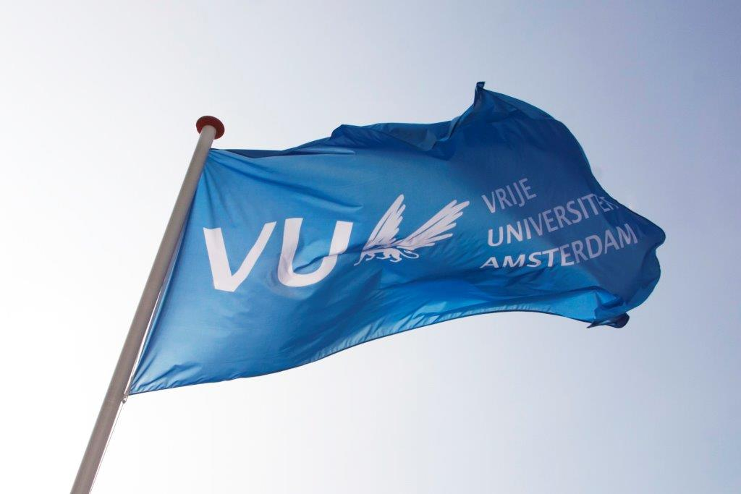
Contents

1. Background information regarding the application………………………………………………………………………..…3
2. Required specifications of the High-intensity amplified femtosecond Ytterbium laser……………………..3
3. Procedure and timetable of the Market Consultation …………………………………………………..…………………4
4. Other terms and conditions ………………………………………………………………………………………....…………………5

Background information regarding the application

The Vrije Universiteit Amsterdam (VU) is a large innovative university which actively contributes to developments in education and research. For more information about the VU, see https://www.vu.nl/en
The section of Biophotonics & Medical Imaging, at the Physics and Astronomy department, has the intention to acquire a high-intensity and high power, amplified, femtosecond Ytterbium laser system as a source for a novel phototransient infrared imaging platform.
The purpose of this market consultation is to find potential suppliers of such an instrument. Candidates are invited to respond on the basis of the information provided in this document regarding functional specifications, delivery, service provision and other conditions.
If, after requesting the information, you decide not to respond further, we kindly request you to notify us.
To be clear: this is NOT a quote request.

2. Required specifications of the high-intensity amplified femtosecond Ytterbium laser

2.1 General description
The amplified femtosecond laser system should be turn-key with a small footprint and deliver high-intensity, sub-200 femtosecond, pulses, centred around 1030 nm at a moderate repetition rate of several thousands of Hertz with the possibility to easily change both the pulse duration and the repetition rate.

2.2 The amplified femtosecond Ytterbium laser system should include the following features:
Hardware
• The system should be a complete set of hardware, software and chiller unit (if necessary).
• The repetition rate should be adjustable in a range of at least 1 Hz – 1 MHz
• Base operation wavelength should be around 1030 nm +- 10 nm
• Minimum output power should be at least 20 W. This output power may be limited to a narrower repetition rate range than the 1 Hz – 1 MHz specified above
• Pulses with an intensity of, at least, 2 mJ should be available while operating the laser at 20 W output power. This intensity may be limited to a narrower repetition rate range than the 1 Hz – 1 MHz specified above
• Pulse durations of shorter than 200 fs are required, with the possibility to tune the pulse duration to several picoseconds
• Pulse energy stability of <0.5 % RMS deviation (24 h) is required
• Good pre/post pulse contrast required pre-pulse: <1:1000; post-pulse: <1:200

2.3 Other features
- Warranty of at least 1 year for the instrument.

2.4 Delivery
Preferred delivery of the Laser System is as soon as possible. We would like to know which lead time is possible.

2.5 Price
The purchase price includes all costs, such as shipping & handling, installation and implementation, guarantees, training and documentation, and any additional costs for travel, accommodation, training and testing.

3. Procedure and timeline of the market consultation

During the market consultation, all communication with regard to this subject is conducted via the purchasing management department of the VU University. Contact details, see below:
Name: | Purchasing Management Department  Dhr. Tarik Ouchan
Faculty / Department  : | Finance Department
Address: | Van der Boechorststraat 1  1083 BT Amsterdam
E-Mail: | aanbestedingen.fpc@vu.nl
Citing | Market Consultation: High-intensity amplified femtosecond Ytterbium laser

Timetable Market Consultation:
Description | Deadline
Publication on www.tenderned.nl | 24-03-2023
Deadline for questions | 05-04- 2023, 11:00 a.m.
Publication Memorandum of Information | 07-04-2023
Last moment to submit answers | 14-04-2023, 11:00 a.m.
Sending summary to participants and closing the market consultation process | 21-04- 2023

You are requested to respond to this market consultation no later than 11:00 am on 14-04 2023. Responses received after this period will no longer be considered.
The VU would like to give you the opportunity to ask any questions you may have about this market consultation.
You can do this by e-mail until 05-04 2023, 11:00 a.m. at the latest. You should send your application and questions by e-mail to aanbestedingen.fpc@vu.nl for the attention of the Purchasing Management department.
When submitting your response, please include "High-intensity amplified femtosecond Ytterbium laser” in the subject line.
Answers to the questions will be published on Tenderned by means of an information memorandum by 07-04- 2023 at the latest.
The VU will keep the option open to invite parties, in response to the submitted responses, to provide additional explanations to your answers orally and/or by means of a presentation. The VU will contact these parties and schedule a meeting in consultation.
The results of the market consultation can be used as input for any tender to be followed. After the market consultation has ended, written feedback of the market consultation is provided to all respondents in the form of a summary of the answers, taking into account any commercial interests of the parties. This feedback does not affect the obligation of the market consultation. Prices and/or rates are excluded from publication.
Candidates who have participated in this market consultation and who have answered the questions will receive the summary by e-mail, no later than 21-04-2023.
This summary will also be published as an appendix to any tender to be followed.
4. Other terms and conditions
In addition to the terms and conditions stated elsewhere in this document, this market consultation is subject to the following terms and conditions:
• Parties cannot derive any (mutual) obligations or rights towards the VU from this market consultation;
• Participation in this market consultation does not guarantee a role as supplier;
• Any costs for participating in this market consultation will not be reimbursed by the VU;
• The official language during this market consultation is in principle English;
• the VU is in no way bound by the results of the market consultation or obliged to realize and/or tender for the subject to which the market consultation relates;
• Claims about the use of information, confidentiality or requests for compensation in connection therewith will not be honored;
• The VU reserves the right to suspend this market consultation temporarily or permanently.

