Annex A Program of Requirements (PoR)

General information about location and installation aspects

Astron, LOFAR distributed Radio-Telescope with central location in Exloo (Drenthe)

The White Rabbit switches will be used to provide a central clock system for the Dutch part of the LOFAR telescope.
The Low Jitter Switches will be placed in a Central location, distributing the clock signal to all stations where the standard White Rabbit switches will provide the clock to the stations

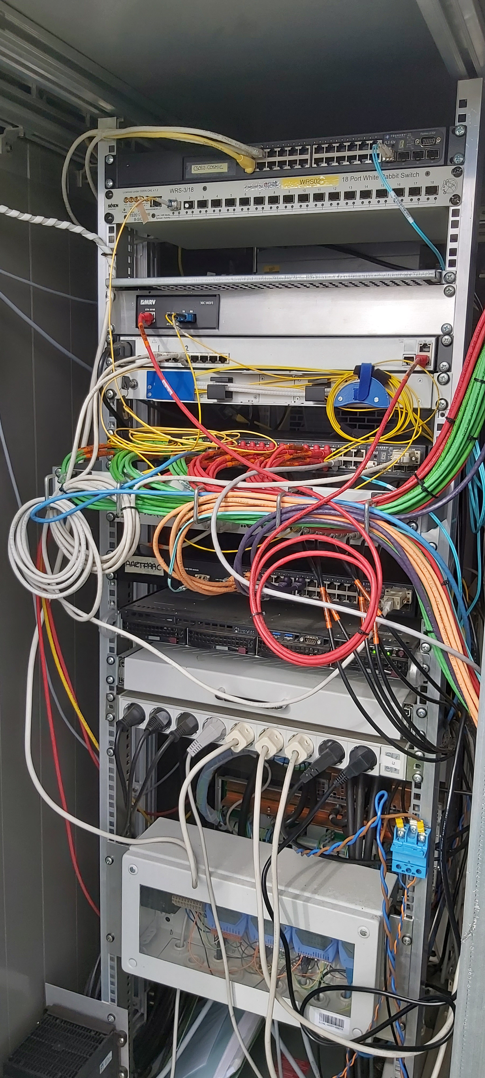
Figure 1: Lofar station Rack with a WR switch installed

Conformity matrices

 | Function | Minimum Requirement |  |  |  |  |  |  | Confirm  Yes/no
R1 | Allan deviation | 10 sec 1.1·10-11
 | (from clock coherence time)
R2 | Drift | <0.125ns / hour
R3⋆ | Clock inputs | 1PPS
R3⋆ | Clock inputs | 10MHz
R3⋆ | Clock inputs | SMA type prefered
R4 | Management inputs | USB terminal connection
R4 | Management inputs | RJ45 1000BASE-T
R5⋆ | Outputs | 1pps
R5⋆ | Outputs | 10MHz
R5⋆ | Outputs | SMA type prefered
⋆ R3 and R5 are no requirements but are wishes. (Information Annex B)
 | Function | Minimum Requirement |  |  |  |  |  |  | Confirm  Yes/no
R6 | Synchronization input, in order to be able to synchronize to i.e. GPS | PPS timing
R6 |  | Amplitude |  | Minimal 1.5 Vpeak-peak
R6 |  | Rise/fall time |  | <3nsec |  |  | <1usec
R6 |  | Jitter |  | <40psec |  |  | <1usec
R6 |  | Pulse width |  | 20-100usec |  |  | >100nsec
R6 |  | Alignment with 10MHz phase |  | <0.2ns (+/- 7 degrees)
R6 |  | output |  | 10MHz
R6 |  | Level (50 Ohm) |  | 13 | +/- 1 |  |  | dBm
 |  | Phase Noise [dBc/Hz]
 |  |  | WR switch LJ |  |  | WR switch
 |  | 1Hz | -95 |  |  | -80
 |  | 100Hz | -115 |  |  | -100
 |  | 100kHz | -138 |  |  | -130
R7 | No. of SFP ports | Minimal 18
R8 | Master availability | at least 99.9%
R9 | Slave availability | at least 99.5%
R10 | Monitoring and control | Ethernet Lan HTTP
 |  | SNMP protocol
 |  | Remote control via ethernet
R11 | Firmware version | V6.01 or newer
 | Function | Minimum Requirement |  |  |  |  |  |  | Confirm  Yes/no
R12 | Hardware version | Based on CERN open hardware design, compatible with CERN hardware. Minimal hardware version V3.4
R13 | PTP support | IEEE 1588-2019 with support for external equipment
R14 | Warranty | Warranty at least 2 years
R15 | Service | - In case of a fault the supplier shall reply within 48 hours  - Supplier shall make a service proposal description of the provided service during the life time (maintenance and malfunctions)  - Manuals and (electrical) schematics shall be provided by supplier
R16 | Service | Replacement equipment should be available within 48 hours for the first 5 years
R17 | EMC compliance | IEC EN 61000-6-2  Electromagnetic compatibility (EMC).  Generic standards. Immunity standard for industrial environments.
R18 | Electro Magnetic Compatibility Information Technology Equipment | Compliant to the CISPR 22 / EN 55022 Class B  standard
R19 | CE approval | The switches shall comply with Conformité Européenne (CE) standard
R20 | Size | Size should be 1U of 19 inch rack space and a maximum depth of 40 cm. (Figure 1 shows the position of a WR switch in a LOFAR station)
R21 | Firmware | Firmware version should be based on CERN open hardware
R22 | Operational environment conditions | 5-50 Celsius, 5-85% humidity

