

Technical Specification Replacement TCS Gas Turbine and Generator

Content
1. INTRODUCTION 1
1.1. About Uniper 1
1.2. RoCa-3 1
1.3. TCS Replacement 2
2. Codes and standards 3
3. Plant Description 5
3.1. MK V Hardware 5
3.2. MK V Software 8
4. Scope of Supply 9
4.1. General 9
4.2. Exclusions 10
4.3. Fixed Scope of Supply – Dismantling and Removal of Speedtronic Mk V Equipment 10
4.4. Fixed Scope of Supply – Installation of new Gas Turbine Control Cabinet 10
4.5. Fixed Scope of Supply – Functional Safety Design Phase and Safety Instrumented System 11
4.6. Fixed Scope of Supply – Functional Safety Sensors and Final Elements 12
4.7. Fixed Scope of Supply – Modification of the Existing Drawing Set 12
4.8. Fixed Scope of Supply – Quarterly Review Visits 13
4.9. Fixed Scope of Supply – System Finger-print 13
5. TECHNICAL Requirements 15
5.1. General 15
5.2. System Requirements 15
5.3. Functionality 16
5.4. Operator Interface 16
5.5. Workstations 17
5.6. Engineering Station 17
5.7. Integration and Interface with Existing Systems 18
5.8. Integration and Interface with New Systems 18
5.9. Diagnostic Facilities 18
5.10. Alarms 19
5.11. Redundancy – Non Safety. 19
5.12. Data Recording, Logging and Archiving Equipment 20
5.13. Interfaces to the PI System 20
5.14. System Remote Access and Cyber Security 20
5.15. Software and Licences 21
5.16. Tag Names and Descriptions 22
5.17. Power Supplies 22
5.18. Cabling 23
5.19. Communications 23
5.20. Environmental Conditions 23
5.21. Electromagnetic Compatibility 24
5.22. Housings 24
5.23. Identification 25
5.24. Fuses and Fault Protection 25
5.25. Earthing 26
6. Inspection and testing 27
6.1. General 27
6.2. Site Survey 27
6.3. Type Testing 27
6.4. Factory Acceptance Test (FAT) 27
6.5. Installation 28
6.6. Site Testing and Commissioning 29
6.6.1. Pre-Commissioning Tests. 30
6.6.2. Commissioning Tests 30
6.7. Site Acceptance Testing 30
7. Warranty 32
8. Spares 32
9. Maintenance and support 32
10. Training 33
11. Project Management 33
12. Information and documentation requirements 35
12.1. Documentation with Bid 35
12.2. Documentation Requirements 36

ACRONYMS/ABBREVIATIONS
Abbreviation | Meaning
BIOS | Basic Input / Output System
CP | Communications Processors
CPU | Central Processing Unit
DCS | Distributed Control System
FAT | Factory Acceptance Test
HMI | Human Machine Interface
HV | High Voltage
IEC | International Electrotechnical Commission
IP | Internet Protocol
IS | Intrinsically Safe
ISO | International Organization for Standardization
I/O | Input / Output
LAN | Local Area Network
LCD | Liquid Crystal Display
KKS | Kraftwerk-Kennzeichensystem
OS | Operator Station
PC | Personal Computer
SAT | Site Acceptance Tests
SIL | Safety Integrity Level
SIS | Safety Instrumented System
TCS | Turbine Control System, specifically the Mk V SpeedTronic or its replacement.
TCP/IP | Transmission Control Protocol/Internet Protocol
VDU | Visual Display Unit

INTRODUCTION
This specification covers the technical aspects for the replacement of the Turbine Control System (TCS) for the Gas Turbine and Generator at the Uniper Roca facility.

About Uniper

Uniper Benelux N.V. produces electricity, heat and steam in the Netherlands. In Belgium Uniper also supply these products to the business-to-business market. The power stations contribute to the security of supply in the Netherlands. In addition, Uniper provide support services that help balance the high-voltage grid. For more than 10 years Uniper has been working closely together with the surrounding industry in Rotterdam to exchange residual materials to reduce our carbon footprint.

Locations within Uniper Benelux N.V are: -
- The Hague
- Leiden
- Rotterdam Maasvlakte
- Rotterdam Capelle (RoCa)

RoCa-3

The RoCa plant is the subject of this project



The RoCa-3 gas turbine was commissioned in 1996. The gas turbine was built under license by Thomassen, to a design of the American General Electric Company. The official type designation "MS PG 9161E". Often this is abbreviated to "Frame 9E". The GT is powered by natural gas fired and delivers 123 MW under ISO conditions (15°C, 1013 mbar).

Whilst the fuel currently used is natural gas, there is planned to be a conversion to Hgas with replacement burners during the 2023 outage. At the same time, a Gas Chromatograph will be installed to provide an Auto Tune facility.

The control of the gas turbine is provided by a GE Mark V TCS. Visualisation is via a single HMI operator station running GE Simplicity version 5.5 under Windows 2000.

The existing overall plant monitoring and control system (DCS) used is the Contronic E system from ABB. During 2022, it will be replaced with a new Siemens PCS7 DCS (DCS7) system. It is responsible for the key monitoring and control functions of the overall plants, including: -
- Overall plant monitoring, control, operation and management.
- Signal input/output and conditioning.
- Open and closed loop control of plant.
- Plant protection functions including Functional Safety.
- Data communications.
- Data recording, alarm/event annunciation and logging, sequence of event recording.

An Overview of the existing scheme is provided in Appendix 3-A.

TCS Replacement

The replacement to the Roca 3 TCS is taking place to replace obsolete equipment, GE Mark V (obsolete in 2014) and Simplicity HMI (obsolete in 2004); but also, to provide the interface for the Combustion (Fuel and burner) system upgrade.

The TCS replacement project is described in this Technical Specification, with the general requirement to: -
- Replace the Governor control panel hardware
- Provide new Governor control software
- Network equipment
- Functional Safety Hardware

The high-level Outline Programme for the upgrade works at Roca 3 are: -
- DCS upgrade of the ABB Contronic E DCS (Outside of scope) – Q3/Q4 2022
- Combustion upgrade for the switch to Hgas (Outside of scope) – Q2/Q3 2023
- Replacement of the GE Mark V Speedtronic TCS (In Scope i.e. this specification) – Q2/Q3 2023 (expected outage start date 4th May 2023)

Codes and standards
The Supplier shall ensure that they comply with all statutory laws and regulations together with all national and project standards.

Where there is a conflict of requirements or the tenderer is unclear as to the requirements, the nominated Uniper Engineer shall be notified.

The Supplier shall bear the responsibility of ensuring that the equipment has been designed and manufactured in accordance with all engineering codes, standards, and governmental regulations applicable to the specified service and that it performs under the conditions specified here after (or later versions if superseded).

- CENELEC rules for general electrical installation, intrinsic safety and standards concerning radio frequency interference
- IEC Codes including but not limited to the following:
  - IEC 60068: Basic Environmental Testing Procedures for Electronic Components and Electronic Equipment.
  - IEC 60529: Classification of Degrees of Protection Provided by Enclosures.
  - IEC 61508: Functional Safety of Electrical/Electronic/Programmable Electronic Safety Related Systems.
  - IEC 61511: Functional Safety – Safety Instrumented Systems for the Process Industry Sector.
  - IEC 61000: Electromagnetic Compatibility.
  - IEC 62443: Security for Industrial Automation and Control Systems
  - IEC 60364: Electrical Installations for Buildings
- Other relevant Industry Standards and Guides:
  - ISO 9001/2/3: Quality Systems.
  - IEC 62682 (ANSI/ISA 18.2) Management of Alarm Systems for the Process Industries
  - VBG R175: IT Security in Power Plants
  - VGB R 170 B1 & B2 (edition 2006)
VGB-R 170 C
  - NIST SP 800-82: Guide to Industrial Control System Security
  - CLP Regulation: The classification, labelling and packaging of substances and mixtures.
  - KKS System (Kraftwerk-Kennzeichnungs-System VDI/VDE 35323).
  - RfG compliance verification Power generating modules type B, C and D, version 1.3.
  - Handleidling compliance monitoring RfG versie 1.0 (Elektriciteitsproductie-eenheden type B t/m D).
  - Netherlands Electricity Grid Code, applicable from 10-07-2019 to present.

If the Supplier proposed equipment manufactured to codes and standards other than those listed about, the Supplier shall justify their inclusion on the basis that they are equivalent or superior to the Codes and standards listed above.

The requirements of the above Codes and Standards shall be applied in the following order of precedence:
- Statutory requirements and guidance notes.
- National/International standards.
- This specification.
- Uniper’s reference documents.
- Industry recognised engineering practice.

Plant Description
This section gives an overview of the existing equipment at RoCa3. It is the Supplier’s responsibility to survey and confirm any information presented below before it is used subsequently in the design.

The current plant supervisory DCS is illustrated in the Architecture drawing in Appendix 3-A.

MK V Hardware

The following diagrams are taken from the GE Mark V documentation, showing how the various functions of the TCS are linked together.
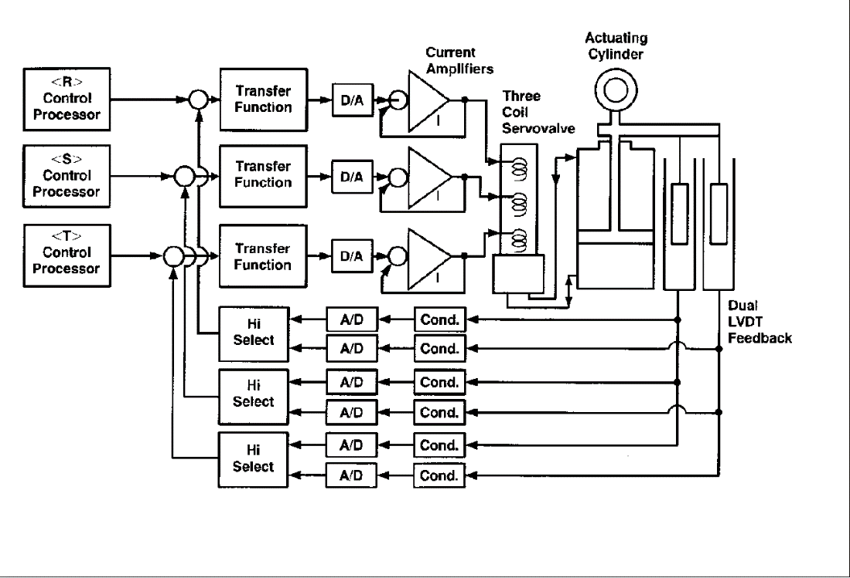
Figure 1 - 2 out of 3 voted Actuator Reference

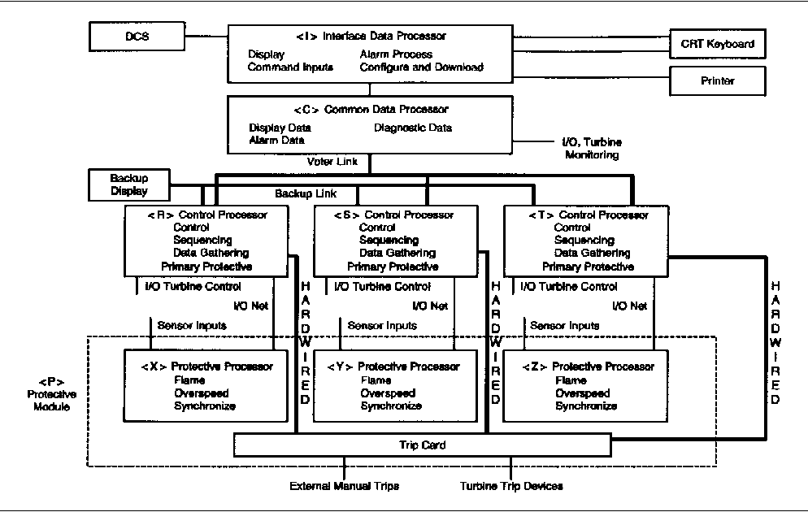
Figure 2 - Arrangement of the GE Mark V Functions

Engineering facilities for the Mark V are located locally to the gas turbine in the RoCa 3 Engineering room where there is a Simplicity HMI. This HMI communicates over Serial Modbus to the DCS for monitoring.

As is standard with the Mark V, only GE ARCNET is used for external communications. Primary interface signals with the DCS are via hardwired connections.

TCS alarms are only presented on the Simplicity HMI, with a single General alarm being raised on the DCS.

A general breakdown of the installed IO is shown below: -

CORE | TERMINAL BOARDS | CARD LOCATION | Typical Device
C | CTBA | 6 | ANALOG I/O (4/20ma input/output)
C | TBCA | 9 | RTD INPUTS
C | TBCB (OPTIONAL | 7 | ANALOG INPUTS (0/1ma, 4/20ma, RTD)
C | TBQA | 8 | THERMOCOUPLE INPUTS
CD | DTBA | 6 | DIGITAL INPUT (Contacts 1 through 46)
CD | DTBB | 7 | DIGITAL INPUT (Contacts 47 through 96)
CD | DTBC | 8 | DIGITAL OUTPUT (Solenoids/Relays 1 through 18; Relays 19 through 30)
CD | DTBD | 9 | DIGITAL OUTPUT (Solenoids/Relays 31 through 48; Relays 49 through 60)
P | PTBA | 6 | PROTECTION I/O (Flame Detectors, Overspeed, Synchronizing, Trip Solenoid Drivers)
PD | PDTB | 1 | PANEL POWER INPUTS
QD1 | DTBA | 6 | DIGITAL INPUT (Contacts 1 through 46)
QD1 | DTBB | 7 | DIGITAL INPUT (Contacts 47 through 96)
QD1 | DTBC | 8 | DIGITAL INPUT (Contacts 47 through 96)
QD1 | DTBD | 9 | DIGITAL OUTPUT (Solenoids/Relays 31 through 48; Relays 49 through 60)
QD2 | DTBA | 6 | DIGITAL INPUT (Contacts 1 through 46)
QD2 | DTBB | 7 | DIGITAL INPUT (Contacts 47 through 96)
QD2 | DTBC | 8 | DIGITAL OUTPUT (Solenoids/Relays 1 through 18; Relays 19 through 30)
QD2 | DTBD | 9 | DIGITAL OUTPUT (Solenoids/Relays 31 through 48; Relays 49 through 60)
R | TBQA | 8 | THERMOCOUPLE INPUTS
R | TBQB | 7 | ANALOG INPUTS (PCD, VDC, Vibration)
R | TBQC | 9 | ANALOG I/O (LVDT/R Monitoring, 4/20ma-IN, 4–20/200ma-OUT)
S | TBQD (OPTIONAL | 7 | PROXIMITOR INPUTS
R,S,T | QTBA | 6 | ANALOG IN/OUT (LVDT Excitation)

The existing cabinet locations and footprints are shown in Appendix 3-B.

Main power supply to the equipment is provided by dual redundant 125VDC power feeds.

Functional and Machine Safety is provided within the Mark V via the Protective Core or <P> Core Safety Protection Module.

MK V Software

The software within the Mark V is mostly available in either paper or electronic form. There are some functions for which the internal logic is not available and is locked. (Refer to section 5.3 b))

Documentation exists for the alarms through the existing HMI.

Automatic sequences are included within the Mark V software, although detailed descriptive documentation is not comprehensive.

Scope of Supply

General
- The Supplier shall indicate compliance with each section and paragraph of this Technical Specification as part of their bid. Where the Supplier deems a section or paragraph to be not applicable to their bid, then they shall highlight this together with the appropriate reasons.

- The Supplier’s scope of supply shall include, but not limited to the replacement of the currently installed Mk V Speedtronic Turbine Control System (TCS). The replacement equipment shall be designed and implemented in such a way to ensure that there is no degradation in existing operational capability, GT performance or system availability whilst retaining operator and maintenance familiarity.

- The Supplier’s scope of supply shall also include the decommissioning and disconnection of nominated mechanical, electrical, communication and instrumentation interfaces; removal to a nominated laydown area the existing equipment and making good of any fixing points if not required for the new equipment. See section 4.3.

- The Supplier’s scope of supply shall also include the disconnection and re-termination of field, communication and power supply cabling. This also includes the removal and safe disposal of cabling where identified as redundant, and the installation of new cabling (including suitable containment) where required to fulfil the design.

- The system supplied by the Supplier shall be provided on a Supply and Installation contract and shall include all engineering, design, procurement and build of necessary equipment, delivery, building works, installation, configuration, testing, commissioning, documentation, engineering support and training required to allow safe, reliable and efficient operation. See section 4.4 onwards.

- It is the responsibility of the Supplier to determine the full extent of the Works to meet the requirements of this specification. This specification whilst intended to indicate the general extent of the works involved is not necessarily exhaustive, insofar as any detailed item or associated work is concerned and shall in no way relieve the Supplier of their responsibility to comply with the specified requirements. The Supplier shall carry out all work and supply all materials required to comply with this specification, unless specifically excluded.

- Any additional requirements or operations that are considered by the Supplier to be necessary to allow for successful execution of the works or deviate from this specification shall be brought to the attention of the Uniper in the tender document.

- Suppliers are requested to visit the site to examine the plant prior to submission of their tender to satisfy themselves that they fully understand the scope of work required. No guarantee of plant access will be given due to commercial operating plant restraints.

- Suppliers will be given access to the site documentation and drawings for the relevant parts of the plant. It shall be the responsibility of the Supplier to satisfy themselves the documentation and drawings are fit for purpose.

Exclusions
- The following aspects of the TCS are excluded from this tender.
- Field Devices, e.g., Instrumentation and actuators (apart from specific Safety Related Devices as covered in section 4.6).

Fixed Scope of Supply – Dismantling and Removal of Speedtronic Mk V Equipment
- The Supplier’s Fixed Scope of supply includes for the removal of the existing in scope Speedtronic Mk V Control cabinet.

- The Supplier shall undertake a full and detailed survey of the Speedtronic Mk V against the supplied drawings, this is to be undertaken prior to the dismantling and removal of the equipment. The outcome of this survey will be a report detailing the accuracy of the existing drawings against the installation. Any observed differences are to be red lined on a Master set of drawings so that they can be incorporated into the Drawing revision process. A list of currently known drawings is presented in Appendix 3-C. Additional drawings may be added should they become important to the project.

- The Uniper will determine the method by which Plant Isolations are provided following a review of the Supplier’s submitted Method Statement, Risk Assessment and Isolation Plan. These isolations will be provided by Uniper and proved to the Supplier as part of the setting to work process, or specifically delegated to the Supplier as part of the Safe System of Work documentation issued to the Supplier at the time of the site works.

- The Supplier shall identify, disconnect, and pull back all external cables from the Speedtronic Mk V panel and leave in a safe state in a nominated barriered laydown position.

- Removed equipment and cabling shall remain the property of Uniper unless otherwise agreed in writing.

- The Supplier shall make good any disturbed floor, wall or ceiling openings before the erection of the new equipment begins unless otherwise agreed. The Supplier shall also provide and be in control of all openings of their responsibility while they are open using solid barriers and signage.

- Non-floor level access services (e.g., scaffold, floor openings) shall be made available by Uniper upon reasonable request from the Supplier.

Fixed Scope of Supply – Installation of new Gas Turbine Control Cabinet
- The Supplier’s Fixed Scope of Supply includes the supply and installation of a replacement Gas Turbine Control Cabinet also known as the TCS, to include as a minimum: -
- A complete migration of the existing TCS functionality.
- Provision of a sufficient number and type of I/O to cater for all existing field devices.
- An additional I/O allowance to cover the existing spares allowance to a minimum of 10% wired to terminals, plus an additional 20% spare slots in I/O racks.
- A complete replication of the Realtime Control system software, with functional cycle times sufficient to meet the requirements of the process and similar to (or better than) those present in the existing equipment. Where these cycle times are significantly different to the existing Speedtronic Mk V this shall be agreed with Uniper during the design phase.
- High availability hardware platform with redundant processing and communication capabilities.
- Replication of the existing Serial Modbus interface to the DCS for status information and feedbacks.
- Replication of the existing hardwired interface to the DCS for Command and Control.
- A high-speed communications interface to the existing station DCS via a modern and supported communications protocol (e.g., Ethernet/Profinet based) for the transfer of command/control and status information between the two systems.
- A set of HMI displays and faceplates integrated into the DCS providing full monitoring, control and diagnostics of the gas turbine / generator and the TCS itself.
- Integrated alarms and events presented within the DCS.
- Integrated data tags available to the PI server.
- Data logging and archival.
- A time synchronisation system to ensure that the internal clocks of all devices (e.g., PLC CPUs, PCs and Servers) are synchronised with a recognised radio beacon. The supplier may propose to Uniper to connect to an existing time synchronisation system where there is sufficient spare capacity to do so and it is suitable, in which case the Supplier will be responsible for any alterations to the existing equipment.
- PC and Server equipment housed in a dedicated ventilated cabinet.
- A colour printer capable of producing A4 and A3 printouts.
- Provision of a HMI display / Engineering Terminal PC in Engineering Room.
- Integration of external systems – see sections 5.7 and 5.8
- Disaster Recovery Software and external media equipment.
- Commissioning.
- Design and Defect warranty period.
- Documentation and drawings – see section 12.2
- Training – see section 10

- The Supplier shall undertake a full recommission and test of the whole replacement system. This shall include all interfaces to retained devices and external equipment. Specifically, these tests shall include but not be limited to: -
  - DCS interface.
  - Field devices, actuators and drives.
  - Power supplies.
  - Electrical devices such as switchgear and synchronisation equipment,
  - Operational tests of mode changes, e.g., fall back to island and re-synchronization.
  - Grid Code compliance testing – see section 6.7 f).

- The Supplier shall provide a TCS that has functionality exactly the same as the existing Mark V, but specifically including: -
  - The gas turbine unit must be able to fall into island operation.
  - It must be possible to Synchronize back from island operation.
  - The gas turbine must meet the requirements as stated in the RfG tests (Requirements for Generators), and the Electricity Grid Code.
  - The gas turbine generator blind load regulation.
  - In addition to the normal I/O tests there shall be interventions from the electrical generator protection.

Fixed Scope of Supply – Functional Safety Design Phase and Safety Instrumented System

- The Supplier shall work with Uniper and Uniper’s Notified Body to perform a suitable and sufficient Functional Safety Risk Assessment of the existing Safety Instrumented Functions, to establish and deliver the requirements of the Safety Instrument System for the TCS replacement in line with established industry practice.

- The Supplier shall include in their scope of supply a Functional Safety Design Phase to demonstrate achievement (through design), verification (through calculation) and validation (through testing) that the Gas Turbine and Generator Safety Instrumented System (SIS) meets the required Safety Integrity Level (SIL) as part of the IEC 61511 Functional Safety Lifecycle.

- The Supplier shall include for the supply of a Safety Requirement Specification (SRS) to formally document the design and associated calculations supporting the provided SIS, plus documentation to confirm that the provided SIS meets the required SIL by providing a SIL verification report.

- The Supplier shall provide an independent SIS to provide Functional Safety protection to the Gas Turbine and Generator equipment. Logic Solvers shall be capable of supporting multiple Safety Instrumented Functions (SIF) with a maximum Safety Integrity Level of SIL 3. Sensors and Final Elements shall be capable of meeting the specific requirements of their individual SIF’s.

- The Supplier shall integrate the Functional Safety System into the Control cabinet equipment, so that whilst it is independent it shall provide a full set of status indications back to the TCS, such as safety interlock conditions and purge timer status. It shall also provide a mechanism by which the Safety System can be reset remotely when conditions allow.

- The Supplier shall provide a full set of proof test protocols to allow the Functional safety system to be periodically tested as per the applicable standard and to comply with the SRS.

Fixed Scope of Supply – Functional Safety Sensors and Final Elements

- Due to the age of the existing equipment, it is highly likely that during the Functional Safety Design Phase it will be determined that the following field devices are no longer suitable for use within a SIL rated safety system and will therefore require replacing. The Supplier shall include for the supply, cable replacement (if necessary), installation, commissioning and loop checking of the following: -
  - Shaft rotational speed sensors
  - Vibration sensors (Gas turbine and Generator)
  - Flame detectors
  - Thermocouples
  - Wheel space temperature sensors
  - Shut off valve
  - Ignitor
  - Emergency stop devices
  - Gas detection

- The Supplier shall include any items supplied as part of this optional scope of supply into the final documentation, training and warranty aspects of the project.

Fixed Scope of Supply – Modification of the Existing Drawing Set

- Uniper will make available to the Supplier the drawings for the existing Speedtronic Mk V system where they exist.

- As part of the site survey described in section 4.3 b) the Supplier shall check the completeness of the existing drawing set against the installed equipment. Any amendments to the drawings highlighted in the site survey are to be incorporated as a revision prior to the drawings being released for the Replacement phase of the project.

- Any paper drawings associated with the TCS replacement that are not available in electronic form shall be scanned in by the Supplier. Drawings that have been scanned and checked by the Supplier shall be provided by the Supplier to Uniper prior to any revisions associated with the replacement project.

- Any drawings requiring scanning by the Supplier shall use a Vector Conversion process so that the resultant CAD files are easily editable using AutoCAD in .dwg format.

Fixed Scope of Supply – Quarterly Review Visits

- The Supplier shall allow for two Quarterly reviews following the successful commissioning of the TCS. These reviews shall be held on or close to the 3 month and 6-month anniversaries of the ‘Return to Service’ hand over date, or on other dates by mutual agreement of both Uniper and Supplier.

- The Supplier shall contact Uniper’s site personnel prior to the visit so that plant logged data and maintenance/operator logs of notable events can be exchanged.

- During each review visit the Supplier shall undertake the following activities in collaboration with Uniper’s site personnel: -
  - Review any outstanding snags raised by Uniper.
  - Review the tuning of the TCS Control Loops.
  - Review the TCS Alarms system with regards to nuisance or alarm floods.
  - Review of System event and error logs.
  - Review of System loading including networks.

- The Supplier shall present to Uniper any remedial actions resulting from the review and have these agreed and planned before implementing.

- Full backups of the system shall be taken at the start of the review visit and on completion if changes to the TCS have been implemented.

- The Supplier shall prepare and issue a visit report of the review findings and actions taken.

Fixed Scope of Supply – System Finger-print

- The Supplier shall allow to conduct a site visit to collect sufficient data from the existing system to form a Finger-print of the overall TCS operational behaviour. This finger-print, in the form of both logged electronic and printed media shall define the base-line performance of both the control system and reporting/alarms system.

- The Supplier shall lead and perform tests on the existing TCS in collaboration with Uniper.

- The Supplier shall produce a report for Uniper using this Finger-print data alongside data from the newly commissioned TCS to confirm that the replacement system performance is as a minimum equivalent to the replaced system for the purpose of Contract acceptance at the final hand-over. Topics that shall be covered in this report include:-
  - Alarm rates during Start-up, Shut-down and Trip.
  - Closed loop control of the Gas Turbine speed and frequency response. Note: additional tests may be stipulated by the power grid network operator.
  - Start-up profiles from operator initiation to target load.
  - Shut-down profile from operator initiation to barring speed.
  - Trip profile from initiation to barring speed/stop.
  - Operation of ancillaries.
  - Data transfer rates to the DCS.

TECHNICAL Requirements

General
- The Supplier shall be responsible for the design and engineering of the system replacement, which shall be integrated with existing plant equipment to meet the following objectives:
- The replacement of the existing system equipment with modern, and a minimum expected life of 20 years after final acceptance.
- Allow operations and maintenance staff to be maintained at current levels.

- The Supplier shall provide a replacement TCS having an overall availability of 99.9% as measured over a 12 month rolling period.

- In general, all components supplied by the Supplier as part of the System shall utilise “Commercially Off The Shelf” devices and technologies which are in widespread use in the control and instrumentation industry.

- All equipment and software provided by the Supplier shall be field proven in a commercial plant operation. Any requirement for bespoke hardware and software that is not part of a standard product, i.e. specifically developed for this project, shall be clearly identified in the tender return as “special to project” hardware and/or software.

- The Supplier shall provide a statement in writing that their system architecture, hardware and software supplied shall be retained in the product ‘Active’ production (e.g. electronic integrated circuits, microchip etc.) phase for another 10 years and supported for a period of no less than 20 years from the contract award date.

- The Supplier shall adopt the engineering units used in the existing MK V Speedtronic for the replacement TCS.

- The Contract Language is English. See also section 5.4 f).

System Requirements

- The system used by the Supplier for identifying and labelling new field devices, data points/parameters and systems shall be consistent with the existing convention and system already adopted at the City Heat site, which is based on the convention as laid down in the Kraftwerk-Kennzeichensystem (KKS) standard for identification system for power stations.

- The replacement system provided by the Supplier shall include operator interface monitoring and control station(s) based on selectable VDU displays, which are to allow safe and effective remote control of plant.

- The replacement system provided by the Supplier shall include facilities to record and archive plant data. These facilities shall allow plant data to be stored, trended and archived for future access and exported to external systems as well as for reporting purpose. See section 5.12

- The replacement system provided by the Supplier shall include all the diagnostic and engineering tools required to allow Uniper to maintain the supplied equipment.

Functionality

- The replacement system provided by the Supplier shall replicate the functionality contained within the existing GE Mark V system, such that the current level of operability, maintainability and controllability of the gas turbine, generator and ancillary equipment is ensured.

- The Supplier shall describe how they intend to accurately replicate functionality where information/documentation on the existing system is not present or is proprietary (i.e. hidden or locked). This description shall initially be presented in the Supplier’s tender submission, laying out the process and steps to be taken; with the detail of how the replication has been undertaken included as part of the Supplier’s Design documentation, including any tests to be performed by the Supplier to verify the replication process.

Operator Interface

- The Operator Interface provided by the Supplier shall allow the display of system and plant parameters, mimic diagram schematics, operating point displays, alarm and event lists, real-time and historical trends, diagnostic information and comprehensive context sensitive help.

- The Operator schematics displays provided by the Supplier shall have a consistent design in terms of layout, hierarchy and navigation arrangement etc., including:-
- Plant mimic display graphics and format,
- Mimic Colours,
- Faceplates,
- Alarms and events displays,
- Display graphics page arrangement and layout,
- HMI display pages navigation hierarchical order and means.

- Each of the Operator Schematics provided by the Supplier shall offer a hierarchy of selectable display, control, trend and alarm displays to allow the operator/engineer to monitor and control the plant.

- All operator schematics and the engineer workstation provided by the Supplier shall allow the current display to be transferred to a file in an industry standard file format, such as JPEG and PDF etc., which the user can recover later.

- All operator workstation schematics provided by the Supplier shall allow the current display to be transferred to hard copy via a printer supplied as part of the contract.

- All operator schematics provided by the Supplier shall be able to switch the displayed Language between the Dutch and English languages for all aspects of use including Alarm text.

- All field devices and selections which can be controlled by the operator shall be provided with operating faceplates by the Supplier.

- Sequence progression displays shall be provided by the Supplier for all sequences, these shall convey to the operator the status and progression of the sequence using easily understood animation and plain textual statements. Sequence controls shall include the ability to step or hold sequence steps where such can be safely done without causing harm to persons or equipment.

- The operator schematics provided by the Supplier shall allow data to be trended from all plant areas in real-time and using historical data (for historical trends).

Workstations

- Where possible, the workstation servers and clients shall be located in the existing workstation locations. Where this is deemed not possible by the Supplier, the Supplier shall propose an alternative arrangement for the accommodation and location of the replacement workstation equipment for the review and agreement by Uniper. The Supplier shall be responsible for the supply, installation and commissioning of the agreed solution.

- System access control facilities shall be provided by the Supplier to limit the ability of unauthorised personnel to operate plant and / or to access override (or similar) functions. The access control facilities shall also allow access to displays to be limited to a ‘read-only’ basis and also allow access to specific displays to be limited. The existing access levels and privileges shall be maintained.

- Password files and information shall only be exchanged between the Supplier and Uniper, and by secure routes which shall be agreed in advance. Exchanges of Password information via email is not allowed. Potential breaches of security shall be notified to Uniper immediately by secure means.

- Workstation equipment provided by the Supplier shall be based on standard personal computer (PC) hardware and shall include a pointing device (e.g. mouse) and keyboard or equivalent ‘soft’ key device (e.g. touch screens) to allow rapid access from display to display. The workstation and schematics shall include features to prevent inadvertent plant operation via the pointing or any ‘soft’ key device.

- Any new or replacement workstation VDUs provided by the Supplier shall be of a flat screen design utilising LCD or newer technology and be designed for 24-7 operation. The display size shall matching the existing VDU. The workstation terminal VDUs shall be capable of accommodating ‘wide-screen’ (e.g. 16:9 ratio) format displays without distortion of the display (i.e. all mimic displays shall be configured and displayed with the same bit resolution ratio as the display).

- The Workstation hardware must be from "A" quality with five-year warranty support from the manufacturer.

Engineering Station

- The Engineering Station equipment (server and clients) provided by the Supplier shall be used for the engineering and configuration of the entire TCS. The Engineering Station shall include the necessary system engineering tools and facilities to allow full access, programming and configure the following key plant monitoring and control system components:-
- Operator Station terminal;
- Operator Station servers;
- Engineering Station server and clients;
- OPC server;
- Plant bus and terminal bus data communication networks;
- Controller modules;
- Network communication modules;
- I/O modules.

- The Engineering Station provided by the Supplier shall also have the facility to allow plant monitoring and control as and when necessary.

Integration and Interface with Existing Systems

- The Supplier shall be responsible for interfacing the replacement TCS with the main DCS using the existing combination of hardwired signals and Modbus serial communications.

- The Supplier shall provide the TCS replacement with an equivalent hardwired interface to retained external systems; such as the DCS, Fire system and others.

- The Supplier shall ensure that following the replacement the signal exchange from the TCS to these external systems shall be unaffected. Voltage levels, loop impedances and signal switching times shall be engineered to be no different to the existing system.

- The Supplier shall provide a serial Modbus interface to the DCS that requires minimal changes to the DCS end of the communication link. Any perceived to the DCS associated with the serial Modbus interface shall be documented by the Supplier and presented to Uniper as a proposal as part of the design phase prior to implementation.

- The Supplier shall as a minimum make the connections to the main DCS safety system for the hardwired Process and Safety Interlocks as the system is currently designed.

Integration and Interface with New Systems

- The Supplier shall be responsible for interfacing the replacement TCS with the new Firing system upgrade associated with the switch to Hgas, plus the accompanying Gas Chromatograph.

- The method of communicating with these new systems has yet to be determined, but the Supplier shall allow for either a hardwired interface (a mix of digital and analogue signals) or a communication interface over a proprietary bus.

Diagnostic Facilities

- The Supplier shall design the replacement TCS such that comprehensive fault diagnostics facilities are available at all operator terminals and engineering workstations, so that failures in control system equipment and field mounted devices can be rapidly identified and rectified.

- The fault diagnostics provided by the Supplier shall include both ‘plant status’ information which shall allow operations staff to diagnose operational problems and control system information which shall allow maintenance staff to diagnose control system faults.

- The ‘plant status’ diagnostics provided by the Supplier shall include facilities to diagnose modulating and sequence control problems such that operations staff can rapidly identify the cause and then take the required action to allowed continued start-up, running and shutdown of the plant (if appropriate by operating automatic control loops or sequences in ‘manual’ mode).

- The control system diagnostics provided by the Supplier facilities shall allow the identification of all failed field devices (transmitters and actuators), control system modules and communications networks.

Alarms

- System alarms and events provided by the Supplier shall be visible on all Operator HMI schematics and including the following information as a minimum:-
- Time Stamp;
- Alarm text;
- Priority;
- Device KKS;
- Acknowledge and reset state.

- Alarm documentation provided by the Supplier shall be provided as per IEC 62682 (ANSI/ISA 18.2) and contain the following for all configured alarms:-
  - Tag ID and description of Alarm Point / Variable
  - Initiating device and Alarm Setpoint / Threshold
  - Expected causes of the Alarm
  - Required operator action when Alarm active
  - Consequences of failing to respond to the Alarm
  - Periodic Test Procedures for Highly Managed Alarms.

- All alarms provided by the Supplier shall be ‘time-stamped’ at source using a master clock, such that alarms from different sources (i.e. control systems) can be analysed in the correct chronological order.

- A facility to Manually Shelve nuisance alarms shall be provided by the Supplier. While a specific alarm is shelved it shall still be logged within the system and available within a Shelved Alarm list. Shelved alarms shall be time limited and shall become visible again after a specified time to be agreed with Uniper.

- The Supplier shall provide a Status or low priority Alarm when ‘Forcing’ is active within the TCS software.

Redundancy – Non Safety.

- To ensure the safety of personnel and protection of plant whilst maximising availability, the Supplier shall employ dual redundancy for critical items of the replacement TCS as a minimum. Non critical items (whose failure will not affect the control or operability of the Gas Turbine) can be non-redundant with agreement of Uniper.

- Dual redundancy or similar approach shall be provided by the Supplier to all relevant components of the replacement system Operator Interface, such that the failure of any one display or PC shall not reduce the ability of the operator to monitor and control the plant.

- The Supplier shall include for monitoring of all redundant system components (including power supplies) such that an alarm is generated if any failure occurs which leads to a loss of redundancy.

Data Recording, Logging and Archiving Equipment

- The TCS provided by the Supplier shall have the capacity to perform data recording, logging and archiving required for the recording and subsequent analysis of plant conditions, events and alarms during all aspects of plant operation.

- The data recording, logging and archiving systems provided by the Supplier shall include suitable levels of redundancy to prevent the loss of critical statutory or equivalent data. Facilities shall be provided such that in the event of a single failure in the data recording and logging system, the availability of the data recording and archiving system is not compromised and that data can be restored from a backup or archive systems such that there are no loss of fidelity or ‘holes’ in the stored data or information.

- The list of signals and frequency of logging to be implemented by the Supplier shall be agreed with Uniper during the design phase.

- Critical signals which may be required as evidence to a regulatory body (e.g. Environmental compliance) shall be configured by the Supplier to be logged without the application of data compression likely to cause the loss of fidelity.

- The Supplier shall provide local secure fault tolerant data storage in the form of a RAID array of sufficient size to store the logged data set for 1 year.

Interfaces to the PI System

- The replacement HMI system shall interface with the existing OSI PI server via its OPC server.

- The Supplier shall be responsible for the installation and/or migration of the necessary software services and applications to the replacement OPC server, including configuration of the PI interface. Due to the importance of this data, the PI interface must be fully operational and verified before the return to service of the power station following the TCS replacement plant outage.

System Remote Access and Cyber Security

- The Supplier shall provide all hardware, software and assistance to Uniper required to protect the TCS and associated components from the threat of ‘cyber-attack’.

- The Supplier shall ensure that all supplied control system equipment meets the requirements and recommendations of the relevant internationally recognised Standards related to industrial control system security, including IEC62443. The provisions required to be complied with in these standards include, but not limited to:-
- Facility for a tracking and logging audit trail of system access and modifications made.
- Multi-level access to enable different types of system activities that can be controlled, subject to the access rights allocated.
- Facility to prevent unauthorised access to the HMI system and any other directly connected plant monitoring and control system, including controller, communication and I/O modules.

- The Supplier shall disable, through software or physical disconnection, all unneeded communication ports and removable media drives, or provide engineered barriers, and provide documentation of the results.

- The Supplier shall password protect the BIOS from unauthorized changes unless it is not technically feasible, in which case the Supplier shall document this case and provide mitigation measures.

- The Supplier shall provide protection against ‘malware’ (malicious software including, but not exclusively, viruses, worms, Trojans) gaining access from external systems to the replacement TCS. Any malware protection must be capable of being updated to detect and respond effectively to the latest threats.

- The Supplier shall provide, prior to handover, login and password details of all configured system accounts. This shall include all accounts used by the Supplier and their subcontractors. The access rights system shall be a scalable system that allows different levels of access to plant control system functions (e.g. editing of control and protection systems, editing of mimic displays, temporary inhibiting / shelving of alarms, ‘forcing’ of values).

- The Supplier shall ensure that a software update management process is available, documented and implemented to ensure the most up-to-date approved patches and application updates are installed to address weaknesses within the Operating System and applications.

- Uniper will provide one hardened termination point for connection by the Supplier where external connections are provided to allow external access to the replacement TCS for the purposes of, including but not limited to; maintenance, monitoring, backups etc. Operation of the Plant will not be reliant on communication with systems through this connection. The Supplier will define all connections, ports and protocols which are intended to pass through this connection.

- The Supplier must ensure the backup arrangements should cover all systems information, applications, and data necessary to recover the complete system in the event of a disaster. Backups must be capable of being stored offline from the system, such that the whole system can be restored onto newly formatted storage disks/memory cards, i.e. ‘Bare-metal Restore’.

- The Supplier shall avoid the use of Wireless communications including Bluetooth peripherals. Where such technology cannot be avoided it shall only be considered for use in exceptional circumstances and by prior consent of Uniper. Secure end-to-end encryption must be employed

Software and Licences

- The Supplier shall supply all necessary software at the version as implemented on running Plant, with a final version on contract completion if different from the former. On the completion of final commissioning all software parameters, programs and records shall be updated to include any modifications made during commissioning.
- The Supplier shall provide all programs in a source code format which is comprehensively documented in the Contract Language. All software program media and firmware shall be uniquely identified by labels or other means stating the programme function, its modification level and the date.

- The Supplier shall provide all software installation files, records and system disks of all programmable equipment on media approved by Uniper. This shall include installation details (disks for the replacement system and computing equipment) and shall include records, programs and installation disks for all control system equipment. All software media shall be uniquely identified by labels or other means stating the programme function, its version and the date.

- The Supplier shall provide all software licences for the system, its operating systems and for all proprietary equipment. These shall be deemed as an integral part of the system and be given to Uniper following successful final commissioning.

- The Supplier shall provide proprietary Disaster Recovery software which is fully compatible with the TCS. It shall have the capability of providing both incremental backup and restorations, plus also be able to perform a full ‘Point in Time’ restoration of the entire System.

- The Supplier shall keep Uniper fully informed of the followings during the project development phase, warranty period and any subsequent support period:
  - Any new issues of software or firmware.
  - Any faults found on existing issues of software or firmware.
  - Any obsolescence issues.
  - Any virus updates or updates to network security components.

Tag Names and Descriptions

- The tag naming convention and description shall be consistent with those used in the existing plant. Agreement must be obtained from Uniper prior to any alteration or deviation being made by the Supplier.

Power Supplies

- The incoming power supplies available in the existing system panels are twin independent 125V DC station protected supplies.

- The capacity of the power supply to support the new equipment shall be assessed and verified by the Supplier during the site survey. Should a deficiency be detected then this shall be raised with Uniper at the soonest possible opportunity.

- The Supplier shall provide Dual redundant power supplies for control voltages within the TCS to ensure the best levels of availability. The status of each power supply shall be monitored continuously, and an alarm initiated in the event of either supply failing. The transfer between supplies shall happen without interruption.

- The Supplier shall install Surge suppression across inductive devices such as solenoid coils.

Cabling

- Where practicable, the Supplier shall reuse existing field cabling. The Supplier shall be responsible to ensure that the existing cabling is suitable for the new installation and propose any addition and/or deviation to Uniper for review and comment.

- Power, communication and instrumentation signals shall be segregated where the Supplier installs new cables.

- The Supplier shall apply new cable and wire numbers on cables which are being re-terminated, where the original marking has deteriorated or is missing. All cables shall have a unique wire number in line with the existing cable marking convention applied in indelible ink at both ends of the cable. These shall be shown on the relevant project documentation. All cables cores shall be uniquely identifiable.

- Any replacement or new bus structure implemented by the Supplier shall have diagnostic features and required hardware (e.g. Profibus plugs with diagnostic programming ports) designed in from the inception.

- Where Cabling is disturbed as part of this project, the Supplier shall test the affected signals and remake or replace as necessary any damaged connections or cable lengths.

- Where the Supplier is installing fibre-optic cable shall match the installed fibre-optic standard. The cable types shall be selected so that at least 50% of the fibre-optic cores are available as spares. The cables must be suitable for being laid outdoors when external to control cabinets and shall be provided with anti-rodent protection. Both ends of the cables shall be terminated in splice boxes. The cable types shall be finalised with Uniper.

- Where the Supplier is installing Copper communication cables they can be used for network connections between network components inside self-contained rooms and for limited distances.

- Category 6 or newer patch cables shall be used for network frequencies of up to 1,000 Mbit, with high-grade screening and designed for areas subject to stress. The RJ45 connectors shall be supplied in high-grade design and specially screened. The cable types to be used by the Supplier shall be submitted to Uniper for review and comment.

- Where necessary, the Supplier shall be responsible for supplying, installing all new cable ways required, the Supplier shall provide suitable spare capacity in all cable ways in order to facilitate the installation of other equipment.

Communications

- Before use by the Supplier, new IP addresses or modifications to existing IP addresses shall be agreed with Uniper.

Environmental Conditions

- All equipment supplied by the Supplier shall be suitable for operation in its installed environment.

- The Supplier shall take all necessary precautions to protect equipment from influence factors which could adversely affect the operation, performance, reliability, life or maintainability of the equipment.

- The Supplier shall ensure as part of their scope of supply that where equipment is installed in an indoor environment, there is satisfactory heating, ventilation and air conditioning available to maintain the design operating environmental condition of the equipment, taking into account the potential heat generated by the equipment itself.

Electromagnetic Compatibility

- The equipment supplied by the Supplier shall not mal-operate due to radio frequency interference including that generated by adjacent equipment (including fluorescent lamps) and portable radio communication transmitters (including any not supplied by the Supplier) being operated in close proximity, and signals from distant radio, television and radar transmitters.

- Whilst the metal enclosure housing of equipment supplied by the Supplier may provide an effective screen to radio frequency interference, the equipment shall also function satisfactorily when the housing is opened for maintenance and testing purposes. Undue reliance shall not be placed upon the fact that the equipment is earthed, as at radio frequencies the earth impedance may be significant.

- All proposed equipment supplied by the Supplier shall be type RFI tested to IEC 61000-4 including transducers/ initiating devices.

- The Supplier shall take all reasonable precautions to minimise the generation of interference by their equipment by incorporating adequate screening and filtering. Equipment shall not generate interference at a level which could be detrimental to its own performance or that of other equipment, or be capable of producing annoyance, discomfort or hazard to personnel (e.g. electrostatic discharge, radiation, etc.).

- Interference at radio frequencies shall be reduced to below the limits specified in EN 55022 and EN 55011. The earthing and cabling arrangements provided by the Supplier shall be such that interference does not result.

Housings

- New equipment housings supplied by the Supplier shall provide adequate protection for the equipment contained within, against the conditions of the environment in which they are to be located.

- The degrees of protection against dust and water provided by housings supplied by the Supplier shall be in accordance with the classification system IEC 60529 or equivalent International Standard. Suitable levels of Ingress Protection shall be chosen to protect the equipment within from the local environment without impinging the function. The degree of required protection shall be subject to agreement with Uniper.

- In general, where equipment is mounted in housings and enclosures, measures (e.g. air conditioning) shall be taken to ensure the temperature within the housing never exceeds the operational design limits of the equipment. Where the temperature inside the housing could exceed the operational design temperature limits of the equipment, the Supplier shall provide an alarm to remotely indicate that the temperature control measures have failed.

- The Supplier shall provide heaters and thermostats where necessary to minimise condensation inside housings. Heaters shall be an enclosed element type with a surface temperature not more than 65ºC.

- All wall mounted boxes fitted by the Supplier shall be installed with spacers, so that a clearance of at least 25 mm is provided between the rear of the box and the wall to avoid retention of moisture behind the box.

- The Supplier shall demonstrate as part of their design submission that they have anticipated and mitigated the risk of fire. Stringent precautions shall be taken to ensure that the probability of a fire occurring within any control and instrumentation system or cubicle is small, and in the unlikely event of a fire occurring, the damage shall be limited to one system or cubicle.

- Housings provided by the Supplier which require regular entry for routine testing or maintenance shall be provided with internal lighting with appropriate form of local control. A minimum illumination level of 200 lux is required.

- Any housing provided by the Supplier which contains intrinsically safe (IS) circuits shall be clearly identified by suitable labelling and indicate the presences of the IS circuits by using blue cable ducting and internal cabinet wiring. Any IS circuits shall be separated from Non-IS circuits by a minimum distance of 50mm.

Identification

- All new or replacement items of control and instrumentation equipment provided by the Supplier shall carry labels such that the item can be identified by a KKS identifier.

- Where an item of equipment is mounted directly on plant or on framework close to plant or inside a panel the Supplier shall fixed an identification label adjacent to the item of equipment in such a manner to be unambiguous.

- Equipment provided by the Supplier shall enable the manufacturer and type of item to be readily identified and shall include serial, batch and version numbers where applicable.

- In addition to the manufacturer's identification, inscriptions to indicate the function of all items of equipment shall be provided by the Supplier for all new and replacement items of control and instrumentation equipment.

- Permanent labels provided by the Supplier shall be mechanically fixed by screws (self-tapping acceptable) or rivets. Changeable labels shall be fixed by coarse threaded screws or suitable clips. Labels made from paper, embossed self-adhesive plastic or metal tape will not be accepted.

- The Supplier shall submit all new labels for approval by Uniper.

Fuses and Fault Protection

- All equipment provided or modified by the Supplier including external connections shall be compliant with IEC 60364 so that sufficient fault protection of the installation and the circuits is achieved.

Earthing

- A suitable earthing system in compliance with IEC 60364 shall be used by the Supplier. If for any reason this is not practicable then the Supplier shall submit an alternative proposal and risk assessment for the acceptance of Uniper.

- All enclosures provided by the Supplier shall incorporate an insulated clean earth bar to which cable screens can be connected. This clean earth bar shall be connected to a convenient local point of the station earth system by a dedicated clean earth cable (i.e. the cable shall be separate to safety earthing). The earth cable connection shall be provided with a system to allow for checking the earth bonding without disrupting the protective function of the earth bar. The minimum size of conductor used shall be 4 mm².

- Where intrinsic safety barriers are provided or modified by the Supplier the enclosures shall also incorporate a separate and labelled insulated intrinsic safety earth bar to which the barriers can be connected.

- Where lightning protection barriers are provided or modified by the Supplier the enclosures shall also incorporate a separate and labelled insulated earth that is separated from any intrinsic safety earth bar or clean earth bar to which the barriers can be connected.

Inspection and testing

General

- The Supplier shall be responsible for setting to work, testing, and commissioning all items of the Replacement and the associated equipment within the scope of supply to demonstrate compliance with the specified requirements. These tests will normally be witnessed by Uniper, or the nominated representative.

- The equipment used for testing and calibration shall be provided by the Supplier and shall have performance parameters such as accuracy, stability, resolution etc., which render it more than adequate for the test requirements. Certified documentation shall be provided concerning the test equipment used and the frequency of calibration.

Site Survey

- The Supplier shall be responsible for conducting a full site survey. The purpose of the survey shall be to review the existing system and plant documentation to ensure its adequacy. Whilst any deficiencies shall be highlighted to Uniper, the Supplier shall remain responsible for fulfilling the requirement of this document. Any deficiency shall be highlighted to Uniper before any significant design or implementation work is progressed.

- The Supplier shall be responsible for taking sufficient Backups of the Speedtronic System during the project at agreed times.

Type Testing

- All off the shelf equipment shall have satisfactorily passed type tests in accordance with the appropriate European or International standards or client performance criteria.

- Equipment may be accepted based on type tests by other recognised organisations, subject to the production of satisfactory documentation by the Supplier.

- The Supplier’s quality plan shall include all proposed tests, and the test results shall form part of the QA record package prepared by the Supplier.

- All equipment supplied by the Supplier shall carry the appropriate CE mark or equivalent.

Factory Acceptance Test (FAT)

- Unless otherwise agreed with Uniper, FAT shall be performed at the Supplier’s works. The whole FAT shall be witnessed by Uniper, or the nominated representative.

- The Supplier shall prepare and submit the formal test specification to Uniper for review and comment, at least six weeks before the date of factory acceptance testing, the formal test specification detailing the tests to be performed and test equipment to be used. It is expected that feedback comments by Uniper to be returned to the Supplier within two weeks of receipt of the test specification document.

- Each Graphic supplied as part of the TCS shall be validated. This shall include checking that the format/mimic correctly represents the plant or system it relates to; access time is acceptable and confirmation that data values originate from the correct source. A sample check of the functionality within each Graphic shall be made, checking each pop-up, faceplate, data entry field and shall include a 30% sample check on analogue value and digital state displays.

- Testing of the alarm functions shall be performed to verify that alarms are correctly displayed under ‘alarm-flood’ conditions.

- The factory testing shall include demonstrations of the following to Uniper’s or nominated representative’s satisfaction: -
  - Where applicable, acceptable controller/processor loading in terms of memory utilisation, processor free-time and program run-time.
  - Where applicable, acceptable communications network (including Fieldbuses) loading, correct behaviour under worst case conditions (to be performed on site) and redundancy fail-over.
  - Robustness to failures (including multiple failures in redundant systems and networks).
  - Ability to diagnose failures (simulated by the removal of power and/or modules).
  - Ability to replace faulty system components/modules under powered-up and on-load conditions.
  - Alarms have been fully migrated.
  - Integration of the various disparate plant control systems, including correct ‘time-stamping’ of alarms and events.
  - Ability to Shelve nuisance alarms.
  - Complete check on the Graphic navigation functions.

- If any failures occur during factory acceptance testing, full details shall be recorded for Uniper who will require evidence that there is no inherent design, manufacturing or software configuration faults. The Supplier will then agree with Uniper whether the test may be restarted or shall be repeated.

- The Supplier shall provide sufficient simulated binary and analogue inputs to allow testing of at least a complete functional group at one time and suitable indicators to visually display outputs of tested equipment, e.g., using PC simulation.

- The system under test shall be configured to the latest agreed data at the time of the test.

- The Disaster Recovery software and hardware shall be used at the end of the FAT to take a full system image. This image shall then be tested by being reapplied to the system, and the system demonstrated as being fully functional following its restoration.

Installation

- The Supplier must ensure that all staff intended to work on the sites have a current and valid VCA Safety Course certificate from a scheme approved by Uniper. All personnel working at site will be required to undertake and pass a site safety induction.

- The Supplier shall supply sufficient staff prior to site works commencing to allow them to be trained under site safety rules to allow them to accept safety documents.

- The Supplier shall submit an Isolation Plan as part of the overall project plan to enable Uniper to integrate this with other activities during the outage. This Isolation Plan must be submitted to Uniper for review and comment at the ‘Release for Installation’ (Project Gate) point on the project schedule prior to work commencing.

- All installation work shall be carried out in line with approved risk assessments and method statements. Method statements and risk assessments must be submitted to Uniper for review and comment at the ‘Release for Installation’ (Project Gate) point on the project schedule prior to work commencing. Acceptable risk assessments and method statements will be required before safety documents are issued.

- Prior to and after any re-wiring or refurbishment work in panels, junction boxes, cable ways and equipment rooms the Supplier shall clean them thoroughly using portable suitable industrial vacuum equipment (e.g., appropriate filters and antistatic), brushes, cleaning cloths and, if necessary, cleaning fluids – in accordance with site CLP Regulation policy. The Supplier will be responsible for removing all scrap and debris from the work area. The Supplier shall include for all cleaning costs.

- All waste materials shall be handled in accordance with Uniper’s and Site instructions and requirements. The Supplier shall include for all waste disposal costs.

- All cabling no longer used shall be removed, wherever possible, and cable ways made good. Uniper shall be notified prior to cable removal to allow for update of site cable registers. If removal of the cable is considered impracticable, following discussions and agreement with Uniper, the cable must be suitably capped, identified and fastened in accordance with Uniper’s and local site instructions and requirements.

Site Testing and Commissioning

- Following installation on site, testing and commissioning should be performed by the Supplier in a systematic manner against the relevant test and commissioning procedures, which must be submitted to Uniper for review and comment at the ‘Release for Installation’ (Project Gate) point on the project schedule prior to work commencing.

- Each test and commissioning procedure shall include, but not be limited to, the following: -
  - Test equipment required
  - Personnel required for test
  - Test objective
  - Testing methodology
  - Results recording proforma

- Test records are to be supplied by the Supplier at the end of successful witness testing. These shall include all modifications made during the manufacturing and testing period, i.e., list of changes, as-built drawings, calibration certificates etc.

- Commissioning shall be carried out live with approved procedures, risk assessments and method statements provided by the Supplier.

- Any testing involving the energisation of equipment beyond the TCS cabinet which poses a risk to personnel or equipment shall only take place once the ‘Release for Hot Commissioning (Project Gate)’ has been sanctioned by the Uniper Engineering Manager.

- All testing and commissioning shall be carried out by the Supplier’s personnel who shall be suitably qualified, experience and familiar with the project.

- Testing and commissioning on site shall generally take place in distinct phases as follows.

Pre-Commissioning Tests.

- After installation, all items of the replaced system equipment shall be subjected to basic checks to verify correct installation (including connection) and to verify that they can perform the function for which they are intended. Typically, these checks shall include visual inspection of installation, power supply connection, network connections, equipment labels etc.

Commissioning Tests

- The full configuration and functionality of the replacement system and all associated system equipment, including all replacement system components, shall be powered up and comprehensively tested in a systematic way and be witnessed by Uniper, or the nominated representative. These commissioning test shall include, but not limited to, the following: -
    - Each Graphic shall be validated. This shall include checking that the format/mimic correctly represents the plant or system it relates to; access time is acceptable and confirmation that data values originate from the correct source. Operation of all plant groups from the Central Control Room shall be proved.
    - Complete test of the Data exchange with the DCS.
    - Access, diagnostics and configuration of the overall plant monitoring and control system, including controller modules, communication module, I/O modules, instrumentation wire break, and control system data communication networks.
    - Verification and optimisation of network and control system CPU utilisation and loading.
    - Full testing of system and network redundancy and fail-over.
    - Testing shall be performed to demonstrate that all equipment fulfils its functional requirement under normal operating and fault conditions, has adequate stability, and can operate without frequent attention.
    - Interface to the Synchronisation equipment. This test is of the upmost importance due to the potential for significant damage if wrongly executed.

Site Acceptance Testing

- The Supplier will be required to perform the SAT on site in line with an approved Site Acceptance Test document. This test shall be witnessed by Uniper or a nominated representative.

- The Supplier’s Site Acceptance Test document should be structured to allow a full demonstration of the supplied equipment to be performed, including a walk down of the installation, review of calibrations, review of test documents and full functionality tests on the equipment.

- The Supplier shall submit the Site Acceptance Test document and associated risk assessments at the ‘Release for Installation’ (Project Gate) point on the project schedule prior to the start of commissioning and SAT.

- The system will not be fully accepted by Uniper until these tests have been successfully completed.

- Upon the successful completion of the Site Acceptance Test the Supplier shall take a full system image using the Disaster Recovery tool and present this to Uniper as part of the ‘As Commissioned’ project documentation.

- The Supplier’s Site Acceptance Test document shall include a detailed description of how the replacement system shall be tested in accordance with the Netherlands Electricity Grid Code. The replacement system shall include all the necessary injection points, so that the Supplier can connect their own certified test equipment to demonstrate and record the tests to the agreement of the witnessing competent body. Applicable reference documents are listed in section 2.

Warranty

- The Supplier shall provide a minimum of a 36 month warranty from the date of the ‘Hand-over’ (Project Gate) point on the project schedule on all equipment, materials, workmanship and software design, including third party equipment and workmanship. See also section 5.5 f) for additional cover regarding Workstation hardware.

- The Supplier shall nominate a person who shall be responsible for all Defect issues during this period. Uniper shall notify the Supplier’s nominated person of any Defects Liability claim and the Supplier shall provide a timely acknowledgment within 1 working day, and a practical response within 2 working days.

- All hardware supplied will be covered by an on-site defect liability period and defective components will be repaired or exchanged in a timely manner not exceeding 3 hours after notification to the Supplier’s nominated person.

- To provide the fastest possible part exchange process the Supplier shall propose a ‘Bonded spares’ option for the duration of the Warranty period with Uniper for critical items identified by the Supplier.

- The Supplier shall be responsible for maintaining a log of all warranty claims occurring from the start of site commissioning to the end of the warranty period. The log shall include details of the cause of the failures and the remedial action taken.

- The Supplier shall at the end of the warranty period analyse these records and report to Uniper.

- During the warranty period and for an additional 10 years after warranty expiry the Supplier shall keep Uniper fully informed of any 'type' or latent defects found on any equipment supplied. This shall include defects that may affect the performance of any other equipment provided within the scope of this Specification.

Spares

- The Supplier shall provide priced 5-years recommended spares list with their bid. This list shall include; part numbers, equipment descriptions, choice of suppliers, availability, typical lead times and recommended quantities. These spares shall be split into two kinds;
  - Critical: The system will not operate without this item.
  - High Priority: The system can operate but with reduced redundancy.

- The Supplier shall provide one set of commissioning spares (one each of each type of I/O module plus 20% coverage for all fuses). These shall remain the property of Uniper on completion of commissioning. Any spares used during commissioning shall be replaced by the Supplier under warranty.

Maintenance and support

- The Supplier shall submit within the bid document full costs and proposals for a 3 year Maintenance and Support contract.
- The Supplier’s support proposal shall include for 24 hour 7 days a week telephone support for the duration of the warranty period. Should a site visit be necessary a suitably qualified and experienced presence on site within 3 hours is a key requirement.

- A clear statement should be made as to the size, structure and location of the Supplier’s support team that is available for maintenance and support activities.

- The Supplier shall build into the system and support contract the necessary software and protocols by which the TCS itself can be accessed remotely. The method of connection will be via a secure cyber connection provided by Uniper, details of which will be provided following contract award.

- The Supplier’s proposal shall include the provision for comprehensive maintenance and support services for the TCS. Services to be included as a minimum but not limited to are :-
  - The taking of backups and disk images of the TCS.
  - Testing system redundancy.
  - Installation of OEM recommended patches and updates.
  - Installation of Operating System patches and upgrades.
  - Review of system Alarms with proposals to rectify any system abnormalities.
  - Product alert reviews and mitigation proposals.

Training

- The Supplier shall submit within the bid document details of recommended training courses (including costs) available for operations and maintenance personnel. These training courses shall be specific to the project. Details shall be provided as to the course location, content, size (number of people), hardware availability and documentation.

- The Supplier shall provide sufficient material and training sessions to accommodate 5 Operations shifts. A separate single training session shall be provided for Engineering staff to cover the system and hardware aspects of the TCS. Training materials shall be provide after in PDF and editable formats.

Project Management

- The Supplier shall ensure that sufficient qualified personnel are allocated at all times to the implementation of this project.

- The Supplier shall provide a detailed project schedule showing best achievable major milestones. This schedule shall be used as the controlling document during the implementation and reporting. It shall clearly show any “float” time together with the freeze dates required by the Supplier and milestones for equipment design, manufacture and delivery. The schedule shall also show required dates for Uniper supplied design data.

- In Project Programme should be resource loaded and should contain the following per activity as a minimum: -
  - Progress update
  - Actual start date
  - Actual finish date
  - Remaining duration
  - Percentage complete
  - Interaction with other activities
  - Identification of Critical Paths

- Whilst it is the Supplier’s responsibility to build the Project Schedule there is an expectation that the following distinct Tasks and Project Gates should be included as a minimum: -
  - Contract Award
  - Site Survey
  - HSSE Plan
  - Quality Plan
  - Functional Safety Risk assessment
  - Functional Design Specification
  - Design Freeze (Project Gate)
  - Procurement of Hardware
  - Hardware Build
  - Design of Software
  - Software Build
  - Release for Installation (Project Gate)
  - FAT
  - Site Implementation
  - Site Commissioning
  - Release for Hot Commission (Project Gate)
  - SAT
  - Training
  - Hand-over (Project Gate)
  - Warranty Start
  - Warranty End

- Project information shall be exchanged securely between the Supplier and Uniper. To assist this process Uniper shall make available access to a secure shared Microsoft OneDrive/SharePoint folder, to specified personnel of the Supplier. Information stored in this OneDrive/SharePoint folder shall remain the property of Uniper, and shall not be distributed outside of the Supplier’s project team. This information shall be deleted and any paper copies destroyed following Final Acceptance of the system by Uniper.

- It is anticipated that there shall be regular project meetings attended by the Supplier, Uniper and/or nominated representative:
  - Project kick off meeting
  - Project monthly review meetings
  - At each Project gate
  - Pre outage meeting
  - Site Acceptance Meeting
  - And other meetings as reasonably required during the project.

- The Supplier shall be responsible for recording and issuing full and agreed minutes of all project meetings.

- The Supplier shall agree a Design Freeze following the completion of the Functional Design Specification review by Uniper.

- The Supplier shall agree a 'Release for Installation’ (Project Gate) point on the project schedule with Uniper. At this point Uniper will have reviewed and supplied comments to the following documentation sets: -
  - Design Documentation, such as the FDS and drawings.
  - Factory Acceptance Test Document
  - Isolation Plan
  - Method Statements and Risk Assessments for Installation
  - Commissioning Documents
  - Site Acceptance Test Document

- The Supplier shall agree a Site Software Freeze date with Uniper. This is likely to be at the time the Supplier takes the final project baseline backup prior to the start of the Software migration phase.

- The Supplier shall manage all interfaces between the respective stages of works and any other works being carried out at the site with respect to adjacent operating plant and provide necessary liaison with Uniper during the contract period.

- The Supplier shall maintain full responsibility for the gas turbine equipment being replaced, this also included the interface to any external equipment until Hand Over (Project Gate) has been completed.

Information and documentation requirements

Documentation with Bid

- The tenderer shall provide documentation to enable assessment of the design. The tenderer shall provide full details of the proposed system within the technical documentation. The proposal document shall consist of at least: -
  - Technical proposal that includes a description of the proposed system together with the necessary system architecture drawings, dimensional drawings for major equipment and panel design
  - System block diagram showing key system components and their interconnectivity with each other together with the data exchange mechanism proposed (including the type of data exchanged).
  - Equipment data sheets
  - Itemised commercial proposal for all systems, services and spare parts prices
  - Project plan – this preliminary plan shall identify major milestones including site survey, engineering, manufacturing, testing and delivery, installation and commissioning.
  - Quality plan and ISO-9001 certification
  - Outline Health, Safety and Environmental Plan, detailing how the project will be delivered without risk to humans or the environment. It is expected that this document will be further developed through the design phase.
  - Statement of capability that includes CVs of key personnel who will execute the project from kick off, engineering, testing, commissioning and on-going support.
  - Sample project documentation including typical risk assessments and method statements, testing and commissioning procedures.
  - List of software applications and versions to be supplied.
  - List of applicable firmware versions to be supplied.
  - External Equipment general arrangement modifications if appropriate.
  - List of start-up and commissioning spares and any additional items to complement 3-years operating spares requirements, including all tools, test equipment and accessories necessary for preventative maintenance and trouble shooting. The tenderer shall state in the bid document which parts/items are available ex-stock. If items are not ex-stock, delivery times should be stated.
  - List of deviations and exceptions from this specification, associated documentation or Codes and Standards.

Documentation Requirements

- The Supplier shall be responsible for the supply of all relevant documentation associated with the TCS replacement.

- All documentation shall be submitted to Uniper for review and comment. Uniper reserves the right to refrain from acceptance depending on the criticality of the document. However, acceptance does not relieve the supplier of their responsibility as per the contract scope.

- The documentation deliverables (to be known as the Documentation Pack) shall include, but not limited to, the following:-
- Document schedule.
- Block cable diagrams.
- Cable schedule modifications.
- Cable routing drawing modifications.
- Modifications to cable termination schedule and drawings.
- Cable identification/numbering system (to be consistent with that used at the existing station).
- System Function Design Specification, which must include, but not limited to:-
  - System architecture and layout (hardware and software, data communication network architecture and layout).
  - Description of system design functions and operations (including system hardware/software overview, interfaces (hardware & software) and communication networks).
- Graphics display layout and hierarchy
- System security access setup
- Data storage and archiving strategy and structure
- Factory Acceptance Test specification/procedures
- Tag and/or input/output point configuration details
- Graphics display configuration details
- Wiring termination drawings where relevant
- Site installation and commissioning schedules/procedures
- Isolation Plan
- Quality Plan
- SHE Plan
- Method Statements and Risk Assessments
- Site Acceptance Test specification/procedures
- SIL certificates and safety manuals for all safety system components (where applicable).
- Operation & Maintenance (O&M) manual (including detailed system operation information; the complete detailed system/equipment operation instruction; components data; system fault diagnostic information; as-built drawings; system configuration details (hardware & software); system/component reliability/failure rates data).
- All relevant application program source code listings (all application programs must not be protected in anyway, e.g. password protected, and must be available to be read and modified by Uniper where necessary).
- All necessary software certificates and licenses.
- System Usernames, Passwords and Access codes.
- Disaster Recovery image and restoration instructions.

- The Documentation Pack shall be updated following the successful Site Acceptance Test and shall be submitted to Uniper within 2 months.

- All drawings and documentation shall be provided in both hard copy and electronic media. The electronic media specifications shall be as follows:-
- All drawings in AutoCAD editable format and PDF
- All word processing documents in Microsoft Word format
- All spreadsheets in Microsoft Excel format
- All databases in Microsoft Access 365 format
- The electronic copy of documentation shall be provided on suitable removable media, e.g. DVD, CD ROM etc.

Appendix 3-A – Overview of the Existing TCS/DCS at RoCa
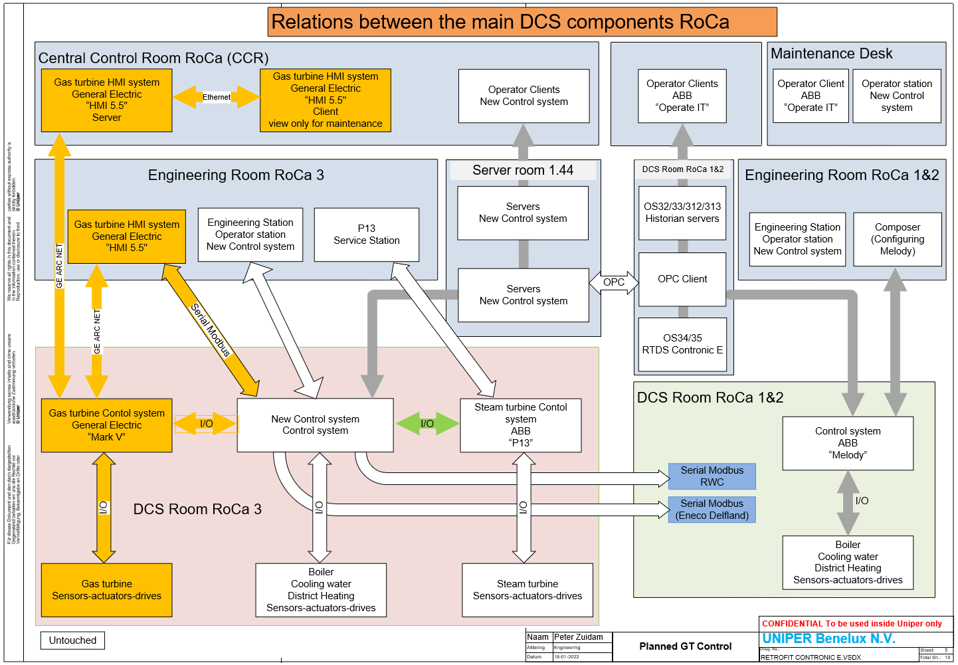
Appendix 3-B – Existing GE Mark V Cabinet Information
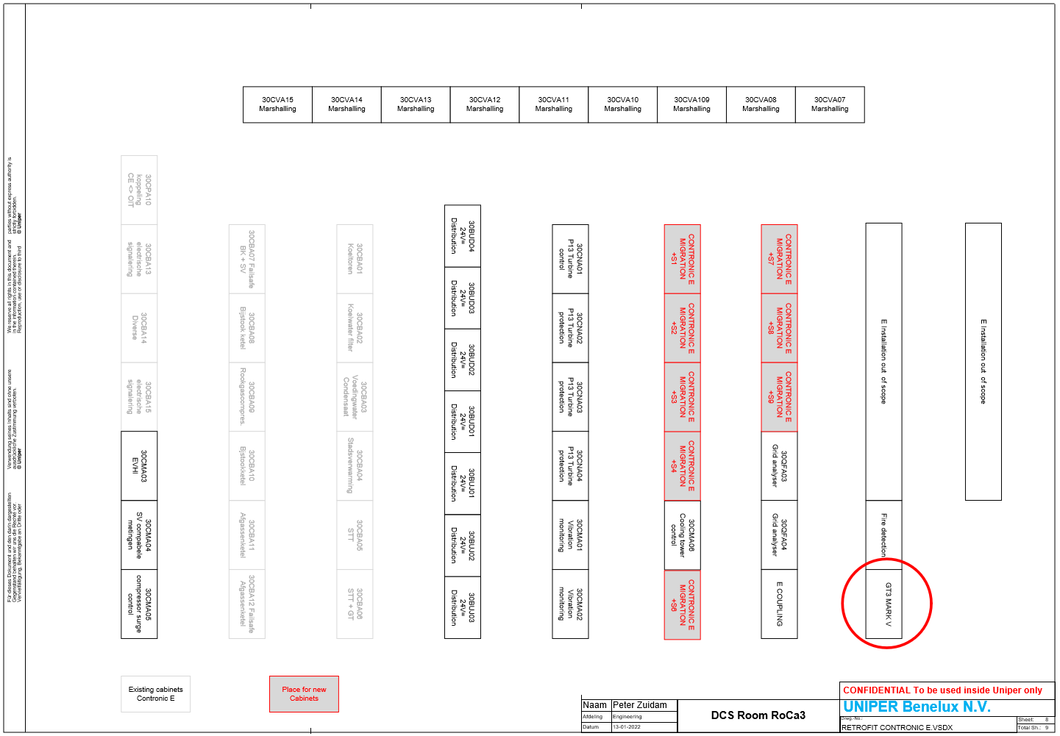

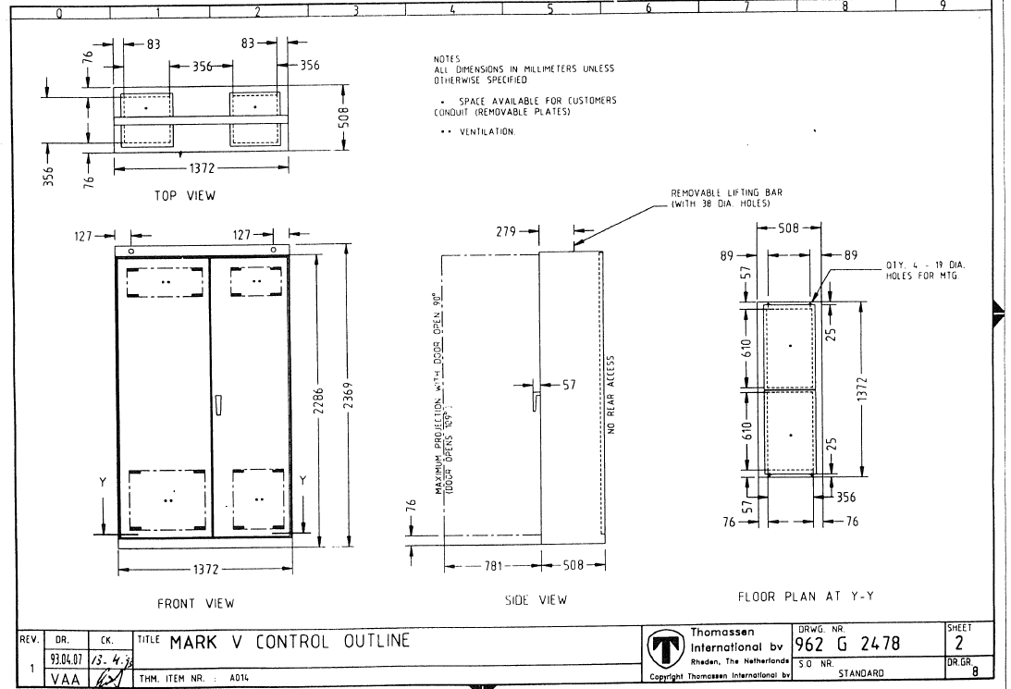

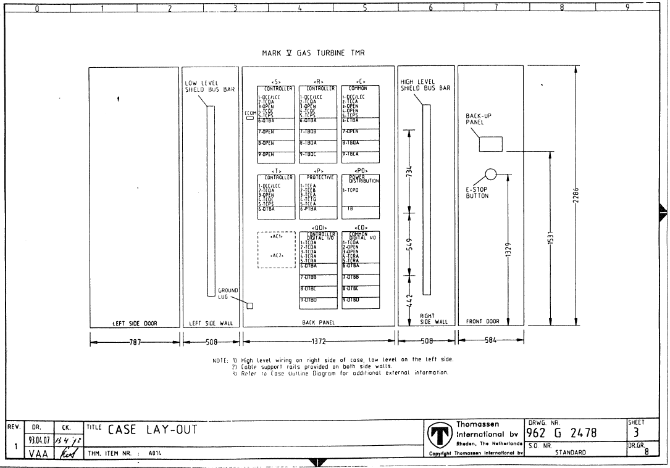

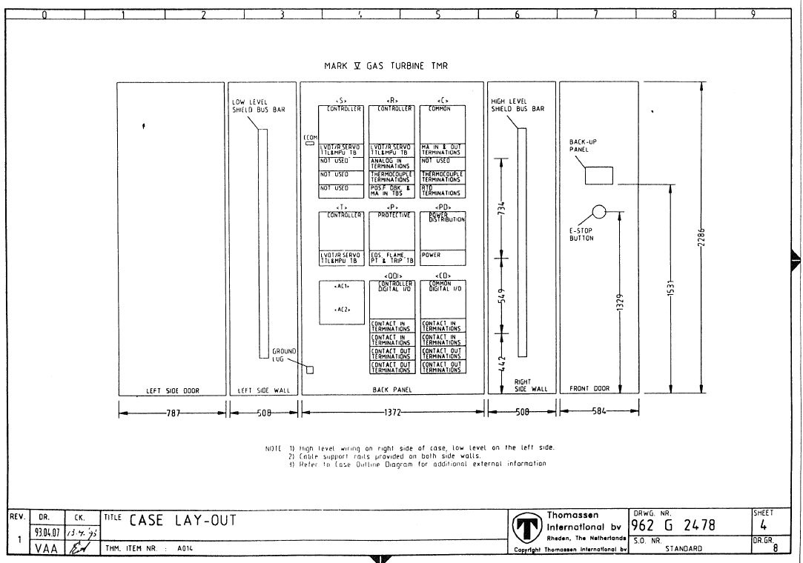

Appendix 3-C – List of Drawings
(Note: These lists are not guaranteed to be complete and should be checked by the Supplier)

Thomassen Drawings
Drawing ID | Page | Description
962 G 2879 | 1 | COVERSHEET
962 G 2879 | 2 | COVERSHEET
962 G 2879 | 3 | DEVICE NOMENCLATURE JB1BA & JB18B
962 G 2879 | 4 | DEVJCE NOMENCLA TURE JB19 & JB20
962 G 2879 | 5 | DEVICE NOMENCLA TURE JBSS & JB59
962 G 2879 | 6 | DEVICE NOMENCLA TURE JB68 & JB69
962 G 2879 | 7 | DEVICE NOMENCLA TURE JB77 & JB85
962 G 2879 | 8 | NOTES
962 G 2879 | 9 | SPARE
962 G 2879 | 10 | JB1BA-X1 WHEELSPACE THERMOCOUPLES
962 G 2879 | 11 | JB18A-X1 BEARING THERMOCOUPLES
962 G 2879 | 12 | JB18B-X1 WHEELSPACE THERMOCOUPLES
962 G 2879 | 13 | JB18B-X1 THERMOCOUPLES L.O. SYSTEM
962 G 2879 | 14 | SPARE
962 G 2879 | 15 | JB19-X1 FLAME DETECTORS PRIM.
962 G 2879 | 16 | JB19-X1 FLAME DETECTORS SEC.
962 G 2879 | 17 | JB19-X1 VIBRA TION SENSORS
962 G 2879 | 18 | JB19-X1 MAGNETIC PICK-UPS
962 G 2879 | 19 | JB19-X1 VARIABLE INLET GUIDE VANES
962 G 2879 | 20 | JB19-X2 BEARING THERMOCOUPLES
962 G 2879 | 21 | J819-X2 THERMOCOUPLES
962 G 2879 | 22 | SPARE
962 G 2879 | 23 | JB20-X1 SOLENOIDS
962 G 2879 | 24 | JB20-X1 LIMIT SWITCHES
962 G 2879 | 25 | JB20-X1 LIMIT SWITCHES
962 G 2879 | 26 | J820-X1 FIRE DETECTION
962 G 2879 | 27 | JB20-X1 FIRE DETECTION
962 G 2879 | 28 | JB20-X2 IGNITION TRANSFORMERS
962 G 2879 | 29 | JB77-X1 FIRE DETECTION
962 G 2879 | 30 | JB55 VIBRA TION DETECTORS
962 G 2879 | 31 | JB59 VIBRA TION DETECTORS
962 G 2879 | 32 | JB85 VIBRA TION DETECTORS
962 G 2879 | 33 | JB100-X1 EXHAUST THERMOCOUPLES
962 G 2879 | 34 | JB100-X1 EXHAUST THERMOCOUPLES
962 G 2879 | 35 | JB100-X1 THERMOCOUPLES
962 G 2879 | 36 | SPARE
962 G 2879 | 37 | JB100-X1 EXHAUST THERMOCOUPLES
962 G 2879 | 38 | JB100-X1 EXHAUST THERMOCOUPLES
962 G 2879 | 39 | JB100-X1 THERMOCOUPLES
962 G 2879 | 40 | JB100-X1 THERMOCOUPLES
962G3184 | 1 | COVERSHEET
962G3184 | 2 | DEVICE NOMENCLATURE JB1 & JB2
962G3184 | 3 | DEVICE NOMENCLATURE JB10
962G3184 | 4 | NOTES
962G3184 | 5 | SPARE
962G3184 | 6 | JB1-X1 PRESSURE TRANSMITTERS
962G3184 | 7 | JB1-X1 TEMPERATURE ELEMENTS - RTD
962G3184 | 8 | JB1-X1 BEARING TEMPERATURE
962G3184 | 9 | JB1-X1 VIBRATION SENSORS
962G3184 | 10 | JB1-X1 POSITION TRANSMITTER
962G3184 | 11 | JB2-X1 SWITCHES
962G3184 | 12 | JB2-X1 SWITCHES
962G3184 | 13 | JB2-X1 SWITCHES JB2-X1 SWITCHES
962G3184 | 14 | JB2-X1 SWITCHES
962G3184 | 15 | JB2-X1 FIRE DETECTORS
962G3184 | 16 | JB2-X1 SOLENOIOS & TRANSMITTER
962G3184 | 17 | SPARE
962G3184 | 18 | JB10-X1 AC HEATERS
962G3184 | 19 | J810-X1 AC MOTORS
962G3184 | 20 | JB10-X1 AC MOTORS
962G3184 | 21 | JB10-X2 DC MOTORS
906G2877 | 1 | COVERSHEET
906G2877 | 2 | DEVICE NOMENCLATURE
906G2877 | 3 | NOTES
906G2877 | 4 | JB130-X1 STOP/SPEED_RATIO VALVE_
906G2877 | 5 | JB130-X1 GAS CONTROL VALVE
906G2877 | 6 | JB130-X1 GAS CONTROL VALVE
906G2877 | 7 | JB130-X1 GAS CONTROL VALVE
906G2877 | 8 | JB130-X1 SPARE
906G2877 | 9 | JB130-X2 PRESSURE TRANSMITTERS
906G2877 | 10 | J8130-X3 -GAS- DETECTORS
906G2877 | 11 | SPARE
906G2877 | 12 | JB131-X1 SWITCHES
906G2877 | 13 | JB131-X1 SWITCHES
906G2877 | 14 | JB131-X2 SOLENOIDS
906G2877 | 15 | SPARE
962G5155 | 1 | COVERSHEET
962G5155 | 2 | DEVICE NOMENCLATURE
962G5155 | 3 | JB213 PRESSURE SWITCHES & TRANSMITTER lube oil
962 G 3471 | 1 | COVERSHEET
962 G 3471 | 2 | CONNECTION DIAGRAM JB250 (lighting encloser)
962 G 3471 | 3 | CONNECTION DIAGRAM JB251 (lighting encloser)
962 G 3471 | 4 | CONNECTION DIAGRAM JB252 (lighting encloser)
962G3472 | 1 | COVERSHEET
962G3472 | 2 | SPARE
962G3472 | 3 | LUBE OIL TANK 88QV-1 88QV-2
962G3472 | 4 | EXHAUST FRAME COOLING
962G3472 | 5 | VENTILATION GAS TURBINE ROOF BBEF-1,2
962G3472 | 6 | VENTILATION GASTURBINE ROOF 88EF-3,4
962G3472 | 7 | VENTILATION GASTURBINE ROOF
962G3472 | 8 | VENTILATION GAS TURBINE ROOF
962G3472 | 9 | VENTILATION GAS TURBINE ROOF
962G3472 | 10 | VENTILATION ACC. COMPARTMENT
962G3472 | 11 | THERMOCOUPLES TURBINE COMPARTMENT
962G3472 | 12 | ACOUSTICAL ENCLOSURE SAFETY SWITCHES
962G3472 | 13 | ACOUSTICAL ENCLOSURE SAFETY SWITCHES
962G3472 | 14 | ACOUSTICAL ENCLOSURE SAFETY SWITCHES
962G3472 | 15 | WASHWATER UNIT 23WK-1,2
962G3472 | 16 | WASHWATER UNIT BBDM-1 88TW-1
962G3472 | 17 | GAS COMPARTMENT VENT. FAN 88VL-1
962G3472 | 18 | HUMIDITY SENSOR 95RH+A T -ID-10
962G3472 | 19 | FIRE PROTECTION
962G3472 | 20 | ANTI-ICING CONTROL SYSTEM JB330 + JB380
962G3472 | 21 | ANTI-ICING CONTROL SYSTEM JB331
962G3472 | 22 | FIRE PROTECTION
962G3472 | 23 | FIRE PROTECTION
962G3472 | 24 | LUBE OIL THERMOCOUPLES
962G3472 | 25 | COOLING WATER BBTK-12
962G3472 | 26 | COOLING WATER
962G3472 | 27 | SPARE
962G3472 | 28 | GAS SUPPLY
962G3472 | 29 | FUEL GAS SUPPLY
962G3472 | 30 | PRESSURE TRANSMITTERS
962G3472 | 31 | THERMOCOUPLES BLEED HEATING
962G3472 | 32 | SOLENOIDS
962G3472 | 33 | GAS DETECTORS EXHAUST VENTILATION
962G3472 | 34 | STARTMOTOR 88CR-1
962G3472 | 35 | AC-DC MOTORS
962G3472 | 36 | LEAK WATER DETECTION

Contronic E Drawings
Drawing | Description
31MBY00 FE Gas turbine
31MBY0010 FE Gas turbine | Inhoudsopgave
31MBY00 FE Gasturbine | Inhoudsopgave
30CMA03CE001 | Kost 30CMA03
31M-33UT | Deur GT3 omkasting
31M-39VS11 | Tril lager 1 A
31M-39VS12 | Tril lager 1 B
31M-39VS21 | Trll lager 2 A
31M-J9VS22 | Tril lager 2 B
31M-39VS23 | Tril lager 2 C
31M-39VS24 | Trll lager 2 D
31M-39VS31 | Tril lager 3 A
31M-39VS32 | Tril lager 3 B
31M-39VS41 | Tril GEN Jager 4 A
31M-39VS42 | Tril GEN lager 4 B
31M-39VS51 | Tril GEN lager 5 A
31M-39VS52 | Tril GEN lager 5 B
31M-39VS61 | Tril GEN lager 6 A
31M-39VS62 | Tril GEN lager 6 B
31M-96FG-1 | P aardgastoevoer
31M-96VC11 | Ax verplaatsing lager 1
31M-96VC11 | Ax verplaatsing lager 1
31M-96VC12 | Ax verplaatsing lager 1
31M-96VC12 | Ax verplaatsing lager 1
H 31M-CA 1/FREQ | GT in alert bedr
31M-FQ-1 | F gas GT
31M-FQ-1 | F gas GT
31M-FQ-2 | F gas GT
31M-FQ-2 | F gas GT
31M-L90FREQ | Prim frequentie Invloed
31M-51X | In programma
31M-S26TCX | GT vermogen
31M-S30X | Mark V Alarm Claxon Resetten
31M-S3RS | GT gereed voor start
31M-S43R | Centrale bediening GT
31M-S52GX | Generatorschakelaar GT
31M-S8 3PSEL | Vermogensreg GT
31M-S94X | Uit programma GT
31M-TNH | Toeren GT
31M-TNH | Toeren GT
31M-TTXM | T gemiddeld uitlaat GT
31MBP00C0011 | Stookwaarde gos GT
31MBP00C0012 | Dichtheid gas GT
31MKA00RX001 | Ontlading fase R GT -GEN
31MKA00SX001 | Ontlading fase S GT -GEN
31MKA00TX001 | Ontlading fase T GT-GEN
31M-3CP | Ketel gereed v GT-start
31M-L1-EXHLIM | Afregelen T uitl GT
31M-l 1FSSTOP | BA Vrijg GT
31M-L 1FSSTOP-1 | Vrijgave GT
31M-L1FSSTOP-2 | Vrijgave GT
31M-L 1FSSTOP-3 | Vrijgave GT
31M-GA1 | GT bedieningskeuze
31M-CA1 | GT bedieningskeuze
31M-CA70R4/CS | Vermogen GT

