Site Studies Wind Farm Zone
Nederwiek, Lagelander, Doordewind and Search Area 8

Geological Desktop Study for Various Sites
Annex 7

Starting Point and Assumptions

Colophon
Project name | Geological Desktop Study for multiple Dutch Offshore Wind Farm Zones
Project number | WOZ
Version | 1 June 2022
File name | VS_20220712_GEO_Annex 7 - Starting Points and Assumptions_V03_F.docx
Annex(es) | 3
Author | M. Hofstra
Reviewed | P. Lebbink
Approved | M.Brijder

Revision History
Date | Page | Revision
12 July 2022 | - | First publication

Contents

1 Introduction 5
2 General introduction to the offshore wind energy in the Netherlands 6
3 General introduction Nederwiek WFZ 9
4 General introduction Lagelander WFZ 10
5 General introduction Doordewind WFZ 11
6 General introduction Search Area 8 12
7 Quality requirements 13
8 Communication 16

Introduction
This document provides the starting points and assumptions for the IJmuiden Ver Wind Farm sites I-VI. The starting points and assumptions are to be used by contractors when executing investigations, studies or likewise, for the development of the IJmuiden Ver Wind Farm sites I-VI and commissioned by one of the following organisations:
- The Ministry of Economic Affairs and Climate Policy
- The Ministry of Infrastructure and Water Management
- Netherlands Enterprise Agency (RVO)
- Rijkswaterstaat
- Tennet TSO B.V.

This document is part of the QA/QC process for these studies.

Please note:
- This is a living document; before use check the revision history for the latest updates (to be confirmed by your client)

If you have any queries please contact your client.

General introduction to the offshore wind energy in the Netherlands

2.1 Existing offshore wind farms
The Netherlands’ existing offshore wind farms have a combined capacity of approximately 3,000 MW, of which 2,000 MW is fully operational.
Table 1 Wind Farms in the Dutch North Sea (operational or under construction)
Windfarm | Sites | Distance of the coast | Year of commissioning | Turbines | Owner
Offshore Wind Farm Egmond aan Zee (OWEZ) |  | 10-18 km | 2008 | 36 Vestas 3 MW | Noordzeewind (joint venture NUON and Shell)
Prinses Amalia Wind Farm |  | 23 km (12 NM) | 2009 | 60 Vestas 2 MW | Eneco
Luchterduinen |  | 23 km (12 NM) | 2015 | 43 Vestas 3 MW | joint venture Eneco and Mitsubishi Corporation
Gemini |  | 85 km | 2017 | 150 Siemens 4 MW | Northland Power, Siemens, Van Oord and HVC
Borssele | I – II | 22 km | 2020 | 94 Siemens 8 MW | Ørsted
Borssele | III – IV |  | 2020 | 77 Vestas 9,5 MW | Blauwwind
Borssele | V |  | 2021 | 2 Vestas 9,5 MW | Two Towers
Hollandse Kust (Zuid) | I – IV | 18 km | Under construction | 140 Siemens 11 MW | Vattenfall
Hollandse Kust (noord) | V | 18 km | Under construction | 69 Siemens 11 MW | Crosswind

2.2 The roadmap 2030 & 2030+ towards 21 GW offshore wind power
The Dutch Government has established the goal to have 21 GW of offshore wind energy capacity installed around 2030. To achieve this, the offshore wind roadmaps 2030 and 2030+ set out a schedule of tenders for wind farm permits, with each tender offering an area comprising an installed capacity of at least 0,7 - 1 GW. Wind farm developers can apply in tenders for the permits to build and operate a wind farm according to a Wind Farm Site Decision. Winners of these permit tenders will be granted a permit and a grid connection to the main land. RVO is responsible for the site data, which can be used for the preparation of bids for these tenders.

The wind farms will be built in designated Wind Farm Zones. Wind farms outside these Wind Farm Zones are prohibited. Within the designated Wind Farm Zones the government defines the specific Wind Farm Sites where wind farms can be constructed, using a so-called Wind Farm Site Decision (‘Kavelbesluit’). This Wind Farm Site Decision contains all conditions for building and operating a wind farm on that specific site.
The Dutch Government provides comprehensive site data and Dutch transmission system operator TenneT is responsible for grid connection.
In this RVO has been assigned to characterize two additional Wind Farm Sites within the IJmuiden Ver Wind Farm Zone to prepare for the development of offshore wind.

Table 2 Wind Farm Zones in the Dutch North Sea
Wind Farm Zones in the Dutch North Sea
Wind Farm Zone | Wind Farm Site | Tender | Capacity | Owner
Borssele | I and II | 2015 | 752 MW | Ørsted Borssele 1 B.V.
Borssele | III and IV | 2016 | 731 MW | Blauwwind II C.V. (Shell, Van Oord, Eneco, Diamond Generating Europe)
Borssele | V | 2016 | 19 MW | Two Towers
Hollandse Kust (zuid) | I and II | 2017 | 740 MW | Chinook (Vattenfall)
Hollandse Kust (zuid) | III and IV | 2018 | 760 MW | Vattenfall
Hollandse Kust (noord) | V | 2019 | 759 MW | Crosswind
Hollandse Kust (west) | VI and VII | 2022 | 2 x ≥700 MW | t.b.d.
Hollandse Kust (west) | VIII | 2026/2027 | ≥700 MW | t.b.d.
Ten noorden van de Waddeneilanden | I | 2026/2027 | ≥700 MW | t.b.d.
IJmuiden Ver | I and II | Q4 2023 | ≥ 2 x 1,000 MW | t.b.d.
IJmuiden Ver | III and IV | Q4 2023 | ≥ 2 x 1,000 MW | t.b.d.
IJmuiden Ver | V and VI | Q2 2025 | ≥ 2 x 1,000 MW | t.b.d.
Nederwiek | I | Q2 2025 | 2,000 MW | t.b.d.
Nederwiek | II and III | 2026/2027 | ≥ 2 x 2,000 MW | t.b.d
Doordewind | I | 2027 | 2,000 MW | t.b.d.
Doordewind | II | 2027 | 2,000 MW | t.b.d.

An overview for the Roadmap 2030 is provided in Figure 1.
In the beginning of 2022 the Dutch Government announced three new Wind Farm Zones called Lagelander, Nederwiek and Doordewind. The development of the southern part (HKWWFS VIII) of the Hollandse Kust (west) Wind Farm Zone and the IJmuiden Ver Wind Farm Sites V-VI in the Ijmuiden Ver Wind Farm Zone was also confirmed. Together this is expected to be sufficient for an additional 10,7 GW.

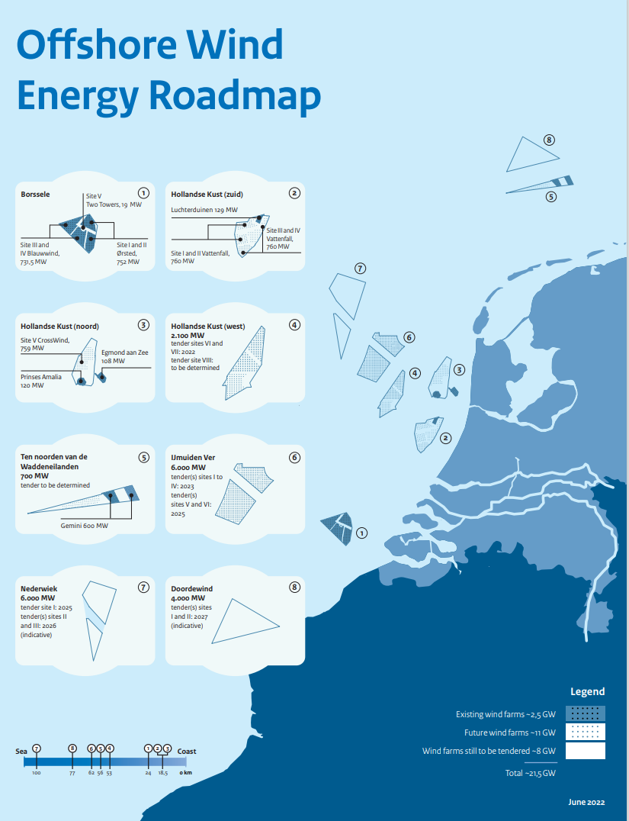
Figure 1 Dutch Offshore Wind Farm Zones overview for road map 2030

General introduction Nederwiek WFZ

The Nederwiek Wind Farm Zone (NWWFZ) is located 100 kilometres off the west coast of the Netherlands. General characteristics of the NWWFZ are shown in 2. The Annex to this document provides the coordinates of the Wind Farm Zone.
The Nederwiek Wind Farm Zone Wind Farm Zone is planned to contain a total capacity of 6,000 MW divided over 3 sites of 2,000 MW each. The wind farm permit tender is divided in two phases scheduled to become available between 2025 and 2026. Nederwiek Wind Farm Site I is planned to be the first phase within the Wind Farm Zone and is an addition to the roadmap 2030+.

Table 2 Characteristics of the Nederwiek Wind Farm Zone
Characteristics
Water depth | Approximately 25-36 mLAT
Distance from shore | Approximately 100 km
Total Wind Farm Zone area | Approximately 947 km²

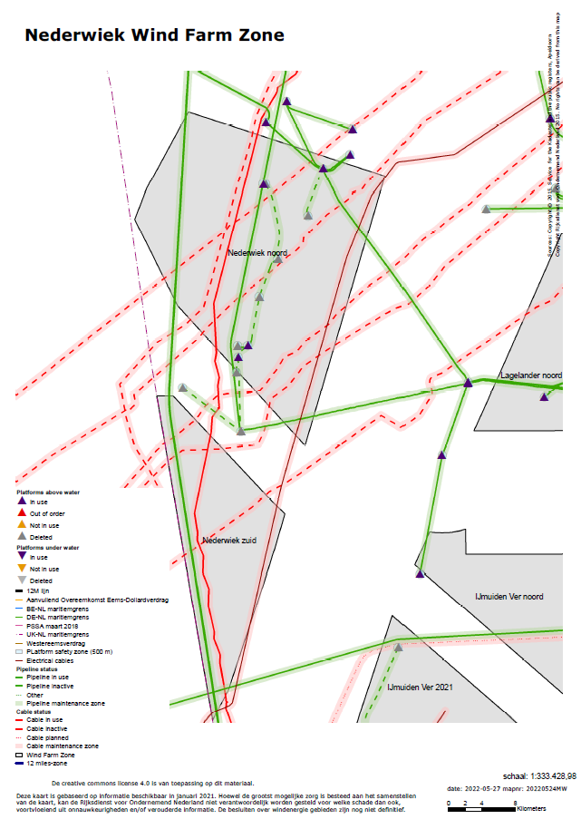
Figure 2 Nederwiek Wind Farm Zone

General introduction Lagelander WFZ
The Lagelander Wind Farm Zone (LLWFZ) is located 30 kilometres off the west coast of the Netherlands. General characteristics of the LLWFZ are shown in Table 3. The Annex of this document shows the coordinates of the Wind Farm Zone. Figure 2 shows an overview of the Wind Farm Zone.

The Lagelander Wind Farm Zone is not yet part of the current roadmap.

Table 3 Characteristics of the Lagelander Wind Farm Zone
Characteristics
Water depth | Approximately 16.5-47 m LAT
Distance from shore | Approximately 30 km
Total Wind Farm Zone area | Approximately 844 km²

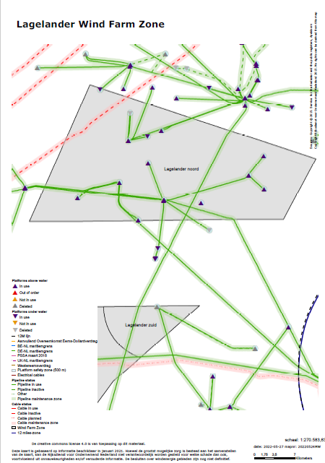
Figure 3 Lagelander Wind Farm Zone

General introduction Doordewind WFZ
The Doordewind Wind Farm Zone (DDWWFZ) is located 80 kilometres off the north coast of the Netherlands. General characteristics of the DDWWFZ are shown in Table 4. The Annex of this document shows the coordinates of the DDWWFZ. Figure 4 shows the Wind Farm Zone.

The Doordewind Wind Farm Zone is planned for a total capacity of 4,000 MW divided over 2 sites of 2,000 MW each. The tender is divided in 2 phases of 2 sites scheduled to become available in 2027.

Table 4 Characteristics of the Doordewind Wind Farm Zone
Characteristics
Water depth | Approximately 35-45 m LAT
Distance from shore | Approximately 80 km
Total Wind Farm Zone area | Approximately 565 km²

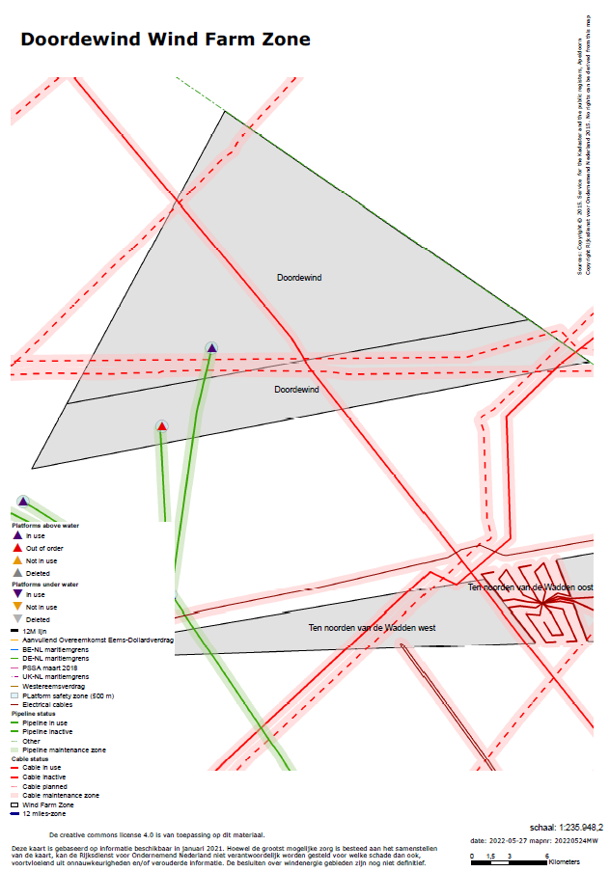

Figure 4 Doordewind Wind Farm Zone

General introduction Search Area 8
Search Area 8 (SA8) is located 30 kilometres off the north-west coast of the Netherlands. General characteristics of SA8 are shown in Table 5. The Annex of this document shows the coordinates of the Search Area. Figure 5 shows an overview of the Search Area.

Search Area 8 is not yet part of the current roadmap and is not designated as Wind Farm Zone (yet).

Table 5 Characteristics of Search Area 8
Characteristics
Water depth | Approximately 25-30 m LAT
Distance from shore | Approximately 30 km
Total Wind Farm Site area (V-VI) | Approximately 176 km²

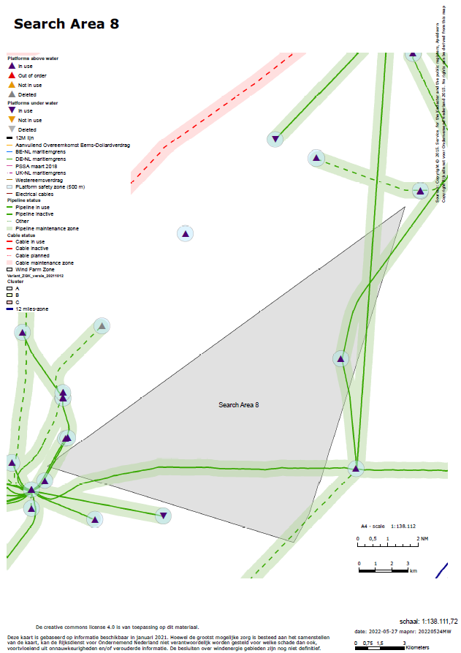
Figure 5 Search Area 8

Quality requirements
This chapter describes quality requirements including data model and GIS data deliveries. During the process and delivery of the data further information or explanations can be requested at RVO.

As RVO will make this data public available the metadata must comply with the GDPR (AVG) requirements.

Spatial data

All created data in the study will be delivered by the supplier in GIS format. The supplier will need to comply with the data requirements set out by RVO and provide an inventory list of the deliverables supplied. The inventory should include project name, name of contractor and responsible person, survey date, product medium (i.e. hard drive, web service, etc.), folder structure and description of data contents.

- The data should be delivered in one of the following formats: ESRI File Geodatabase, TIFF or ESRI Shapefile (.shp). Should another format be used this can only be delivered after consulting with RVO.
- Both raw data and processed data along with any relevant GIS workspaces (MXDs) are required and should also include the associated reports and charts.
- Data preferably in a data model format like the SeaBed Survey Data Model (http://www.iogp.org/bookstore/product/guidelines-for-the-use-of-the-seabed-survey-data-model/)
- Data described in the IHO S44 standards should be delivered according to that standard: https://iho.int/uploads/user/pubs/Drafts/S-44_Edition_6.0.0-Final.pdf The geodetic system used for horizontal projections is European Terrestrial Reference System 1989 (ETRS89). EPSG code: 25831 http://www.epsg-registry.org/. If another CRS is used the transformation parameters to ETRS89 needs to be included.
- All GIS data shall be provided with Metadata describing specific details and origin regarding the spatial data. The requirements regarding the metadata are included in Annex A.

Taxonomy

All contractors must use the taxonomy as presented in the taxonomy list, which is available online at https://offshorewind.rvo.nl/file/view/55039930/Taxonomy+List+Offshore+Wind+Energy+-+Dutch_English

GIS Metadata requirements

The requirements for GIS metadata which all Contractors shall comply with is shown in Annex A of this document.

Units and datums

SI units (ISO/IEC 8000) are applicable for any activities carried out at the Wind Farm Zone.

The chart datum is Lowest Astronomical Tide (LAT).

All positioning data shall be collected in the European Terrestrial Reference System 1989 (ETRS89)
and projected using ETRS89 Transverse Mercator Coordinate Reference System (UTM Zone 31N).
The reference for this system is EPSG Projection code 25831 - ETRS89 / UTM zone 31N.

Document control requirements
The naming of the documents shall be standardized in order to facilitate the document control during the whole project. The following naming code is required for all documents produced within the project:

VSA_Date_Organization_Name document_Author_Version_Status

- VSA: Various sites
- Date: yyyymmdd, e.g. 20210101
- Organization: Name of the organization e.g.
  - ”RVO” for all internal and general documents produced by the Netherlands Enterprise Agency (RVO)
  - Consultant or Contractor name (shortened)
- Name document: Make sure the name clearly explains the content, include here the original name if from external party
- Author: Abbreviation of the author if an internal document. Author shall be removed for final documents
- Version: Revision number or date, respectively V01 till V0x_D or 20200101_F
- Status: (D) for draft documents, (F) for signed and approved documents

VSA will be used in case it concerns all or multiple sites. In case of a specific Wind Farm Zone the following naming codes will be used: NW, DWD, LL, SA8.

Standards, formats, templates

All reports will be written in English and include an English management summary.

Contractors provide for each completed study a publishable summary for the Project and Site description. Maximum 2 A4 including some high-resolution pictures or graphs.

All reports must use the terminology as specified in Annex A of the Starting points and assumptions. For your convenience this dictionary is also available as XLSX file.

Reports and deliverables will be delivered by contractors in pdf and original, regular, formats (docx; xlsx; pptx; etc).
Final reports will have a cover according to the corporate identity of the Netherlands Enterprise Agency, with the following text:

• Front:
Offshore wind energy Netherlands
Site data Nederwiek Wind Farm Zone (or likewise Doordewind Wind Farm Zone, Lagelander Wind Farm Zone, Search Area 8)
Name document

• Back:
A colophon with the following content:

The creative commons license 4.0 apply to this material. (including a Creative Commons logo

and hyperlink to the relevant Creative Commons website page: https://creativecommons.org/licenses/by/4.0/)

• The (investigation) (report) was carried out by <<name contractor>>, commissioned by RVO, an agency of the Ministry of Economic Affairs and Climate Policy. Whilst a great deal of care has been taken in compiling the contents of this document and the mentioned investigations, Netherlands Enterprise Agency (RVO) cannot be held liable for any damages resulting from any inaccuracies and/or outdated information.

• Contact
Netherlands Enterprise Agency (RVO)
Croeselaan 15 | 3521 BJ | Utrecht | The Netherlands
P.O. box 8242 | 3503 RE | Utrecht | The Netherlands
www.rvo.nl/http://english.rvo.nl

• Netherlands Enterprise Agency (RVO) | Date of publication

Other data

In the case of collected data: primary data must be delivered in regular formats.

Deliverables (results / maps)

All maps (in GIS and PDF) will not show the investigation areas nor the specific Wind Farm Sites. The maps will only show the outer boundary of the Wind Farm Zone Boundary of the Wind Farm Zones or Search Area.

Storage of data (electronic / hardcopy)
The Netherlands Enterprise Agency will store all reports and other relevant documents for at least five years both electronically and hardcopy.

Communication

Confidentiality

All information provided to contractors/suppliers by the Ministry of Economic Affairs and Climate Policy and/or the Netherlands Enterprise Agency and/or the Ministry of Infrastructure and Water Management and/or Rijkswaterstaat and/or TenneT must be regarded confidential.

All deliverables produced by contractors/suppliers remain confidential until a deliverable has been made public by the Ministry of Economic Affairs and Climate Policy and/or the Netherlands Enterprise Agency and/or the Ministry of Infrastructure and Water Management and/or Rijkswaterstaat and/or TenneT.

Accessibility public information
- Site investigations: offshorewind.rvo.nl
- SDE: http://english.rvo.nl/subsidies-programmes/stimulation-sustainable-energy-production-sde
- Wind farm Site Decisions and EIA: https://www.rvo.nl/subsidies-regelingen/bureau-energieprojecten/lopende-projecten

Authorities

Wind Farm Site Decision (‘Kavelbesluit’):
Ministry of Economic Affairs and Climate Policy
Laura Jansen
E l.e.jansen@minezk.nl
T +31 (0)6-29645189

Rijkswaterstaat
Raoul Syrier
E raoul.syrier@rws.nl
T +31 (0)6 11072554

Site data:
Netherlands Enterprise Agency
Matté Brijder
E matte.brijder@rvo.nl
T + 31 (0)6 27878952

Grid connection (‘Transmissiesysteem op zee’):
TenneT TSO BV
Johan Dekkers
E johan.dekkers@tennet.eu
T +31 (0)6 29360328

Media
All media contacts will be coordinated by the Ministry of Economic Affairs and Climate Policy. If a supplier is approached by press representatives than he/she should refer to the spokesman of the Ministry only.

Ministry of Economic Affairs and Climate Policy
Caspar Itz
c.itz@minez.nl
+ 31 610551061

Email

All emails related to the site investigations must be send in CC to the project mailbox: VSA@rvo.nl Or in case of a specific Wind Farm Zone: NW@rvo.nl, LL@rvo.nl, SA8@rvo.nl or DDW@rvo.nl.

The subject of an email related to e.g. Nederwiek needs to start with the date and the abbreviation of NW. Then also it needs to be followed by an abbreviation of the type of site survey. E.g. : NW 20210806 GDS for the geological desk study for Nederwiek.

Emergency Response
In case of an emergency suppliers are obliged to inform the Netherlands Enterprise Agency immediately.

GIS Metadata requirements
Goal of metadata requirements is to make sure the future users of this data can use this data in the appropriate way and find out what the constraints of the usage of the data is from the metadata.

Format
All data collected, either in the field or in a desktop study, by third parties must be provided with metadata. Data is preferably collected in an ArcGIS file geodatabase (version 10.6 or lower). In this case, metadata is stored within the data in the database. In case of a shapefile, GML or GRID metadata must be provided in pure XML-format as separate files.

Metadata must be compliant with the Dutch standard for metadata ISO 19115 version 2.0.0 (or any version available at the time of creating the data), in addition the column names of all datarecords More information on the standard can be found here:
https://www.geonovum.nl/geo-standaarden/metadata/nederlands-metadataprofiel-op-iso-19115-geografie

To validate your metadata a validator is available from the website of Geonovum:
https://validatie.geostandaarden.nl/etf-webapp/testprojects?testdomain=Metadata

Manufacture options

Creating metadata should preferably done when the data is acquired or created and checked and finalised before delivering the data.

Preferred option:
Organisations that use Esri software can use the GeoSticker application to create and edit metadata: http://www.esri.nl/geosticker.

Other options:
The Metadatamaker offered by the RWS can also be used to make the metadata and can be found at http://rws.metainfomaker.nl/
The Nationaal Georegister (NGR) allows meta data to be made, to do this a guest account is required. This can be requested by mailing to EZ geodatabeheer (geodatabeheer.GISCC@rvo.nl )

Other options are possible as long as the data will be validated by the metadata validator for ISO 19115 version 2.0.0 (or newer version available at the time of creating the data) at the website of Geonovum

Metadata elements with explanation:
Identification
  - File title:
No abbreviations, complete title of the dataset covering the content of the dataset.
  - Status:
According a standard list:
completed; historicalArchive; obsolete; onGoing; planned; required; underDevelopment.
  - Source data date:
    - creation YYYY-MM-DD
    - publication YYYY-MM-DD (date of approval by RVO.nl)
    - revision YYYY-MM-DD

  - abstract:
Short description of the content of the dataset.
  - Subject / topics:
Define the key topic(s) of the dataset
  - Keywords:
Keywords describing the dataset, e.g.
- Wind Farm Site
- Wind Farm Zone … (Nederwiek)
- …
- …

  - Revision frequency:
N/A
  - Next revision date:
N/A
  - Purpose of production:
Concise description of the original aim of the dataset
  - Denominator :
Scale on which the dataset can be used.
  - useLimitation :
Applications for which the data set is not to be used. I.e. Not to be used for navigation. Not to be used on a scale larger then 1:50.000
  - accessConstraints:
None, data will be published in the public domain
  - useConstraints:
The creative commons license 4.0 apply to this material. See hyperlink
https://creativecommons.org/licenses/by/4.0/"

This investigation was carried out by …, commissioned by RVO, an agency of the Ministry of Economic Affairs and Climate Policy. Whilst a great deal of care has been taken in compiling the contents of this investigation, RVO cannot be held liable for any damages resulting from any inaccuracies and/or outdated information.
  - otherConstraints :
Other restriction(s) if any.
  - Description complementary document or website:
On the RVO.nl website general information about offshore wind energy can be found as well as links to more detailed information regarding the information of the investigation where this deliverable resulted from.

Quality
  - General origin:
General description of when, how and where the data was created / collected.
  - Accuracy:
Describe accuracy of the dataset.
  - Completeness:
Is the dataset complete? If not, a description of the incompleteness is necessary.
  - Processing of data (if applicable):
If data is processed, description of each step is required i.e. transformation or generalisation
  - Source datasets (if applicable):
Description of used source datasets (if any).

Coverage
  - Geographical coverage:
Geographical coverage of the file e.g. The Netherlands, North Sea.
  - Validity period:
Define start and end date of validity of the dataset.

Content
  - Attribute information:
Description of all attributes, including - if applicable – all possible values and its measurement.

General
  - Contact information:
As this information will be made publicly available personal information should be avoided and generic contact details should be provided. If personal email addresses are provided that person should have given consent to use their e-mail address.

Contact information of client and/or creator and/or point of contact. At least one contact is mandatory. Name organisation, role organisation (owner, processor, point of contact, administrator, provider, creator), and an generic email address of contact department
If website is available, name of contact and role of contact

Do to the GDPR it is no longer desirable to have personal information in the data, it is preferred to have a general email instead of a personal one and a function title instead of a person’s name.

Client:
Business Name: …
Contact Person: …
Address: …
Telephone: …
Email
Creator:
Business Name: …
Contact Person: …
Address: …
Telephone: …
Email: ...

There is one major difference between the Dutch metadata standard ISO 19115 version 2.0.0 and the RVO metadata requirements: the description of the content of the dataset. A description of all attributes, including - if applicable – all possible values and its measurement is mandatory and not optional.

