Additional Material for the Heat Pump Market Consultation

- Additional Data on available space for the Specified location

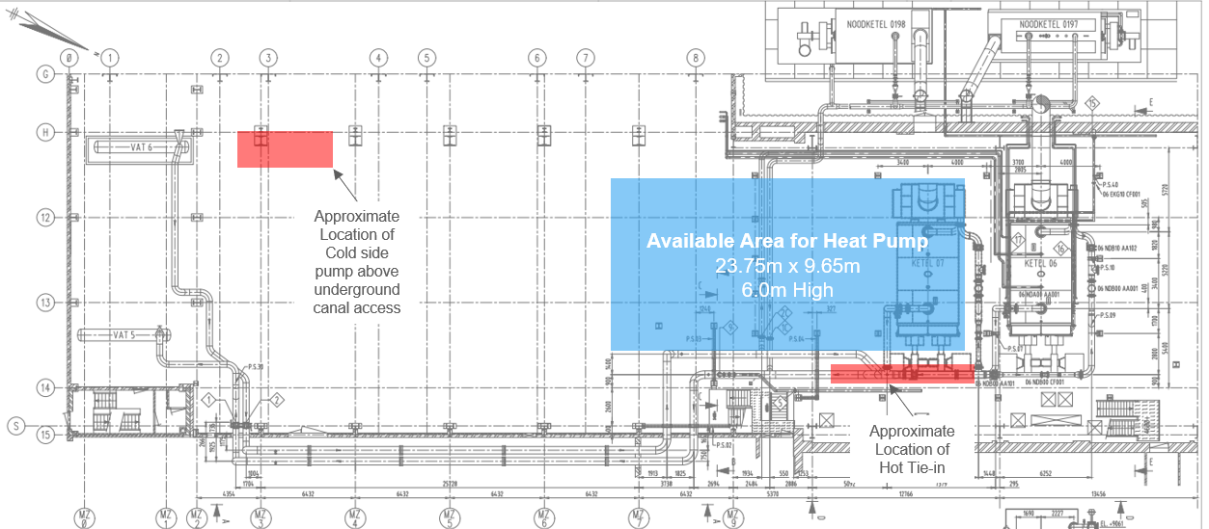

Diagram above shows the available location and volume for the heat Pump Project. Also shown in red are the location of the Hot and cold tie in locations. Piping from these location will be dependent on HP supplier requirements.

- The measurements of the gate for the truck entry (width and height), see picture below

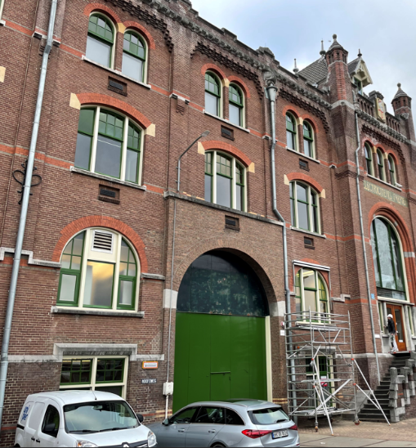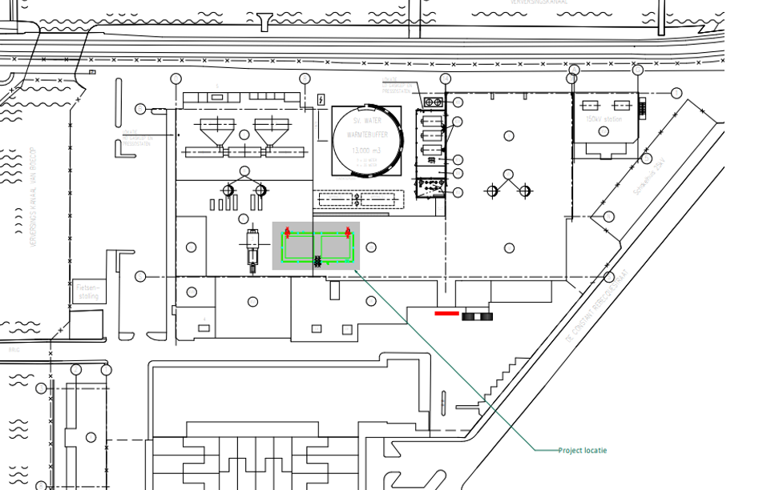

Access for the Heat Pump delivery will be through the main entrance (Green) door as shown in the photo and indicated on the overview drawing below.
The green door is approximately 4.5m wide by 4.5m high

- Additional Data on Electrical Tie in locations

A new 10kV network is being installed at Den Haag. A 10kV connection can be made available at the area for the heat pump as specified by the requirements of the project.

- Additional Data on Existing Site Control System

The existing Site DCS is supplied by ABB with multiple modifications undertaken for different projects. A thorough status review of the DCS and the requirements for integration of this project among others is ongoing and planned to be completed prior to Q4 2022. More information will then be made available.

- Additional Data regarding welding requirements

All welding and cutting activities in the area will be managed through the sites existing permitting system. All activities will be risk assessed with appropriate method statements created.

- Additional Comments regarding certificates and regulatory requirements

All supplier will be expected to comply with all legal requirements and standards according to the rules applicable in the Netherlands.
Specific requirements imposed by the project from the subsidy application for example have been communicated in the market consultation (COP > 3 for example).

