

Market consultation

for: E-Beam Evaporator

Contracting authority:
The Netherlands Organisation for Applied Scientific Research TNO

Document ref. : 2021 FPL/INK 114
Date : 29-06-2021

Contents
Introduction 3
TNO………………………………………………………………………………………………………………………………………………………..3
Organisational structure 3
Purpose of the market consultation 4
Schedule 4
Basic principles and preconditions 5
Form and content 5
Intellectual property rights 5
Use of TNO logo 6
Background 7
Clarification of the functional desired requirements 7

Introduction
The document describes the organisation TNO, its content and objective of the market consultation, the schedule, preconditional and procedural matters.

TNO, department Holst Centre intends to purchase an E-Beam Evaporator. TNO would like to gain more information from the market by conducting this market consultation. The gained information might be used as input for the formal tender process. Therefore, any party which is able to deliver such system for the purposes described in section [3] is invited to contact TNO to present the costs and (technical) possibilities of their E-Beam Evaporator.

After this market consultation, TNO will decide which Tender procedure is the most appropriate choice to buy a E-Beam Evaporator.

TNO
TNO, the Netherlands Organisation for applied scientific research, was founded by law in 1932 to enable business and government to apply knowledge. As an organisation regulated by public law, we are independent: not part of any government, university or company.

TNO connects people and knowledge to create innovations that boost the competitive strength of industry and the well-being of society in a sustainable way. This is our mission and it is what drives us, the over 3,400 professionals at TNO, in our work every day. We work in collaboration with partners and focus on nine domains.

Organisational structure
TNO’s high level of ambition demands an appropriate organisational structure and corporate culture. Staff must be given every support as they pursue innovation and productive cooperation. The current organisational structure is shown below

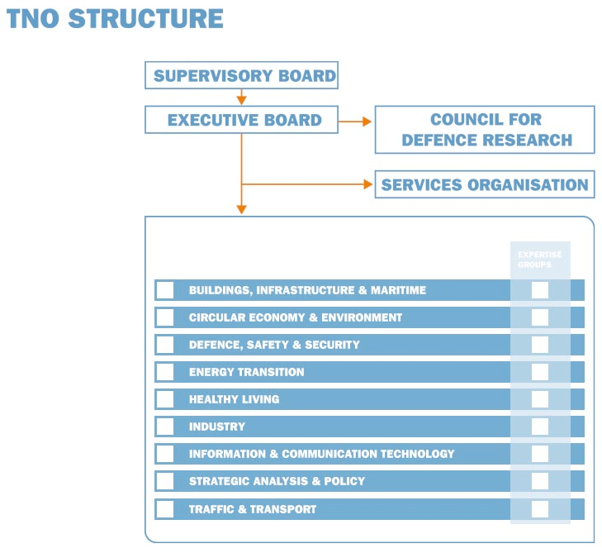

Focus area
The focus area ‘Industry’ to which the Holst Centre belongs, represents an essential link in the search for solutions to the major societal challenges that we face. We aim to help by using our specialist knowledge in the following focus areas:
  - Nanofabrication for patterning and metrology, for example in the semiconductor sector
  - Satellite instrumentation for earth observation and astronomy
  - Precision instrumentation for scientific applications
  - Thin-film electronics for a wide range of applications, from medical sensor systems to automotive applications in dashboards
  - 3D printing processes for new applications, focusing on scaling up printing technology in serial production
  - Quantum computers and quantum communication to strengthen computing power and secure communication flows
  - Smart materials, bio-aromatics and electrification for a greener chemical industry.

If you would like further information about a domain or a specific subject, please take a look at: www.TNO.nl.

Procurement
On behalf of TNO, the Procurement department supervises all procurement, purchasing and tendering procedures and works closely together with Holst Centre in this market consultation. As part of the Finance, Procurement & Legal (FPL) division, the Procurement Department is also responsible for organizing and implementing all procurement processes in keeping with the corporate objectives of the organisation.

Purpose of the market consultation
Before proceeding with the preparation of a possible tender, TNO wants to consult the market on how this tender can best be structured (broadly speaking). Within the scope of the market consultation, advice is sought to gain insight into the potential market for the delivery of an E-Beam Evaporator for TNO. The market consultation is open to all players in the market.

With this market consultation TNO wishes to gain insight into what is technically feasible on the basis of the functional & technical specifications as specified in chapter 4. In this way we want to give parties the opportunity not only to get involved at an early stage, but also to think along with us about what the best solution might be for TNO. After all, the insights obtained can be taken into consideration in the final formulation of the specifications for the (possible) future Tender and allows participants to contribute to the success of the Tender.

The purpose of the market consultation is covering the following aspects:
- To gain more insights in the pricing models of the different ;
- To gain more insights in discriminating factors for different configurations of the E-Beam Evaporator;
- To gain more insight into the current possibilities and the choice on the market; to get a clear understanding of the visions, ideas and suggestions of market participants;
- To gauge market interest for this Tender;
- To decide which procurement strategy is best suited to our functional requirements in the current market.

TNO wishes to be advised based on the existing situation (see section 3.1).

The results of the market consultation may be processed in the Tender documents, without being traceable to participants of this market consultation.

Schedule
No dialogue sessions are planned during this market consultation. However, if the input provided leads to additional questions at TNO, TNO will ask for a written and/or oral explanation.

The schedule of the market consultation is shown in the table below.
Deliverable / activity | Responsible | Date
Market Consultation document published by TNO | TNO | 29-6-2021
Deadline for submitting your questions on the Market Consultation document | Subscriber | 12-7-2021
Deadline for TNO to reply to the questions (anonymised) and publish any additional information or revision of this document | TNO | 16-7-2021
Deadline for submitting your input | Subscriber | 23-7-2021
Possibility for TNO to ask clarification to each party individually when necessary (information will be included in the summary) | Subscriber/TNO | 28-7-2021
TNO summary of market consultation results | TNO | 30-7-2021

Basic principles and preconditions
The basic principles and preconditions mentioned below apply to this market consultation:
- TNO observes the principles on non-discrimination and transparency when carrying out this market consultation;
- This document is solely intended for market consultation purposes and thus is not part of the possible Tender procedure. In short, just a consultation round;
- This market consultation does not serve to make a pre-selection from candidates or interested market parties in the context of the planned tender;
- Market participants who do not apply for this market consultation will not be excluded from participating in the (possible) final Tender. Similarly, market participants who join this market consultation will not be excluded or privileged from participation in the (possible) final Tender;
- This market consultation is non-binding, both for the participants and for TNO;
- Parties who may or may not participate in this market consultation cannot derive any mutual obligations or rights vis-à-vis TNO;
- Participating to this market consultation does not confer no entitlement at obtaining a contract award;
- TNO shall not reimburse any eventual costs in participating to this market consultation;
- Participating market parties agree that the information provided by them can be processed anonymized in the further elaborating program of requirements;
- In the context of the market consultation, provided information may differ from the information that will be provided in the (possible) Tender procedure;
- The contribution of participating Parties will be handled as much as possible with confidentiality and in any case TNO will take into account the legitimate interests of the parties;
- The official language during this market consultation will be Dutch and/or English;
- TNO is in no way bound by the outcome of the market consultation or obliged to realise and/or put out to tender the desired investment to which the market consultation is linked;
- No claim will be honoured for the use of information, confidentiality, or request for compensation herewith;
- All documents submitted by the participating Parties are considered public documents and shall be copy-right free. If copyrights are applicable, TNO is protected by the participating Parties;
- No value judgment can be attributed to TNO’s answers to questions given by you;
- TNO reserves the right to:
  - perform the proposed procurement process in a different way, in terms of content and style, than the process that may have been communicated;
  - to cease publication of the market consultation temporarily or permanently.
- Participating in this market consultation, constitutes the Parties unconditional approval of the procedure as stated in this document.

Form and content
The consultation is set up as follows:

Written responses
Any interested market party who believes that they can contribute to the market consultation, should respond to the consultation document in writing, by e-mail. Responses should be received by TNO no later than 23-7-2021. Responses can be sent to:

Name : Mark Berkhout
Position : Junior buyer
Department : Procurement
E-mail : mark.berkhout@tno.nl

In the heading of your e-mail and in all future correspondence relating to this market consultation should be clearly mentioned ‘Market consultation 2021 FPL/INK 114_E-Beam Evaporator’.

The information received may lead to more in-depth questions for TNO. Optionally, TNO may therefore decide to hold a second round of in-depth questions. For this second round of in-depth questions TNO will only invite those parties who also participated in the first round. In addition, TNO leaves the possibility open to invite market parties without justified reasons and to ask for an additional explanation of the answers received.

Intellectual property rights
Save for the exceptions provided by the law, nothing from this market consultation document may be reproduced (other than for the purpose of this document) in any form, by print, photocopy, DVD, CD-ROM, microfilm or other means, without the prior written permission of TNO.

Use of TNO logo
It is not permitted to copy, modify or otherwise use the TNO logo on any documents submitted by the Tenderer further to the Tender Procedure.

Background
TNO at Holst Centre has as a goal to develop a pre-pilot line for foil- and silicon-based (flexible) electronic and photonic devices. TNO operates extensive laboratory facilities, part of which are in a cleanroom environment, for the fabrication of these devices. Some of the production steps involved are the deposition of metal and metal oxide layers that, after micro-patterning, can act as an electrode, insulator or catalytic layer.

TNO intends to publish a tender for an E-Beam Evaporation system that allows for the deposition of thin films and multilayers of metals and metal oxides. Individual layers typically have a thickness in the range of 1 – 1000 nm. A standard layer will be a 100nm thick Al₂O₃ layer or a 1nm thick Ti or Fe layer. TNO wants to be able to deposit on samples of 4 x 6 inch round and 3 x 152 mm x 152 mm square, around 3-4 deposition runs a day.

Clarification of the functional & technical desired requirements

- TNO will place the system in an ISO 7 cleanroom. What is the particle count you expect to have from such a system? TNO is concerned about moving parts in the chamber that might be a source of particles (for example the rotating holder, the shutter, etc.).
- Could you comment on whether this is a valid concern, and if so, give advice on how to approach this issue?
- Do you have any recommendations for what the best base and processing pressure is for one of our standard recipes, i.e. the evaporation of AI₂O₃, in order to have a good batch-to-batch reproducibility?
- How long would it realistically take to pump down from ambient atmospheric pressure to the abovementioned pressures?
- Could you indicate the pros and cons for both a cryo pump and a turbo pump in your delivered systems? Please elaborate.
- Please indicate whether costs are a pro or a con.
- What are important factors for minimizing pump-down time? For instance, is wall heating an important factor? Please elaborate.
- Please indicate the expected costs (rough estimate) and lifetime for the different factors.
- What factors are essential for avoiding any oil back-diffusion? For instance, is a dry roughing pump essential? Please elaborate.
- Please indicate the expected costs (rough estimate) and lifetime for the different factors.
- TNO wants to be able to evaporate metal oxides like Al₂O₃ or MoO₂ from Al₂O₃ sources and MoO₂. This should be possible with a normal E-beam evaporation process (not reactive evaporation). There are several options to tune the stoichiometry of the deposited layer, like including an ion gun. Would such an ion gun have any added benefits for the purposes for which TNO intends to use the machine? Would you propose another option? What are estimates of the additional costs (rough estimate) for the options?
- TNO wants to process 4 batches a day with 100 -150 nm Al₂O₃ each. What is the suitable pocket size for such volumes?
- Can larger pocket sizes still be used for the evaporation of smaller amounts of precious materials (Au or Pt for example)?
- What is the recommended electron-gun power and power supply for the evaporation of Al₂O₃, Fe, Cu, Al, Pd, Ti, Au, MoO₂? Please elaborate.
- Could you explain the function of a flexible beam sweep system, and whether you would recommend it to TNO based on our purpose for the machine? Could you also give a price indication (rough estimate)?
- Would you recommend having a second electron-gun in the chamber, even if TNO doesn’t need to do parallel evaporation for layer doping? Please elaborate.
- What are possible and recommended substrate preconditioning/activation/cleaning methods? For instance, would you recommend using Glow discharge? Could you also give a price indication (rough estimate) for the recommended methods?
- TNO intends to reproducibly deposit extremely thin films (in the range of 1-2 nm). It shall not be a closed layer. What solution would you recommend for accomplishing this? Please elaborate.
- During the FAT and/or SAT, all requirements, preferences and options that are part of the contract will be subject to acceptance tests. Would you like to share your FAT/SAT protocol with us?
- Are you open to doing a trial on one of your machines with materials TNO provides?

