Market consultation
For soil displacement technique also known as ploughing in pipelines
Door
C.W. Schat

Department
N.V. Nederlandse Gasunie
Report
Market consultation
Date
12 march 2021
Document
Market consultation
Status
Final

Table of contents
1 GENERAL INFORMATION 3
1.1 N.V. Nederlandse Gasunie 3
1.2 Ploughing in pipelines 3
2 Market consultation 5
3 Test case for Gasunie 6
4 Points requiring attention 8
5 Disadvantages of this technique 9
6 Basic principles 10
7 Opportunities for Gasunie 11
8 Questions for market consultation on ploughing in 12
9 Exchange of information 13
10 Conditions 14
Attachment 1 Reference 15

GENERAL INFORMATION

N.V. Nederlandse Gasunie
Gasunie is a European gas infrastructure company. The Gasunie network is one of the largest high-pressure pipeline networks in Europe and consists of more than 15.000 km of pipelines in The Netherlands and Northern Germany, dozens of installations, and approximately 1.300 gas receiving stations.
The annual throughput of gas is approximately 125 billion cubic meters. Gasunie serves the public interest in the markets in which it is active and strives to create optimal value for stakeholders.

More information about Gasunie can be found on https://www.gasunie.nl/en/startpagina.

Ploughing in pipelines
Along with many other asset owners, Gasunie is closely involved in developments to promote sustainability in Europe and the Netherlands in particular. Studies are currently being carried out in many areas towards a more energy-efficient society, in which sustainability is a key element for achieving targets set for 2030 and 2050. As such, Gasunie has incorporated the Sustainable Development Goals into its policy and translated them into Gasunie Green Deals (https://www.gasunie.nl/en/about-gasunie/csr/allocating-gasunies-green-deals-to-the-sdgs). In this connection, Gasunie is also exploring alternative methods for laying steel pipelines and one of these methods is to feed long pipeline sections into the ground by means of a soil displacement technique.

Using the soil displacement technique (also known as ‘ploughing in’) to install steel pipelines for natural gas transport has not been carried out before in the Netherlands. In 2017, PWN, a water treatment company in North Holland, gained experience on Texel from ploughing in two parallel DN300 (12”) steel cemented water pipes. In doing so, PWN learnt that this ploughing system, an innovative pipe-laying method, can be used more widely. There are distinct advantages, such as no longer having to pump out groundwater, no extensive excavation work and a smaller working area compared to traditional pipe laying via an open trench. The speed at which the pipes can be laid and the lower costs are also an eye-opener compared to traditional methods.

The process: cables and pipelines are ploughed in by using a soil displacement technique. This technique involves the use of two machines, which are a mobile winch (1) and a plough (2) which pulls the cable/pipeline (3) behind it and inserts it into the ground this way.
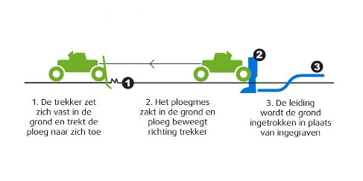
1. The tractor anchors itself in the ground and pulls the plough towards it
2. The plough blade sinks into the ground and the plough moves towards the tractor
3. The pipeline is fed into the ground instead of being dug in
At present there is insufficient knowledge in the Netherlands (particularly with regard to the effects on agricultural engineering and soil mechanical aspects with regard to soil behaviour) about the tensile forces to pull in a pipeline and practical implementation aspects such as maximum length of the string to be pulled in, assembly sites, etc.
Furthermore, in the Netherlands there are not yet any valid standards for ploughing in cables and pipelines, however in Germany, among other countries, it has been a proven technique for decades and is described in the following standards and books:

Worksheet GW 324 2007-08: milling and ploughing procedures for gas and water pipes

DWA-A 160: milling and ploughing procedures for sewers and drains

Cost-effective construction of drinking water pipes : instructions for milling in and ploughing in in rural areas

Worksheet GW 324 08/2007: milling and ploughing procedures for gas and water pipes; requirements, quality assurance and inspection

In addition to PWN’s experiences in the Netherlands, the ploughing system has also been used worldwide for a long time. This work has been carried out in countries including Germany, Austria, Canada, UK and Australia as well as the Middle East, etc. Ploughing in pipelines, including steel pipelines, has therefore become an innovative method for the Netherlands that deserves further investigation, looking specifically at whether it can be broadly applied to Gasunie.

Market consultation
Gasunie is closely involved in developments to promote sustainability in Europe and the Netherlands in particular. Studies are currently being carried out in many areas towards a more energy-efficient society, in which sustainability is a key element for achieving targets set for 2030 and 2050. As such, Gasunie has incorporated the Sustainable Development Goals into its policy and translated them into Gasunie Green Deals (https://www.gasunie.nl/en/about-gasunie/csr/allocating-gasunies-green-deals-to-the-sdgs).

In this connection, Gasunie is also exploring alternative methods for laying steel pipelines and one of these methods is to feed long pipeline sections into the ground by means of a soil displacement technique.

Gasunie is looking for a contractor who has in the last 5 years, ploughed in steel pipelines ranging from diameters of 4” to 24”, with continuous lengths of >200m, divided over several sections or strings.

With this consultation Gasunie wants to get more information about:
A contractor who is interested in ploughed in steel pipelines.

If a contractor is interested in working for the Gasunie as described in this market consultation, the contractor can follow the instruction in Chapter 7.

Activity schedule:
Publication of the consultation: 15 March 2021
Deadline submission of response: 26 April 2021

Test case for Gasunie
Gasunie’s first test case, in April 2020, involved realignment of a DN100 (4”) pipeline over 600 m, partly by ploughing method and partly by conventional method. See the links below to the films of this test:
- https://youtu.be/h3ysmsOoINQ : Ploughing 210 m – 4” in Arum 29-04-2020
- https://youtu.be/F5S0QdQrYLY : Conventional pipeline installation and installation by ploughing

and the following photos:
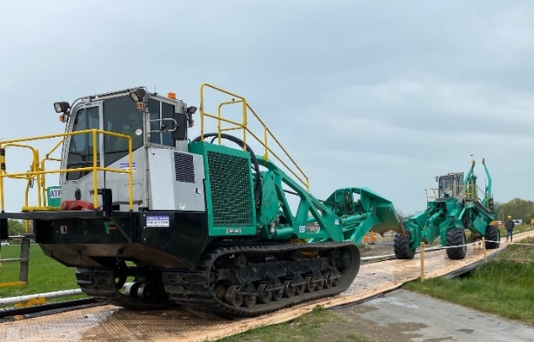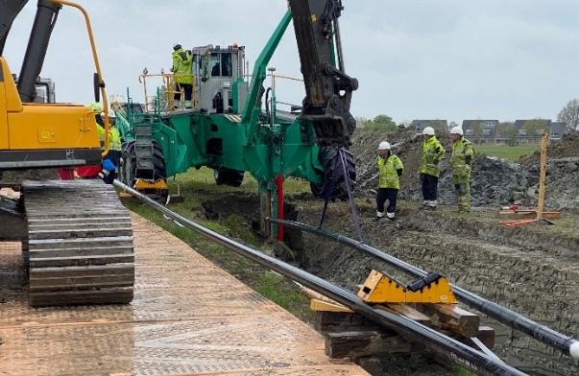
Photo 1: mobile winch + plough Photo 2: connecting 4“ pipeline in pull hole

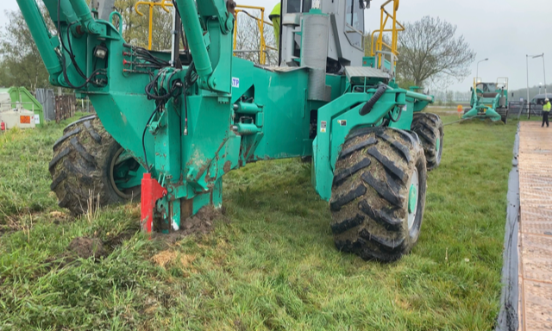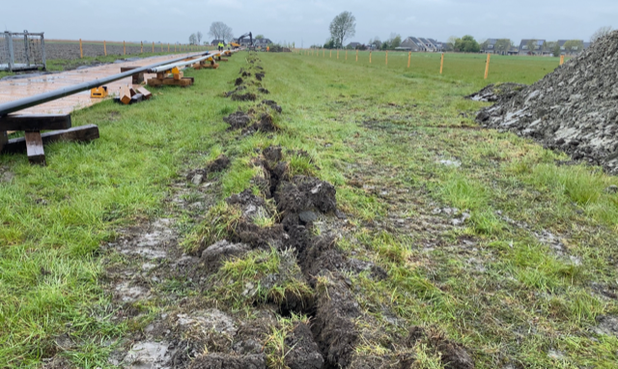
Photo 3: ploughing action Photo 4: furrow at ground level
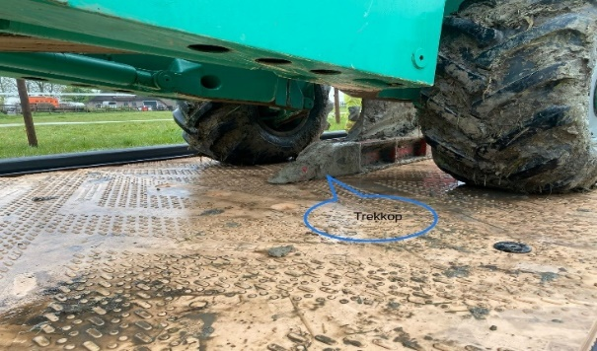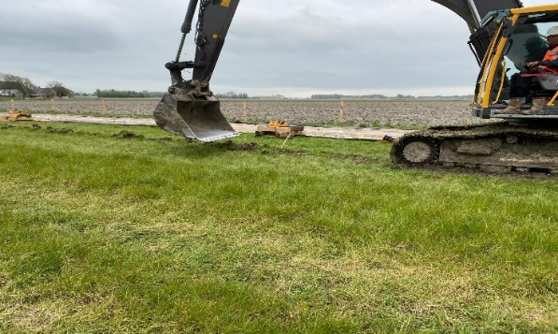
Photo 5: pull head adjustable to max 2.80 m depth Photo 6: pressing furrow with crane

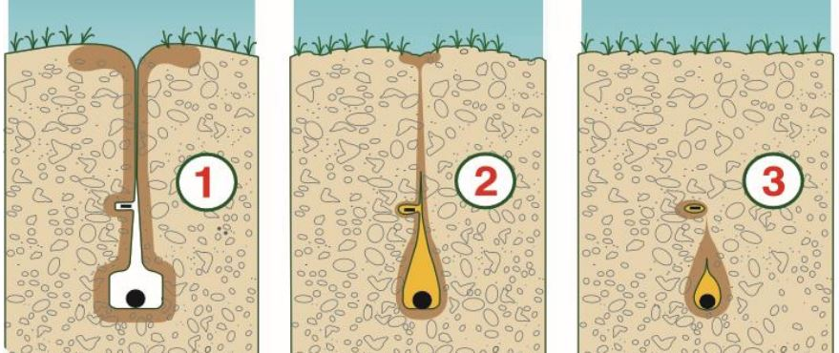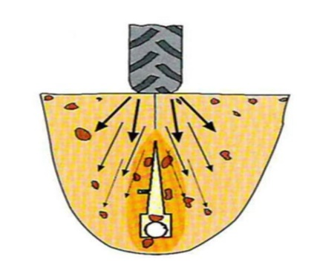
Photo 7: diagram of trench cross-section Photo 8: diagram of trench pressing

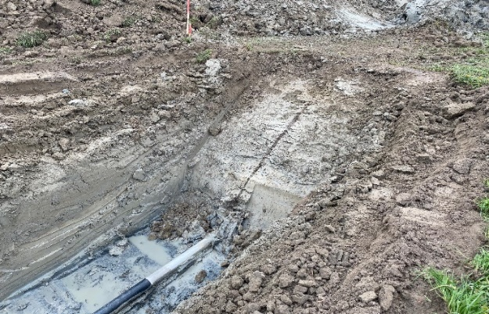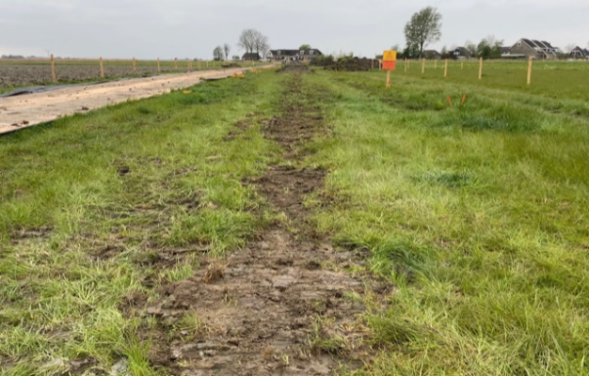
Photo 9: final situation after furrow has been pressed down Photo 10: final situation at ground level

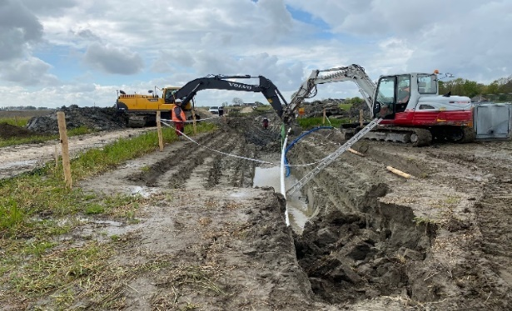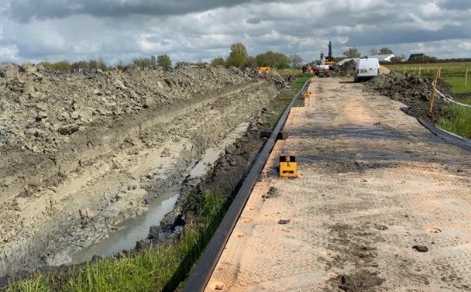
Photo 11: remaining pipework in conventional laying Photo 12: remaining pipework in conventional laying

Points requiring attention
A number of aspects are summarised below, including costs, corporate social responsibility and purchasing and details of technology found in literature and the internet from research into this ploughing technique. Following the first test case in Arum, some of these points have now been provisionally assessed/weighted/evaluated.

4.1 Costs:
- Faster installation (up to 10x faster than conventional pipe-laying, laying rates of 600-700 m/day possible) – and the work process can be set up easily and under controlled conditions (prefab) 24/7
- Working area is half what is usually necessary as only minimal earthmoving required (significantly lower clean-up costs/replanting costs/compensation to owners and users)
- Hardly any soil shortages and no mixing of topsoil, B-C-layers
- Groundwater pumping and discharge hardly necessary with corresponding advantages (costs/pollution/salinisation/PFAS), except at the tie-in locations
- No need for water deferrization plants
- No need for pipeline route drainage
- Limited costs for redrainage or repairing existing drainage
- Much less damage to crops (less time spent on valuations and less compensation)
- Less/no ground subsidence (lower restoration costs)
- Pipe-laying depth (GPS-controlled “on-the-flight” possible) to 2.60 m bottom of trench possible, laying no more expensive than, for example, with 1 m coverage (trend in the Netherlands is to build deeper and deeper infrastructure in connection with subsidence effects (drying out, fall in groundwater level etc.))

4.2 Corporate Social Responsibility (CSR) and Purchasing:
- No subsidence or settlement in the surrounding area (buildings) as a result of groundwater pumping (less damage)
- No longer any need to inspect buildings and no causes of damage
- Considerably less CO2 and NOx emissions (gains of up to 400% possible) => as a result, CSR footprint very low
- Ground opened up for only a short period of time; pipeline can be installed and trench backfilled in one single operation
- Ecological burden is minimal and short-lasting
- Only a very small working area required
- Very suitable for use in vulnerable natural habitats and peatlands; minimal settlement or peat oxidation
- Less permits required
- Short construction period meaning minimal nuisance for land users
- Treating the environment with care leads to positive image-building for asset owner

4.3 Technique:
- Very safe pipe-laying method; no risk of trench collapsing
- System can be applied to almost every type of soil (apart from hard rock)
- Less manpower and machinery needed (< costs)
- Pipeline diameters up to 16” in steel (now) and 24” in HDPE already available
- The necessary surveys (geohydrological GH, GT, CT, ecological, exploratory) can be performed more easily and quickly (< costs)
- Construction of temporary route is simpler (less deliveries of sand/wood chippings)
- Wide curving routes possible
- Ditch crossings easier to construct
- What is the back-up provision in the event of equipment failure. How long can there be a stand-down period.
- How is extra tractive force created / which facilities are possibly additionally necessary when one wants to retract pipes in weak soils.

Disadvantages of this technique
Of course, there are also disadvantages to this pipe-laying technique, i.e.:
- Existing infrastructure (roads, third-party cables and pipelines) is a point requiring attention
- Laying technique most effective in open areas (so not urban)
- Maximum pipeline diameters have not yet been extensively tested. We know that, in Australia, DN600 (24”) HDPE water pipes have been fed through and, in Germany in July 2020, DN300 (12”) and DN400 (16”) steel water pipes. Further research is necessary to properly assess whether larger diameters for steel pipes from DN450 (18”) to DN900 (36”) are also possible in Dutch soil.

Basic principles
After analysing the data, Gasunie has put together a summary of this pipe-laying method containing 4 basic points:
- Safe: the method is very safe due to limited use of manpower and equipment and the work process is very controlled with maximum monitoring
- Economical: the method is very cost-effective as earthmoving, groundwater pumping and drainage water treatment are all kept to a minimum
- Speed: the method significantly increases the rate at which cables and pipelines can be laid per unit of time
- Protects the environment: the method has only a very slight impact on the environment and much lower CO2 and NOx emissions. It provides for installation with minimal disruption preserving the aesthetic value of the immediate surroundings, also, in particular, during implementation

Opportunities for Gasunie
Using the soil displacement technique (ploughing in) to lay pipelines offers Gasunie many opportunities for installing pipeline systems, particularly in outlying areas, faster and possibly cheaper. There are opportunities for the expected project portfolio in particular.

Questions for market consultation on ploughing in
For the purpose of the points described above, Gasunie is holding a European market consultation in order to take stock of whether the market can meet the company’s demands with regard to ploughing in pipelines.
A number of questions/criteria have been identified in this regard:
A References:
Have you, in the last 5 years, ploughed in steel pipelines ranging from diameters of 4” to 24”, with continuous lengths of >200m, divided over several sections or strings?
- If yes, give the following details per project
- Which diameter(s) did it relate to?
- What was/were the section length(s)?
- What type of soil was it?
- Did you perform the work as main contractor or subcontractor?
- Can you provide references relating to work performed over the last 5 years?

- If no: Can your organisation plough such pipeline routes itself or would it use a subcontractor?
- Which references can you provide to support this?

B Experiences and developments:
- What is the largest diameter of pipeline that you have ploughed in?
- What is your specific experience with different soil types and what are the specific technical solutions?
- What is your experience of ploughing in soft peaty non-load-bearing ground?

- What do you envisage as the largest diameter that you could plough in at the moment
- In harder/load-bearing ground?
- In soft ground?

- Do you intend to develop so that you will be able to plough in larger diameters
- If yes, which maximum diameter do you anticipate being possible?
- In harder/load-bearing ground?
- In soft ground?
- If no, what is preventing you from doing this?

C Commercial aspects:
- Do you have equipment available for inserting pipelines by means of the soil displacement technique, as described in this document
- Are you contractually bound to one party and if so, who?
- Are you prepared to work as a subcontractor for a main contractor?
- Are you prepared to work with Gasunie to develop this technique further and to carry out tests for this purpose?

Exchange of information
The exchange of information for this market consultation is carried out electronically via Tenderned, www.tenderned.nl. The use of Tenderned is free of charge.

If you have a product that might be interesting for Gasunie to use as described in this document, please send an email to C.Schat@gasunie.nl.

Please answer the following question:
- What kind of services do you offer? For example only delivering of products like packers and safety valves or also design, connections, production, testing, construction etc.?

Please include the following information in your email:
- A reference showing that the supplier has experience with hydrogen activities
- A reference showing that the supplier has experience with products or projects comparable with the subscription in this market consultation.
Reference can be submitted on the basis of the model in Attachment 2. This is a model that can help you to describe the reference. It is not required to fill in all details of the reference. The main thing for Gasunie is to find out which suppliers are in the market for these kind of products.

For questions about this consultation you can contact, Mr. C.W. Schat via C.Schat@gasunie.nl.

Conditions
By taking part in this market consultation you agree with the following conditions:

- Answers must be sent via email to the contact person of this consultation;
- Communication is in the English language;
- Participants cannot derive any rights based on this market consultation;
- Your answers are confidential and shall only be shared within Gasunie;
- The provided information will only be used for further studies and advice;
- If a solution is interesting for Gasunie we can contact you for further information;
- Gasunie is not bound by the results of the market consultation;
- No rights may be derived from the planning. Gasunie reserves the right to change the planning.

Attachment 1 Reference
Reference can be submitted on the basis of the model below. A separate form for each reference can be submitted. This is a model that can help you to describe the reference. It is not required to fill in all details of the reference. The main thing for Gasunie is to find out which suppliers are in the market for these kind of products.

Please include the following information:
- A reference showing that the supplier has experience with hydrogen activities
- A reference showing that the supplier has experience with products or projects comparable with the subscription in this market consultation.

Reference form number <N>

Details of the reference requirement (core competence) to which the reference relates:
<description of reference requirement X>
<description of reference requirement Y>

1 | Address details
 | Name of Client authority or company
 | Address
 | Postcode & Place
 | Contact person
 | Telephone number
 | Business sector
2 | General information
 | Start date
 | End date
 | Total amount | <Indicate the scope of the total contract in euros>
 | Share of the contract | <State the % of the total contract performed by the applicant/ tenderer itself >
 | Role in the contract | <describe the role in the contract, for example partner in a partnership / contractor / main contractor / subcontractor / supplier / other, i.e.…>
3 | Description of the supply / service / work
 | Title | <Give the title of the contract>
 | Nature, Scope and functionality (scope) | <State the specific contents of the contract / description of the scope (maximum of 100 words)>
 | Skills applied  (activities) | <Give an overview of the most important skills that were deployed and/or the most important activities that were performed in order to complete the contract successfully (maximum of 100 words)>
 | Result | <Describe the final concrete result achieved and how the result and/or ‘conformance to requirements’ has been demonstrated (maximum of 100 words)>

