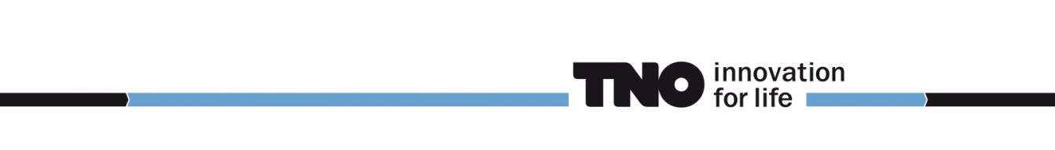

Public Procurement Guidelines

Applicable to the European Public Tender for project:
DME MeOH product purification and storage

Appendix A02

Self-declaration form

N.B. The Tenderer should not enclose this page upon submission of the Tender

Reference : 2020 FPL/INK171
Date : 03-11-2020

Please use the form that can be found:

In the Tenderned application or in:

https://ec.europa.eu/growth/tools-databases/espd/filter?lang=Gb

The European Single Procurement Document (ESPD) is a self-declaration form used in public procurement procedures by public buyers and businesses in the EU. Before the introduction of the ESPD, companies were required to submit various documents to prove that they fulfil the exclusion and selection criteria of a tender, for example have paid taxes and have not been convicted of criminal activity. Now, companies are able to meet these obligations with a single ESPD self-declaration form. The actual documents will only have to be provided by the winner of the tender. The ESPD service is also integrated with e-Certis - a mapping tool used to identify and compare certificates requested in public procurement procedures across the EU.

Signature:

Company Name : ……………………………………………………

Name of duly authorised officer : ……………………………………………………

Job Title : ……………………………………………………

Signature : ……………………………………………………

Tender submitted at ………………………………………, date……………………………………………………

