Schedule 15
Procedure for mandatory notification of data leaks and information security incidents

Version: 1.01
Adopted: 17 September 2018

Institute for Safety
Management support division
Postal address: PO Box 7010
6801 HA Arnhem
Visiting address: Kemperbergerweg 783, Arnhem
www.ifv.nl info@ifv.nl
Telephone +31 26 355 24 00

Imprint
Contracting Authority: IFV management
Contact person: Wim Papperse
Title: Reporting procedure for data leaks and information security incidents
Date: 18 July 2019
Status: Adopted on 17 September 2018
Version: 1.1
Authors: Carla Franken, Leon Visser, Frank Cools, Omko Huizenga

Table of contents

Introduction

1 Purpose

2 Definitions

3 Scope of application

4 Protocol
4.1 Identification and reporting of an incident
4.2 Registration of an incident
4.3 First analysis of the incident
4.4 Set-up of Data Incident Committee
4.5 Analysis of the data leak
4.6 Notification of the Operations Director
4.7 Reporting to the Dutch Data Protection Authority
4.8 Performing an investigation into incident or data leak
4.9 Data-leak closing meeting: discussion of the report and adoption of improvement measures
4.10 Report to the data subject(s)
4.11 Implementation of improvement measures
4.12 Close and record the report

Annex 1 - Data Leak Report Form

Annex 2 - Information for the members of the Data Incident Committee

Annex 3 - Information for internal staff to be interviewed by the Data Incident Committee

Annex 4 - Information for external staff to be interviewed by the Data Incident Committee

Introduction

As of 1 January 2016, the Dutch Personal Data Protection Act (“DPPA”) has been amended. Since then, the reporting of data leaks is mandatory. As of 25 May 2018, the DPPA has been replaced by the GDPR. The data leak notification obligation remains in force under the GDPR and has been extended by an obligation of in-house data leak notification obligation, even if it refers to minor matters. This data leak notification obligation means that companies, public authorities and other organisations processing personal data must report data leaks immediately to the Dutch Data Protection Authority (DPA), and in specific cases also to the data subject(s). The data subject is the party whose personal data have been leaked.

The companies, public authorities and other organisations falling under the data leak notification obligation must make a well-informed assessment themselves as to whether or not a concrete data leak that comes to their knowledge falls within the scope of the legal data leak notification obligation.

This procedure sets out how to act within the Institute for Safety (IFV) when a data leak is at stake or when there is a suspicion of a data leak. The data leak notification obligation is also applicable to IFV, if the data leak was caused at a third party, for instance a processor of personal data of IFV. This procedure is partly based on the policy rules of the DPA on the data leak notification obligation prescribed in the Dutch Personal Data Protection Act. Per reported data leak, the management of IFV takes the liberty to assess whether the procedure can be followed, or whether deviation from this procedure is justified.

As of July 2018 this procedure has been adjusted on the following points:
> | This procedure now includes the handling of data leaks as well as information security incidents. The main reason for this is the major overlap between both subjects: many reported incidents turn out - after investigation - not to be data leaks yet often require a new or adjusted measure. Taking these measures falls within the domain of information security.
> | The wording has been adjusted in order to comply with the GDPR.
> | The flow chart has been adjusted in consultation with the privacy project group. The description of the process has been adjusted accordingly, it being understood that the original wording has been adopted as much as is possible.

1 Purpose
The purpose of this procedure is to lay down which steps must be taken by IFV when taking knowledge of or suspecting an incident that may be qualified as a data leak or information security incident.

This procedure strives for the following result:
> consistent compliance with a uniform procedure;
> observation of due care in securing the interests of IFV, the data subject, or another company involved in the incident, being a (possible) data leak;
> a meticulous and systematic analysis of the incident, being a (possible) data leak, in order to reveal risk moments within the process. A central factor is to establish the shortcomings in the (application of) technical and organisational security measures, which (possibly) have led to the incident;
> enhancing that suitable improvement measures be taken and those improvement measures be firmly anchored on a permanent basis;
> accomplishing an adequate and uniform internal - and upon request external -accountability for the handling of an incident, being a (possible) data leak.

The description of this procedure elaborates the individual steps that need to be followed.

2 Definitions

DPA
Dutch Data Protection Authority.

GDPR
General Data Protection Regulation - the privacy law replacing the Dutch Personal Data Protection Act as of 25 May 2018.

Data subject
An identified or identifiable natural person to whom personal data relates (article 4 GDPR).

Security leak or incident
A breach of security in which personal data are not exposed to loss or unlawful processing; this does not refer to a data leak but to a security leak or incident.

Data incident
An incident concerning personal data of which it has not yet been established whether it is a data leak.

Data Incident Committee
A temporarily appointed investigation committee who will see to an investigation into a (possible) data leak and report the outcome.

Data leak or personal data breach
A breach of security leading to the accidental or unlawful destruction, loss, alteration, unauthorised disclosure of, or access to, personal data transmitted, stored or otherwise processed (article 4 GDPR).

Third parties
Any of the external parties involved in the incident other than the data subject, for instance a processor of personal data.

Invitees
Internal data subjects invited to the meeting(s) discussing the incident.

Incident
A possible security incident overriding the protection of personal data at some point so that the personal data are exposed to loss or unlawful processing. It is then irrelevant whether or not the controller has taken suitable technical or organisational protection measures. Each data leak is an incident, but not each incident is a data leak.

Personal detail
Any information relating to an identified or identifiable natural person (article 4 GDPR).

Controller
The party who, alone or jointly with others, determines the purposes and means of the processing of personal data (article 4 GDPR).

Processor
A natural or legal person, public authority, agency or other body which processes personal data on behalf of the controller (article 4 GDPR).

Processing of personal data
Any operation or set of operations which is performed on personal data or on sets of personal data, whether or not by automated means, such as collection, recording, organisation, structuring, storage, adaptation or alteration, retrieval, consultation, use, disclosure by transmission, dissemination or otherwise making available, alignment or combination, restriction, erasure or destruction (article 4 GDPR).

3 Scope of application
This procedure is applied for the reporting and handling of (possible) data leaks and information security incidents within IFV, or of (possible) incidents taking place outside IFV, but for which IFV in its capacity as Controller bears the ultimate responsibility (for instance regarding a Processor).

4 Protocol
A flow chart has been drawn up for the overall view, and then specific information is worked out per process step for the deliverable activities and corresponding responsibilities and powers.
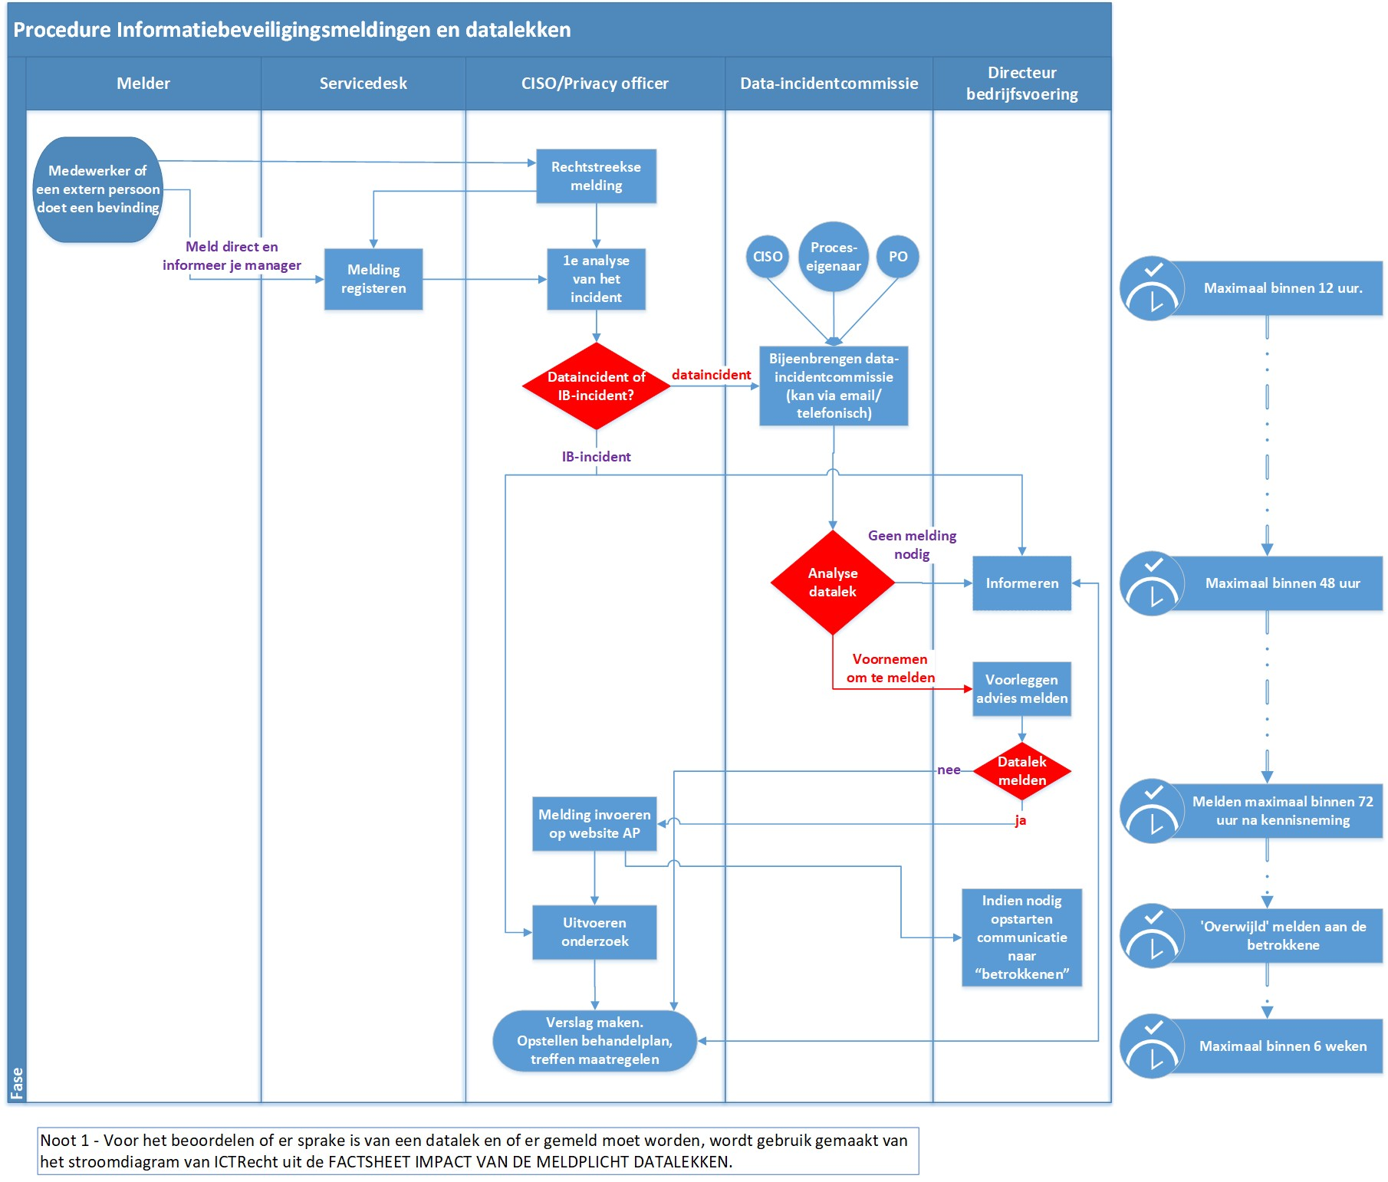

4.1 Identification and reporting of an incident
Staff who establish an incident must report this immediately to their manager, the service desk, data protection officer (“DPO”), or security officer. Then this procedure will be set in motion.

Also (the staff of) a Processor may establish a data leak and report it to their principal within IFV.
In addition, it is also possible that reports regarding a data leak come in from outside IFV, for instance from security investigators, media, or a data subject whose personal data leaked.

4.2 Registration of an incident
The incident will be recorded by the Service Desk by making use of the commonly used incident registration system. Typical characteristics of the incident will be recorded as well, so that it can be retraced later as data leak or information security incident.
If reporting directly to the CISO or privacy officer, the report will be recorded by the Service Desk after all, in principle.

If the privacy of the data subjects so requires, it is permitted to register the incident with the DPO or privacy officer only. This may refer to incidents about colleagues, or of which the data subject has indicated to handle it confidentially. The Privacy officer will keep a separate register for this, which is complementary to the registration of the Service Desk.
4.3 First analysis of the incident
The CISO and/or privacy officer will make a first analysis of the incident together. The question that needs answering is:
> Is this a data incident, an information security incident, is it both, or is everything okay?

A guideline for answering this question is: does this refer to personal data, yes or no? If yes, it is a data incident and a Data Incident Committee will be set up.

In case of an information security incident, the Operations Director will be informed and the monitoring and handling of the incident will be set in motion.

This first analysis takes place no later than 12 hours after the incident has been reported. The result of the analysis will be recorded in the applicable registration.
4.4 Setting up a Data Incident Committee
Data Incident Committee consists of at least three members aiming at carrying out a further in-depth investigation. For the composition of the Data Incident Committee due consideration will be given to the nature of the incident. Typically, the committee will be composed of the Privacy officer, CISO, and the process owner to which the incident refers (typically a head of department).

> The Operations Director will see to disclosure of all available information regarding the data leak to the members of the Data Incident Committee.
> The Operations Director will facilitate the Data Incident Committee where necessary.

4.5 Analysis of the data leak
The Data Incident Committee makes an analysis as to whether this is indeed a data leak, making use of the flow chart of legal consultancy ICTRecht. This chart originates from the “factsheet impact of the data leak notification obligation”.

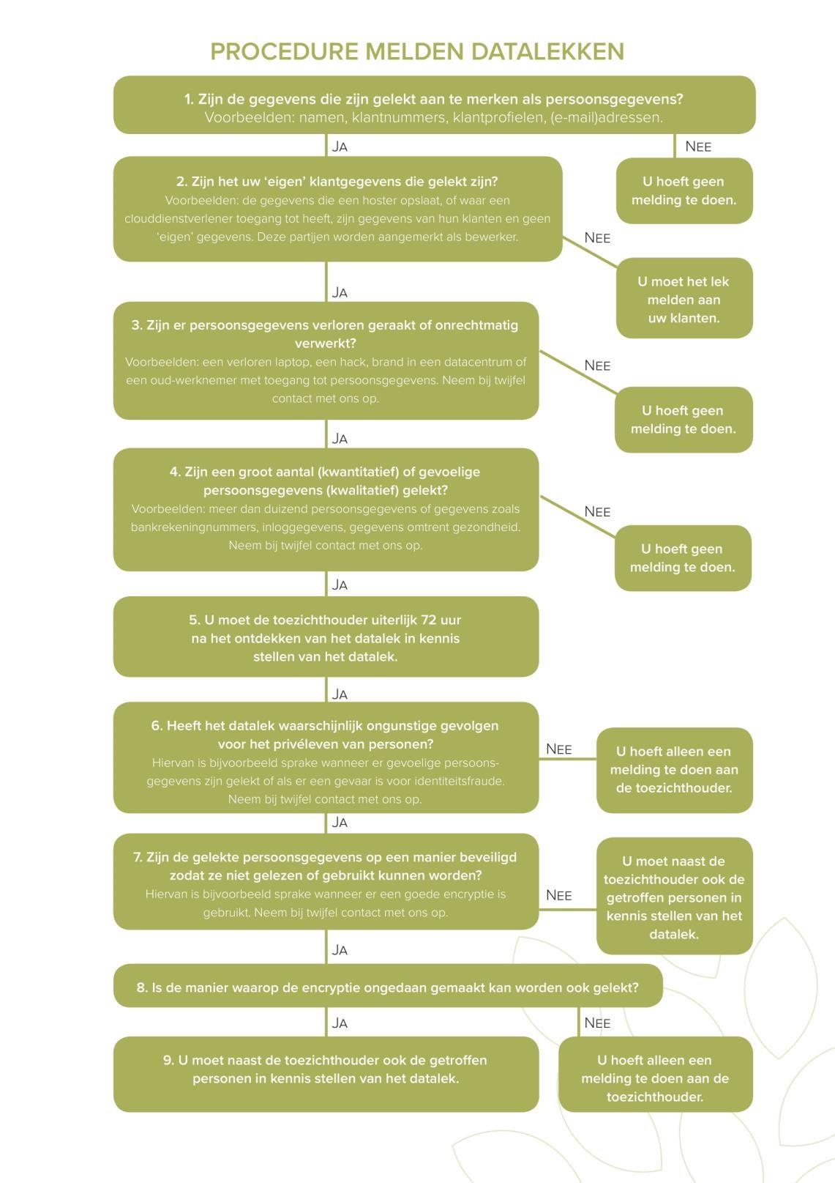

Figure 1 Procedure for the analysis of data leaks (source: ICTRecht)
> In the assessment the following aspects play a role, inter alia:
- Is there a loss of personal data? This means that IFV no longer has these data, because they have been destroyed or lost otherwise;
- Is this an unlawful processing of personal data? This includes the unintentional or unlawful destruction, loss, or alteration of processed personal data, or unauthorized access to processed personal data or disclosure thereof;
- Is a single shortcoming or vulnerability in the security at stake?
- Can it reasonably be excluded that a security breach has led to unlawful processing?
- Have personal data of a sensitive nature been leaked? This may refer to:
    - special personal data in conformity with article 9 GDPR;
    - information regarding the financial or economic situation of the data subject;
    - data which may lead to stigmatisation or exclusion of the data subject;
    - user names, passwords and other login data;
    - data which may be used for (identity) fraud;
- Do the nature and scale of the breach lead to (a significant chance of) serious adverse consequences? Take into account factors such as:
    - the scale of the processing; does it refer to lots of personal data per person, and to data of large groups of data subjects;
    - the impact of loss or unlawful processing;
    - the sharing of the personal data within (care) chains; this means that the consequences of loss and unauthorized alteration of personal data can occur throughout the entire care chain;
    - the involvement of vulnerable groups, for instance the intellectually disabled;

> | If it is believed that this is indeed a (possible) data leak, the communications process towards data subject(s), and, if applicable, the processor will also be discussed;
> | If the incident has not led to loss or unlawful processing of personal data, this is no data leak but a security leak, in which case reporting to the DPA is not at stake. However, the security leak will be investigated in order to prevent repetition.
> | It can also be assessed whether or not it is mandatory to report the data leak to the police in the event of suspicion of an offence (see also 4.3).
> | The Data Incident Committee will see to complete and accurate information as contained in Schedule 1 'Data Leak Report Form'.
  - Advice on reporting or not reporting
> The Operations Director will in all cases be notified of the findings of the Data Incident Committee.

> The Data Incident Committee will draw up an expert opinion for the Operations Director as to whether a data leak must be reported to the DPA. The Operations Director will assess whether or not it will be reported.

  - Reporting to the Dutch Data Protection Authority
> | The privacy officer takes care of a digital report to the DPA in accordance with the DPA online report form well in time (immediately, without unnecessary delay, and if possible not later than 72 hours after discovering of the data leak), with due observance of the relevant DPA guidelines. The Data Incident Committee will gather complete and accurate information within the meaning of Schedule 1 'Data Leak Report Form' forming the basis of the factual report. The privacy officer acts as contact person for the communications towards the DPA. This also applies if it is not yet clear that the incident is a data leak. It is then possible, after determining the nature of the incident, to make additions to - or withdraw - the report to the DPA.
> | The General Manager of IFV is ultimately accountable, and the Operations Director is delegated supervisor over the internal handling of the (possible) data leak in all of its details and over the external finalization with inter alia the DPA, data subjects, and processor. The DPO is supervisor over the process, and the privacy officer will carry out the duties.
> | The immediately involved management sees to it that the staff involved in the incident will be informed, as well as that the staff involved in the incident, the possible data leak, will as soon as possible each draw up their own report regarding the facts and circumstances of the incident. This written information will be submitted to the General Manager and the Operations Director for the members of the Data Incident Committee and the data-leak file.
> | The DPA will send a confirmation of receipt after a data leak has been reported. Only if the report so requires, will the DPA seek contact.
> | In case of a data leak as a result of a (non-ethical respectively malicious) hack (Section 138ab of the Dutch Penal Code), it is important to establish the nature of the leaked personal data as well as the risks of abuse for the data subject(s). In case of a hack, apart from reporting to the DPA, reporting it to the police makes sense in connection with tracking down the offenders. Reporting to the police will proceed via a police liaison officer, if available.
4.8 Reporting to the data subject(s)
> | If a data leak is reported to the DPA, it must also be determined whether the data leak must also be reported to the data subject(s). This is at the discretion of the Data Incident Committee.
> | The assessment as to whether this is an incident that must be reported to the data subjects may be made with the help of the aforementioned flow chart of legal consultancy ICTRecht.
> | At the request of the General Manager, the Operations Director will draft a notification letter to the data subject(s) in consultation with the PR consultant and legal counsel.
> | The Operations Director determines what will be reported to the data subject(s).

> | The report contains in any event the nature of the breach, contact details of IFV where the data subject(s) may obtain more information regarding the breach, and the measures recommended by IFV to the data subject(s) in order to limit the negative consequences of the breach.
> | Each of the data subject(s) will be informed individually.
> | The data leak must be reported immediately to the data subject(s). This means that, after discovery of the data leak, IFV will be at liberty to take some time for further investigation, so that IFV can inform the data subject properly and with due care. However, it cannot be excluded that the data subject(s) may have to take measures following the report for protection against the consequences of the data leak. The sooner IFV notifies the data subject(s), the sooner they can take action.
> | The report to the DPA states whether or not IFV has already reported the data leak to the data subjects, and if not, when IFV will do so. IFV must live up to the deadline that it mentions in the report to the DPA. Should it turn out at a later stage that this deadline is not feasible, IFV will inform the DPA by adjusting the report.
4.9 Investigating the incident or data leak
> | Depending on the seriousness of the incident or data leak, the Operations Director will define an assignment for the Data Incident Committee, who will be notified in writing, accompanied by the deadline by which the General Manager wishes to receive the report. The director will add the following annexes:  - 'Information for members of the Data Incident Committee' (Annex 2)  - 'Information for the interviewing of internal staff by the Data Incident Committee' (Annex 3)  - ‘Information for interviewing (staff of) third parties by the Data Incident Committee’ (Annex 4)
> | Before the prescribed deadline and within the scope of the assignment, the Data Incident Committee will open a (systematic) (internal) investigation into the facts and circumstances of the (possible) data leak.
> | The Data Incident Committee will furthermore investigate whether, and if so, how these types of incidents can be prevented in the future (the avoidability aspect).
> | The Data Incident Committee has the following powers:  - the possibility to interview everyone;  - to examine all relevant documents;  - access to all locations, within the scope of what the committee deems necessary for a meticulous analysis;  - for the external processor, the arrangements will apply as laid down in the processor agreement.
> | The Data Incident Committee has rounded off the incident the investigation within 6 weeks after discovery.

> | The Data Incident Committee may decide to involve external experts in the investigation in consultation with or at the request of the General Manager.
> | The Data Incident Committee will analyse all data in conformity with Annex 5 'Data Incident Committee Reporting Format'. Subsequently the Data Incident Committee will send the draft report to the Operations Director for further discussion.
> | Before the closing meeting takes place, the Operations Director will schedule a meeting with the members of the Data Incident Committee to pre-discuss the draft report.
> | The Data Incident Committee will submit the draft report to the interviewed internal and external parties for double-checking on factual inaccuracies.
> | The Data Incident Committee will subsequently draw up a draft report.

4.10 Implementation of improvement measures
> | The manager in whose domain the improvement measures lie, is responsible for implementation of the adopted improvement measures, oversees the communications concerning and the implementation of the improvement measures, sees to it that the implemented measures are evaluated on practicability and process improvement, and the progress will be reported to the General Manager of IFV.
> | If a processor needs to take improvement measures, the manager who is the principal of this processor will be responsible.
> | The CISO will monitor the progress.
4.11 Closing meeting in the event of a data leak: discussion of the report and adoption of improvement measures
> | The Privacy officer will schedule a closing meeting to discuss the report of the Data Incident Committee.
> | The General Manager, the Operations Director, the members of the Data Incident Committee, a member of the MT, and/or an immediate supervisor, the PR consultant, and possibly the legal counsel will be invited to the closing meeting. The invitees will receive a copy of the draft report from the Operations Director.
> | In the closing meeting the General Manager will discuss the report and the proposed SMART-defined improvement measures.
> | During the meeting, the position of the General Manager on the report of the Data Incident Committee will be determined and arrangements regarding improvement measures will be recorded. During the meeting it will be determined whether, and how, the data leak will be reported to the data subject(s).
> | After the meeting, the invitees receive the final report.
4.12 Closing and recording the report
> | The Operations Director will inform the General Manager, the manager, and/or immediate supervisor involved, those involved in the calamity, the PR consultant, and possibly the legal counsel once the data leak has been finalized and the report has been closed.
> | The Data Incident Committee will be dissolved by the General Manager of IFV.
> | The members of the Data Incident Committee will destroy any documentation still in their possession.
> | The data leak file will be archived in digital format by the privacy officer for at least 1 year. If there are valid grounds to keep it archived longer, the Operations Director will be informed.

Sources
- General Data Protection Regulation;

This Procedure for mandatory data leak notification is adopted at the meeting of the management and MT of IFV on XXXX

Signature of General Manager of IFV:

L.C. Zaal

Annex 1 Data Leak Report Form
1. Which organisation or company is at stake here? Please complete the following information.
- Name of organisation/company
- (Visiting) address
- Postcode
- City
- Chamber of Commerce registration number

- Give a summary of the incident, in which the security breach of the personal data has occurred.

3. Of how many people are personal data involved in the breach?

4. Please describe the group of people whose personal data are involved in the breach. Specify how many.

a. At least: (please specify)
b. No more than: (please specify)

5. When did the breach take place? Choose one of the following options and specify where necessary.
- On (date)
- Between (starting date of period) and (end date of period)
- Still unknown

6. What is the nature of the breach? You may tick more than one option.
- Reading (non-disclosure)
- Copying
- Modification (integrity)
- Deletion or destruction (availability)
- Theft
- Still unknown

7. What type of personal data does this refer to? You may tick more than one option.
- Name, address, and city of residence
- Telephone numbers
- E-mail addresses and other addresses for electronic communications
- Access data and identification details (for instance login name, password or customer reference number)
- Financial data (for instance bank account number, credit card number)
- Dutch tax and social security number (“BSN”) or social security number (“sofi”)
- Passport copies or copies of other identity documents
- Gender, date of birth and/or age
- Special personal data (for instance race, ethnicity, criminal data, political affiliation, union membership, religion, sex life, medical data).
- Other information, notably (please specify)

8. Which consequences may the breach have for the privacy of the data subjects? You may tick more than one option.
- Stigmatisation or exclusion
- Harm to the health
- Exposure to (identity) fraud
- Exposure to spam or phishing
- Different, notably (please specify)

9. Which technical and organisational measures did the organisation take to tackle the breach and to prevent further breaches?

10. Have the personal data been encrypted, hashed or otherwise been made incomprehensible or inaccessible to unauthorized persons? Choose one of the following options and specify where necessary.
a. Yes
b. No
c. In part, notably (please specify)

11. If the personal data have been made incomprehensible or inaccessible in whole or in part, how was this accomplished? Answer this question if you chose option (a) or (c) in question 10. If you have made use of encryption, please clarify the manner of encryption.

12. Does the breach refer to people in other EU Member States? Choose one of the following options.
a. Yes
b. No
c. Still unknown

Annex 2 Information for the Data Incident Committee members

Introduction
The General Manager of IFV has established that a data leak is at stake which, pursuant to the GDPR, has been reported to the Dutch Data Protection Authority (DPA). The General Manager will be looking forward, at the latest within 6 weeks after the data leak has been reported, to the report on the facts and circumstances of the data leak and a proposal on how such an incident can be prevented in the future. In order to arrive at a solid report, an investigation by the Data Incident Committee is necessary.

You have agreed to participation in a Data Incident Committee composed ad hoc.
Meanwhile, you have been invited to an introductory meeting with the Operations Director.
In order to prepare this meeting, you receive the following information which is relevant to you. You may ask questions during the meeting and the investigation.

Commitment in terms of time
Depending on the complexity of the data leak and the experience of the committee members, each member will spend 10 to 24 hours over a period of four weeks.

Documents/information
Please find enclosed:
- a copy of the report form to the DPA;
- a written assignment of the Operations Director to carry out an investigation, stating a deadline for submission of the report to the invitees;
- if available, the own reports of data subjects drawn up at the request of the manager involved;
- the IFV procedure for mandatory data leak notification including annexes, in which all steps of the process as well as the individual powers and responsibilities are set forth.

Powers
As investigator you have the authority to interview everyone, examine all documents and access all locations if and insofar as important for the investigation. Should the investigation so require, you will have the authority to involve an external expert in your investigation after consulting the General Manager. The Operations Director will inform you on your powers vis-à-vis the processor pursuant to the processor agreement between IFV and the processor.

Interviews with (internal and external) data subjects
As investigator you will also interview (internal) data subjects in addition to the investigation, including (if applicable) third parties working for IFV. It may also be necessary to interview data subject(s) in accordance with the definition of GDPR (on other words the persons whose data are at stake).

A method to interview data subjects within a short period of time is so-called 'carrousel method', meaning that you invite all data subjects for a meeting consecutively (after each other).

The secretariat of the Operations Director (or the secretariat of the department involved where the data leak occurred) will book meeting rooms and will schedule times for interviews with data subjects. With the confirmation of the meeting, Annex 3 to the Data leak procedure must be sent along to the internal persons who will be interviewed, and Annex 4 to external persons (staff of third parties). This annex contains relevant information for the persons who will be interviewed.

It is important to draft a written report of a meeting with a data subject (internal or external), and to send it to the data subject for double-checking on factual inaccuracies. They will not receive the (draft) report.
Where necessary, you may incorporate the received information into your report to the General Manager.

(Final) Report of Data Incident Committee
Annex 5, the report of the Data Incident Committee, serves as a basis when carrying out the investigation and will be leading for you when drawing up your report to the General Manager.
Subsequently the draft report will be forwarded to the Operations Director who, together with your committee, will discuss the draft report. You will receive an invitation from the Operations Director.
Please send your final report to the Operations Director before the deadline specified in the assignment.
Your final report will subsequently be discussed with the General Manager, the Operations Director, the manager and/or immediate supervisor, the members of the Data Incident Committee, the PR consultant, and the legal counsel.

The General Manager will decide whether or not to go along with the outcome of your report, and will also decide which improvement measures will be implemented. At the request of the General Manager, the Operations Director will also draw up a notification to data subject(s) in accordance with the GDPR, in consultation with the PR consultant and the legal counsel.

Afterwards, as member of the Data Incident Committee, you must destroy all paper and digital documents related to the data leak. The data-leak file will be archived in digital format for at least one year by the secretariat of the Operations Director.

Evaluation of final report and procedure of data leak investigation
The Operations Director will evaluate the procedure of the investigation and the final report with the Data Incident Committee.

Points of contact
The manager/immediate supervisor involved will be the point of contact in terms of in-depth matters regarding the data leak and coordination with the department(s) involved.
The Operations Director will coordinate the data leak investigation within the organisation, and will be available if, for instance, you have questions or would like to confer about the assignment, the (draft) report, the prescribed deadline and/or the approach of the DPA.

Kind regards,

Operations Director

Annex 3 Information for the interviewing of internal staff by the Data Incident Committee
(Please write a separate e-mail with confirmation of the meeting, when, where, with whom, the amount of time needed, as annex to this letter.)

Dear colleague,

You have been asked to cooperate towards an incident investigation. Below we will give you information on the reason for our request, the way in which the investigation will be carried out, your role and position in the investigation, and the further progress of the procedure.

Reason for our request
Pursuant to the General Data Protection Regulation (GDPR), the management of IFV is held to report data leaks to the Dutch Data Protection Authority (DPA). IFV must report each data leak in which personal data have been exposed to loss or unlawful processing. For this purpose, our organisation has adopted the Procedure for mandatory data leak notification (see Annex). Recently an event occurred within our organisation, which was reported by the General Manager to the DPA. In compliance with this procedure, the Operations Director has set up a Data Incident Committee consisting of the following persons: __________________ (please complete names).

This committee is carrying out an investigation into the facts and circumstances of the incident and will issue an expert opinion for possible measures to be taken in order to prevent the incident from happening again in the future. In order to be able to do its job properly, this committee has been authorized to interview everyone, examine all documents, and also access all locations. The Data Incident Committee will first analyse all data and then draw up an internal report on to the management, which report will be anonymised, in principle.

What does this mean for you?
During the investigation in order to properly analyse a data leak, use will be made as much as possible of the knowledge of staff involved and experts on the subject matter of the incident.
This is why the Data Incident Committee has scheduled a meeting with you. The purpose is to learn from you what happened and what measures can be taken in order to prevent these types of incidents from happening again.

What will happen with the information provided by you?
Openness is of the essence in such an investigation. Only with complete openness can the real causes of incidents be identified and assessed.
The Data Incident Committee will take minutes of the meeting with you, which will be sent to you for double-checking on factual inaccuracies.
The information provided by you may be used for the report of the Data Incident Committee to the management. The integral report will not be sent to you. The purpose of the report is to provide a better understanding of the incident and to make recommendations for measures that will prevent repetition. The report is confidential and entirely anonymous, in principle. The report will be submitted to the General Manager, after which the report will be discussed. Subsequently, the General Manager will decide whether or not to go along with the outcome of the report and what improvement measures must be taken. The management is responsible for the implementation of the measures.

Who receives a copy of the report?
The data leak reporting procedure states who will receive a copy of the report. The information from the report is often abstract and on a higher level than the organisation itself. It is necessary that the manager/immediate supervisor involved will provide a brief account to the department as well as explanatory notes, paying attention to the experiences of internal data subjects and what in the department could be done better or different following the data leak.

Can I speak my mind or will this get me into trouble later?
It is desirable that you provide the Data Incident Committee with all required information in order to make solid analysis of the event and take suitable improvement measures. The option of sanctions will exclusively be at stake, for instance in a labour-law sense, if all of the circumstances justify this.

Other parties who have an interest in the information
Also the data subject(s) within the meaning of the GDPR (an identified or identifiable natural person to whom personal data relates), or the legal representative(s) thereof, received information from IFV regarding the data leak, the outcome of the performed internal investigation, and the implemented improvement measures, if any.

Retention of findings of the investigation/reports
Exclusively the report to the DPA and the final report of the Data Incident Committee will be archived for at least one year in digital format by the secretariat of the Operations Director.

We thank you in advance for the fact that you are willing to render your cooperation to the investigation.

Kind regards,

The Data Incident Committee

Annex: Procedure for mandatory data leak notification

Annex 4 - Information for interviewing external persons by the Data Incident Committee
(Please write a separate e-mail with confirmation of the meeting, when, where, with whom, the amount of time needed, as annex to this letter.)

Dear (please complete name),

You have received a request to render your cooperation to the incident investigation in which XXXX (complete as applicable) is involved. Below, we will give you information on the reason for our request, the method of investigation, your role and position within the investigation, and the further progress of the procedure.

Reason for our request
Pursuant to the General Data Protection Regulation (GDPR), the management of IFV is held to report data leaks to the Dutch Data Protection Authority (DPA). IFV must report each data leak in which personal data have been exposed to loss or unlawful processing. Recently an event has occurred involving XXXX (briefly explain who/what the incident refers to). The General Manager has reported this incident as data leak to the DPA. The Operations Director has set up a Data Incident Committee consisting of the following persons: XXXX (please complete name and position of members of the Data Incident Committee). This committee is performing an investigation into the facts and circumstances of the data leak and will issue an advice on possibly needed measures to prevent such an incident from happening in the future. In order to do its job properly, this committee has been authorized to interview everyone, examine all documents, and also to access all locations. The Data Incident Committee will first analyse all data and will then draw up an internal report for the General Manager which will be anonymised, in principle.

What does this mean for you?
During the investigation, in order to be able to analyse a data leak properly, use will be made as much as possible made of the knowledge of data subjects involved in the incident. This is why the Data Incident Committee has set a meeting with you to hear your experiences as well. The purpose is to learn from you what happened and which measures can be taken in order to prevent these types of incidents from happening again.

What will happen with the information provided by you?
Openness is of the essence in such an investigation. Only with complete openness can the real causes of incidents be identified and assessed. The Data Incident Committee will take minutes of the meeting with you, which will be sent to you for double-checking on factual inaccuracies. The information provided by you may be used for the report of the Data Incident Committee to the General Manager.

The purpose of the report is to provide a better understanding of the incident and to make recommendations for measures that will prevent repetition. The report refers to an internal report, is confidential and fully anonymous, in principle. The report will be submitted to the General Manager, after which the report will be discussed. Subsequently the General Manager will decide whether or not to go along with the outcome of the report and which improvement measures must be taken.
The General Manager will discuss the outcome of the report and the necessary improvement measures in a suitable manner with the processor and/or the responsible immediate supervisor of your company.

Should you have any questions, you may ask the members of the Data Incident Committee during the meeting.

We thank you in advance for the fact that you are willing to render your cooperation.

Kind regards,

The Data Incident Committee

Annex 5 - Data Incident Committee Reporting Format

Data Leak Report

<please complete department(s)>

IFV

Date of draft: <please complete>
Date of meeting with management: <please complete>
Final date: <please complete>

Data Incident Committee:
- <please complete name>
- <please complete name>
- <please complete name>

1. Assignment and duties

Below you will find brief explanatory notes on how to write the report.
- Write a brief and concise report.
- Use the font and lay-out of this model report.
- See to a logical structure fitting within this format, and try to avoid repetition as much as possible.
- In the structure it is especially important that the description of the incident, the description of the causes, the assessment thereof and the recommended improvement measures are a logical consequence of each other.
- Ensure that the report has no spelling errors and/or grammatical errors (use spelling checker).
- Chapters do not need to start a new page; it was done in this model for easy reading only;
- Keep using the same tense when writing your report (present perfect).
- Clarify complex medical terminology.
- Make the incident visual where possible, for instance by adding a picture or drawing.

1.1 Date of incident
Please indicate here during what period the data leak has taken place and when the data leak was noticed. Please indicate also on what date the report was made by the General Manager to the Dutch Data Protection Authority.

1.2 Composition of the Data Incident Committee
The Data Incident Committee consists of the following people:
- title, initials, surname (position, possibly relevant working background)
- ….

The members of the Data Incident Committee have been able to carry out the investigation fully autonomously, have not been involved in the incident, and are not working at the department where the incident took place.

1.3 Full description of incident
Please give a description of the incident. Describe in clear terms what has taken place, setting out the events and data. Do not yet go into possible causes, this will be dealt with later.

1.4 Assignment to Data Incident Committee
The assignment described by the management and can be copied literally from the assignment form that the Data Incident Committee receives at the start of the investigation.

2. General information

2.1 Personal data
Give a summary of the incident in which the security breach of personal data has occurred.
Of how many people are personal data involved in the breach?
Give a description of the group of people whose personal data are involved in the breach.
When did the breach take place?
What sort of personal data does this refer to?

Please note: when writing your answer, you may make use of Annex 1 “Data Leak Report Form”.

2.2 Nature of the breach
Give a description of the nature of the breach. When writing your answer, you can make use of Annex 1 “Data Leak Report Form”.

2.3 Consequences for the data subject(s)
A data subject is to be understood as any identified or identifiable natural person to whom personal data relates, in conformity with the definition of the GDPR.
Please describe which consequences the breach may have for the privacy of the data subject(s).
When writing your answer, you can make use of Annex 1 “Data Leak Report Form”.

2.4 Notification of data subjects
Has/Have the data subject(s) or the legal representative(s) thereof been informed about the data leak incident and the report to the DPA? If so, by whom, and when was this discussed?

2.5 Full overview of internally and externally involved staff
In the table below, please specify which of the staff have all been involved internally as well as externally (by third parties). The real first letters of the surnames may not be reflected in the report, give everyone a letter in alphabetical order.

Name | Position
Ms A. | …
Mr B. | …
Etc.

2.6 Interviews with internally and externally involved staff
For his data leak investigation the following interviews were held:
- Ms A (position)
- Mr B (position)
- et cetera.

If any data subjects were not heard in conformity with the definition of the GDPR (the person whose data this refers to) and/or their legal representative, explain why not.

3. The investigation

3.1 Focus of the investigation
Please describe - following the progress of the data leak - where the focus of the incident investigation was placed, using the following questions:
- What were the key events causing the incident?
- Which critical moment or event may never occur ever again? This does not refer to the damage for the data subject, but the moment (cause) that could cause the damage (follow-up).
- What must this investigation prevent in the future?

The answers to these questions do not need to be repeated literally in the report, but are meant to help the Data Incident Committee to write the report and with the investigation.

4. Basic causes for the incident

4.1 Flow chart of causes
Make a flow chart of the causes (preferably in PowerPoint or Visio) for this case and add it as annex.

4.2 Discussing cause & effect factors and safety barriers
This paragraph deals with the various factors which led to the incident. This may be regarded as the narrative explanatory notes to the flow chart of causes, paying extra attention to causality and safety barriers.

4.3 Damage for the data subject(s) or the organisation, right of recourse for the processor
Set out the damage suffered by the data subject(s) as a result of the incident.

4.4 Other findings
Give explanatory notes to other findings which have not yet been dealt with in this Chapter, yet ought to be part of the report. Are there no other findings? Then this paragraph can be deleted.

4.5 Avoidability
Please explain whether or not avoidability is at stake.

5. Professionalism

5.1 Professional standards and protocols
Was the work carried out in accordance with the professional standards? In terms of protocols, was the work carried out as agreed, and if not, what was the motivation for deviating from protocol? Please add the quoted standards or protocols as annex.

5.2 Other findings in terms of professionalism
In the area of professionalism there are still a number of other matters deserving the attention and consideration by the Data Incident Committee. If one of the following questions had a key impact on the incident, please include it in this paragraph. Are there no other findings in terms of professionalism? Then this paragraph can be deleted. .
- What was the role and responsibility of the professionals and staff involved? Has each of them taken up - or been able to take up - their role and responsibility? Please clarify.
- Was the authority and competence of the data subjects on the right level?
- Was there adequate transfer of information?

6. Organisational aspects

In the area of organisational aspects there are a number of other matters deserving the attention and consideration by the Data Incident Committee. If one of the following questions had a key impact on the incident, please include it in this chapter. Make paragraphs if more than one ‘loose-end’ matter needs discussing.

6.1 Findings in terms of organisational aspects
Are there no other findings in terms of organisational aspects? Then this paragraph can be deleted.
- Were there any organisational shortcomings, and if so, which shortcomings?
- Has the behaviour of one or more staff members played a role?
- Has the knowledge level of one or more staff members played a role?

6.2 Findings in terms of technical aspects
Were there any technical shortcomings, and if so, which shortcomings?
Are there no other findings in terms of technical aspects? Then this paragraph can be deleted.

7. Conclusion

Repeat the investigation assignment asked in paragraph 1.4 and answer it. In order to avoid lengthy pieces of text, it may be an idea to number the individual basic causes in this chapter. Make sure not to repeat the entire report; this is just a summarizing conclusion.

8. Advice and improvement measures

This chapter describes the improvement measures resulting from the investigation. The Data Incident Committee makes recommendations in broad outline, giving due consideration to the following aspects:
- Are the improvement measures defined according to the principles of SMART (Specific/ Measurable/ Appealing / Realistic/ Time-bound)?
- Is it clear for whom the improvement measures are meant and how they will be safeguarded?
- On which term must these measures be taken up?

Please use the table below to show the improvement measures.

Improvement measure | Responsible person | Finalization deadline

9. Sources

Please mention all sources used during the investigation. Subsequently, under the annexes, add all quoted standards or protocols. For lengthy protocols or standards, the relevant quoted passage may also suffice.

