Market consultation in connection with Building a Movement to Value Water

Publication date: 2 January 2020
Status: Final
Reference: IUC 201911149

Table of Contents

Definitions 3
1 Introduction 4
1.1 Description of future assignment and objective of market consultation 4
Background 4
The Challenge 5
The Objective 6
Process 7
1.2 Organization 8
2 Procedure for market consultation 9
2.1 General 9
2.2 Communication and submitting answers to the market consultation 9
2.3 Planning 9
2.4 Questions about the consultation 9
2.5 Additional proposals 9
2.6 Results of the market consultation 9
2.7 Legal relationship 9
3 Information request 10

Definitions
Market consultation parties | Interested parties who respond to the market consultation posted by the client
Question and answers | A document in which the questions asked by the interested parties are included in an anonymous form, including the answers given by the client.

Introduction

Description of future assignment and objective of market consultation
With this market consultation, the organization wants to receive information regarding Building a Movement to Value Water.

Based on the results of the market consultation, RVO will determine whether the contract will be placed on the market.

Background
In July 2018, the UN’s High-Level Political Forum concluded that the world is off-track to meet the sustainable development goal on water and sanitation (SDG 6).
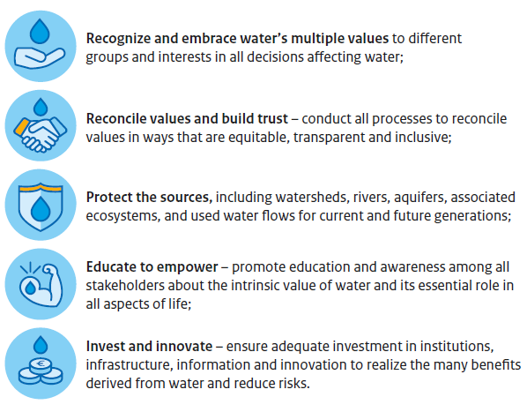
It is in this context that the High-Level Panel on Water (HLPW) recommended that we all need to understand, value and manage water better. The HLPW defined 5 principles to value water better and triggered the Valuing Water Initiative (VWI) to put these into practice. This initiative aims to generate experience regarding how to “sustainably, efficiently, and inclusively allocate and manage water resources and deliver and price water services accordingly” (HLPW, 2018).
VWI believes that societal norms, systems, and behaviors around the way we (as individuals, governments, companies) value water must change. VWI is fundamentally a collaborative initiative, looking for synergy with relevant other initiatives, many of which may not explicitly address water. The initiative adapts and grows through experience and learning and is built around four pillars, which represent four strategic areas of intervention and activities:

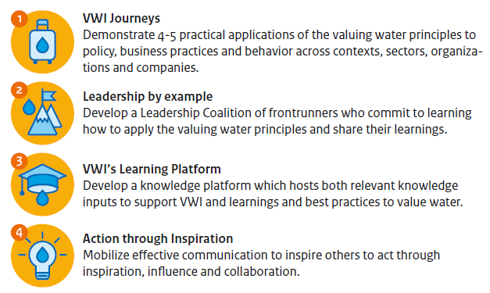

The Challenge
Water as a topic, and its effects when it’s too little, too much or too dirty, have been communicated for decades. Several methods, including doom scenarios, alarming information, urge to humanity, business relevance and others, have been employed. However, water being a complex topic with several aspects and nuances, seems to not touch the hearts of policy makers, business, financiers or even civil society, even after several crises and logical moments where its uptake could be expected.
Outside of the water sector, key actors (policy makers, industries, society) largely do NOT seem to be prioritizing or even realizing that water stress is real, relevant and material- to business, society and the environment.
This is especially strange in sectors such as food, beverage, energy, mining, textile, paper, cities, health, plastics, climate change, adaptation etc. where water is a critical input.
Suspected causes for this include:
- No unified voice – Each entity who communicates finds a “cause within a cause,” which means several messages and actions are being sent into the market. This causes confusion, saturation and a “numbness,” which either leads to people ignoring the messages, not understanding the messages, or simply not acting.
- No clear demand – Fossil fuels and plastic have shown what can be achieved when a clear demand such as “no coal” or “no single use plastic” is campaigned for effectively with a clear demand and action plan. Water lacks such an equivalent leading to people doing what they can do, not pushing themselves to do more because no one is asking.
- Too big a problem – When the same message is sent to entire communities, the problem can seem out of control and too big for any one community to control. Therefore no one acts.
- Lack of customization – Linked to the above, if the message is not spoken in a way that each community best reflects to, then you can’t hold their importance. Customization includes choice of medium, message, tone, method, and several other factors which require dedicated communications professionalism.
- Lack of visibility – Often people act when they see visible impacts which affect their lives. Smoke and air pollution, plastic in oceans and beaches are examples of such issues. The world therefore comes together on this. Water, while there are droughts and floods, seems to not be able to attract such combined action.
- Individual pain needs to translate into community pain – Think about vaccines – people have stopped seeing the impacts of not vaccinating because certain diseases are not commonplace anymore and fewer people are dying from them. That doesn’t mean that we can stop valuing vaccination. However, the impacts of non-vaccination are also felt at an individual level and bringing communities together is proving to be a challenge unless entire communities feel the impact. We need collective/community voices which represent both the powerful and the vulnerable.
- No mainstream voices – Water is still spoken about by the public sector, NGOs, water experts, etc. No mainstream voices are spreading the message. The messages therefore speak to “converts” and don’t move outside of typical sectors and actors to the “unusual” actors who we need in order to achieve systemic change.
- Multiple values of water – Water has hugely diverse and sometimes contradicting values to different sets of people. The fractured, personal-interest-driven state of approaching water also divides perspective on the collective value of water. It therefore has been extremely difficult for the water sector to be more unified in “our ask” and therefore we often end up competing for the limited attention, resources and funds of key actors who can take up limited action. This also leads to people seeing all water conversations as “WASH” (Water, Sanitation & Hygiene) conversations, which also makes it harder to rope non-state actors into the conversation.

All of this leads to the situation where many, mainly water-related, companies, NGOs or knowledge institutes and initiatives advocate the importance of water, often those communications refer to specific aspects, or simply, institutional viewpoints with conflicting perspectives. Most lack mass and power, reaching limited audiences.
A systemic change in how we approach creating this demand for valuing water is needed. So far, the sector has done what every sector does in a certain phase of maturity – continue with more of the same activities and initiatives. We need actors who can drive change and take us to the next level, a place where all our efforts are combined with best-in-class actors so that together we can create a much stronger demand for valuing water.

The Objective
VWI is looking for an expert / organization who is able to use the framing of ‘Valuing Water’/’Value Water!’ to create a movement through which more and more people demand that governments, industries and society take water seriously, this must lead and recognize that water has many values, which when recognized can provide ample reason to act. By creating powerful and effective messaging, we want to arm those who are working on water to motivate key actors to prioritize water in their decision making.
VWI believes that creating such a critical mass in water communication which is cohesive while remaining effective in speaking to different key actors in their own language requires a strategic entity which is dedicated to solving the challenges described in the previous section.
VWI wants to help to identify this entity and provide it with “kick starter” funds which will help it to identify and mobilize other experts and contributors to join in this effort.
Such an entity should be able to effectively strategize on targeting the objective as mentioned above. Therefore VWI wants to identify those actors who have:
- An understanding of why previous attempts have failed to create a demand for valuing water;
- The ability to arrange co-financed/multi-donor communication efforts, attracting sponsors and campaign financing;
- Campaigning expertise which is properly targeted and intelligent;
- The ability to find and bind strong actors in the water and communication spaces who look beyond their individual needs and instead want to address the broader needs as described above;
- Access to best-in-class communication strategists and agencies who can determine what kinds of material needs to be produced and can produce it effectively;
- The ability to work in and create a spirit of collaboration, not competition, between actors in the water and communication spaces;
- An understanding of processes that drive or target systemic change in sectors, industries, markets or society;

A willingness to focus on being effective rather than politically correct is important, to avoid messages becoming bland or conformist. We want to be bold!

Process
VWI is seeking for replies “to ask questions about the consultation” from parties to participate in this phase of the assignment to give us input and reflection on our challenge and objective, who are capable to think with us how we can have our needs carried out as well as possible and convert this into an appropriate market question.
Your input and responses will be used to develop a Terms of Reference/Statement of Requirements with a potential budget between 250,000 – 500.000 euros, to be tendered by RVO in accordance with applicable Dutch and European law.
Your submission should be maximum 3 pages (font style Verdana, 10 punts) and may contain the answers of one or more of the following questions:
- What lessons can be learned from other effective example(s) of campaigns with “vibe”, energy and moods similar to what VWI intends to create?

- What could be the most relevant target groups to inspire and mobilize for the VWI topic and what methods are deemed to be most successful?
- When drafting a contract to achieve the stated objectives, what are the different considerations we definitely should include and what should we be mindful of?

- Considering the challenges highlighted in Section 2, which kinds of partners and skill sets/capacities/talents will we need to achieve the objective in Section 3, and why?
- Your view on how realistic is it to expect a third party to design a strategy and then organize and coordinate this process on behalf of VWI.

- Besides kick starter funding, what role should VWI be playing to start this process and during it?
- If we would like to mobilize a celebrity led campaign as part of this contract, who should we be engaging with and what next steps should we take?

- What other suggestions and inputs do you believe to be relevant to the eventual Terms of Reference for the assignment.
Next Steps

You may submit written questions about this assignment to RVO until 23:59 CET on 17 January 2020. Anonymized answers to these questions will be made public on or before 24 January 2020.
The deadline for market parties to respond to the consultation is 31 January 2020 (look at page 8, 2.3 planning).

Parties with the appropriate capacity and experience may be invited to participate in consultations in February 2020 to contribute and provide further input for the Terms of Reference for the assignment.

Procedure for market consultation

General
You are invited to provide the requested information as completely as possible.
This market consultation is explicitly not part of a tendering procedure.

Communication and submitting answers to the market consultation
We kindly request you to send all communication regarding this procedure to RVO.nl via TenderNed.

If you have any functional or technical questions regarding TenderNed, you can contact the TenderNed service desk on weekdays between 08:30 and 18:00 on 0800-8363376 or via servicedesk@tenderned.nl. You can also consult the eHandbook via http://www.tenderned.nl/egids/. See also: Six-Steps-to-bidding-for-public

Planning
With regard to this market consultation, the following timetable applies:

2 January 2020 | Publication of market consultation
17 January 2020 | Deadline for market parties to ask questions about the consultation
24 January 2020 | Deadline for the client to answer questions from market parties
31 January 2020 | Deadline for market parties to respond to the consultation

The organization will inform you in the event of a change in the deadlines.

Questions about the consultation
You can ask the contact person substantive questions about the market consultation. The deadline for submitting questions is specified in the schedule. All questions, including the corresponding answers, will be answered anonymously by e-mail or TenderNed.

Additional proposals
The organization is interested in your answers. If you also have other useful comments that we can use in any assignment, we look forward to hearing from you.

Results of the market consultation
The organization can use the information that has been collected as a result of this market consultation when preparing a possible assignment. Interested parties should bear in mind that information that they provide in the context of this market consultation can be made public (in anonymous form).

The organization wants to be able to use the information provided by interested parties without reservation. For this reason, the organization will not accept any claims/reservations from interested parties about the use of information or confidentiality. By participating in this market consultation you consent to this.

In the event of a tender, no distinction will be made between parties that may or may not have participated in the market consultation.

Legal relationship
Market consultation is without obligation for all parties (the organization and the interested parties) and does not in any way imply an obligation to enter into a legal relationship with participants. No rights can be derived from participation in the market consultation or information provided during the market consultation.

Information request
You are invited to fill out the following information and questions as fully as possible.

Name of interested party:
Name of contact person and position:
Tel. Contact number:
Contact person:
Address:
Postal address:
Website:
Question no. | Question and answer
Question 1
Answer
Question 2
Answer
Question 3
Answer
Question 4
Answer
Question 5
Answer
Question 6
Answer
Question 7
Answer
Question 8
Answer
Etc.

The term ‘entity’ implies the selected party or parties that are contracted at the conclusion of this process. The entity could be a single organization, or a collaboration of select individuals from different organizations.

