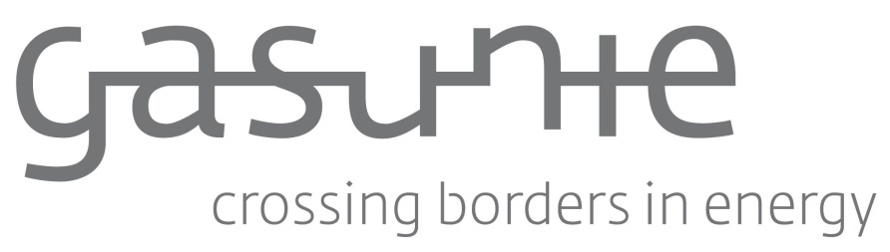

Market Consultation

Plastic pipelines for the benefit of N.V. Nederlandse Gasunie

Contact: Mrs. A. van der Harst

Version 1.0

N.V. Nederlandse Gasunie
Groningen, October 2019

© Full or partial adoption or reproduction of the contents of this document, in whatever manner, without prior written permission from the copyright owner, is prohibited, except for restrictions set by law. This prohibition also covers full or partial adaptation.

TABLE OF CONTENTS
Contents
1 GENERAL INFORMATION 3
1.1 N.V. Nederlandse Gasunie 3
1.2 Plastic pipelines 3
1.3 Market consultation 3
1.4 Scope 4
2 PROCEDURE 5
2.1 Schedule 5
2.2 Exchange of information 5
2.3 Conditions 5

GENERAL INFORMATION

N.V. Nederlandse Gasunie
Gasunie is a European gas infrastructure company. The Gasunie network is one of the largest high-pressure pipeline networks in Europe and consists of more than 15.000 km of pipelines in The Netherlands and Northern Germany, dozens of installations, and approximately 1.300 gas receiving stations.
The annual throughput of gas is approximately 125 billion cubic meters. Gasunie serves the public interest in the markets in which it is active and strives to create optimal value for stakeholders.

More information about Gasunie can be found on https://www.gasunie.nl/en/startpagina.

Plastic pipelines
The energy market is changing. Also in The Netherlands. The core business of Gasunie is transporting high pressure natural gas in The Netherlands and the northern part of Germany.
But the transition to a carbon free energy society means other types of energy carriers and other gaseous mediums that have to be transported in large volumes through pipelines.

At this moment all the Gasunie pipelines used for transporting natural gas are steel pipelines. Gasunie is investigating the use of other materials for gas transport.
Therefore Gasunie wants to know more about in the possible use of plastic materials for pipelines. We think that plastic pipes could be an alternative material with interesting benefits and a lower Total Cost of Ownership. But at this moment we do not have enough useful information to analyse the savings potential of plastic pipe.

Market consultation
Gasunie wants to get a better impression of the available possibilities in the market for plastic line pipe.

With this consultation Gasunie wants to receive more information about:
- Line pipe products that are available in the market;
- Costs of the line pipe itself, appendages such as couplings, bends, valves;
- Construction method and associated costs;
- Degradation process of the pipe;
- Transport possibilities of different kind of gases other than natural gas;
- Possibilities for repair under operational conditions;
- Possibilities of making new connections under operational conditions;
- Applicable standard(s);
- Connection with steel pipelines (welded);
- Advice about valve applications and materials;
- Monitoring the integrity of the pipe;
- Permeation rate per gas type.

As a guidance for the requested information a question form is given in the annex.

The information of this consultation will be used to advise the department Asset Management within Gasunie.

Scope

Below are listed the currently identified scope and requirements as a reference for answering the questions in 1.3 above.

Scope
Outer Diameter (inch)* | 4, 6
Pressure (bar(o) (MOP) | between 8 and 80
Temperature (°C) | between -20 and +50
Gas type | Natural gas, bio gas  H₂, CO₂, O₂, H₂S, N₂  and condensate
* If larger pipe diameters are available, share the information with us.

PROCEDURE

Schedule

Activity | Date / Period
Publication of the consultation via Tenderned | 7 October 2019
Deadline submission of response via Tenderned | 18 November 2019

Exchange of information
The exchange of information for this market consultation is carried out electronically via Tenderned, www.tenderned.nl. The use of Tenderned is free of charge.

If you have a product that might be interesting for Gasunie to use for new connections and gasses, please fill in the Question Form in Annex 1. You can send the Question Form and prices to A.van.der.Harst@gasunie.nl.
For questions about this consultation you can contact, Mrs. A. van der Harst via A.van.der.Harst@gasunie.nl.

Conditions
By taking part in this market consultation you agree with the following conditions:

- Answers must be sent via email to the contact person of this consultation;
- Communication is in the English language;
- Participants cannot derive any rights based on this market consultation;
- Your answers are confidential and shall only be shared within Gasunie;
- The provided information will only be used for further studies and advice;
- If a solution is interesting for Gasunie we can contact you for further information;
- Gasunie is not bound by the results of the market consultation;
- No rights may be derived from the planning. Gasunie reserves the right to change the planning.

Annex 1 Question Form
- What kind of services do you offer? For example only delivering of plastic pipes or also design, connections, production, testing, construction etc.?
Answer

- Do you have any reference projects?

Answer

- What is the range in size (inner/outer diameters), pressure and lifetime that you can deliver?
Answer

- What kind of media can your plastic pipe transport? For example natural gas, N₂, H₂, biogas, CO₂ etc.
Answer

- What kind of coupling can you offer to connect the plastic pipeline to existing steel pipelines?
Answer

- Do you also offer other products like bends, fittings, valves etc. that are suitable for the required media?
Answer

- What are your prices for the pipe as submitted in answer to question 3 for lengths of 1000, 2000, 5000 m.
Answer

- What are your prices for the couplings, valves, bends, fittings?

Answer

- Can your pipe be used for horizontal underground drilling?

Answer

- Is there an inspection method to verify the integrity of the plastic pipeline? Is it possible to detect degradations
Answer

- Which standards are applicable to your pipe, couplings, bends, valve?
Answer

- Can the plastic pipe be repaired under gas pressure ? For example after excavation damage.
Answer

- What are the permeation rate per gas type for the pipes and connections you offer?
Answer

Examples of pipe made from plastic are reinforced thermoplastic pipe and thermoplastic composite pipe.

