
AMSTERDAM AIRPORT SCHIPHOL
CAPITAL PROGRAMME
MARKET CONSULTATION
for the construction of the new terminal building at Amsterdam
Airport Schiphol
QUESTIONNAIRE
Closing date for response to questionnaire: 6 August 2018 17.00

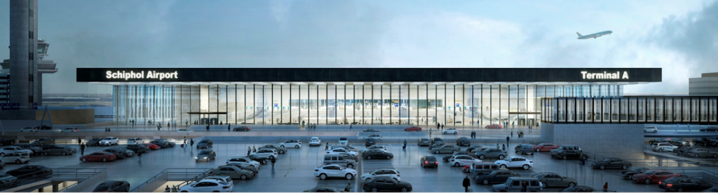

QUESTIONNAIRE
General business information
Question 1
Schiphol would like to receive the following information about your organization:
a) Name of the organization
…………………………………………………………………………………………………………….
b) Address of the organization
…………………………………………………………………………………………………………….
…………………………………………………………………………………………………………….
c) Contact details (name, e-mail and telephone number)
…………………………………………………………………………………………………………….
…………………………………………………………………………………………………………….
d) Overview of the activities that your organization carries out
…………………………………………………………………………………………………………….
…………………………………………………………………………………………………………….
…………………………………………………………………………………………………………….
…………………………………………………………………………………………………………….
e) Turnover excl. VAT for 2017 in €
…………………………………………………………………………………………………………….
…………………………………………………………………………………………………………….
f) Number of employees
…………………………………………………………………………………………………………….
g) Other relevant information that you wish to mention

…………………………………………………………………………………………………………….
…………………………………………………………………………………………………………….
…………………………………………………………………………………………………………….
…………………………………………………………………………………………………………….

General questions about the tenders
Question 2
Do you have any comments on the packaging approach?
…………………………………………………………………………………………………………….
…………………………………………………………………………………………………………….
…………………………………………………………………………………………………………….
…………………………………………………………………………………………………………….
…………………………………………………………………………………………………………….
Question 3
Which packages are of interest to your organization and of which parts would you source with in-house capability or wider supply chain?
…………………………………………………………………………………………………………….
…………………………………………………………………………………………………………….
…………………………………………………………………………………………………………….
…………………………………………………………………………………………………………….
…………………………………………………………………………………………………………….
Question 4
Within your industry, have you seen examples of similar procurement and contracting strategies on other projects that have worked well or lessons
learnt?

…………………………………………………………………………………………………………….
…………………………………………………………………………………………………………….
…………………………………………………………………………………………………………….
…………………………………………………………………………………………………………….
…………………………………………………………………………………………………………….
Question 5
Are you intending to respond to the tender when it’s issued, for example would you have the capacity in terms of your other commitments?

…………………………………………………………………………………………………………….
…………………………………………………………………………………………………………….
…………………………………………………………………………………………………………….
…………………………………………………………………………………………………………….
…………………………………………………………………………………………………………….

Question 6
If you do not intend to bid, can you explain the reasons why?

…………………………………………………………………………………………………………….
…………………………………………………………………………………………………………….
…………………………………………………………………………………………………………….
…………………………………………………………………………………………………………….
…………………………………………………………………………………………………………….
Question 7
KL AIR are developing the design, therefore there is no design responsibility for the contractor. What are your comments on this?

…………………………………………………………………………………………………………….
…………………………………………………………………………………………………………….
…………………………………………………………………………………………………………….
…………………………………………………………………………………………………………….
…………………………………………………………………………………………………………….

Question 8
It is possible to bid for more than one package e.g. both the Basement and the Terminal. If you were to bid more than one package would you intend to bid in a joint venture or independently for each of the packages?

…………………………………………………………………………………………………………….
…………………………………………………………………………………………………………….
…………………………………………………………………………………………………………….
…………………………………………………………………………………………………………….
…………………………………………………………………………………………………………….

Question 9
Do you have any comment on the suggested JV composition proposed by Schiphol for the main terminal package?
…………………………………………………………………………………………………………….
…………………………………………………………………………………………………………….
…………………………………………………………………………………………………………….
…………………………………………………………………………………………………………….
…………………………………………………………………………………………………………….

