 | 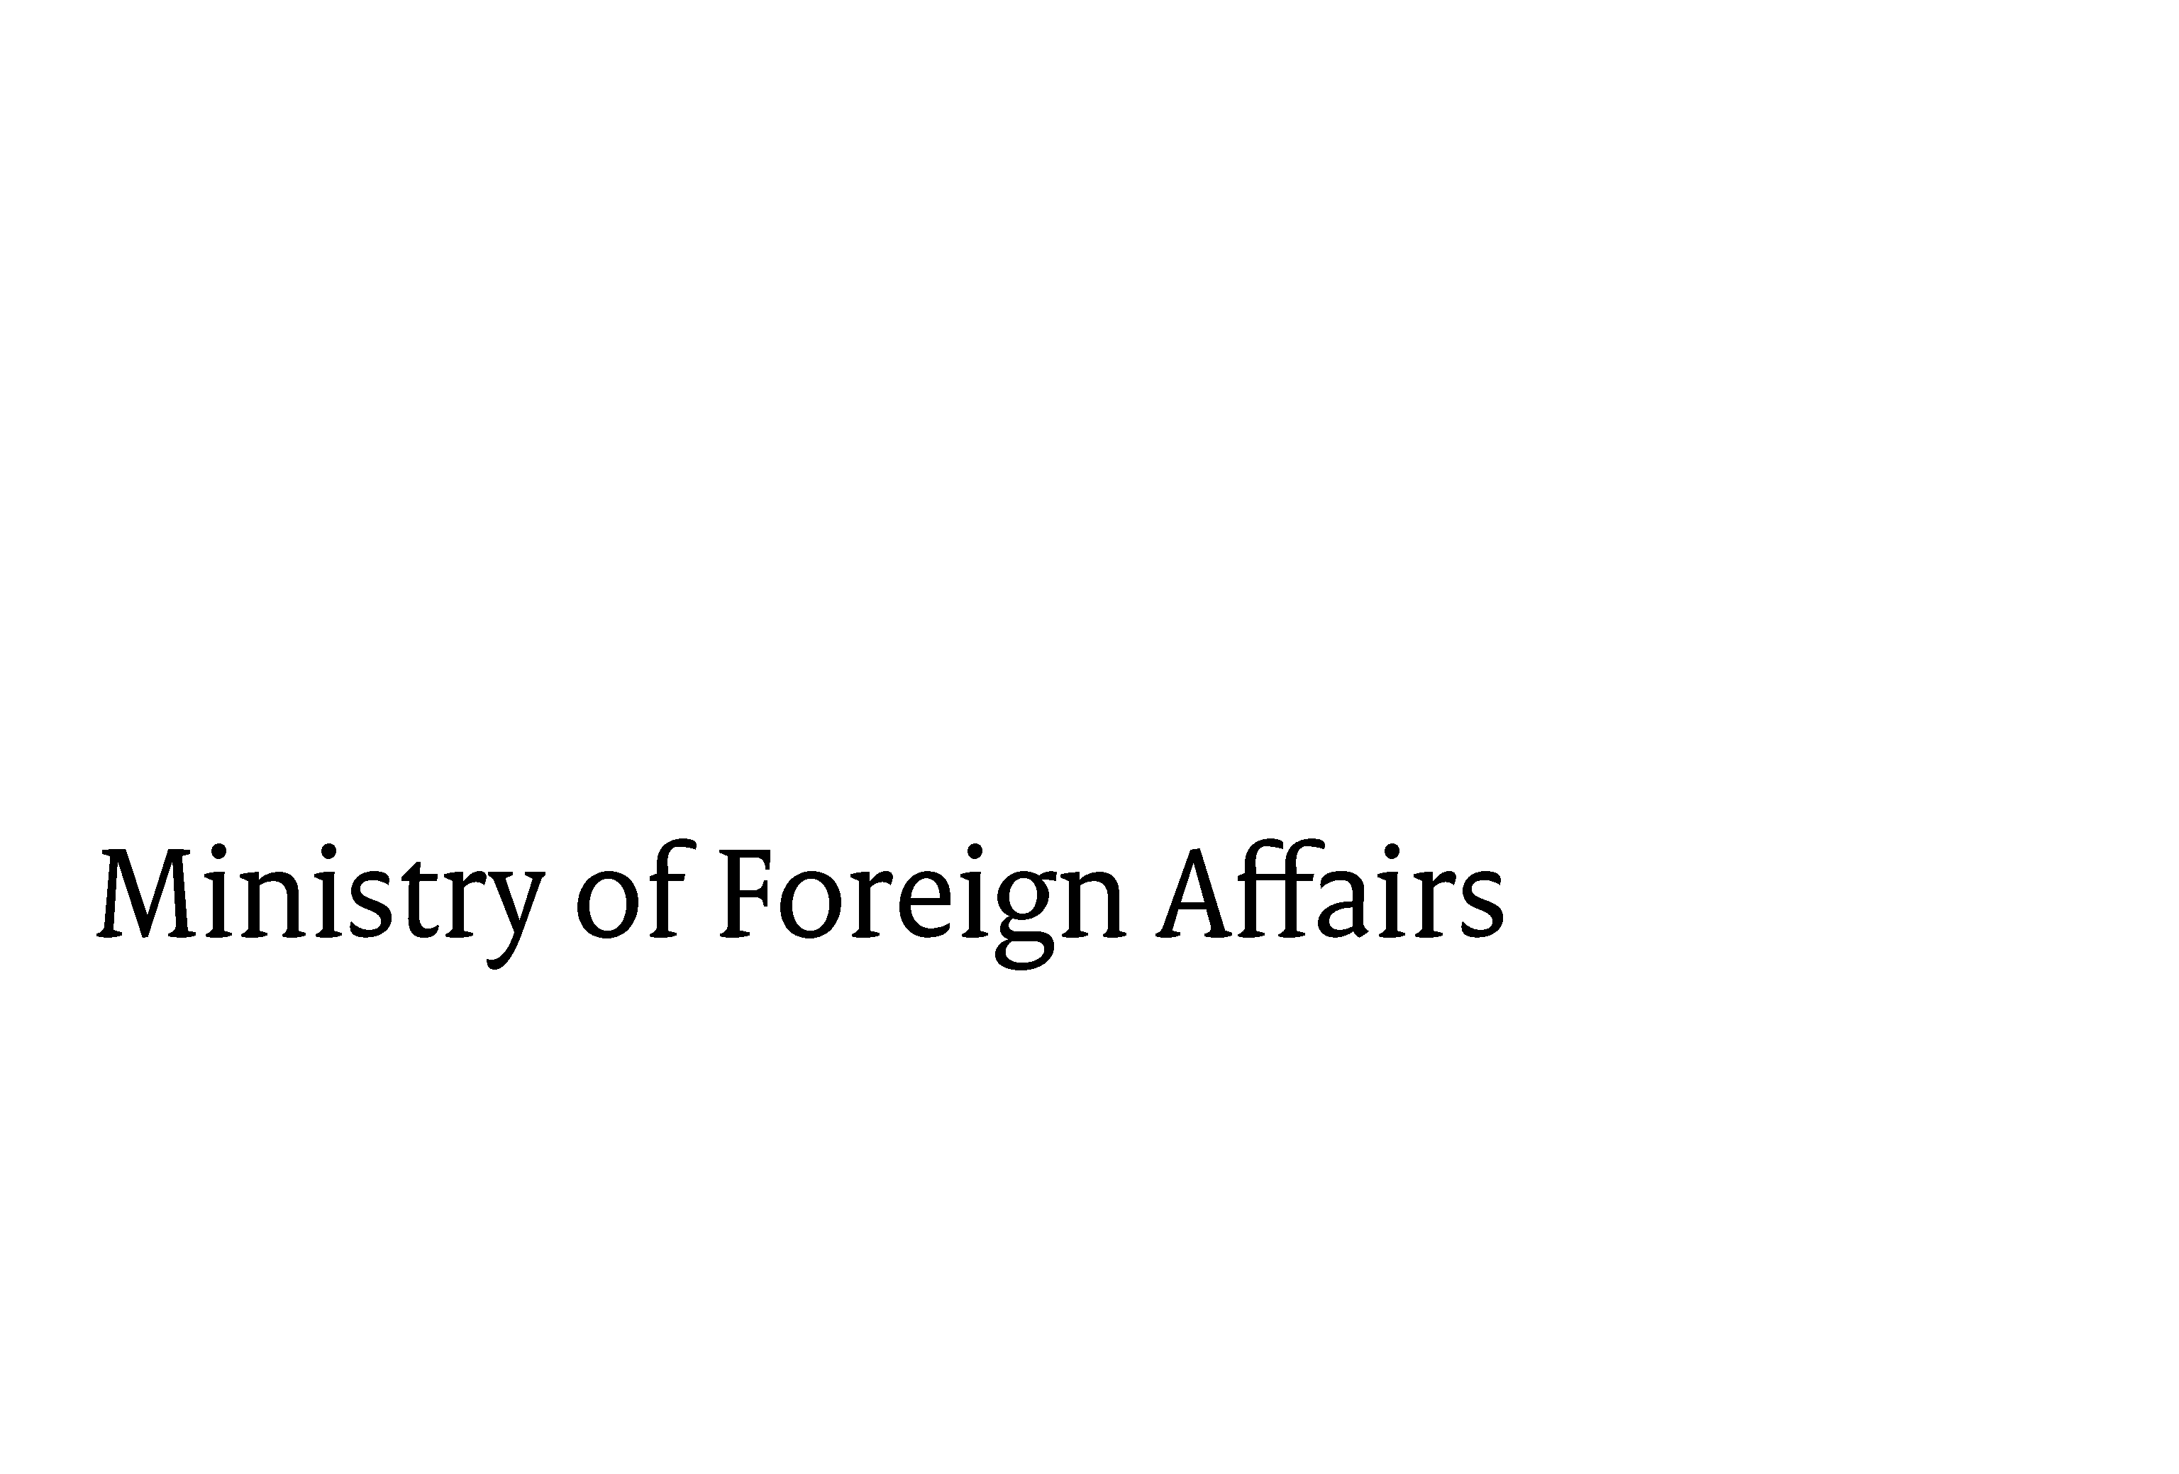

Annexe to tender document
Open EU award procedure:

EX ANTE EVALUATION, FEASIBILITY STUDY AND BASELINE SURVEY

FEZ/IM-318/Accra



Ministry of Foreign Affairs
The Embassy of the Kingdom of the Netherlands in Ghana, Accra Printed: 4 oktober 2012
FEZ/IM version: 20100803

Contents

1. Organisational details and declarations/statements 3
2. Minimum requirements 8
3. Specifications (Programme of requirements and wishes) 10
4. Knock-out criteria 11
5. Award criterion: quality (weighting factor 80%) 12
6. Award criterion: price (weighting factor 20%) 12
8. Statement of Agreement 13

Annexe to tender document
Open EU award procedure:

EX ANTE EVALUATION, FEASIBILITY STUDY AND BASELINE SURVEY
FEZ/IM-318/Accra

Organisational details and declarations/statements

How to submit information

Tenderers should present the information requested in this Annexe using the order, layout and tabs specified below.

- Tab 1: Checklist
- Tab 2: Organisational details
- Tab 3: Minimum requirements
- Tab 4: Knock-out criteria
- Tab 5: Award criteria
- Tab 6: Statement of Agreement

Checklist
Grounds for exclusion | Does the tenderer comply?
The tenderer does not find itself in one or more of the circumstances referred to in article 45 of the Public Procurement Tendering Rules Decree (BAO) | Yes No
The tender was submitted on time | Yes No
All declarations/statements, annexes and other information submitted are correct, complete and regular | Yes No
The tenderer is not acting contrary to the tender instructions and/or conditions | Yes No
Minimum requirements | Does the tenderer comply?
Minimum turnover | Yes No
Minimum technical ability / references | Yes No
Minimum quality | Yes No
Minimum staffing | Yes No
Knock-out criteria | Does the tenderer comply?
Does tenderer meet all knock-out criteria? | Yes No
Award criteria | Supplied?
Did tenderer supply information on all award criteria? | Yes No
Statement of Agreement | Signed?
Statement of Agreement | Yes No

Organisational details
Tenderer A / Lead party of consortium / Principal contractor

Name of tenderer A / lead party of consortium / principal contractor
Name of liaison officer
Position of liaison officer
Name of deputy liaison officer
Street and no.
Postcode and city
Country
Telephone
Email
Main activity of tenderer
Contract activities to be performed by tenderer / lead party of consortium / principal contractor

If applicable: Consortium member B / subcontractor B
Name of consortium member B / subcontractor B
Name of liaison officer
Position of liaison officer
Name of deputy liaison officer
Street and no.
Postcode and city
Country
Telephone
Email
Contract activities to be performed by consortium member B / subcontractor B

If applicable: Consortium member C / Subcontractor C
Name of consortium member C / subcontractor C
Name of liaison officer
Position of liaison officer
Name of deputy liaison officer
Street and no.
Postcode and city
Country
Telephone
Email
Contract activities to be performed by consortium member C / subcontractor C

Activities to be performed by consortium members / principal contractors / subcontractors

If you are submitting a joint request to participate, you should indicate in the table below how the activities (or services, supply of products, tasks, turnover, deployment of staff) will be divided between the consortium members or contractors.

Division of tasks between consortium members / between principal contractor and subcontractors | % performed by tenderer A / lead party of consortium / principal contractor | % performed by consortium member B / subcontractor B | % performed by consortium member C / subcontractor C
Activity / product / service X (describe)
Activity / product / service Y (describe)
Activity / product / service Z (describe)
Extend if necessary

By signing the Statement of Agreement, the consortium members / the principal contractor declare/declares that, if they are / it is awarded the contract, the lots will be performed in accordance with the percentages shown in this table.

Holding company / group

If the tenderer / any consortium member / the principal contractor or any subcontractor is owned by a holding company or is part of a group of companies, it must enclose an organisational chart showing the shareholding structure and the name, address and place of establishment of the parent company.

If the tenderer (or any consortium member / the principal contractor or any subcontractor) is owned by a holding company or is part of a group of companies and wishes to use the parent company’s resources, a declaration must be submitted stating that, for the duration of the contract, the parent company will act as guarantor for the tenderer with respect to the fulfilment of obligations pursuant to the contract, should the contract be awarded to the tenderer. If the parent company has issued a declaration of joint and several liability in accordance with article 403, title 9, book 2 of the Dutch Civil Code, a copy of this declaration will suffice.

Is the tenderer / any consortium member / the principal contractor or any subcontractor owned by a holding company or is it part of a group of companies? | Yes/no
Organisational chart enclosed under the tab:
Guarantor’s declaration enclosed under the tab:

Proof of enrolment in a commercial or professional register

The tenderer must submit recent (not older than four months) proof of its enrolment in a commercial or professional register in the country in which it is established (in the Netherlands, the Kamer van Koophandel) or a certificate as referred to in article 47 of the BAO attesting to the signatory’s power of representation. In the case of a consortium, all the members should submit a certificate. Subcontractors do not have to submit a certificate.

Proof of enrolment enclosed under the tab:

Declaration under article 45 of the Public Procurement Tendering Rules Decree (BAO)

By signing the Statement of Agreement, the tenderer / principal contractor (also acting on behalf of the subcontractors) / each consortium member individually declare(s) via its legally authorised representative that it has not been the subject of a conviction by final judgment for one or more of the reasons listed below:
a) participation in a criminal organisation, as defined in article 2 (1) of Council Joint Action 98/733/JHA;
b) corruption, as defined in article 3 of the Council Act of 26 May 1997 and article 3 (1) of Council Joint Action 98/742/JHA;
c) fraud within the meaning of article 1 of the Convention relating to the protection of the financial interests of the European Communities;
d) money laundering, as defined in article 1 of Council Directive 91/308/EEC of 10 June 1991 on prevention of the use of the financial system for the purpose of money laundering.
The tenderer also declares that:
a) it is not bankrupt or being wound up, its affairs are not being administered by the court, it has not entered into an arrangement with creditors, it has not suspended business activities and is not in any analogous situation arising from a similar procedure under national laws and regulations;
b) it is not the subject of proceedings for a declaration of bankruptcy, for an order for compulsory winding up or administration by the court or of an arrangement with creditors or of any other similar proceedings under national laws and regulations;
c) it has not been convicted by a judgment which is final and unappealable in accordance with the legal provisions of the country of any offence concerning its professional conduct;
d) it has not been guilty of grave professional misconduct proven by any means which the contracting authorities can demonstrate;
e) it has fulfilled obligations relating to the payment of social security contributions in accordance with the legal provisions of the country in which it is established or with those of the country of the contracting authority;
f) it has fulfilled obligations relating to the payment of taxes in accordance with the legal provisions of the country in which it is established or with those of the country of the contracting authority;
g) it is not guilty of serious misrepresentation in supplying the information required under the legislation on the qualitative selection criteria or has not supplied such information.

Minimum requirements

Minimum turnover

Does the tenderer satisfy the minimum requirement for turnover as described in 5.2? Has the tenderer attached the relevant annual reports including an audit opinion (review opinion) under this tab? | Yes No  Yes No

  - Minimum technical ability / references

Does the tenderer satisfy the minimum requirement for technical ability / references as described in 5.2? | Yes No

Reference 1
Contract performed by: | Tenderer A  Consortium member B / Subcontractor B  Consortium member C / Subcontractor C
Client’s name and place of establishment
Name and position of contact at client who can be approached for further information
Telephone number of contact
Brief description of the main activity which is relevant to the current contract
Was the contract indeed related to WASH programmes funded by leading international organisations such as the World Bank, UN, EU and/or ADB and/or major bilateral donor agencies? | Yes No
Was the contract indeed related to ex ante evaluations and feasibility studies for World Bank, UN, EU and/or ADB and/or major bilateral donor agencies? | Yes No
Was the contract indeed related to the West-African region? | Yes No
Value of the contract:  Does the value of the contract at least satisfy the requirement specified in 5.2? | Yes No
Was the contract completed after the date specified in 5.2?  Duration of the contract:  Does the duration of the contract satisfy the requirement specified in 5.2? | Yes No  months  Yes No
Has the tenderer submitted a declaration from the client on how satisfied it was with the way the contract was performed (indicating that the client was at least ‘satisfied’)? | Yes No

Reference 2
Contract performed by: | Tenderer A  Consortium member B / Subcontractor B  Consortium member C / Subcontractor C
Client’s name and place of establishment
Name and position of contact at client who can be approached for further information
Telephone number of contact
Brief description of the main activity which is relevant to the current contract
Was the contract indeed related to WASH programmes funded by leading international organisations such as the World Bank, UN, EU and/or ADB and/or major bilateral donor agencies? | Yes No
Was the contract indeed related to ex ante evaluations and feasibility studies for World Bank, UN, EU and/or ADB and/or major bilateral donor agencies? | Yes No
Was the contract indeed related to the West-African region? | Yes No
Value of the contract:  Does the value of the contract at least satisfy the requirement specified in 5.2? | Yes No
Was the contract completed after the date specified in 5.2?  Duration of the contract:  Does the duration of the contract satisfy the requirement specified in 5.2? | Yes No  months  Yes No
Has the tenderer submitted a declaration from the client on how satisfied it was with the way the contract was performed (indicating that the client was at least ‘satisfied’)? | Yes No

Reference 3
Contract performed by: | Tenderer A  Consortium member B / Subcontractor B  Consortium member C / Subcontractor C
Client’s name and place of establishment
Name and position of contact at client who can be approached for further information
Telephone number of contact
Brief description of the main activity which is relevant to the current contract
Was the contract indeed related to WASH programmes funded by leading international organisations such as the World Bank, UN, EU and/or ADB and/or major bilateral donor agencies? | Yes No
Was the contract indeed related to ex ante evaluations and feasibility studies for World Bank, UN, EU and/or ADB and/or major bilateral donor agencies? | Yes No
Was the contract indeed related to the West-African region? | Yes No
Value of the contract:  Does the value of the contract at least satisfy the requirement specified in 5.2? | Yes No
Was the contract completed after the date specified in 5.2?  Duration of the contract:  Does the duration of the contract satisfy the requirement specified in 5.2? | Yes No  months  Yes No
Has the tenderer submitted a declaration from the client on how satisfied it was with the way the contract was performed (indicating that the client was at least ‘satisfied’)? | Yes No

Does the tenderer have the required number of staff, as specified in 5.2? | Yes No

Specifications (Programme of requirements and wishes)

Reference is made to the “Terms of Reference” for the “Ex Ante Evaluation, Feasibility Study and Baseline Survey” that form an integral part of the tender documentation. Integral confirmation of these “Terms of Reference” counts as a knock-out criterion for this tender.

Conflict of interest

Are you aware that the winning tenderer (principal contractor, consortium or subcontractor) does not qualify for any assignments under the main WASH program. | Yes No

5. Knock-out criteria

The tenderer should indicate whether it satisfies the knock-out criteria set out in 6.1 of the tender document. By signing the Statement of Agreement, the tenderer affirms that its answers are correct, complete and regular.

Does the tenderer meet knock-out criterion | I | in § 6.1 of the tender document? | Yes No
Does the tenderer meet knock-out criterion | II | in § 6.1 of the tender document? | Yes No
Does the tenderer meet knock-out criterion | III | in § 6.1 of the tender document? | Yes No
Does the tenderer meet knock-out criterion | IV | in § 6.1 of the tender document? | Yes No
Does the tenderer meet knock-out criterion | V | in § 6.1 of the tender document? | Yes No
Does the tenderer meet knock-out criterion | VI | in § 6.1 of the tender document? | Yes No
Does the tenderer meet knock-out criterion | VII | in § 6.1 of the tender document? | Yes No
Does the tenderer meet knock-out criterion | VIII | in § 6.1 of the tender document? | Yes No
Does the tenderer meet knock-out criterion | IX | in § 6.1 of the tender document? | Yes No
Does the tenderer meet knock-out criterion | X | in § 6.1 of the tender document? | Yes No
Does the tenderer meet knock-out criterion | XI | in § 6.1 of the tender document? | Yes No
Does the tenderer meet knock-out criterion | XII | in § 6.1 of the tender document? | Yes No

Award criterion: quality (weighting factor 80%)

 | Award criteria | Weighting factor | Sub-Weighting factor
1 | Quality of service by means of cv’s | 70%
 | 1.1 Team leader/economist (international) |  | 40%
 | 1.2 International team members |  | 30%
 | 1.3 Local team members |  | 30%
 | CV’s will be evaluated based on education, experience and specific knowledge.
 |  |  | 100%
2 | Quality of the proposal | 30%
 | - Quality of the overall methodological approach proposed for the main elements of the assignment (ex-ante evaluation, feasibility study, baseline and M&E framework) |  | 20%
 | - Quality of the proposed organization of the team, division of tasks (and working days) and interaction |  | 20%
 | - Quality of the approach towards interaction with EKN and Ghana authorities |  | 20%
 | - Observations and suggestions on the services required and possible risks identified and proposals on how to deal with such risks |  | 20%
 | - Suggestions for internal quality control and overall supervision of the assignment |  | 20%
 |  | 100% | 100%

Award criterion: price (weighting factor 20%)

Specify your price for the contract below, as requested in 6.2.2 of the tender document.
Prices in euros  all-inclusive | Price per unit  (days) | Quantity  (days) | Total
Team leader | €0.00 | XX days | €0.00
International team members | €0.00 | XX days | €0.00
Local team members
Etc.
Tickets | €0.00 | X | €0.00
DSA | €0.00 | X | €0.00
Etc. | €0.00 | X | €0.00
Total excl. VAT |  |  | €0.00
Total incl. VAT |  |  | €0.00

8. Draft contract and conditions

Files containing the draft public service contract and the General Government Terms and Conditions for Public Service Contracts (ARVODI 2011) are attached.

9. Statement of Agreement

By signing this statement, the tenderer declares that it agrees / the members of the consortium declare that they agree / the principal contractor (also acting on behalf of the subcontractor(s)) declares that it agrees with all the information supplied and the conditions set by the Ministry, and that the information is complete, correct and regular. The tenderer also declares / the members of the consortium also declare / the principal contractor (also acting on behalf of the subcontractor(s)) also declares that the Ministry has the right to verify all information without its/their prior approval.

Name of tenderer A:
Name and position of authorised signatory:
Signature and date:

Name of consortium member B:
Name and position of authorised signatory:
Signature and date:

Name of consortium member C:
Name and position of authorised signatory:
Signature and date:

